Community Gardens Policy

V1

Title | Community Gardens Policy
Summary | The purpose of this policy is to provide a framework for Council to support community gardens.
Document Type | Policy
Relevant Strategic Plan Objectives | - Strategic Direction 1: An ecologically sustainable Inner West  - Strategic Direction 2: Liveable, connected neighbourhoods and transport.  - Strategic Direction 4: Healthy, resilient, and caring communities
Legislative Reference | Local Government Act 1993
Related Council Documents | - Community Gardens Guidelines  - Grants and Fee Scale Policy  - Inclusion Action Plan  - Land and Property Policy  - Living Streets Verge Garden and Adopt-a-Spot Policy and Guidelines  - Parks Plans of Management  - Community Engagement Framework
Version Control | See last page

Contents
1 Purpose 4
2 Background 4
3 Objectives 4
4 Scope 5
5 Definitions 5
6 Statement 6
7 Policy 6
8 General support for community gardens 10
9 Responsibilities 11
10 Associated Procedure 13
11 Breaches of this Policy 14
12 Administrative Changes 14
13 Version Control – Policy History 14

Purpose
The purpose of this policy is to provide a framework for Council to support community gardens.

Background
Council is responsible for managing the competing demands on Council land in the densely populated Inner West. It supports the establishment of community gardens to encourage urban food growing where appropriate. The benefits that flow from the establishment of community gardens include:
- Access to local, organically grown food
- Enjoyable, creative spaces
- Improved wellbeing, social inclusion and community connection, reduced loneliness, and social isolation
- Public examples of sustainable design and alternative ways to use public space
- Enhanced, unique character in neighbourhoods through local cultural enrichment
- Active and healthy communities, through increased passive recreation and healthy eating
- Building a more resilient community who are producers, not just consumers, of food
- Improved opportunities for community resource sharing and reuse, learning and participation in community life
- Reduced emissions through lower intensity food production and composting
- Ecosystem health through green infrastructure, permeable surfaces, and rainwater reuse
- Improved biodiversity through habitat creation

Objectives
The objectives of this policy are:
- To enable community groups to successfully establish and run community gardens
- To ensure community gardens on Council land are appropriately governed, designed, and managed
- To establish a clear and transparent approvals framework for community garden groups on Council land
- To develop a local network of community gardens that is accessible, open, and inclusive and benefits the Inner West community
- To confirm support available through Council

Scope
In scope
This policy applies to all community gardens on Council land in the Inner West local government area.
Out of scope
This policy does not apply to:
- Verges, laneways, and other areas of the road reserve
- Properties that are not owned or managed by Council for example privately owned land, and some Crown Land

Definitions
In the Community Gardens Policy, the following terms have the following meanings:
Community Garden | Community-managed space for non-commercial food growing and other gardening activities, accessible to and for the benefit of the local community
Community garden group (“group”) | Group managing, or seeking to establish, a community garden. For Council to form agreement with it, the group must as a minimum be incorporated and registered with NSW Fair Trading as an association.
Council land | Land owned or under the care, control, and management of Inner West Council, that is both zoned as RE1 Public Recreation and allows for community gardening in its park Plan of Management

Statement
Council aims to enable and encourage community gardens that contribute to an ecologically sustainable Inner West, liveable, connected neighbourhoods, and healthy resilient and caring communities. Community gardens are led by and managed by community members. Community guardianship strengthens the longevity, sustainability, and success of community gardens.
The establishment and development of community gardens on Council land have historically been facilitated through licences although a deed can be used. Community garden groups can apply for Council grant funding to develop appropriately designed and managed community gardens, including groups operating on land not owned or managed by Council.

Policy
Council enables community gardens that operate on land it manages through licences or deeds.
Other community gardens in the Inner West, on land that is not managed by Council (including church and school land), must obtain permission from the relevant land manager, and any relevant planning approvals from Council.
Council may support the establishment or continuation of community gardening on Council land where it can be demonstrated that:

- The park’s Plan of Management authorises community gardening
- The proposed community garden is in keeping with the Plan of Management, the open space values of the park are not adversely affected, and potential for conflict with existing users and neighbours is minimised
- The proposed site is not within an area identified by Council as important for wildlife protection and the potential for conflict with native animals is avoided
- The design and function of the proposed community garden is one which will have long term benefits for the community, is inclusive and not for private benefit
- There is wide support for a community garden in a particular neighbourhood and that such needs are not currently met locally
- There has been comprehensive community engagement on the development of the proposed community garden
- The community garden group has an agreed framework for governance and self-management and resourcing of the proposed community garden for example the group is incorporated, with a risk management framework, Code of Conduct, and resourcing plan
- The group has sufficient resources to establish and manage the proposed community garden in the long term

7.1 Eligibility
To enter a licence or deed of agreement with Council, groups must be non-commercial, not-for-profit, and registered as an incorporated association with NSW Fair Trading (or established as another insurable entity type as agreed with Council). The group’s members and committee should be predominantly Inner West community members. New licences or deeds are developed through an application process, outlined in Section 11. Community gardens must be open to the public at all times and be operated so that they benefit the Inner West community.

7.2 Application process
Establishing a community garden can be a complex and lengthy process that requires consultation with multiple stakeholders. The establishment and management of community gardens requires substantial effort and involvement from community volunteers in planning, decision-making and day-to-day garden activities. Being community-led, community gardens involve minimal Council management, support, or intervention.
The application process is designed to ensure that community garden groups have a solid foundation before a licence or deed is signed, particularly in terms of group governance, project planning and community support.
During the application period, relationships and shared expectations are established between the group, Council, and wider community. Council provides guidance to groups during this time. The goal is that groups are empowered to enjoy relative independence, community goodwill and long-term success.
The flowchart in Section 10 outlines the steps to establish a new community garden.

7.3 Community garden activities
Activities typically agreed to by Council include the installation of raised bed gardens, composting and worm farming, mulching, organic garden management, growing and harvesting of food plants, establishment and maintenance of rainwater harvesting systems, and non-commercial community events like working bees, open days, workshops, and tours.
Due to widespread soil contamination in the Inner West, all new garden beds are required to be raised.
When making decisions about which activities it agrees to, Council will consider the context of each site and each group’s needs and capacity. Some activities may require development approval.

7.4 Access and inclusion
Council has an obligation to ensure that everyone can access and enjoy parks.

Site access
Community gardens must be open at all times for the public to visit.
Gardens in public spaces can be subject to theft or damage including those that have high fences and locked gates. Fostering an inclusive, regularly used space that is valued by the community can be a positive way to reduce this risk.

Accessibility
Community gardens should be designed and operated to be as accessible as possible so that people with diverse experience, abilities and needs are able to participate.
To make the garden accessible groups should consider physical garden layout and structures, garden and task design, training, and communication. Groups are expected to make any reasonable adjustment sought to enable any person to participate in the community garden.

Social inclusion
Community gardens should be welcoming and inclusive places. Inclusive practices should be encouraged and demonstrated by groups. Actions can include
- Foster positive relationships with park visitors and the broader community
- Create an accepting and welcoming group culture
- Offer a range of ways to be involved
- Communicate clearly and simply about community garden group activities and a range of ways to get involved
- Share culturally diverse gardening practices and grow culturally relevant foods.
- Recognise and celebrate everyone’s contributions

7.5 Ongoing requirements
Ongoing requirements will be included as conditions of the deed or licence with Council. Generally, community garden groups are expected to:

- Resource, install and operate the community garden and maintain any community garden assets they install
- Comply with the law, this policy and their deed or licence
- Work safely and manage risks
- Protect the environment
- Ensure the public can visit the community garden at all times
- Maintain a pleasant, safe, and welcoming environment
- Establish and follow a code of conduct and conflict resolution process
- Liaise with Council, provide information and participate in activities as required in their licence or deed
- Support use of the community garden for education and demonstration purposes

7.6 Council fees and charges
Council does not charge groups to use Council land for community gardening. Council reserves the right to charge groups for the cost of utilities, such as water.

7.7 Risk management and insurance
All community garden groups working on Council land must satisfactorily complete a risk management process before a licence or deed to undertake community garden work is developed. It is essential that community garden groups identify and manage risks associated with undertaking a publicly accessible community garden project which must be safe for the public to visit. Groups must maintain a register of members and volunteers, and a record of activities. Council and groups have a duty of care to maintain a safe environment for the community who access community gardens.

Council requires that community garden groups working on Council land hold appropriate insurances. Council provides personal accident insurance cover for individual group members and registered volunteers undertaking approved community garden activities. However, community garden groups must ensure they take out public liability insurance cover to the value of $20,000,000 for any third-party claims.

Any claim made against Council’s insurance policy for an individual will be subject to an assessment by Council’s insurer to determine whether the claim meets the requirements of the policy, whether there is a record of activities undertaken and by whom and whether appropriate risk management and safety practices have been adhered to by the individual.

General support for community gardens
Many community gardens are on land that is not managed by Council, including gardens on church and school land.

Council support is available to all groups running community gardens in the Inner West for example:

- Access to contestable grant funding for the establishment or development of community garden projects, in line with Council’s Grants and Fee Scale Policy and Grant Program Guidelines
- Promotion on Council’s website and communications channels such as event listings and publications
- In-kind support where resources are available (e.g., native seedlings and mulch)
- Free participation in the local community garden network to support peer-to-peer earning and development
- Free or reduced cost access to community venues, in line with the Grants and Fee Scale Policy

Support does not include:

- Administration (e.g., chairing meetings, minute taking, photocopying)
- Operational funding for costs like incorporation fees, wages, and on-going provision of materials
- Financial administration, including holding money on behalf of community garden groups
- Promotional services for individual groups (e.g. maintenance of groups’ social media accounts, online platforms, design, and production of materials)
- Consumables, food, or beverages

Responsibilities
Director Planning is responsible for:
- Executing licences or deeds

Urban Sustainability Manager is responsible for:
- Ensuring that staff have adequate resources to comply with the requirements of this policy
- Reviewing and recommending updates to this policy as and when needed
- Approving community garden applications and recommending Council enters a licence or deed

Urban Sustainability officers are responsible for:
- Reviewing applications in accordance with this policy
- Liaising with groups regarding applications and licences or deeds

Parks Planning officers are responsible for:
- Providing advice on parks plans of management in relation to community garden applications

Parks and Streetscapes Operations, Properties and Urban Forest officers are responsible for:
- Identifying, advising on, and maintaining Council assets at sites (which may include taps, water infrastructure, landscaping, existing garden beds, mown turf, mature trees, buildings, contaminated land)

Lawyer is responsible for:
- Drafting licence or deed
Community garden groups that have a deed or licence with Council are responsible for:
- Developing and maintaining community gardens in accordance with their licence or deed, this policy, and the Community Gardens Guidelines

Associated Procedure
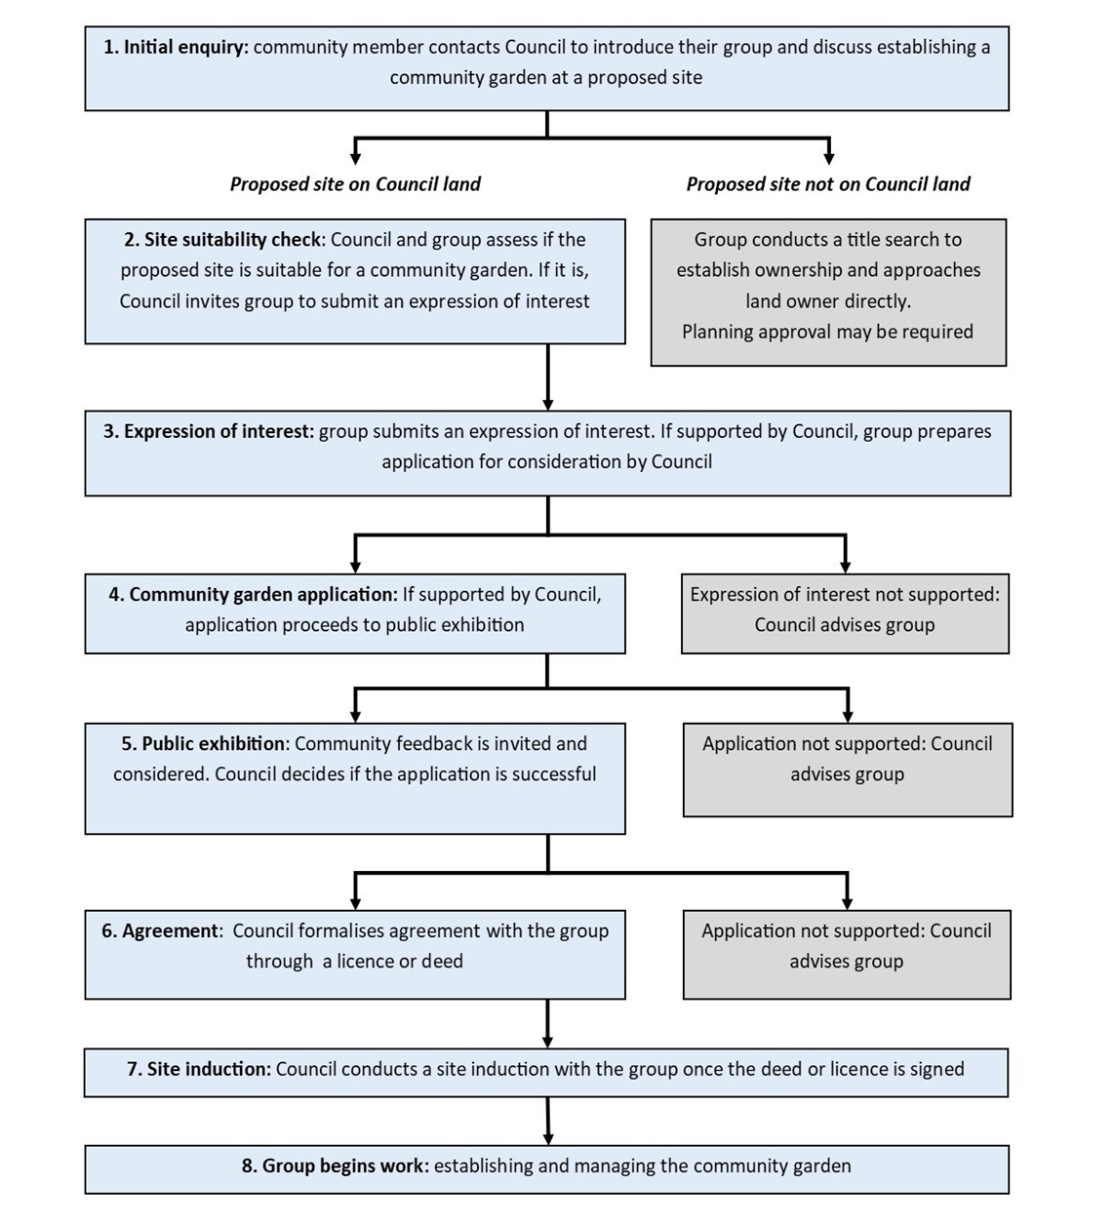
Starting a community garden on council land – refer to the Community Gardens Guidelines for further details

Breaches of this Policy
Breaches of this policy may result in an investigation of the alleged breach in line with relevant Council policies including the Model Code of Conduct. Any alleged criminal offence or allegation of corrupt conduct will be referred to the relevant external agency

Administrative Changes
From time-to-time circumstances may change leading to the need for minor administrative changes to this document. Where a change does not materially alter this document or is considered minor in nature, such as changes to branding, Council Officer titles, department changes or legislative name or title changes, such changes are not required to be formally endorsed.

Version Control – Policy History
This policy will be formally reviewed every three years from the date of adoption or as required.
Governance use only:
Document | Community Gardens Policy | Uncontrolled Copy When Printed
Custodian | Urban Sustainability Manager | Version # | Version 1
Adopted By | Council | ECM Document # | 34179890
Next Review Date | February 2027

Amended by | Changes made | Date Adopted
Environment and Sustainability | Throughout  Minor text and structural changes to clarify meaning, and align with  - Current Community Strategic Plan  - Current Council policies  - Current Council delegations and responsibilities
Environment and Sustainability with Community | Section 7.4 Access and inclusion  - Content expanded and restructured to distinguish between site access, accessibility, and social inclusion
Governance | Throughout - corrections on format  Section 7.7 Risk management and insurance  - Requirement of groups to register with NSW Fair Trading as incorporated associations at minimum  - Edits to align with Council’s insurer’s requirements
Environment and Sustainability with Parks and Streetscapes | Section 7.5 Ongoing responsibilities  Section 9 Responsibilities  - Clarified responsibility for assets

