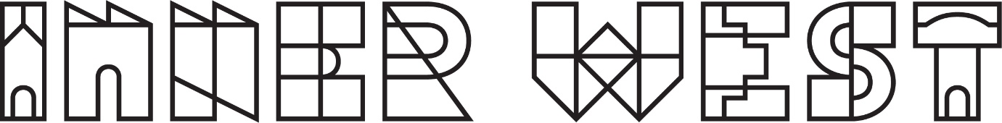

Terms and Conditions for Inner West Council
Children and Young People Strategy survey competition

- The promoter is Inner West Council.

- Everyone who lives, works, studies, plays, visits or conducts business within the Inner West Local Government Area is able to participate in the survey. Inner West Council staff and their families can respond to the survey but are not eligible for prizes.

- By participating in the survey, participants are deemed to accept the Terms and Conditions set out in this document.

- Participant contributors below the age of 16 as of 17th October 2023 must obtain the consent of their parent or legal guardian to participate in this project so that the parent or legal guardian agrees to the Terms and Conditions set out in this document.

- It is free to contribute to the survey and no fee is required.

- Responses will be archived for future researchers and become part of our online research findings in the future.

- There is no need to register as an ongoing user with ‘Have Your Say’ to enter this competition. Instead, Inner West Council will use the contact details you provide in the body of the Survey to contact prize winners.

- Without prejudice to any other provision of these Terms and Conditions, Inner West Council Social and Cultural Planning reserves the right to disqualify any participant for failure to abide by any of the Terms and Conditions set out in this document, or for submitting false, inaccurate or incomplete information, or for any other reasonable cause.

- Entrants to the draw must submit a Survey Response using the Have Your Say Inner West Council Website.
All completed contributions to the survey received through these channels are eligible for the draw.
- yoursay.innerwest.nsw.gov.au

- All respondents that complete a survey will be entered into the prize draw to win one of 3 prizes. Winners are selected at random using a random number generator.

- The survey is open from 09/11/2023 until 01/02/2024. All entrants received during this time are eligible for the draw. The deadline may be extended at the discretion of the organisers if insufficient entries are received.

- The prizes are for 3 x $150 visa debit cards. Total prize value $450. The split of the prize total may be changed at the discretion of the organisers.

- The Promoter is not responsible for any late or invalid entries due to technical issues.

- Winners are selected by random draw from all submitted survey responses within 4 weeks of the closing date of the survey. Winners will be emailed regarding their prize after the draw has been completed.

- If Council does not receive a response to the email within 2 weeks an alternative winner will be chosen. Should an entrant’s contact details change during the promotional period, it is the entrant's responsibility to notify the Promoter. A request to access or modify any information provided in an entry should be directed to the Promoter.

- Contributors may contribute once only.

- Council will publish the names of the prize winners on yoursay.innerwest.nsw.gov.au

- Subject to complying with all relevant State and Territory legislation, the Promoter reserves the right to amend, cancel or suspend this competition if an event beyond the control of the Promoter corrupts or affects the administration security, fairness, integrity or proper conduct of the competition. The Promoter will disqualify any individual who has tampered with the entry process or any other aspect of this draw.

