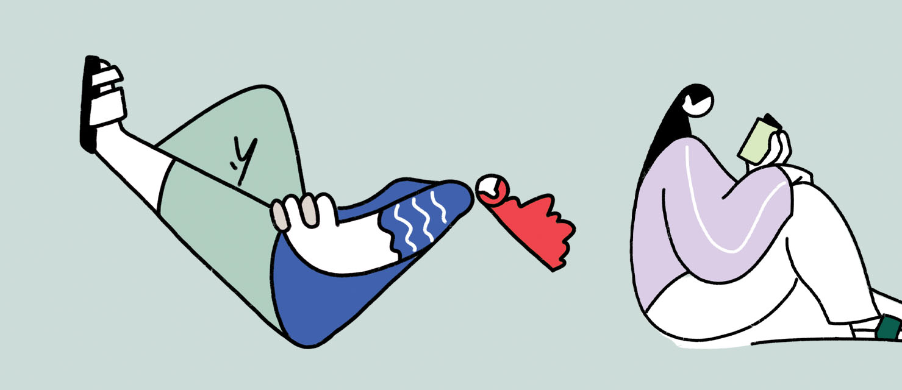

Engagement outcomes report

Balmain Library Upgrade engagement with young people

Contents
Summary 3
Background 4
Promotion 4
Engagement methods 4
Engagement outcomes 4
Part one – online survey results 4
Part two – workshop 12

Summary
From 16 June to 16 July 2023 community members aged 12-24 were invited to complete an online survey through Your Say Inner West about their opinions on Balmain Library. 256 people visited the Your Say Inner West project webpage and 55 participants completed the online survey.
56% of participants had been to Balmain Library before with 74% visiting every few months. 75% visit the library to read and like the study spaces, quiet area and range of books available. 42% would attend the library more if there was more material available to borrow and more comfortable spaces.
44% had never been to Balmain Library and the main reason was that they go to a different library. Marrickville and Haberfield Library were the most popular libraries that the participants visited instead.
On 14 July 2023 an in-person workshop was held with 16 participants aged 12-16 at Balmain Library. The workshop involved a tour of the library followed by an activity about what the group did and did not like, how they would improve and an interactive digital survey.
The key themes from the workshop showed that the participants liked the computers, the decorations, variety of books and the multiple spaces.
They did not like the lack of comfortable furniture, lack of advertisements and that the teen room was small.
Improvement suggestions included a café, games room and large sign out the front.
All participants of the workshop received $50 gift card for their time.
Feedback has been reviewed, analysed and themed for inclusion in this report. All verbatim comments are contained in the Appendix.

Background
During July and August 2022, Council sought feedback from the community on ideas for the future of Balmain Town Hall Precinct and upgrading Balmain Library. During the consultation period only five people aged 18-24 provided feedback.
During the first meeting of the Balmain Working Group on 8 December 2022, it was identified that further engagement should take place with young people to inform any future upgrade of Balmain Library.

Promotion
The project was promoted through the following channels:
- Council social media channels
- Posters out all Inner West Libraries
- Council’s Local Democracy Group - Young Leaders Working Group
- Council’s library school holiday programs
- Customer Service Stall at Easton Park Rozelle
- Elkington Park Plan of Management and Master Plan drop in session
- Balmain PCYC
- Member of the P&C at Annandale Public School and Sydney Secondary College
- Email to registered members of Your Say Inner West aged 12-24 (140 recipients)
- Email to registered members of Your Say Inner West interested in youth projects (122 recipients)

Engagement methods
The stakeholder group was consulted via:
- Online survey on Your Say Inner West
- In-person workshop at Balmain Library

Engagement outcomes

Part one – online survey results
Who we heard from
Participants were asked how old they were and what suburb they lived in.

24% of participants were aged 12, 20% were aged 17 and 13% were aged 13.

Majority of participants lived in Balmain (20%), 15% lived outside the Local Government Area and 11% lived in Stanmore or Lilyfield.
Community members were asked whether they had visited Balmain Library before and what makes a great library. For those who had visited they were asked how often, what they like and what would make them visit more. For those who had never been they were asked why.
Staff reviewed, analysed and themed the comments submitted in the open-ended question. Verbatim comments can be found in the Appendix.

What we heard
Q1. Have you ever been to Balmain Library?

56% had been to Balmain Library and 44% had not.

Q.2 How often do you visit?

Majority of respondents visited the library every few months or once a year or less.

Q.3 What are the main reasons you visit the library?
Participants could choose multiple options
Majority of participants attended Balmain Library to read (75%), study (45%), to borrow materials (45%) and because they enjoyed the space (45%).
Q4. What do you like about the library?
Participants could choose multiple options

Majority of participants liked the study spaces (61%), quiet areas (61%) and the books available (58%).

Q5. What would make you visit more?
Participants could choose multiple options
Majority of particiapnts would viist the library more if it had more comfortable spaces (42%), more material to borrow (42%), more workshop grams (32%), more spaces to work alone (32%) and later opening hours (32%).

Q6. Why don’t you visit Balmain Library?
This question was asked to those who have not been to Balmain Library before.
Participants could choose multiple options
58% advised that they go to a different library, 17% would attend if there was better public transport and 19% live too far away.

Q7. Which library do you go to?
Participants could choose multiple options
44% of respondents went to Marrickville or Leichhardt Library, 33% visited Stanmore Library or other libraries outside of the Inner West Local Government area and 22% visited Ashfield and Leichhardt Library.

Q.8 Describe the vibe of Balmain Library in three words.
This question was asked to those who had been to Balmain Library before.

28% described the library as quiet, 22% as peaceful and 13% as old or cozy.

Q.9 In your words what makes a great library?
All participants were asked this question. This was an open-ended question.
Staff reviewed, analysed and themed the comments submitted in this question and full responses are available in the Appendix.

Theme | Percentage of people who mentioned this theme | Number of total mentions
Variety of books and materials | 55% | 30
Variety of spaces | 33% | 18
Study areas | 25% | 14
Good aesthetics | 24% | 13
Quiet | 24% | 13
Comfortable furniture | 15% | 8
Easy to access and use | 15% | 8
Food available near by | 9% | 5
Variety of workshops and events | 9% | 5
Clean | 5% | 3
Fast internet | 5% | 3

Part two – workshop
A workshop with 16 participants aged 12-16 was held at Balmain Library. The session started with a tour of the library and participants were asked to think about what they did like, what they did not like and what they would improve.
After the tour, the group was asked to write down their responses. These were then compiled into themes by Council staff and the participants were asked to vote on what was most important using three dot stickers.
Staff reviewed, analysed and themed all responses to these questions and full responses are available in the Appendix.
What do you like?
Theme | Total votes
Decorations | 8
Computers | 7
Comfortable furniture | 7
Quiet spaces | 6
Multiple spaces | 5
Neat | 4
Outdoor area | 3
Kids spaces | 2
Variety of books | 2
Good vibes | 2

What you don’t like?
Theme | Total votes
Lack of bean bags/comfortable furniture | 12
The chill-out room is too small | 8
Lack of advertisements | 8
The colour scheme | 5
Not enough Spiderman DVDs | 3
Books are hard to find | 2
No charging stations | 2
No sound proof room | 2
Not enough light/too dark | 2
Signage or lack of | 2
Not enough creative spaces | 1
No board game area | 1

Other things the group did not like included lack of advanced books for younger children, too much space for young children, that the library was not children-friendly and was too small.
What would you improve?
The group was asked to imagine one idea to improve the library if they had unlimited funds. After each idea was put on a board the group was asked to vote on which idea they liked best.
The activity highlighted that the group wanted the library to have food available, fun spaces and activities and clear signage on the building.
Idea | Total votes
Café | 4
Games room with VR headset | 3
Huge sign out the front | 3
Multiple chillout rooms | 2
Music room with bean bags | 1

Other ideas included a Mr Beast video promoting the library, bigger chillout room with bean bags, water dispenser and cups, movie theatre and a makeover to the building.
Digital Interactive survey
After the exercise, the group was invited to take part in an interactive digital survey which included two questions regarding the library followed by trivia questions.
