Risk Management Policy

V1

Title | Risk Management Policy
Summary | This policy establishes the foundation for a consistent, proactive and measurable approach to effective risk management across all Inner West Council (“Council”) assets, operations and strategies.
Policy Type | Policy
Relevant Strategic Plan Objective | Strategic Direction 5: Progressive responsive and effective civic leadership.
Legislative Reference | Local Government Act 1993  Office of Local Government (OLG) Guidelines for Risk Management and Internal Audit for Local Government in NSW
Relevant Council References | Related policies:  - Risk Management Procedure  - Business Continuity Procedure  - Fraud and Corruption Control Policy  - Fraud and Corruption Control Procedure  - Incident Management Procedure  - Insurance Policy  - Work Health and Safety Policy  - Work Health and Safety Procedure  - Code of Conduct  - Australian Standard AS/NZS ISO 31000:2018 – Risk management guidelines
Version Control | See last page

Contents

1. Purpose 4
2. Scope 4
3. Definitions 4
4. Risk management 6
5. Roles and responsibilities 12
6. Incidents and business continuity 15
7. Breaches of this policy 16
8. Administrative changes 16
9. Version control – policy history 17

Purpose
The purpose of this policy is to set out how Council assesses and manages risks that may arise while delivering its strategic and operational objectives. This policy sets out processes and tools that Council uses where a risk manifests in the form of an incident, or where business continuity measures require activation.
The Risk Management Policy and the Risk Management Procedure (together termed the Risk Management Framework) ensure that Council is appropriately identifying, analysing, evaluating and treating potential risks. Further procedures aligned with the Risk Management Framework also provide Council with effective processes and tools to respond to incidents and other events requiring business continuity measures.
The Risk Management Framework facilitates the safe and effective delivery of Council objectives and enhances Council’s corporate image as a professional, fiscally reliable, responsible and ethical organisation.

Scope
This policy applies to all Councillors, Council Officers, service providers/service partners and volunteers of Council.

Definitions
In the Risk Management Policy, the following terms have the following meanings:

Table 1 - Definitions
Term | Meaning
Council | Inner West Council.
Council Officers | Inner West Council members of staff (including full-time, part-time. casual and contracted staff).
Councillor | An Inner West Council elected representative.
critical business function | The meaning given to this term in the Business Continuity Management Procedure.
Executive Team | Council’s Executive team:  - General Manager  - Director Community  - Director Corporate  - Director Infrastructure  - Director Planning  - General Counsel.
Manager | Any Council Officer who manages, oversees, or is in any way responsible for any other Council Officer, Councillor, volunteer or service provider/service partner.
risk | The effect of uncertainty on objectives, where an effect is a deviation from the expected. It can be positive, negative or both, and can address, create or result in opportunities and threats.
risk appetite | The amount and type of risk that Council is willing to take on or accept in order to meet its objectives. It sets the tone for risk taking in general.
risk management | Coordinated activities to direct and control an organisation with regard to risk.
Risk Management Framework | The collective term to refer to the Risk Management Policy and the Risk Management Procedure.
risk management process | The systematic process set out in Council’s Risk Management Framework for processing risks, with steps including understanding and setting the scope, context and criteria of the process, and identifying, analysing, evaluating, treating, and recording and reporting on risk.
risk register | The registers maintained by the Risk and Audit Manager detailing Council’s risks, including those which have been treated and those which are accepted.
stakeholder | Anyone who may affect, be affected by, or perceive themselves to be affected by the Council. Examples include but are not limited to Council Officers, residents of the LGA, major service providers/service partners, contractors, sub-contractors and people visiting the LGA.
volunteer | A formally recognised, unpaid member of the public who assists with providing Council services e.g. Visitor Information Centre/Library.

Risk management
Council is committed to achieving effective and responsible risk management in accordance with the Australian Standard AS/NZS ISO 31000:2018 – Risk management guidelines. Council will ensure that its assets, activities and strategies do not place people, property or the environment at unreasonable levels of risk.
An integrated and consistent approach has been adopted within the Risk Management Framework to ensure that risks are identified and addressed during planning, decision-making and everyday operations.
Council achieves effective risk management by implementing the following:
- Establishing processes to respond to risk incidents and to maintain business continuity as discussed in the following section.
- Embedding risk management into all aspects of Council’s corporate planning and operations.
- Promoting and supporting risk management practices throughout the organisation.
- Fostering a culture that encourages accountability for risk management throughout the organisation.
- Ensuring all Councillors and Council Officers accept personal and collective responsibility for achieving positive risk outcomes.
- Assigning accountabilities and responsibilities at appropriate levels within the organisation.
- Undertaking risk management processes in accordance with the Risk Management Framework at all times.
- Maintaining a comprehensive and regularly updated risk register to identify and monitor strategic and operational risks and associated treatments.
- Requiring quarterly risk reporting to the Executive team and Council’s Audit, Risk and Improvement Committee (ARIC).
- Utilising Council’s Internal Audit function to ensure independent guidance on risk management effectiveness is provided to the ARIC.
- Implementing and communicating governance processes that ensure compliance with relevant legislation, Council policies and the Australian Standard AS/NZS ISO 31000:2018 – Risk management guidelines.
- Sound oversight of contracts, contractors, tenants and committees of management to ensure that appropriate risk controls and insurances are in place.
- Applying risk management processes into all pre-employment screening.
- Carrying out prompt and thorough reviews of any incidents or claims, to respond to imminent risks and highlight patterns and areas of risk management deficiency.
- Developing and implementing training to guide and assist Council Officers in their operational areas.
- Establishing accountability for responding to recommendations from internal and external audit and other authoritative organisations (e.g. ICAC, NSW Ombudsman, Information and Privacy Commission of NSW) within agreed timeframes.

Risk appetite
Council acknowledges that not all risk is able to be treated or avoided to achieve Council’s strategic objectives. Accordingly, Council may accept levels of risk which align with its risk appetite. At times, Council may also accept levels of risk which may exceed Council’s risk appetite with ongoing careful review and approval of the relevant risks by the Executive team, and Council as required.
Council has an appetite for accepting a level of risk which appropriately balances the rights, expectations and quality of life of the people that Council serves with its obligations to provide a safe working environment for Council Officers and customers, and which provides for continuity and sustainability of Council services and growth.
Council’s appetite for risk is outlined below and will vary depending on the category and type of risk. Council Officers undertaking the risk management process must consider Council’s risk appetites. Risks rated as high or extreme (whether before or after the implementation of risk treatments) must be reviewed and approved by the Executive team. The Executive team must consider any legal, regulatory and policy requirements prior to approving an activity rated high or extreme, including any Council resolution requirements.
Note that the risk appetites are based on the ratings within the risk matrix in the Risk Management Procedure.

Table 2 – Risk Appetites
Category | Council’s Risk Appetite
Economic and Financial | Generally, Council has a low-risk appetite for activities that threaten the long-term financial stability of the Council.  It is recognised however, that sustainability will require investigation into enhancing and/or diversifying income streams so, subject to the below, Council will accept up to medium rated risks for discrete activities or projects that may provide additional income streams or enhance economic diversity. Opportunities of this nature may require external stakeholder support and will be subject to due diligence, with appropriate risk treatments implemented.  Council’s investment policy stipulates a very low appetite for risks in investments, which is imposed by legislation.  Council will not accept any medium to extreme risks relating to illiquidity, with the focus on maintaining liquidity within imposed statutory financial ratios.  While effective management of projects is important to Council, Council acknowledges the current economic realities, labour market and supply chain issues facing Australia and the LGA and will accept up to medium risks towards project cost and time overruns, however appropriate reporting and escalation are to occur, and lessons learnt from these are to be reviewed to prevent reoccurrence.
Reputation and Corporate Image  Leadership and Political Awareness | Council’s aim is to foster a high degree of community confidence in its services. Consequently, Council has a low-risk appetite for engaging in activities that could damage the reputation and corporate image of Council.  Council has a diverse community and stakeholder needs and expectations and therefore accepts medium risk for complaints.  Council will not except high or extreme reputational risks that may result in substantiated complaints from the community and/or other key stakeholders.  Council will not accept high or extreme risks for sustained and substantiated negative media coverage.  The Council will not accept medium to extreme risks for the provision of inaccurate qualified advice or unethical actions.
Corporate Governance / Compliance and Legal | Council has a minimal risk appetite for activities that pose risks of breaching legal and regulatory requirements, or that expose Council to risks of theft, fraud or misconduct.  Council has obligations, both mandated and recommended, through numerous statutory and regulatory requirements and guidelines.  There is recognition that Council must accept minimal risk for some non-compliance due to competing or changing requirements or minor breaches from time to time.  However, Council will not accept low to extreme risks of non-compliance with such requirements and guidelines, or non-reporting of breaches and non-compliance to appropriate authorities.  Council’s risk appetite for conflicts of interest and similar matters is low. Conflicts must be declared, pre-emptively or as soon as known, and managed in light of statutory responsibilities.  Council will accept up to medium risks associated with leading challenges, in an open and transparent way, to out of date, restrictive and unnecessarily risk-averse legislation and requirements.  Council will not accept low to extreme risks for theft, fraud or misconduct by Councillors and/or Council Officers or volunteers.
Environmental | Council values the environment and will always consider its impact. Generally, Council has a low-risk appetite for activities that pose negative environmental risks.  Council will not tolerate medium to extreme risks for not fulfilling its obligations to the built and natural environment including management of contaminated sites, sensitive or high profile sites, waste services or Council’s preparation, planning, response and recovery to environmental hazards. Such risks must be appropriately treated.  Council recognises the multiple stakeholders and responsibilities involved in fulfilling the obligations and needs to accept minimal and low environmental risks.
People | Council has a low appetite for implementing practices and procedures that may result in large scale dissatisfaction within the workforce. Council will, within established guidelines and practices, consult with its workforce. Council will accept up to medium risks arising from change that impacts its workforce when focused on delivering appropriate, effective and efficient outcomes.
Health and Safety | The safety of Council Officers, service providers/service partners, volunteers and the public is a priority for Council, and as such, Council has a low risk appetite for activities that pose safety risks.  Safe working practices are continually being improved and refined and there is no appetite for Council Officers, service providers/service partners and volunteers not following due process where there are safety risks to themselves or others.  Due to the scale, nature (extended trading and operating hours for some services), locations and diversity of Council deliverables, it is realistic to acknowledge that minor injuries may occur from time to time. Council strives to have Lost Time Injuries (LTI’s) at zero.  Council will accept risks that pose minimal and low risks to safety (noting continuous improvement and ensuring control effectiveness in WHS matters is a priority for Council). Council will not accept medium to extreme risks that would result in major injuries or fatality.  Where injuries or near misses occur, legislative requirements and Council’s Incident Management Procedure are to be followed.  Council seeks opportunities to develop a multi-skilled workforce which includes Council Officers increasing their skills and knowledge, as well as encouraging initiative and enthusiasm. Whilst these are considered positive aspects, Council has no appetite for Council Officers performing duties for which they are not suitably qualified or trained or acting outside of their delegated authority.  Where legislative requirements allow and/or formal qualifications and training are not required to perform certain duties, Council will assess risks according to this risk appetite table depending on the activity being undertaken and implement appropriate risk treatments, including supervision and oversight of activities and outcomes, as required to reduce such risks.
Procurement and  Project, product and service delivery | Council has a medium risk appetite for activities that risk impairing its commitment to providing efficient and reliable services and delivery of projects to its customers and the community. Improving our service delivery is a priority for Council – projects which may enhance service delivery over the longer term may involve short term impacts to service delivery.  The Council will not accept high or extreme risks for unplanned disruptions to critical business functions, including contracted services, as described in Council’s Business Continuity Management Procedure. Where there are disruptions to critical business functions, these are to be addressed within recovery time objectives established in Council’s Business Continuity Management Plan.  Council will also not accept high or extreme risks for disruption to other supplementary services, however Council will accept minimal to medium risks in circumstances where resources need to be directed to the continuity of critical business functions.  Council encourages innovation and therefore will accept medium risks for considering and implementing service level enhancements and efficiencies when aligned with all other aspects of this risk appetite statement.
Technological and information management | (Considered in conjunction with Project, Product and Service Delivery risks)  To support service delivery across all of Council deliverables, Council will only accept up to low risks of Information Technology systems failures, data loss and security breaches.  Council will not accept medium to extreme risks relating to both physical and cyber security where if such risks were to materialise, it would result in stolen data, financial loss and/or damage to Council property. Council accepts as part of its commitment to innovation, Council may need to upgrade security systems, and consequently accepts up to low risks for undertaking these activities. Any higher rated risks must be reduced with appropriate risk treatments.
Assets, facilities and security | Council has a low-risk appetite for activities which pose risks to Council assets, facilities and security (including cyber security).  Council will not accept medium to extreme risks arising from activities that may damage assets beyond the usual wear-and-tear.

Roles and responsibilities
Council’s roles and responsibilities structure for risk management is consistent with the ‘three lines of defence’ model, as outlined in Figure 1 below:

Figure 1 – Three Lines Model
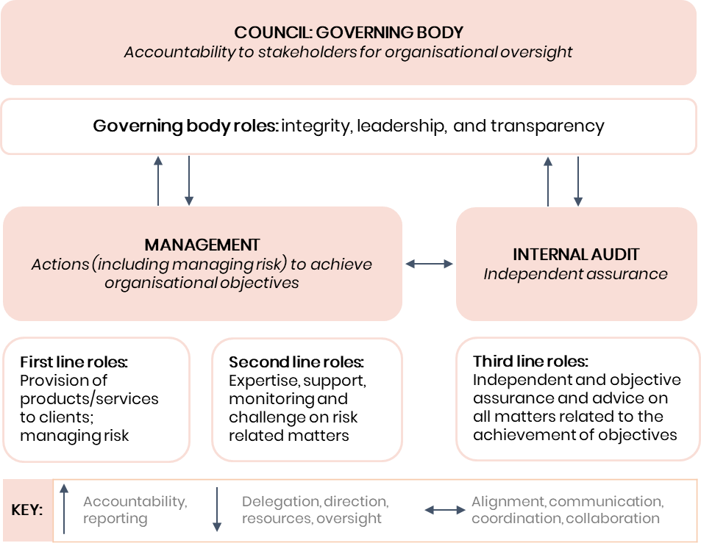

Council
Council is responsible for establishing the foundational elements of Council’s Risk Management Framework and setting the ‘tone at the top’. This includes approving by resolution Council’s risk appetite (in consultation with the ARIC). Council will also discuss the annual self-assessment of the Council’s Risk Management Framework with the General Manager and the ARIC at Council’s strategic assurance meeting held each Council term.

General Manager
Consistent with the General Manager’s role under section 335 of the Local Government Act 1993 to conduct the day-to-day management of Council, the General Manager has ultimate responsibility and accountability for risk management in Council. This includes the following:
- Overseeing Council’s Risk Management Framework and ensuring it is effectively communicated, implemented, and reviewed regularly.
- Approving the Risk Management Procedure and Council’s risk management plans and reports.
- Promoting and championing a positive risk culture.
- Assigning authority and accountability for risk management to appropriate Council Officers in Council, and ensuring they are held accountable for these responsibilities.
- Annually attesting that Council’s Risk Management Framework complies with the Guidelines for Risk Management and Internal Audit for Local Government in NSW.
- Approving Council’s implementation of corrective actions recommended by Internal and External Audit and ARIC.
- Discussing the annual self-assessment of the Council’s Risk Management Framework with Council and the ARIC.

Senior Manager Governance and Risk and the Risk and Audit Manager
The Senior Manager Governance and Risk and the Risk and Audit Manager are responsible for the following:
- Supporting the General Manager and Executive team by coordinating and providing clear and concise risk information, advice and/or reports that can be used in planning and decision-making.
- Ensuring risk ratings are escalated to the applicable officers for approval and that high and extreme risks are reported to the Executive team.
- Maintaining Council’s risk registers.
- Providing a quarterly report to the Executive team and the ARIC and attending meetings (where requested).
- Conducting and reporting to the General Manager on an annual self-assessment of the Council’s Risk Management Framework in line with section Error! Reference source not found. of the Risk Management Procedure.
- Ensuring the ARIC receives an annual update on Council’s insurance cover, claims and arrangements.
- Helping to build a risk management culture within Council by making sure that relevant Council Officers receive the training required for them to comply with this Risk Management Framework, and making sure that risk management information, guidance notes, risk assessment tools and other relevant information are made available on Council’s intranet for all Council Officers to access.
- Ensuring that the Risk Management Framework is integrated to enable all Council Officers to conveniently undertake risk management in their day-to-day work.
- Supporting Council Officers with their risk management obligations and providing them with training and advice on how to ensure risk management compliance.
- Assessing risk registers, reports and treatment plans for completeness, accuracy and consistency.
- Managing and reviewing Council’s Risk Management Framework as required.

ARIC
The ARIC is responsible for supporting Council and the General Manager and for ensuring that the Risk Management Framework is appropriate and operationally effective. The ARIC is responsible for the following:
- Reviewing the quarterly report provided and assessing whether risks at all levels are identified, assessed and reviewed regularly by Council.
- Providing assistance and advice in relation to the management of risk or governance arrangements on individual projects, programs or activities.
- Reviewing Council’s insurance coverage, claims and arrangements.
- Reviewing the Risk Management Framework annually and making recommendations.
- Providing an assessment of the effectiveness of Council’s risk management framework to the governing body each Council term, as part of the ARIC’s four-yearly strategic assessment.

Internal Audit
Council’s Internal Audit function is responsible for independently reviewing and providing advice to the ARIC and Council annually on the effectiveness of the Risk Management Framework.
The function’s role is to provide advice and challenge and support management’s decision-making, as opposed to taking risk management decisions itself. The function does not manage any of the risks on behalf of Council, set the risk criteria or appetite, impose risk management processes, decide or implement risk responses, and is not accountable for risk management activities.
Council appoints an independent Internal Audit firm to conduct internal audits, provide certain advice on risk management matters and to independently review Council’s completion of internal audit recommendations, to preserve the independence of this function.

Managers
Managers of each Business Unit will be responsible for ensuring that those under their supervision participate in risk management training and undertake the risk management process in line with the Risk Management Framework. Managers will also be responsible for partaking in the development and improvement of the Risk Management Framework, including by providing feedback to the Risk and Audit Manager.

Council Officers
Council Officers are required to actively participate in the risk management process and must comply with the Risk Management Framework at all times.
Council Officers must undertake the following:
- identify risks within their business unit.
- Implement risk treatment plans.
- Monitor risks.
- Follow the risk management process in accordance with the Risk Management Procedure.
- Communicate escalating risks to their Manager.

Incidents and business continuity
Council acknowledges that even with the most thorough preparations, risks can still manifest, and incidents can still occur.
Through the alignment of its Incident Management Procedure and Business Continuity Management Procedure to the Risk Management Framework, Council ensures that Council Officers have the procedures, processes and tools to address incidents in a safe and timely manner and can restore Council operations to business-as-usual as quickly as possible.
Council effectively responds to incidents and disruptions to critical business functions by implementing the following:
- Establishing teams of Council Officers with clear and specific functions to respond to incidents and disruptions to critical business functions.
- Proactively undertaking analysis exercises to determine the impact of incidents and disruptions to critical business functions on Council’s operations.
- Providing templates and by developing Incident Action Plans and Business Continuity Plans (as per the relevant Procedure).
- Defining required actions to be taken in the event an incident or disruption to Council’s business occurs.
- Proactively assessing risks that arise from incidents or disruptions by undertaking the risk management process in line with the Risk Management Procedure.
- Promptly reviewing operations following an incident or activation of a Business Continuity Plan or Plans, to improve Council’s risk management, incident response, and business continuity processes.
- Continuous improvement of its incident management and business continuity management via evaluation and pre-emptive practice exercises.

Breaches of this policy
Breaches of this policy may result in an investigation of the alleged breach in line with relevant Council policies including the Code of Conduct.
Any alleged criminal offence or allegation of corrupt conduct will be referred to the relevant external agency.

Administrative changes
From time-to-time circumstances may change leading to the need for minor administrative changes to this document. Where an update does not materially alter this document, such a change may be made including branding, Council Officer titles or department changes and legislative name or title changes which are considered minor in nature and not required to be formally endorsed.

Version control – policy history
This policy will be formally reviewed every three years from the date of adoption or as required.
Governance use only:
Document | Risk Management Policy | Uncontrolled Copy When Printed
Custodian | Senior Manager Governance and Risk | Version # | Version 1
Adopted By | Council | ECM Document # | 37565401
Next Review Date | April 2026

Amended by | Changes made | Date
Governance and Risk | New Policy | 11 April 2023

