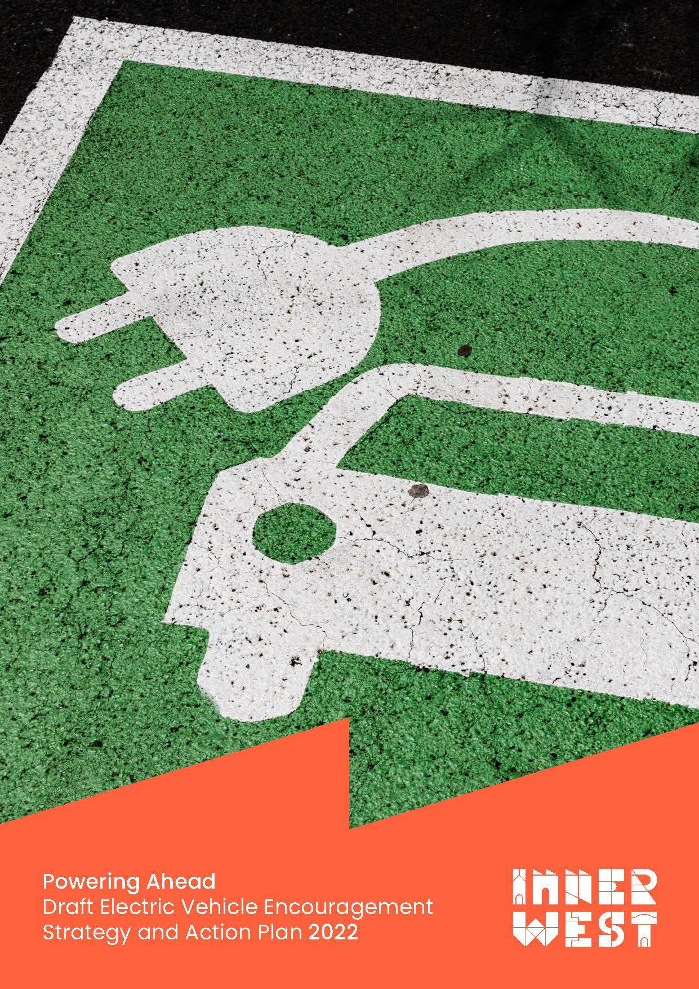
Contents
Purpose of this document 1
Introduction 2
Context 4
Vision 5
Intrinsic Goal 5
Specific EV actions from Going Places 5
What Council can do: 5
What Council can influence: 5
Other Complementary Policies 1
Council 1
State 1
Federal 1
Related Council resolutions 1
What we need to know about Electric Vehicles? 5
What is an EV? 5
Car manufacturers' commitments 6
Existing demand 8
Potential demand 8
Why buy an EV? 9
How Do We Charge an EV? 12
Levels of charging facility 12
Types of plugs 13
Existing charger network 14
INITIAL CONSULTATION 16
What do people think? 16
Draft Electric Vehicle Strategy & Action Plan 18
The Strategy 19
Goal 19
Vision 19
Ambitions 19
Year 1 19
Year 2 19
Year 3 19
Year 4 20
Year 5 20
The Draft Action Plan 21
Principle 1 (Public Charging) 21
Action 1.1 21
Action 1.2 21
Action 1.3 21
Action 1.4 21
Action 1.5 21
Action 1.6 22
Action 1.7 22
Action 1.8 22
Action 1.9 22
Action 1.10 22
Principle 2 (Private Charging) 22
Action 2.1 DCP Requirements – Residential 22
Action 2.2 DCP Requirements – Non-Residential 23
Action 2.3 23
Action 2.4 23
Action 2.5 23
Action 2.6 24
Action 2.7 24
Principle 3 (Incentives and Encouragements) 25
Action 3.1 25
Action 3.2 25
Action 3.3 25
Action 3.4 25
Action 3.5 25
Action 3.6 25
Action 3.7 26
Action 3.8 26
Key Projects 26
APPENDIX A - MAYORAL ROUNDTABLE OUTCOMES SUMMARY (24 August 2022) 27
APPENDIX B – DRAFT SITE SELECTION GUIDELINES FOR KERBSIDE RESIDENTIAL CHARGING FACILITIES (for charger and dedicated car space) 34
APPENDIX C – Infrastructure State Environmental Planning Policy (Part 3, Division 17) 36

Disclaimer - The information contained in this document was correct at the time of writing (October 2021). It should be noted that the electric vehicle environment in Australia is constantly changing and since that time a number of new government initiatives have been announced and technical attributes of chargers, plugs and the network may have changed. It is considered that these changes will not fundamentally alter the principles and recommendations contained in this draft Strategy.

Purpose of this document
This draft Strategy and Action Plan has been prepared to provide the Community with an opportunity to comment on inner West Council’s suggested approach to the encouragement of electric vehicles.
The document on exhibition comprises four parts:
- Background on the current circumstances associated with electric vehicles in Sydney's Inner West;
- Draft Strategy;
- Draft Five-Year Action Plan;
- Draft Site Selection Guidelines for Kerbside Residential Charging Facilities.
Subsequent to receiving Community comments on this document, it is proposed that a final version of the Electric Vehicle Encouragement Strategy will be adopted by Council for implementation.
The final, long term, Strategy will include:
- Goal;
- Vision Statement;
- Set of ambitions; and
- Set of three key principles.
Separately, a Five-Year Action Plan, comprising a set of recommended actions and key projects will be produced
In reviewing this document it should be recognised that the draft Strategy & Action Plan provide more recommended actions than are realistically achievable within a five-year time frame, however Council is using this exhibition to gather Community feedback on the importance of the various actions with a view refining their priorities. This will, then, permit Council to develop a realistically implementable five-year action plan.
While the Strategy will set a long-term vision, the Action Plan will be regularly reviewed and adjusted to respond to the changing circumstances associated with electric vehicles and to reflect Council success in encouraging electric vehicle uptake.
Thank you for helping Council better understand our Community's needs and desires in relation to electric vehicles.

Introduction
The Electric Vehicle Encouragement Strategy (The Strategy) will be prepared in recognition of both the environmental benefits of Electric Vehicles (provided that they are a powered by renewable fuel sources) and the growing demand for Electric Vehicles (EVs). In preparing the Strategy, the focus has been on electrically powered cars, however electric bikes and other electrically powered micro mobility devices will also be considered in this Strategy.
Electric Vehicles generally fall into four categories:
- Hybrid Electric Vehicles (HEVs);
- Plug-in Hybrids (PHEVs);
- Battery Electric Vehicles (BEVs); and
- Hydrogen Fuel Cell Electric Vehicles (FCEVs).
For the purpose of this Strategy the term “EV” has been used to generally represent all of these vehicle types. Singular terminology or abbreviations will only be used when addressing aspects relating to a specific type (e.g. FCEVs).
It is also important to note that the majority of Connected and Autonomous Vehicles (CAVs) anticipated to be introduced to our transport network, over the next decade or more, will also be electric vehicles.
This Strategy is set within the framework of Council’s Community Strategic Plan and its Integrated Transport Strategy (GOING PLACES). It is also informed by Council’s various sustainability, climate change and net zero policies.
Figure 1 shows that the Strategy will be similar to Council’s Integrated Transport Strategy; having an overall vision (and set of ambitions) that is supported by three key principles and a series of related actions. Additionally, the strategy recommends a series of key projects to be initiated by Council.
It is anticipated that the EV Encouragement Strategy will also provide an Implementation Road Map (5 Year Action Plan). This will include monitoring and review steps that will permit the plan to be refined in response to changing circumstances and changing technology.
EV encouragement is only one element of Council’s Integrated Transport Strategy, which prioritises active transport (e.g. walking, cycling) and public transport. Nevertheless, EVs offer public health benefits and environmental benefits (when powered by renewable energy) and Council therefore aims to support the transition to EVs. Council also recognises that the transition is inevitable, with various car manufacturers announcing that they will discontinue Internal Combustion Engine (ICE) vehicles over the next ten years. Early planning for this transition is therefore important to prepare Inner West residents and ensure that infrastructure is in place.
Additionally, while the draft Strategy lists specific actions and projects, it is important to recognise that the EV environment is constantly changing. Consequently, the Strategy should not restrict Council’s ability to adapt and respond to new opportunities that may arise (e.g. partnership proposals, government initiatives or new funding sources).
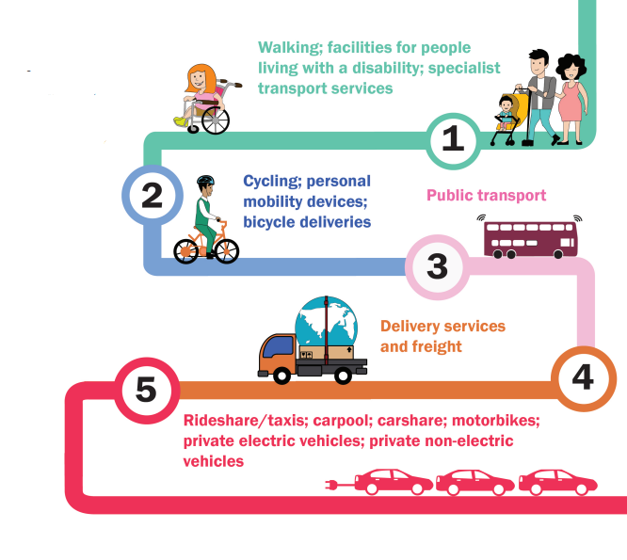
Figure 1 - Policy Structure

PRINCIPLE 1
PRINCIPLE 3
PRINCIPLE 2
AMBITIONS
VISION
KEY PROJECTS
A
C
T
I
O
N
S

A
C
T
I
O
N
S

A
C
T
I
O
N
S

Figure 2 – Road User Hierarchy/Priorities from Inner West Council Integrated Transport Strategy (2020)

Context
Our Inner West 2036 - Community Strategic Plan (CSP) – The CSP identifies the community’s vision for the future, long-term goals, and strategies to get there and outlines how Council will measure progress towards that vision. The CSP identifies five strategic directions that support the goals of the community. The Electric Vehicle Strategy aligns closely with Strategic Direction 1: An ecologically sustainable Inner West and goes towards achieving the community’s vision through CSP Outcome 1.4: Inner West is a zero emissions community that generates and owns clean energy.
The key policy setting the scene for the Electric Vehicle Encouragement Strategy is Going Places (Council’s Integrated Transport Strategy) which included the following:

Vision
That:
Growing numbers of Inner West residents, workers and visitors prefer to walk, cycle and use public transport because it is convenient, enjoyable and healthy.
The Inner West transitions to environmentally sustainable transport.
Everyone is connected to their community and local services, and can access educational, retail, cultural and recreational districts, as well as jobs and services across local and regional areas.
The transport network enhances local economic vitality, with freight and goods movements separated from people by space and/or time.

Intrinsic Goal
To reduce private car dependency for all trips and
to convert travel from less sustainable modes to more sustainable modes.

Specific EV actions from Going Places

What Council can do:
- Prepare a transport technology framework, which identifies locations for electric vehicle charging powered by renewable energy and an assessment framework for Council’s support of new transport technologies;
- Renew (convert) Council’s vehicle fleet to electric vehicles and facilitate opportunities for Council leaseback vehicles to be affordably released onto the used vehicles market (once their leases expire), increasing the supply of affordable electric vehicles on the Australian market; and
- Require major new developments to include charging facilities.

What Council can influence:
- Working with the State and adjacent Council’s to provide a unified approach to electric vehicle charging;
- Support Sydney’s bus network being converted to an electric fleet.
In considering this draft Strategy and Action Plan it is important to recognise that it is primarily aimed at measures to encourage the uptake of electric private cars in preference to private cars with internal combustion engines. Other elements of Council Strategic Transport Planning have recently been, or are currently being, developed to foster increased use of public and active transport, including the Inner West:

- Car Share Harmonisation Policy;
- Parking Strategy;
- Bicycle Strategy and Action Plan;
- Public Transport Position Statement.

Other Complementary Policies

Council

- Climate and Renewables Strategy
- Lease Back Fleet Policy
- LEP/DCP
- Affordable Housing Strategy
- Retail and Employment Land Strategy
- Public Domain Guidelines
- Inner West Parking Plan
- Zero Waste Strategy
- Community Assets Needs Strategy
- Traffic and Transport Needs Study
- Place-Based Urban Design

State
- NSW Electric Vehicle Strategy 2021
- Future Transport 2056
- Beyond the Pavement
- Landscape Guideline
- NSW Electric and Hybrid Vehicle Plan
- NSW Net Zero Plan
- Building Momentum State Infrastructure Strategy 2018-2038
- Sydney Green Grid
- Greater Sydney Region Plan- Eastern City District Plan

Federal
- Future Fuels Strategy
- Smart Cities Plan

Related Council resolutions
As well as adopting the Integrated Transport Strategy (26 March 2020) and various climate change, sustainability and net zero polices/strategies, on 6 July 2021, specifically in relation to Electric Vehicles, Council resolved as follows:
To receive a report back on the following:
- Explores funding opportunities from the NSW and Federal governments for installing charging infrastructure in the Inner West
- Resolves to ensure that planning processes for installing chargers is streamlined and simplified for businesses and residents
- Provides information through all of its communication channels of how Inner West businesses can install charging infrastructure
- Works with the local taxi and rideshare industry to facilitate charging facilities where the Council can provide suitable parking or assistance
- Works with the Southern Sydney Regional Organisation of Councils (SSROC) and Re: Mobilise to prepare of a comprehensive fleet transition plan including light and heavy vehicle fleet with a goal of adopting zero-emissions transport where a fit for purpose and cost-effective alternative exists on the whole of life costing basis …
- Council to plan for complete transition to EVs by 2025 starting in the 2021-22 financial year; and
- Council notes the Community Strategic Plan states: "Government makes responsible decisions to manage finite resources in the best interest of current and future communities". Considering this, and the climate emergency that Council declared in May 2019, the fleet should be electrified as soon as possible. As such, all newly leased or purchased IWC passenger and utility fleet vehicles will be zero emissions vehicles (where fit for purpose) beginning no later than EOFY 2021-22.
This Strategy focuses on electric vehicles within the Community and also addresses the transition in Council’s own fleet, which will be detailed in the Corporate Fleet Transition Plan currently under development.

What we need to know about Electric Vehicles?

What is an EV?
As shown in Figure 2, there are several types of EVs, including:
- BEVs (Battery EVs): Powered entirely by electricity. Battery EVs produce no tailpipe emissions.
- FCEVs (Hydrogen Fuel Cell Vehicles): Use a fuel cell instead of a conventional battery. Currently FCEVs charge at speeds similar to ultra-fast (Level 4) EV chargers. They are filled with hydrogen which is then converted to electricity.
- PHEVs (Plug-in hybrid): Contains both a small battery and petrol, or diesel, engine and uses both the electric motor and the fuel engine.
- HEVs (Hybrid EVs): Contain both a small battery and petrol, or diesel, engine and use both the electric motor and the fuel engine. HEVs are not charged from the grid (that is, they are not plugged in to charge their battery). The batteries in HEVs are charged by recovering energy normally lost while braking (regenerative braking), and from the petrol engine when it is efficient to do so. HEVs use the battery to assist the engine during acceleration and to drive the car at slow speeds for short distances. The petrol engine is used at other times.

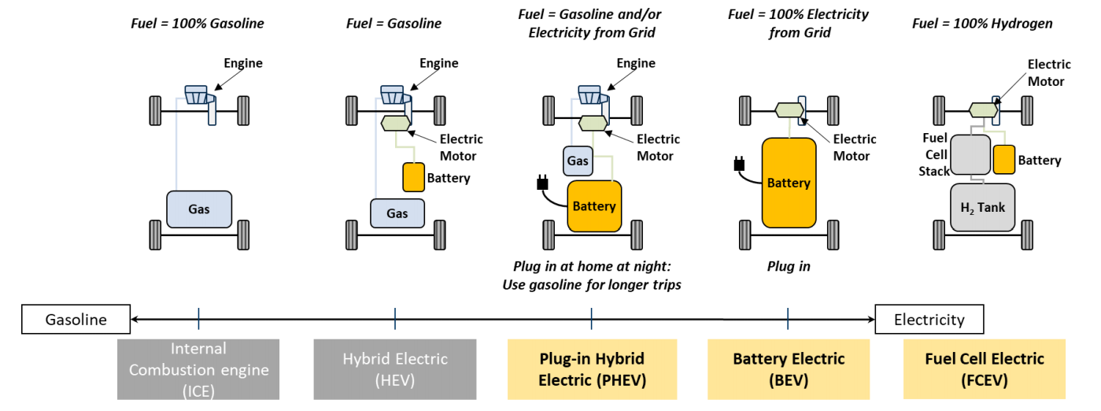
Figure 2 - Type of electric vehicles (from City of Toronto EV Policy)

Car manufacturers' commitments
Over the past decade all major car manufacturers have committed to a conversion from ICE technology to electric vehicles. This is strongly complemented by a series of government policies including targets set by the European Union and the United States, as well as the New South Wales Government’s Electric Vehicle Strategy.
Commitments by manufacturers and the majority of the world’s governments mean that by 2030 the model mix offered by all major car manufacturers will be electric vehicles (BEVs and HFCEVs).
Figure 7 summarises current commitments from the majority of car manufacturers.
Additionally, many manufacturers are looking at providing more entry level electric vehicles and supplementing their services by:
- Providing their own charging networks (e.g. Tesla);
- Working with finance companies or electricity providers to provide more equitable and user-friendly cost solutions;
- aligning themselves with battery manufacturers to exclude the battery from the vehicle’s purchase price, with the battery being provided as part of a lease which includes a maintenance agreement.

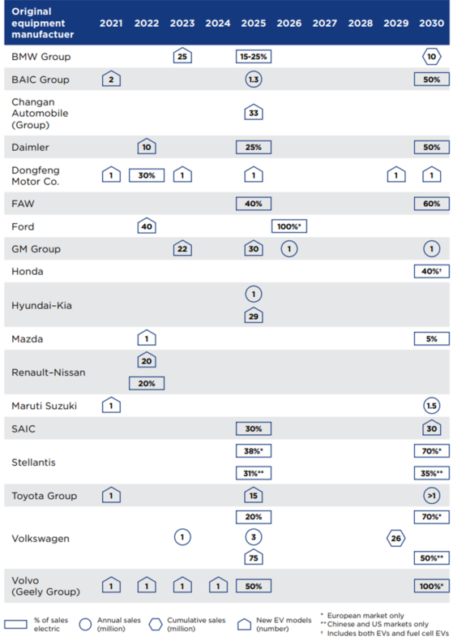
Figure 7 - Key car manufacturer commitments (from NSW Electric Vehicle Strategy)

Existing demand
Electric vehicles currently only represent around 1% of new vehicle purchases in Australia each year. Their popularity is continuing to grow with record sales of 469 electric vehicles in Australia in March 2021 (the highest monthly number of new electric vehicles ever sold in Australia).
In 2020, 163 electric vehicles were registered in the Inner West and Figure 8 shows the distribution of electric vehicles across the Inner West and adjacent LGAs. While the number of EVs registered in the Inner West is generally lower than LGAs to our north, east and west, consideration must be given to the limited ability of much of our housing stock to accommodate on-site charging.
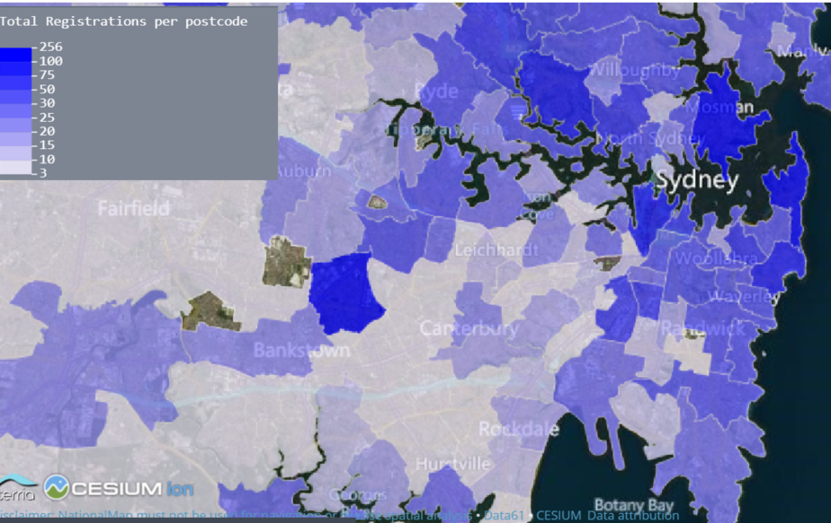
Figure 8 - Existing EVs registered x postcode area (from Nation Map – Australian Federal Govt)

Potential demand
In developing this demand projection, provision of readily available electric vehicle charging has been combined with the NSW Electric Vehicle Strategy’s goals of:
- Pricing parity between EVs and ICEs by 2027
- 30% of new car sales being electric by 2027, and
- Projected annual sales of EVs (in Figure 9)
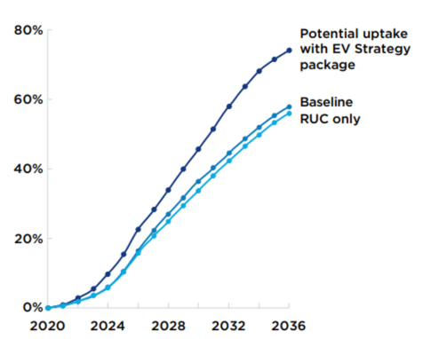
Figure 9 - BEV Share of new vehicle market … comparing uptake rates with/without proposed Road User Charge (RUC) - (from NSW EV Strategy)

Why buy an EV?
While electric vehicles (private cars in particular) have many of the same impacts as conventional ICE cars, they do have numerous benefits, as shown in Figure 11. As a consequence of these benefits and the knowledge that many car manufacturers will not be producing ICEs from 2030, increasing numbers of people will be purchasing EVs over the next 10 years. Clearly, governments at all levels will need to respond to this need/desire/demand.
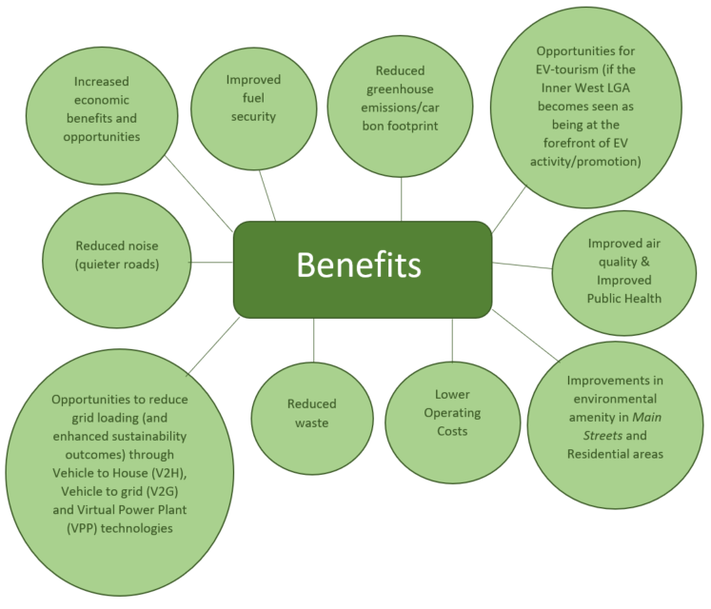
Figure 11 – Benefits of Electric Vehicles

Noting that purchase price and range anxiety are key barriers that deter individuals from purchasing an EV, the NSW State Government recently released its Electric Vehicle Strategy. This Strategy aims to achieve price parity by 2027, while discussions with charging and energy providers suggests that parity may be achieved as early as 2025. Consequently, it can be anticipated that demand for charging facilities will significantly increase over the next 3-5 years.
Currently, private vehicles are used less than 10% of the time and often travel less than 200 kilometres per week (with the majority of mileage being accrued during holiday periods). EV users would require a car charge with a frequency of once a week.
Should Councils and the State be able to ensure ready availability of charging, the critical determinant would then be the comparative running costs between EVs and ICEs.
Once local and state governments initiate measures to improve price parity between EVs and ICEs, and ensure the ready availability of charging, the comparative running costs between EVs and ICEs will be a critical determinant. As shown in Figure 12 comparison of running costs clearly favour EVs.
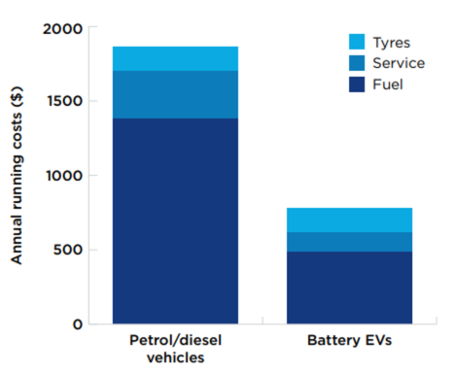
Figure 12 - Comparison of annual running costs of a medium size sedan (from NSW EV Strategy)

How Do We Charge an EV?

Levels of charging facility
There are five levels/speeds of charging facility:
- Level 1 (Slow AC)
  - 10-15 amp
  - Up to 2.3 kW
  - Adds 3-8 km of range for each hours of charging
  - Takes 5-12 hours to fully charge
  - Usually via charging pillars, light poles and kerb-chargers
  - ‘Residential charging”

- Level 2 (Medium AC)
  - 30 amp
  - 7-22 kW
  - Adds 16-33 km of range for each hours of charging
  - Takes 2-4 hours to fully charge
  - Usually in car parks and private developments
  - “Destination charging”

- Level 3 (Fast DC)
  - 25 – 120 kW (3 phase power)
  - Charges up to 70% in 30 minutes (e.g. adds 120-250 km of range)
  - Usually via rapid charge hubs/kiosks, service stations, kerbside hubs, retail/commercial developments
  - Used to “top-up” and provided extended range in a minimum time
  - “Top-up charging”

- Level 4 (Ultra-Fast Charger)
  - 150-350 kW (3 phase power)
  - Charges up to 70% in 10 minutes
  - Usually via rapid charge hubs/kiosks, service stations, kerbside hubs, retail/commercial developments
  - Used to “top-up” and provided extended range in a minimum time
  - “Top-up charging”
  - Only suitable to specific vehicles

- Inductive (Wireless)
  - Up to 7.2 kW (30 amp)
  - Takes 8-12 hours to fully charge, but can be used in roadways to provide ‘charging on the move”
  - Not currently readily available in Australia
  - Higher rated systems included induction charging in traffic lanes currently being developed

Types of plugs
While there are a total of eight plug types available in Australia (Figure 13), five are currently in popular use:
- Two types of an AC charging plug (Type 1 & 2):
- DC Charging Plug (CHAdeMo and CCS)
- The proprietary Tesla Plug
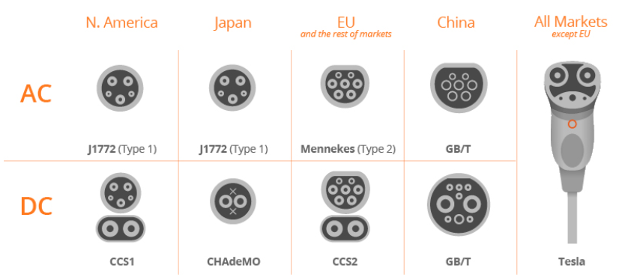
Figure 13 – Plug types currently in use (from Enel X)
The Australian Government is moving towards standardising these and charging unit manufacturers are exploring options for adapters, converters and multitype charging units.
This strategy will not make recommendations on preferred plug types, leaving market forces and government intervention to sort this out with charging unit manufacturers exploring options for adapters, converters and multitype charging units.

Existing charger network
At this time there are a total of nine networks available in the Sydney Regions (Figure 14) with this number gradually growing through new apps and start-up enterprises, each offering its members new and innovative incentives.
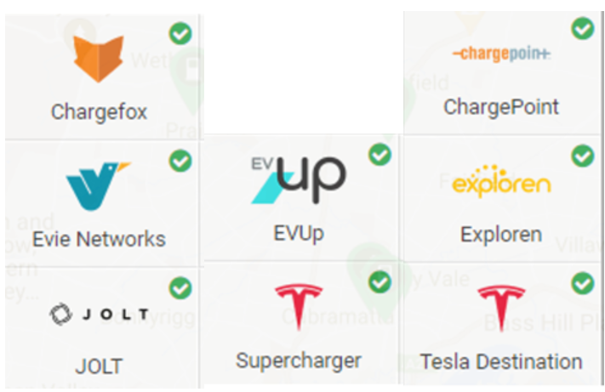
Figure 14 – Charging networks currently available in the Sydney Region (from Plugshare)

As shown in Figure 15 there are currently only 5 public EV charging locations in the Inner West LGA, however several developments (e.g. Wests Leagues Club, Ashfield) supply multiple wall sockets within their parking areas, thus providing opportunities for Level 1 slow charging.
As shown in Figure 16, charging locations are distributed across the region, state and country, with growing networks along key transport corridors particularly in country areas. Under existing plans more remote country areas will be served in the near future.
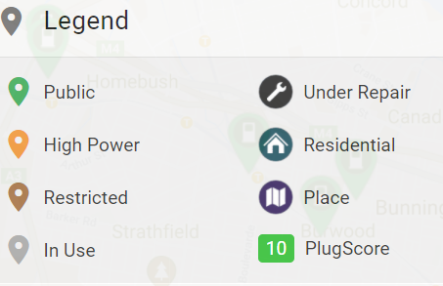
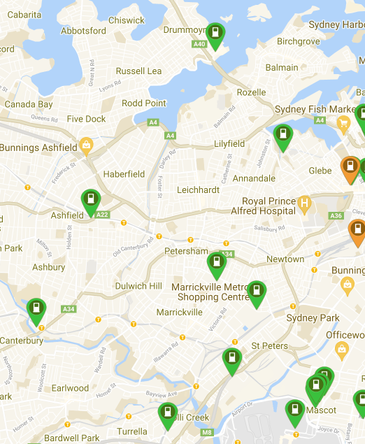
Figure 15 – Inner Sydney EV chargers (from PlugShare)

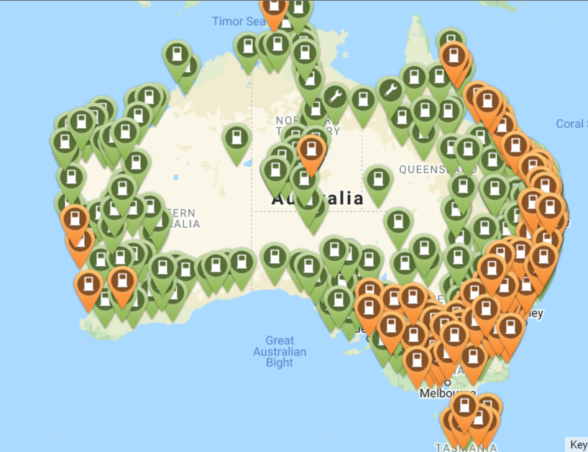
Figure 16 – indicative map of EV chargers across Australia (from PlugShare)

INITIAL CONSULTATION
To develop the draft Electric Vehicle Encouragement Strategy, six months of consultation was carried out with numerous stakeholders including:
- Members of Council’s Transport Advisory and Environment Advisory Committees;
- Residents who had contacted Council’s Strategic Transport Planning Team regarding opportunities for electric vehicle charging (during 2019-2020);
- Power providers;
- NRMA;
- Electric Vehicle Council (of Australia)
- Charging unit manufacturers;
- Vehicle manufacturers;
- Electric vehicle charging firmware and software providers;
- Motoring journalists;
- Key government agencies and electric vehicle organisations ;
- Other Councils;
- Inner West Council staff.
Additionally, on 24 August 2022, Inner West Council hosted a Mayoral EV Roundtable with 23 participants including industry experts, community representative, officers from councils that have already established EV strategies, as well as officers from Inner West Council.
The Roundtable was used to inform refinement of the draft Strategy with a particular emphasis on 'What Council can do". Suggestions from the Roundtable have now been incorporated into this draft Strategy's recommended actions.
A summary of the outcomes of this round table is included as Appendix A.

Numerous relevant documents were also reviewed including:
- Government policies (domestic and international);
- Policies of other Councils (domestic and international);
- Scholarly articles and papers;
- Web resources provided by both pro-and anti-EV groups/organisations

What do people think?
During preparation of this discussion paper many of the stakeholders referred to above were asked the following four key questions
- Question 1 (Key objectives of Strategy) – What would you like Council to achieve through its Electric Vehicle Encouragement Strategy?
- Question 2 (Barriers to increased EV uptake) – What are the key concerns, regarding EVS, that need to be addressed for the Community?
- Question 3 (Desired outcomes of the Strategy) – What are some desired outcomes you would like to see?
- Question 4 (Key actions to implement) – What are some recommended actions you would like to see?

In summary the key barriers identified are shown in Figure 17 below.
Barrier | Types of Action
Upfront cost | Government support (e.g. removal of stamp duty, absence of operational taxes, purchase grants and subsidies)  Education (re. lower on-going costs and the overall benefits of EV use when paired with renewable energy sources, including environmental and public health benefits)  Incentives and encouragements  - Free Council car park parking for a limited time
Availability of charging (Range Anxiety) | Provision of charging facilities (both private and public)  Streamlined approval process for chargers  Education on the “real charging demand” (i.e. how often the average car needs to be charged)
Time taken to charge an EV | Installation of faster chargers  Education on energy asset management (when to charge, where to charge and how best to charge)
Lack of sustainable power sources to charge | Government support (e.g. support of renewable energy programs)  Policies that make use of renewable energy sources for public chargers mandatory
Understanding the potential benefits of EVs | Education (e.g. social media, workshops, Council newsletter, field days)  Incentives and encouragements:  - Spare the air day where residents are encouraged to generate zero carbon emissions for a day  - Test drive electric vehicle days  - Information campaigns outlining the broader benefits of electric vehicles, especially those charged using renewable energy sources including:  - Improved air quality resulting in public health benefits (Noting the significant local improvement achieved in underground car parks, shopping areas and school pick up sounds);  - reduced noise resulting in improved local amenity, with some studies even indicating lower stress levels for drivers and passengers;  - significantly lower maintenance costs than ICEs;  - charging infrastructure available in the LGA.
Figure 17 - Overcoming the Barriers

Draft Electric Vehicle Strategy & Action Plan
This draft Strategy and Action Plan has been prepared to provide the Community with an opportunity to comment on Inner West Council’s suggested approach to the encouragement of electric vehicles.
The final, long-term Strategy will include:
- Goal;
- Vision Statement;
- Set of ambitions; and
- Set of three key principles.
Separately, a 5 Year Action Plan, comprising a set of recommended actions and key projects will be produced.
In reviewing this document it should be recognised that the draft Strategy & Action Plan provide more recommended actions than are realistically achievable within a five-year time frame, however Council is using this exhibition to gather Community feedback on the importance of the various actions with a view refining their priorities. This will, then, permit Council to develop a realistically implementable five-year action plan.
While the Strategy will set a long-term vision, the Action Plan will be periodically reviewed and adjusted to respond to the changing circumstances associated with electric vehicles and to reflect Council’s success in encouraging electric vehicle uptake.
Under the NSW Local Government Act 1993, Councils are required to develop a hierarchy of plans known as the Integrated Planning and Reporting (IPR) Framework. This framework assists Councils in delivering their community’s vision through long, medium and short-term plans. The purpose of the framework was to formalise strategic and resource planning across NSW Councils and ensure long term planning is based on community engagement leading to a more sustainable local government sector.
Implementation of the Electric Vehicle Strategy will be embedded in Council’s Integrated Planning and Reporting (IPR) Framework and timelines to ensure that priorities are included in the long-term planning and short-term delivery of Council’s projects and programs. Longer term outcomes will be in the high-level Delivery Program which is a four-year document that aligns with the term of the elected Council. Each year priorities will be detailed in Council’s one-year Operational Plan and these will be reported to Council and the community through the Quarterly Reporting process. In addition to these actions, Council will also create efficient and effective measures and targets that will be used to demonstrate Councils’ progress against service delivery and will ascertain whether Council is moving towards or away from the communities’ priorities as outlined in the Community Strategic Plan – Our Inner West 2036.

The Strategy

Goal
To make the Inner West the best place in Australia to own and operate an Electric Vehicle.

Vision
If trips use private vehicles, they should be powered by the most sustainable means available and Council should encourage this by providing adequate incentives, including charging opportunities, to facilitate increased use of Electric Vehicles by the Inner West Community.

Ambitions

Year 1
- The Development Control Plan (DCP) requires the provision of EV charging facilities in major developments.
- Council collaborates with organisations to develop pilot charging schemes and demonstration projects.
- A simplified approval pathway is developed for both private and public EV charging facilities.
- Council explores opportunities to develop a Hydrogen Fuel Cell (HFC) demonstration project.
- Council establishes a transition plan for its own passenger fleet.
- Council commences its EV awareness campaigns.

Year 2
- The initial pilot schemes developed in Year 1 grow by at least 10%.
- The HFC demonstration project (if deemed feasible in Year 1) becomes operational.
- Inner West Council expands its EV educational and promotion activities by working with adjacent Councils.
- Council rolls out a program to provide charging units powered by renewable energy sources in its larger public off-street parking areas.

Year 3
- The initial pilot EV charging scheme, developed in Year 1, continues to grow by at least 10% p.a.
- “Lessons learned” from the HFC demonstration project in Year 1 are assessed, and:
  - shared with other Councils;
  - used to consider the expansion of FCEVs in the Inner West, including potentially Council’s own fleet.
- Through its support for electric vehicles, Inner West Council becomes recognised as the leader in local government electric vehicle encouragement and uses this to create a plan for “EV Tourism” as part of its economic development planning;
- Council work with car share operators, taxis companies, ride share operators and charging providers to introduce EVs into the Inner West fleet, supported by EV charging facilities.
- Transition plan for Council’s own passenger fleet is underway (Corporate EV Plan).

Year 4
- The pilot charging schemes, from Year 1, lead to the creation of comprehensive charging networks catering for the whole Inner West LGA
- If successful, the HFC demonstration project from Year 1, acts as a promotional and education resource, providing data to inform the development of new pilot programs across Australia.
- All priority residential areas (areas with a significant proportion of dwellings not having their own off-street parking) have public charging units
- Council’s EV education and awareness program has grown to include a series of annual events
- Transition plan for Council’s own passenger fleet continues (Corporate EV Plan).

Year 5
- The pilot charging schemes from Year 1 move from a pilot scheme to a series of permanent networks
- Council reviews its EV Encouragement Strategy with a view to introducing new incentives and exploring new initiatives
- Council reviews the HFC demonstration project to consider future expansion of HFC technology into Council fleet and opportunities to assist other Councils in developing similar programs
- EVs represent at least 10% of cars in the Inner West.

The Draft Action Plan
In reviewing this Draft Action Plan, it is essential to note that the 43 actions proposed could not be simultaneously implemented. Consequently, feedback is specifically sought (during the draft Strategy’s Community Consultation Phase) on the comparative priorities of the various actions (e.g., Short, Medium and Long Term).

Principle 1 (Public Charging)
Charging facilities should be provided for use by the Community, particularly in areas where off-street access to residential properties is limited.

Action 1.1
Council works with charging providers to develop pilot programs to initiate the phased-in provision of charging facilities in each of Council’s public off-street parking areas. These programs should aim at providing a minimum of 2 bays (1 charging unit) dedicated to electric vehicle charging in each off-street parking area that has 20 or more car spaces .
The programs should be designed in a manner which rolls out additional electric vehicle charging spaces each year based on a combination of current usage and anticipated growth in demand. Ultimately, these programs should also include the provision of electric vehicle charging adjacent to other Council facilities (e.g. community centres)

Action 1.2
Council works with charging providers to develop pilot programs to initiate the phased-in provision of kerbside charging facilities in areas where housing does not generally have driveways/off-street access (and consequently residents are unable to provide their own on-site charging facilities). NOTE - In order to do this Council should finalise a set of site selection criteria … see Appendix B for Draft Site Selection Criteria.

Action 1.3
Public off-street charging facilities should use only renewable energy sources wherever practical.

Action 1.4
Council should work with existing local service stations providers to include EV charging facilities in existing and new service stations.

Action 1.5
EV charging units for cars should provide charging opportunities for the charging of electric micro-mobility devices (e.g. e-bikes and e-PMDs). Ultimately, Council should examine whether there is a sufficient demand to warrant the provision of charging facilities exclusively for e-bikes and other electric micro-mobility devices. If the analysis proves that sufficient demand exists, Council should establish micro-mobility charging hubs at key locations, where several e-bikes and PMDs can be simultaneously charged.

Action 1.6
Council should explore funding models, including Government Grants and private enterprise initiatives for the provision of public electric vehicle charging stations. In particular Council should examine options which are available to provide quality charging facilities, that are affordable for residents, employees, and visitors to the LGA while having no direct cost to Council

Action 1.7
As part of Council’s future parking meter renewal and street furniture programs, a proportion of the suitable assets should be capable of charging electric vehicles

Action 1.8
Council should work with Ausgrid to ensure that, subject to the delivery of suitable lighting pole designs (e.g. recognising the local character including heritage considerations) at least 20% of new lighting poles in the Inner West LGA should be capable of accommodating EV charging units.

Action 1.9
Council should develop a simple, equitable approval pathway for the establishment of public vehicle charging facilities (Noting that the State Government’s Infrastructure SEPP already provides opportunities for an approval pathway- Appendix C)

Action 1.10
Council should work with charging providers and the community at large, to develop an enforcement regime to ensure that EVs do not overstay their charging time in designated spaces and that non-EVs do not use EV charging spaces with the incorporation of a public awareness campaign.

Principle 2 (Private Charging)
The ability to provide charging facilities in all private developments should be easily achieved.
Action 2.1 DCP Requirements – Residential
- All new car spaces for single dwellings, including alterations and additions, (where car spaces are permitted) should be provided as electric vehicle charging spaces (Level one or faster)
- All car spaces to be provided for new dwelling house developments including alterations and additions (where car spaces are permitted) should be provided as electric vehicle charging spaces (Level one or faster) prior to occupation of the building or subdivision of the property whichever occurs first.
- All new multi-unit residential developments should provide electric vehicle charging spaces (Level 1 or faster) for no less than 20% of all car spaces.
- Parking spaces in new multi-unit residential developments should be future-proofed/EV Ready through the provision of conduits and cables to ALL car spaces (to permit residents to readily add charging units to individual bays). Further, the development must be able to demonstrate that its proposed electrical infrastructure is sized to support a future scenario where 100% of all spaces are used for EV charging simultaneously.
- All new multi-unit residential developments should provide electric vehicle charging spaces (Level 1 or faster) for no less than 10% of all visitor car spaces (or a minimum of 1 space if less than 10 visitor spaces are to be provided)
- All new multi-dwelling residential developments shall provide ready-to-use charging points, in areas dedicated to bicycle parking, for no less than 50% of bicycle spaces.
Action 2.2 DCP Requirements – Non-Residential
- All new non-residential developments should provide ready-to-use electric vehicle charging spaces (Level 3 or faster) for no less than 10% of all car spaces.
- Parking spaces in new non-residential developments should be future-proofed/EV Ready³ through the provision of conduits and cables to 50% of all car spaces (to permit owners/tenants to readily add charging units to individual bays). Further, the development must be able to able to demonstrate that its proposed electrical infrastructure is sized to support a future scenario where at least 50% of all spaces are used for charging simultaneously.
- All new non-residential developments should provide electric vehicle charging spaces (Level 3 or faster) for no less than 10% of all visitor car spaces.
- All new non-residential developments shall provide ready-to-use charging points, in areas dedicated to bicycle parking, for no less than 25% of bicycle spaces.

Action 2.3
Private developers should be encouraged to use renewable energy as the power source for their electric vehicle charging wherever possible.

Action 2.4
Council should work with car share providers, ride share providers and taxi companies (including peer-to-peer car share), to encourage the use of electric vehicles. This should include the development of a fast-track process for approval of charging facilities for such operations. Simultaneously, Council should work with carshare operators and charging providers to introduce and ensure adequate provision of charging facilities for electric car share vehicles in the Inner West

Action 2.5
Council should develop a simple, equitable, approval pathway for the establishment of private electric vehicle charging facilities including a streamlined approval process for the assessment of retrofitted electric vehicle charging in existing developments.

Action 2.6
Council should explore its role in EV demand and asset management programs in conjunction with the State Government and grid managers (such as Ausgrid). This would include potential for Vehicle to Home (V2H), Vehicle to Grid (V2G) and Virtual Power Plant (VPP) asset management programs.

Action 2.7
Council should explore opportunities to develop guidelines for the safe charging of EVs for residents who do not have off-street access or a nearby public charging unit.

Principle 3 (Incentives and Encouragements)
Community awareness of the diversity of benefits associated with electric vehicles encourages increased uptake and appreciation of electric vehicles

Action 3.1
Council should develop a community-based EV awareness and education campaign to increase awareness of the benefits of Electric Vehicle ownership. Such a campaign should include consideration of the overall benefits, including reduced noise, improve public health and enhanced local environment.
The awareness campaign could include incorporation into events such as its “Footprints Festival”, and creation of a “Spare the Air” day campaign

Action 3.2
Council should develop an “EV Tourism” promotion campaign through its Economic Development Team in which semi-regular electric vehicle special events are supported (e.g. featuring of EVs in Inner West Events such as EDGE). Such day tourism should include projects which foster better understanding of EVs (mythbusting), encouraging EV demonstration days (test drives) and general information sessions.

Action 3.3
Council should examine opportunities to encourage the manufacturing of EVs and EV components, as well as conversion of classic cars to EV drives, in its various industrial areas, through refinements to land use zoning and/or Incentive schemes

Action 3.4
Council should continue to convert its fleet to EVs and so lead by example while at the same time assisting in growing the proportion of EVs in the used vehicle market (thus making EVs more readily affordable). The passenger fleet transition plan should also include opportunities for electric bikes/PMEVs, and consider the potential for Virtual Power Plants when this is supported by energy market rules

Action 3.5
Council should work with SSROC and adjacent Councils to develop a unified approach to the encouragement of EV uptake, possibly through the establishment of a sub-regional working group. Such collaboration could include working with SSROC, the State Government and other Councils to encourage the use of electric public transport that uses renewable energy sources

Action 3.6
Council should examine opportunities to work with organisations/companies to develop an EV Energy Asset Management System, possibly including development of a Virtual Power Plant (VPP) project using a combination of Council’s own vehicle fleet, EVs belonging to local businesses and new (or retrofitted) residential developments. To facilitate this Council should work with key stakeholders, including the Federal Government to explore opportunities to modify Australian Standard 4777 (or to develop a new stand-alone standard) to permit and encourage the development of energy asset management systems such as Vehicle to Grid (V2G), Vehicle to Home (V2H) and Virtual Power Plant (VPP) projects.

Action 3.7
Should Council introduce fee-based resident parking scheme permits, a trial should be introduced where electric vehicles are provided with permits at a discounted rate.

Action 3.8
To ensure equity and parity between EVs and ICEs, Council should advocate the State Government to discourage the introduction of a Road User Charge (RUC) for EVs,(including questioning the proposed nexus between the existing fuel excise and road maintenance expenditure). If an RUC is introduced for electric vehicles (as outlined in the NSW Electric Vehicle Strategy - 2027 or once 30% of new car sales are electric vehicles), Council Should advocate for this RUC to be applied to all vehicles (i.e. including ICEs) rather than presenting a split system. Simultaneously Council should advocate for national fuel efficiency standards to be applied to all motor vehicles

Key Projects
- Council should work with power providers and charging providers to establish a minimum of 3 pilot programs for the provision of electric vehicle charging facilities in Council’s off-street public parking areas and other Council facilities. Each pilot program should run for a minimum of 5 years and should be monitored, reviewed and adapted to provide the greatest possible benefit for the Inner West Community.
- Council should work with power providers and charging providers to establish a minimum of 3 pilot programs for the provision of electric vehicle charging facilities in neighbourhoods where a significant proportion of houses do not have driveways/off-street access. Each pilot program should run for a minimum of 5 years and should be monitored, reviewed and adapted to provide the greatest possible benefit for the Inner West Community.
- Council should examine opportunities to establish a hydrogen fuel cell demonstration project, potentially including a production facility powered by renewable energy sources and an FCEV community bus.

APPENDIX A - MAYORAL ROUNDTABLE OUTCOMES SUMMARY (24 August 2022)
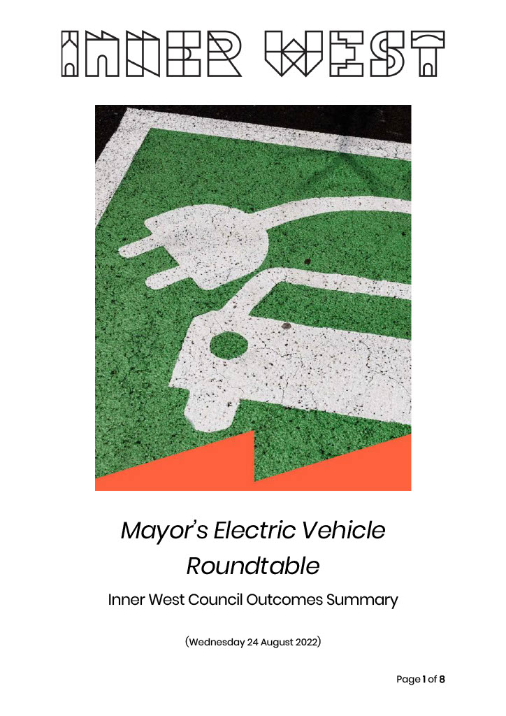
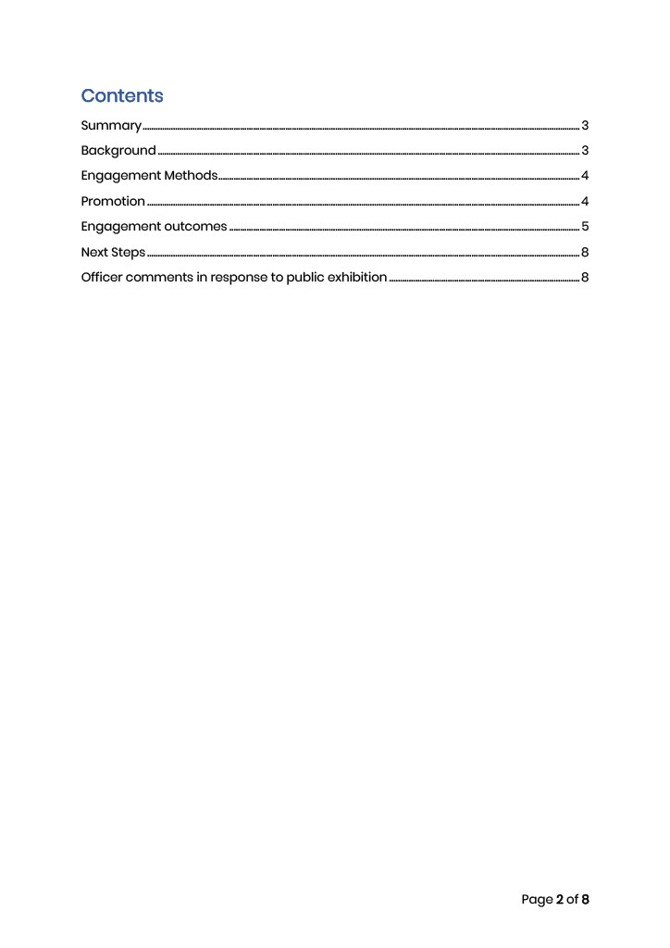
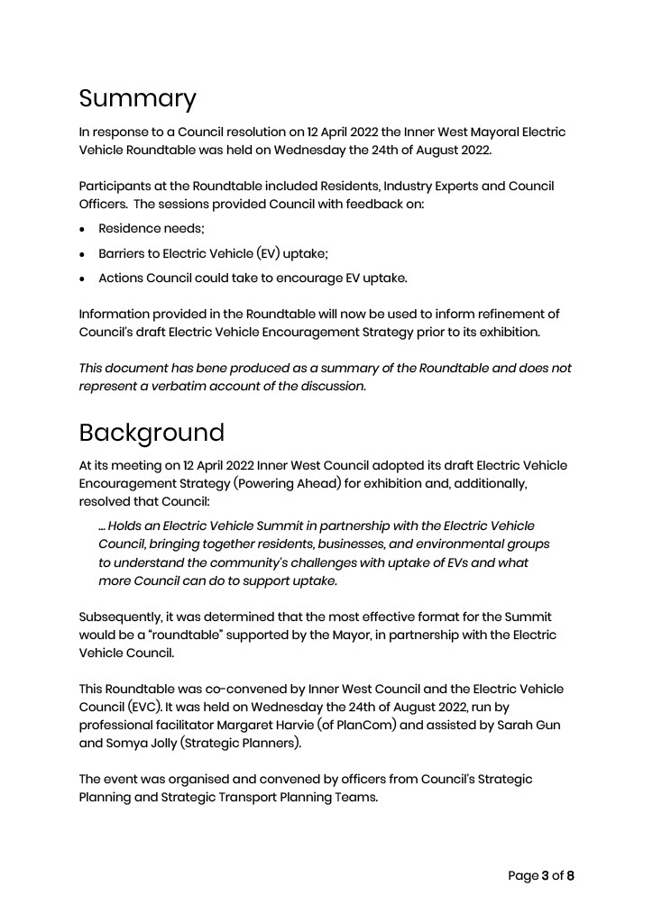
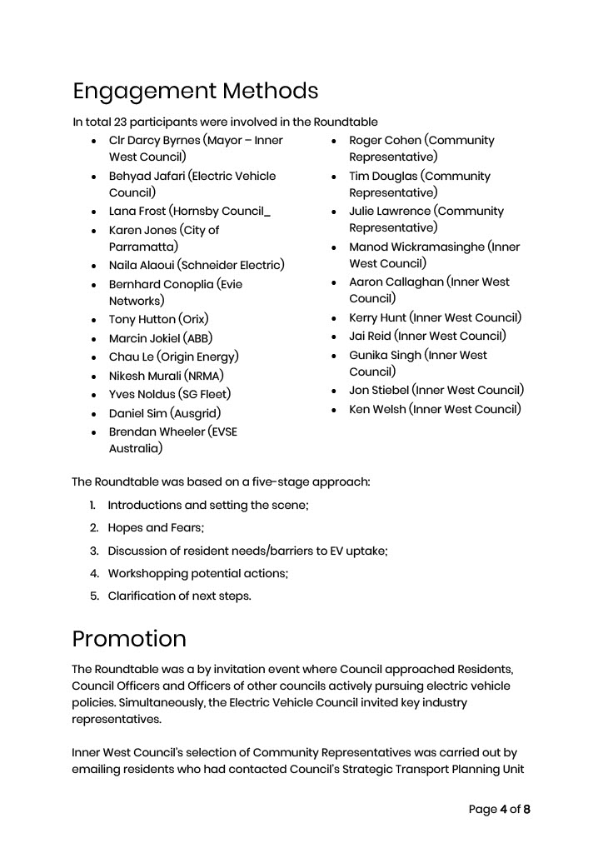
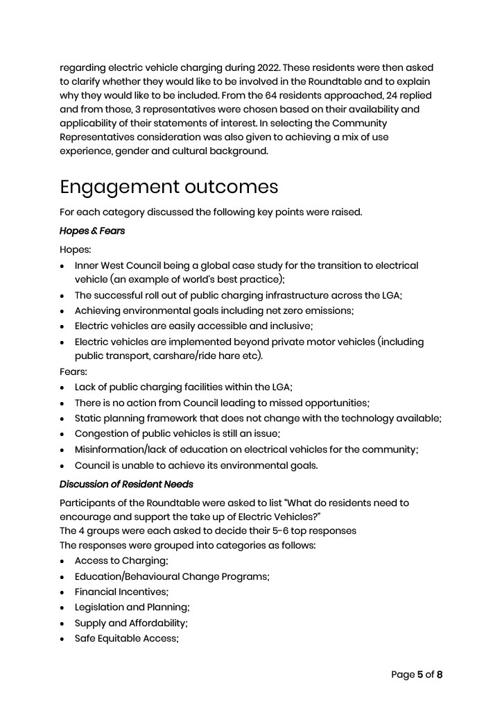
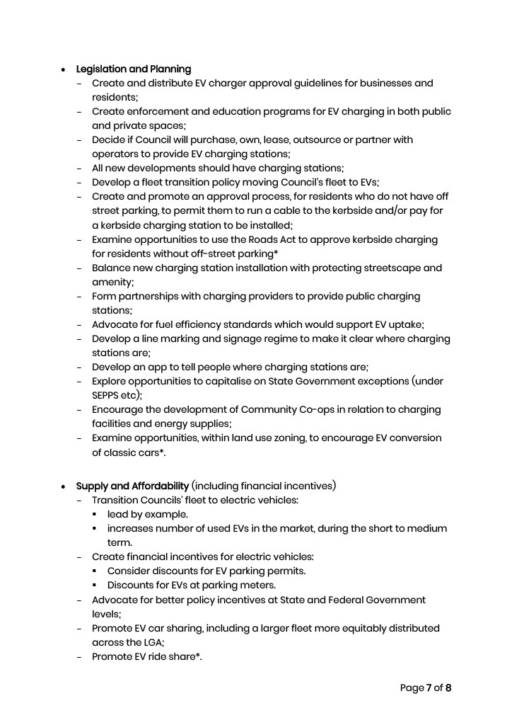
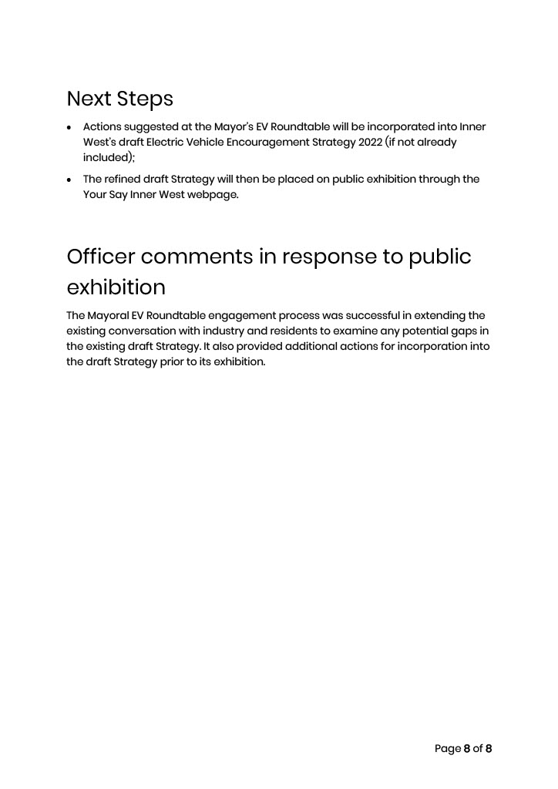

APPENDIX B – DRAFT SITE SELECTION GUIDELINES FOR KERBSIDE RESIDENTIAL CHARGING FACILITIES (for charger and dedicated car space)
Selection of suitable sites for the provision of kerbside electric vehicle charging facilities within a residential area will be based on consideration of the following criteria:
- The site is included in an area designated as an EV Charging Priority Neighbourhood (based on likely demand and proportion of properties without off-street access) by Council and permitted under relevant legislation
- A safety audit is conducted and the site is deemed safe and appropriate. The safety audit should include, but not be limited to, consideration of:
  - Sightlines
  - Manoeuvring space
  - Impedance of bike lanes
  - Public safety including pedestrian and cycle impacts (particularly noting impacts of the station hardware and cables), including trip hazards)
  - Impact on footpaths, inducing any reduction of footpath widths
  - Impact on waste/garbage removal
  - Potential for passive surveillance (including street lighting)
  - Other impacts on public safety
- There will be no functional reduction in the width of the existing footpath
- Appropriate adjacent land uses, based on the following prioritised hierarchy:
  - not directly outside a private dwelling (unless written agreement is provided by the householder, and householders on either side of the chosen site);
  - not directly outside a child-care centre
  - not directly outside single retail or commercial premises located in residential areas
  - adjacent to public land such as a park
  - adjacent to a public facility such as a Council administration centre, community centre, leisure centre, school or library
  - adjacent to the side boundary of single dwellings
  - Adjacent to existing residential flat buildings
- Must be supported by the power provider to ensure sufficient capacity on the local power grid or can be reasonably upgraded. (Noting that Council will bear no cost or responsibility for the provision of, or upgrade to, electrical supply infrastructure to service a proposed EV charging site, unless subject to a specific prior agreement);

- The energy source for the charger should use renewable energy;
- The facility is compliant with relevant Australian Standards and Regulations for occupational health and safety. Further, the charging facility hardware must be located a safe distance away from hazards (e.g. dangerous goods and fuels); and
- At least 30% of dwellings in the street should have no off-street access/driveways;
- Consultation is undertaken with adjacent premises with more than 66% of households in the street, responding to the survey, supporting the provision of an EV charging unit within the street;
- Should be a public road under the care and control of Council;
- Can the facility be located in a manner which permits the associated charging bay to be DDA compliant;
- Access to the facility should be available 24/7
- Consider:
  - relevant environmental, public domain and streetscape impacts
  - whether it is possible to convert the facility from a single car space to two car spaces if future demand warrants
- Applicants should identify potential demand (existing and /or future demand)
- The site must be clearly visible, linked to an appropriate booking/management app and supported by appropriate Wayfinding
- The operator agrees to taken on all liability issues associated with the charging unit
It should be noted that Council’s approval of a charging facility at any given location will not exclude other providers from establishing facilities nearby, nor does it establish a precedent for approval at nearby locations. Each application will be dealt with based on its own merits and its ability to satisfy all or most of the above criteria.

APPENDIX C – Infrastructure State Environmental Planning Policy (Part 3, Division 17)
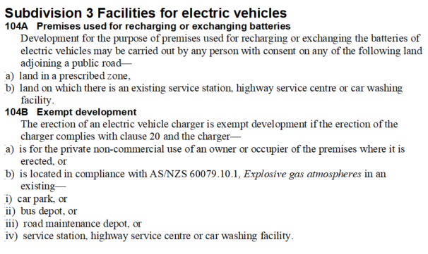

In calculating the rates of provision of electric vehicle charging spaces, the requirement should be rounded up and a minimum of one electric vehicle charging space should be provided in any new development.
EV-ready parking space: cabling to the space, and spatial allowance for GPO or charging head unit are provided

