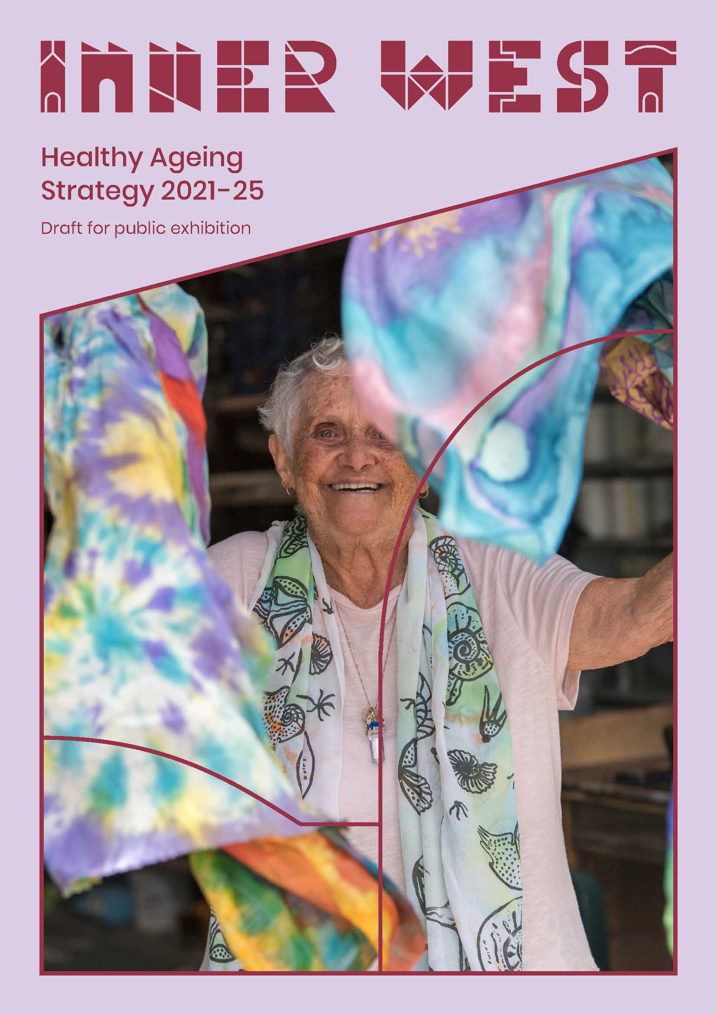

Draft Healthy Ageing Strategy for the Inner West 2021-2025

Contents
Table of
Contents 2
Aboriginal and Torres Strait Islander Statement 3
Executive Summary 3
Introduction 4
What is healthy ageing? 4
How was the Healthy Ageing Strategy developed? 5
Profile of ageing in the Inner West 5
Strategic approach 7
Key priorities for Council action 7
Council’s role 7
Strategic focus areas 8
What is Council currently doing? 9
Implementation of the Healthy Ageing Strategy 11
Appendix 1 12
Inner West Council’s Integrated Planning and Reporting Framework 12

Aboriginal and Torres Strait Islander Statement

Inner West Council acknowledges the Gadigal and Wangal peoples of the Eora Nation, who are the traditional custodians of the lands in which the Inner West local government area is situated.
We celebrate the survival of Aboriginal and Torres Strait Islander cultures, heritage, beliefs and their relationship with the land and water. We acknowledge the continuing importance of this relationship to Aboriginal and Torres Strait Islander peoples living today, despite the devastating impacts of European invasion. We express our sorrow for past injustices and support the rights of Aboriginal and Torres Strait Islanders to self-determination.
Inner West Council understands our responsibilities and role in working with the Aboriginal community to promote cultural heritage and history, address areas of disadvantage, and protect and preserve the environment as well as sites of significance to Aboriginal peoples. In doing so, we acknowledge that Aboriginal cultures continue to strengthen and enrich our community.

Executive Summary

The Inner West’s population is ageing. Today, among our own community of more than 200,000, almost 55,000 people – or about one in four – are aged 50 years or older. This trend is projected to continue in the coming years, and by 2026 more than 3,400 people are also expected to be living with dementia in the Inner West.
Our ageing population presents both a challenge and an opportunity for the Inner West Council to support its communities to continue to lead full and rewarding lives as they age. Through extensive community consultation, expert advice and research into national and international best practice, Council has developed the Health Ageing Strategy and Action Plan 2021-2025 to guide its policy and program support for older members of the community.
The Healthy Ageing Strategy focuses on delivering across six priority areas over the next five years:
- staying active
- getting around and staying connected
- housing, employment and financial security
- safety
- learning and sharing knowledge
- health and diversity.

Introduction

It is well established that social connection is essential for good physical and mental health across all life stages. As people age, connection with family, friends and the broader community grows in importance as the frequency and nature of people’s social contact can be reduced through retirement, for example, or changes in living circumstances.
Research demonstrates that continuing to participate in the community as we grow older is an important part of health ageing. Participation in social and cultural activities creates social inclusion and promotes greater health and wellbeing (Haslam, 2019).
The Healthy Ageing Strategy 2021-2025 builds on the former Leichhardt Council Healthy Ageing Plan. The strategy recognises that the needs of older people in the Inner West are diverse. Following best practice, the strategy and supporting action plan has a particular focus on supporting older people to stay engaged in the community regardless of their circumstances.

What is healthy ageing?

According to the World Health Organization, healthy ageing is “the process of developing and maintaining the functional ability that enables wellbeing in older age”. This means that as people age it is important for them to develop and maintain the capabilities that allow them to do what they value. This includes a person’s ability to:
- meet their basic needs
- learn, grow and make decisions
- be mobile
- build and maintain relationships
- contribute to society.

What determines healthy ageing?
With the world’s population ageing at a faster rate than in the past, there is an increasing focus on understanding the factors that contribute to healthy ageing.

The World Health Organization has found that an older person’s capacity and circumstances are shaped by the cumulative impact of advantage and disadvantage across their lives. This includes factors such as the family they were born into, gender, ethnicity, level of education and financial resources.

It also highlights that there is no typical older person. Some older people are strong mentally and physically while others require extensive care and support. It is important that policies are framed to improve the functional ability of all older people, whether they are robust, care dependent or in between.

In addition, healthy ageing research and literature point to the close connection between social participation and ageing well. Social and structural factors including financial security, housing, transport, accessible urban design, cultural background, gender, information access, support services and connectedness to family and community also influence the ability to age well (Haslam, 2019).

How was the Healthy Ageing Strategy developed?

The Healthy Ageing Strategy 2021-2025 is a four-year roadmap for Inner West Council to support a growing number of residents to continue to live full and rewarding lives as they age.
Through surveys and focus groups, more than 600 residents from across the Inner West contributed their views on the interests, needs, aspirations and challenges of people as they age. Service providers and community-based organisations, stakeholders from government and business, and Council staff also contributed to the development of the strategy.
In addition to the contribution from community and other stakeholders, the strategy reflects input from an expert forum, and findings from healthy ageing research and literature.

Profile of ageing in the Inner West

More than 200,000 people live in the Inner West, and the population is growing. At the 2016 census 54,628 people were aged 50 years or over, and 31,969 were 60 years and over.
The Inner West Council’s Healthy Ageing Strategy 2021-2025 is focused primarily on people aged over 50 years. The total number of people aged over 50 in our community will increase significantly as a result of ageing of existing residents, and new residents moving into the area.
Residents aged 50 years or over are diverse. A key feature of the community is the ageing of the wave of migrants who made the Inner West suburbs their home in the 1950s and 1960s. The largest (non-English) language groups for residents 50 years and over include Arabic, Cantonese, Greek, Italian, Mandarin, Nepali, Portuguese, Shanghainese, Spanish and Vietnamese.
Residents in this age group also have varied faiths, diverse sexual orientation, and differences in their relative socio-economic advantage and disadvantage.
An additional consideration that may impact older residents in the Inner West is that physical inactivity, being overweight, obesity and low vegetable intake are more likely in areas that experience more disadvantage, and these factors can contribute to high incidents of falls, diabetes, cardiovascular disease and a predicted growth in dementia.

Table 1: Inner West population over 50 years in 2016
Age Group | Ashfield  Djarrawunang Ward | Balmain  Baludarri  Ward | Leichhardt  Gulgadya  Ward | Marrickville  Midjuburi  Ward | Stanmore  Damun  Ward | Inner West % | Greater Sydney %
50-59 years | 4,669  (12.3%) | 4.906  (13.5%) | 4,425  (11.7%) | 3,859  (11.2%) | 3822  (11%) | 12% | 12.2%
60-69  years | 3,095 (8.1%) | 3,889 (10.7%) | 3,308 (8.7%) | 2,768  (8%) | 2,486 (7.2%) | 8.6% | 9.4%
70-84 years | 2,767 (7.2%) | 2,337 (6.5%) | 2,637 (6.9%) | 2,360 (6.9%) | 1,714 (4.9%) | 7.5% | 7.5%
85 years and over | 879 (2.3%) | 431 (1.2%) | 798 (2.1%) | 645 (1.9%) | 347 (1%) | 1.7% | 2%

By 2026 the following changes are predicted:
- the Inner West population will grow by 13% to 216,917
- people aged 50 years and over will increase by 24% or 54,628 to 67,556 people
- people aged 55 years and over will increase by 21% or 8,862 people to 51,257 people
- people aged 65 years and over will increase by 29% or 6,669 people to 29,693 people
- people aged 85 years and over will increase by 37% or 1,174 people to 4,319 people.
The Inner West’s older population remains balanced across men and women until the age of 85 where women begin to outnumber men. By the age of 85 and over, women make up 63% of the group while men make up 37%.
Table 2: Future population projections
2016 |  | 2016 to 2026 |  | 2016 to 2036
 |  | +
2016 population data |  | 2026 population projections |  | 2036 population projections
50-59 years | 22,659 (12%) | 50-59 years | 24,858  (11%) | 50-59 years | 26,331  (12%)
60-69 years | 16,437  (9%) | 60-69 years | 18,419  (9%) | 60-69 years | 20,032  (9%)
70-84 years | 12,387  (7%) | 70-84 years | 16,960  (5%) | 70-84 years | 20,113  (9%)
85 years and over | 3,145  (1.6%) | 85 years and over | 4,319  (2%) | 85 years and over | 5,664  (2.5%)

The prevalence of dementia increases with age. Dementia Australia reports that three in 10 people over the age of 85, and almost one in 10 people over 65 have dementia and that dementia is now the leading cause of death among women in Australia. It is projected that 3,489 people will be living with dementia in the Inner West by 2026 climbing to almost 5,000 people by 2036.

Strategic approach

Key priorities for Council action

Through community engagement, the following areas were highlighted for Council to support healthy ageing:
- public space and infrastructure for creating a liveable and inclusive community as people age
- lighting, pathways and green spaces influence how safe the Inner West feels, and in turn perceptions of safety
- becoming a more dementia friendly city
- celebrating the diversity of our population and developing responses that meet the specific needs of residents
- public and community transport to enable participation in community life
- access to secure and stable housing as people retire and get older
- greater access to opportunities for paid work, and volunteering opportunities matched to a person’s skills and interests
- access to information to navigate the different stages of life including financial literacy, care, services and support.

Council’s role

Under the Local Government Act 1993, local councils are required to develop a hierarchy of plans known as the Integrated Planning and Reporting Framework. This framework assists councils in delivering their community’s vision through long, medium and short-term plans.
The Inner West Community Strategic Plan, Our Inner West 2036, identifies the community’s vision for the future, long-term goals, and strategies to get there and outlines how Council will measure progress towards that vision. The Plan identifies five strategic directions that support the goals of the community. The Healthy Ageing Strategy aligns closely with Strategic Direction 4: Caring happy healthy communities.
Our Inner West 2036 guides Council to achieve the outcomes that the Inner West community has identified as priorities:
- inform our strategic decision-making that will shape our future community, economy and environment
- protect and enhance the community’s values and heritage
- pave the way for the future through proactive planning for the impacts of change
- strive for inclusivity, sustainability, resilience, accountability and innovation.
Within this context, Council has identified three key responsibilities that support the Healthy Ageing strategy:
- Facilitator: supporting and working with local community groups, organisations and government agencies to deliver services and infrastructure projects the community needs
- Provider: providing essential social, cultural and community and infrastructure and programs; not replicating what is available in the commercial or not for profit market
- Advocate: advocating to NSW and Commonwealth Governments for the development and implementation of policy for more effective social, cultural and economic outcomes.

Strategic focus areas
The Healthy Ageing Strategy 2021-2025 proposes six focus areas. These and Council’s initial responses are detailed below:
Focus area | Initial responses
Staying active | - develop a community hub model to better connect older people to the broader community  - support a diverse range of wellbeing initiatives in the community  - promote and support intergenerational participation  - evaluate our Healthy Ageing programming and recommend changes to Council  - collaborate with the Local Health District on healthy ageing policy.
Getting around and staying connected | - infrastructure to support the comfortable use of public spaces, such as shade, age-friendly seating, bubblers, accessible toilets and walking with companion animals  - co-design of town centre upgrades with people as they age  - apply age-friendly principles to support older people’s movements across the Inner West  - Advocate for improved public transport options that are accessible  - review and improve local transport provided by Council  - develop more accessible footpaths and pathways across communities  - deliver new and improved community facilities and infrastructure  - ensure accessible parking is available when it is needed.
Housing, employment and financial security | - advocate for a range of fundamental needs for older people including social and affordable housing  - promote financial literacy
Safety | - Council venues are available in times of crisis or emergency  - reduce and prevent family violence and elder abuse.
Learning and sharing knowledge | - increase the visibility of healthy ageing  - support the Inner West Dementia Alliance  - connect to volunteering  - promote resources to support caring  - maximise opportunities to share knowledge and mentor others.
Health and diversity | - collaborate on implementing the Aboriginal Health Strategic Plan of Sydney Local Health District  - provide cultural awareness training for staff  - support the sustainability of groups of seniors from culturally and linguistically diverse backgrounds  - improve capacity to engage in a culturally sensitive way with LGBTIQ+ people.

What is Council currently doing?

Council has invested significantly in promoting and supporting Healthy Ageing, key highlights have included:
- Health and wellbeing education and programs for seniors in collaboration with libraries, Hannaford Centre, community partners such as Services Australia, Trustee and Guardian, Sydney Local Health District, and Uniting

- Active and Connected: A suite of recreational, fitness, arts and wellbeing activities, bus outings and programs designed to promote and encourage healthy ageing. Collaborative development and delivery of programs by Council’s Aquatic Centres, Community Centres, Sport and Recreational Unit, Healthy Ageing Team and Library services

- Actively support and participate in key advocacy and awareness raising initiatives and networks specific to older people, including Coalition of End of Loneliness, Elder Abuse Collaboration, Multicultural Network, Dementia Alliance, Anti-Ageism campaigns

- Supporting volunteer led initiatives such as HOPE Lunch, Women’s Shed and Coffee Clubs

- Employment of Healthy Ageing Programs staff dedicated to championing the voices, aspirations and inclusion of seniors

- Publication of a Seniors Directory

- Annual events such as Seniors festival, Grandparents day, Mental Health Month delivered in collaboration with local community organisations, businesses, artists and multicultural networks

- Council Libraries host Healthy Ageing and Wellbeing Workshops and Talks, including the History and Speaker Series, designed to explore ageing in today’s world

- The Hannaford Centre, a Council funded Community Centre, offering diverse activities and programs for seniors living in the Inner West

- Establishment of Dementia Cafes, designed to create an inclusive social support network for older people living with dementia and their family / carers

- Promoting and supporting the role out of pilot programs and new initiatives designed to increase social inclusion for older people from linguistically diverse background. Recent examples include the My Aged Care Navigator Support Program developed by COTA for Chinese speaking community in Ashfield.

- Facilitate Seniors Local Democracy Working Group, providing local senior residents an avenue to contribute ideas and provide feedback to Council on issues and projects pertaining to healthy ageing

- Grants: Council’s Community Wellbeing, Recreation, Environmental and Arts grants include the funding of programs, services and collaborations specific to older people in the community

- Get Connected Stay Connected: A suite of online workshops and social support groups developed by Council in partnership with SLHD and designed for older people isolated during Covid -19. This program has included the development of a Train The Trainer training package for community organisations and health professionals to deliver these social connection groups in their local communities eg. those from culturally and linguistically diverse backgrounds, Carers of People with Dementia, People Living with Dementia, and Aboriginal and Torres Strait Islander residents

- Connected : Art Exhibition involving participants of the Get Connected Stay Connected programs and other local art groups supported and funded by Council

- Facilitation of the Aged Care Services Interagency network, a network of services working with older people and their carers who promote and support and advocate for the provision of support services and social inclusion for residents over 65 years old

- Provision of Social Support, Meals on Wheels and Aged Care Home Care support services as part of the Commonwealth Home Care Support Funding and Service provision.

Implementation of the Healthy Ageing Strategy

Implementation of the Strategy will be embedded in Council’s Integrated Planning and Reporting Framework and timelines, to ensure that priorities are included in the long-term planning and short-term delivery of Council’s projects and programs.
Longer term outcomes will be in the Delivery Program which is a four-year document that aligns with the term of the elected Council. Each year priorities will be detailed in Council’s one-year Operational Plan and these will be reported to Council and the community through the Quarterly Reporting process. Council will also create measures and targets that will be used to demonstrate Councils’ progress against service delivery and will ascertain whether Council is moving towards or away from the communities’ priorities as outlined in Our Inner West 2036.

Appendix 1

Inner West Council’s Integrated Planning and Reporting Framework

Under the NSW Local Government Act 1993, councils are required to develop a hierarchy of plans known as the Integrated Planning and Reporting (IPR) Framework. This framework assists councils in delivering their community’s vision through long, medium and short-term plans.
Diagram of in the Integrated Planning Framework showing the relationship between Federal, State and regional strategies and plans and how they affect the Corporate reporting structure of the Community Strategic Plan, strategies, resourcing, monitoring and delivery of the four-year action plan.
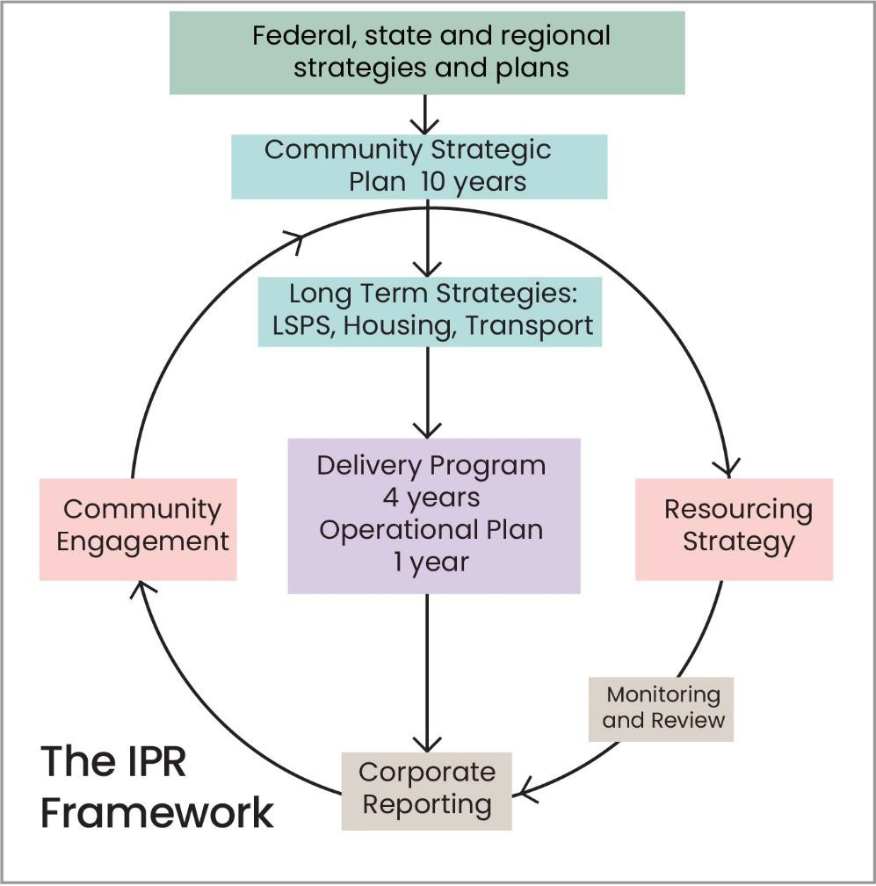

The purpose of the framework was to formalise strategic and resource planning across NSW councils and ensure long term planning is based on community engagement leading to a more sustainable local government sector.

Implementation of the Healthy Aging Strategy will be embedded in Council’s Integrated Planning and Reporting (IPR) Framework and timelines to ensure that priorities are included in the long-term planning and short-term delivery of Council’s projects and programs. Longer term outcomes will be in the high-level Delivery Program which is a four-year document that aligns with the term of the elected Council.

Each year priorities will be detailed as initiatives in Council’s one-year Operational Plan and these will be reported to Council and the community through the Quarterly Reporting process.

In addition to these actions, Council will also create efficient and effective measures and targets that will be used to demonstrate Councils’ progress against service delivery and will ascertain whether Council is moving towards or away from the communities’ priorities as outlined in the Community Strategic Plan – Our Inner West 2036.

Our Inner West 2036 strategic directions and priorities are:
- Creative communities and a strong economy
- Unique, liveable, networked neighbourhoods
- Caring, happy, healthy communities
- Progressive local leadership
- An ecologically sustainable Inner West

1 World Health Organization, Ageing: Health ageing and functional ability 2020 available at https://www.who.int/westernpacific/news/q-a-detail/ageing-healthy-ageing-and-functional-ability

