Loyalty Square, Balmain – Establishing an alcohol-free zone

  - Engagement Outcomes Report
  - 15 January – 19 February 2024

Contents
Summary 3
Project background 4
Promotion and engagement methods 5
Summary of feedback 7
Engagement method online survey 7
Engagement method email and phone 8
Engagement method submissions 9
Next steps 10

Summary

From 15 January to 19 February 2024, the community was invited to provide feedback on the proposal to establish an alcohol-free zone at Loyalty Square, Balmain.
Sixty responses were received via the online survey (55), email (4) and telephone (1) of which 90% were in support of the proposal. Throughout the exhibition period 746 people visited the Your Say project page.
The majority of comments received described that they had either experienced or witnessed anti-social behaviour which impacted their feelings of safety. Additionally, some contributors were in support of implementing a non-smoking zone and other measures such as the addition of CCTV and public domain improvements to improve the area.

Project background

Council is considering making Loyalty Square, Balmain an alcohol-free zone in response to community reports of anti-social behaviour. The initial period for the alcohol-free zone is 12 months. Council has received community reports about alcohol fuelled anti-social behaviour at Loyalty Square, Balmain. On 21 November 2023, Council resolved to prepare a proposal to establish an alcohol-free zone at Loyalty Square, Balmain and to publicly exhibit the proposal for 30 days.

Promotion and engagement methods
Promotion method | Stakeholders engaged
Project page on Your Say Inner West | 746 people visit the project page
Emails to key stakeholders | 630 registered members on the Your Say Inner West platform  Distribution to the Inner West Community Drug Action group (made up of community agencies, drug health, police and health providers)
Letters to residents and local businesses | 150 letters distributed to local residents in surrounding streets and businesses including local licensees
Council website - announcements | Notice on Council website

Community could provide feedback through online survey, by phone and via email
Engagement method | Stakeholders engaged
Online survey/social map/posts on ideas wall/quick pool | 55 surveys completed
Direct contact from residents | Four residents responded via email and 1 via telephone call

Who did we hear from?
Council gathers basic demographic information as part of the participant registration process online at Your Say Inner West. We use this information to understand who has responded and whether we need to engage further on the proposal.

Majority of contributors were between 35 and 69 years of age. The graph below shows the age range breakdown.

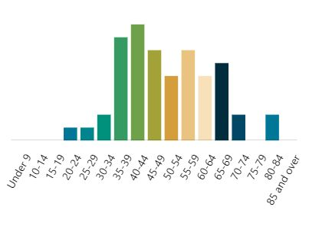
Majority of contributors were from Birchgrove (41).

Summary of feedback

Engagement method online survey

We asked | You said
Do you support the establishment of an alcohol-free zone at Loyalty Square? | 89.9% supported the establishment of the alcohol-free zone.

Do you support the establishment of an alcohol-free zone at Loyalty Square?
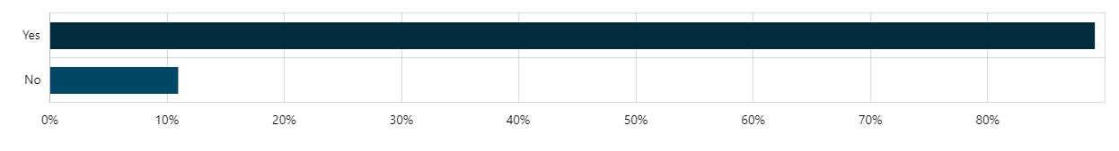

The table below also shows numerical responses to the survey question
 | Number or responses | Percentage
Yes | 49 | 89.09%
No | 6 | 10.91%
Total | 55 | 100%

Thirty-eight on-line respondents provided additional. The table below provides an overview of the suggestions and themes received.
You said | Council response
Examples of direct or witnessed experiences of anti-social behaviour (18) | Noted
Expressing direct support for the ban (12) | Noted
Requests for smoking ban (2) | Noted
Concerns about people with anti-social behaviour moving elsewhere (3) | Noted
Social support for the people with the anti-social behaviour (4) | Noted
Enforcement (3) | Noted
Requests for CCTV (1) | Noted
Improvement of the physical environment develop Darling Street Master Plan (garden beds, lighting, frequent cleaning, (4) | Noted
Not in support of Council intervention and band aid solution (3) | Noted

Engagement method email and phone

Council received four emails and one phone call and 100% were in favour of the proposal.
Four of the respondents provided additional comments. The table below provides a summary of these:

You said | Council response
Examples of direct or witnessed experiences of anti-social behaviour (3) | Noted
Did not feel safe (2) | Noted
The area is not clean | Noted
Police can not enforce | Noted
Redesign the area by removing seating and increasing planting (1) | Noted
Add CCTV (1) | Noted
Actively avoid the area | Noted

Engagement method submissions

One submission was received from NSW Policy Force Leichhardt Area Command. The submission was in support of the proposal.

Next steps
We will prepare a report that will include community feedback and will be considered by Council. Everyone who provided feedback will be notified when the report is considered by Council.

