Proposed permanent road closure Jaggers Lane, Balmain

  - Engagement Outcomes Report
  - 15 Nov 2023 – 22 Dec 2023

Contents
Summary 2
Project background 3
Promotion and engagement methods 4
Summary of feedback 5
Concerns and comments received from participants 6
Next steps 10

Summary

From 15 November to 22 December 2023, Council undertook Community Engagement to residents and businesses near Jaggers Lane inviting to provide feedback on a permanent closure proposal of Jaggers Lane between Duncan Street and Caroline Street, Balmain. A letter was posted to 323 addresses including the owners or residents of affected residents in Waterview Street, Colgate Avenue, Caroline Street, Duncan Street and Jaggers Lane.
In this respect, the community had the opportunity to provide their comments through the variety of methods including an online survey (Your Say Inner West), post, email and phone call.
Prior to the Council’s Community Engagement in November, a petition was submitted to Council in June 2023 requesting for a closure of Jaggers Lane, with 47 signatures. The petition included a proposal for a removable bollard which was to be used for emergency access if required.
At the completion of Council’s Community Engagement, a total of 31 responses were received.
The following criteria were adopted during the collation and tallying of the submissions:
- Each property counted as having one vote regardless of the method the engagement.
- Submissions from people who were neither the residents of the affected area (except owners) nor who did not provided their address were excluded.
- Duplicate votes, including multiple votes from one property have been excluded.
After applying the above, a total of 23 out of 31 submissions supported the permanent closure of Jaggers Lane, which represents a support level of 74.2%.

Project background
In June 2023, Council received a petition from residents requesting the closure of Jaggers Lane, between Duncan Street and Caroline Street, Balmain. The petition was submitted with 47 names and signatures and proposed a closure for motor vehicles in the laneway by installing removable bollards at each end of the laneway which may be removed for emergency access.
The petition prompted an investigation by staff and upon completion of the preliminary investigation, the Local Traffic Committee provided in-principle support and recommended that a Community Engagement be undertaken to gauge the level of support for the closure.
Council was aware of the several Development Applications of properties that would be affected by the permanent closure of the laneway, which were being assessed and incomplete at the time of this Community Engagement.
Jaggers Lane is a laneway comprising of a narrow width and the rationale for the road closure is due to the insufficient road width for pedestrians and vehicles to safety pass each other. Council’s proposed permanent closure will impact all vehicle access to the rear of properties to Jaggers Lane. Under this proposal bollards will not be removable and will only be used for pedestrian and bicycle access.

The proposed closure is shown below:
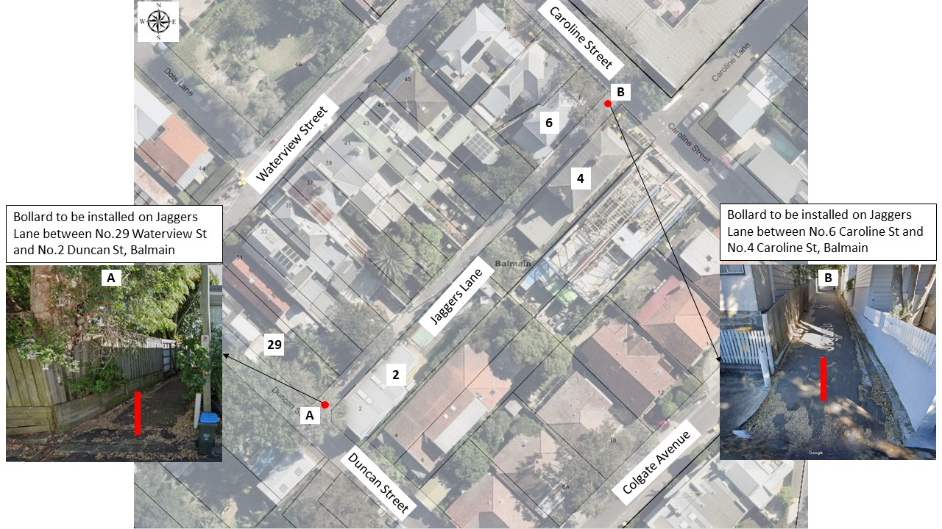

Promotion and engagement methods
From 31 votes received during the public consultation:
Engagement method | Stakeholders engaged
Online survey (Your Say Inner West) | 10 votes received
Email | 15 votes received
Phones | 6 votes received

Summary of feedback

The following criteria were adopted during the collation and tallying of the submissions:
- Each property counted as having one vote regardless of the method the engagement.
- Submissions from people who were neither the residents of the affected area (except owners) nor who did not provided their address were excluded.
- Duplicate votes, including multiple votes from one property have been excluded.
- Properties with multiple and conflicting votes (Yes and No) have been excluded.
Feedback received from the public consultation (31 votes):
We asked | You said | Percentage of response
The proposed permanent road closure in Jaggers Lane | Agreed with the proposal | 74.2% (23)
 | Disagreed with the proposal | 25.8% (8)

It should be noted that out of the original petition for the closure of Jaggers Lane, 28 petitioners were found to be eligible to participate in the survey. 21 petitioners completed the survey, and 7 petitioners did not participate in the survey.

Concerns and comments received from participants

Concerns received from the opposing votes:
We asked | Concerns | Council response
The proposed permanent road closure in Jaggers Lane | - The lane was closed for many decades  - Low traffic and low risk  - Less people using the lane way  - No frequent simultaneous use of the laneway by both pedestrians and cars  - No actual data or supporting evidence provided to sufficiently prove the safety issue in Jaggers Lane or the proposal will address the claimed issue  - Cyclist would not use Jaggers Lane | Although there have been no reported crashes between pedestrians and vehicles, the current road arrangement will have a risk of conflict.  Based on the recent traffic count collected in February 2024, average traffic volume along Jaggers Lane was very low.
 | - Closure will not improve the pedestrian safety as footpath connections are not well established at both ends | Both Caroline Street and Duncan Street feature footpaths on some sections and such pedestrians are expected to share the roadway in some sections.
 | - Increase traffic congestion on Waterview St and surrounding streets | The increase in traffic in the surrounding roads as a result of closing Jaggers Lane is not significant.
 | - Potential removal of parking of the affected residents | Noted
 | - Electric cars can be parked in Jaggers Lane | Noted. Parking is not permissible in the laneway as it will obstruct vehicular access for others.
 | - The laneway can be used during the renovation and maintenance | Noted. Parking is not permissible in the laneway as it will obstruct vehicular access for others.
 | - closure of the lane will hinder emergency vehicles and maintenance vehicles  - Residents currently use the laneway for deliveries, and to drop off items  - Waterview St is extremely narrow making it difficult to do simple things like dropping off residents or groceries | Noted
 | - Rather than two bollards placed one at each end of the lane, a single bollard can be placed in the middle of the lane.  - Instead of road closure, shared zone to be introduced  - “One Way” and “No Parking” signs can be erected instead of road closure | Installation of a single bollard, shared path, One Way sign and No Parking signs will not address the safety issues.
 | - Council intention to widen the access to Jaggers Lane from Duncan Street (referred to a DA for 2 Duncan Street) | Noted
 | - Potential for antisocial behaviour due to lack of visibility and surveillance  - If closed, Jaggers Lane would unlikely be maintained, weed growth unchecked, bitumen potholes, and potentially a dumping ground for rubbish | Noted
 | - Devaluing the affected properties  - Increase building and renovation cost due to lack of access.  - The road closure can impact the saleability of the affected properties | Noted
 | - Access to utilities including Sydney Water and Ausgrid will be impacted. | The proposal has been sent to several external organisations and utility companies for their feedback. The issues and comments have been listed and considered in the report to the Local Traffic Committee.
 | - Impact of rezoning: The NSW Government is set to rezone much of Balmain in order to encourage higher density, increase to density will result in further demand for on-street parking | Noted. There is no rezoning proposed.

Comments received from the supporting votes:
We asked | Comments | Council response
The proposed permanent road closure in Jaggers Lane | - The bollard to be removable when emergency/maintenance is required | The proposed bollards are permanent.  Removable bollards are not recommended as Jaggers Lane is a public road and no key or special access can be provided to affected residents.  In addition, installing removable bollards with key can make the closure ineffective as pedestrians are still exposed to vehicular traffic.
 | - The Lane is very narrow and was not designed for vehicle traffic  - There has never been access for private off-street parking from Jaggers Lane  - Not enough manoeuvring space at ends to access the laneway  - the continuing vehicle presence (developers/builders) and blocking the laneway  - The Lane is not wide enough to be a safe, shared vehicle/pedestrian zone  - There is concern about property damage in general as the lane is so narrow  - The Lane is used constantly by the larger community for all sorts of activities - walkers, parents with prams, cyclists, dog walkers, kids playing etc etc  - The Lane provides a safe means to manage waste and recycling bins  - The Lane provides safe access to the shops and transport at Darling Street  - There is no footpath on east side of Waterview Street between Duncan Street and Caroline Street, so the Lane is in effect the footpath for these residents  - The laneway provides an important pedestrian friendly arterial to Darling Street for the local community while Waterview St, the other partial alternative does not provide bike, pram or child friendly access  - The road closure proposal provides amenity value to the area  the use of Jaggers lane for motor traffic would require the removal of parking spaces at both ends (on Darling St and on Duncan Lane). The turning circle for vehicles emerging from the lane would not be large enough for a safe entry or exit unless 2 or 3 parking spaces were removed in both streets. | Noted.

Next steps
A report, including feedback from the community, will be considered by Council’s Local Traffic Committee on 18 March 2024. The Committee’s recommendations will then be considered by Council where a final decision will be made.
All community members who provided feedback will be advised if they are interested to attend the Traffic Committee.

