7 February 2024

<First and last name>
<Address 1>
<Address 2>
<Suburb NSW 1234>

Dear <name>

Have Your Say
Converting Lewisham Street, Dulwich Hill to one-way between New Canterbury Road and The Boulevarde

Council is proposing one-way conversion of Lewisham Street, Dulwich Hill between New Canterbury Road and The Boulevarde.

Background
The Dulwich Hill North Local Area Traffic Management (LATM) study adopted by Council in 2017, identified the narrow road width of Lewisham Street which makes it difficult for two vehicles to pass.

To manage the additional traffic, Council is proposing to convert Lewisham Street to one-way northbound between New Canterbury Road and The Boulevarde. This will require the following changes:

- A new concrete island on the northern side of Lewisham Street, just east of The Boulevarde. This will require the removal of one parking space on the southern side of Lewisham Street to ensure delivery vehicles can turn out of the adjacent driveway.
- A directional pavement arrow on Lewisham Street, just east of The Boulevarde.
- A ‘No Entry’ and ‘One-Way’ sign installed on the concrete island, facing north to enforce the one-way restriction.
- A ‘No Left Turn’ and ‘One-Way’ sign on the southern side of Lewisham Street, facing north at The Boulevarde.
- ‘No Stopping’ signs at the intersection of Lewisham Street and The Boulevarde to ensure compliance with the NSW Road Rules which prohibits vehicles stopping within 10 metres of the intersection of a road.
- ‘One-Way’ signs at the intersection of New Canterbury Road and Lewisham Street.
The diagrams below show the proposed changes
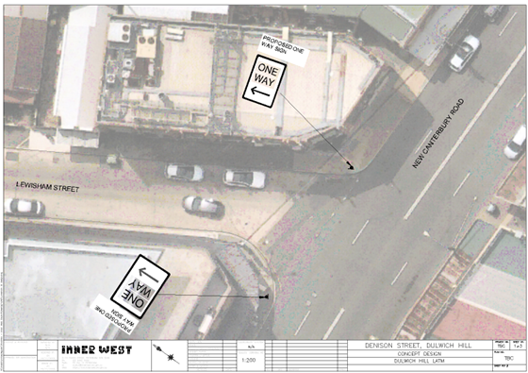
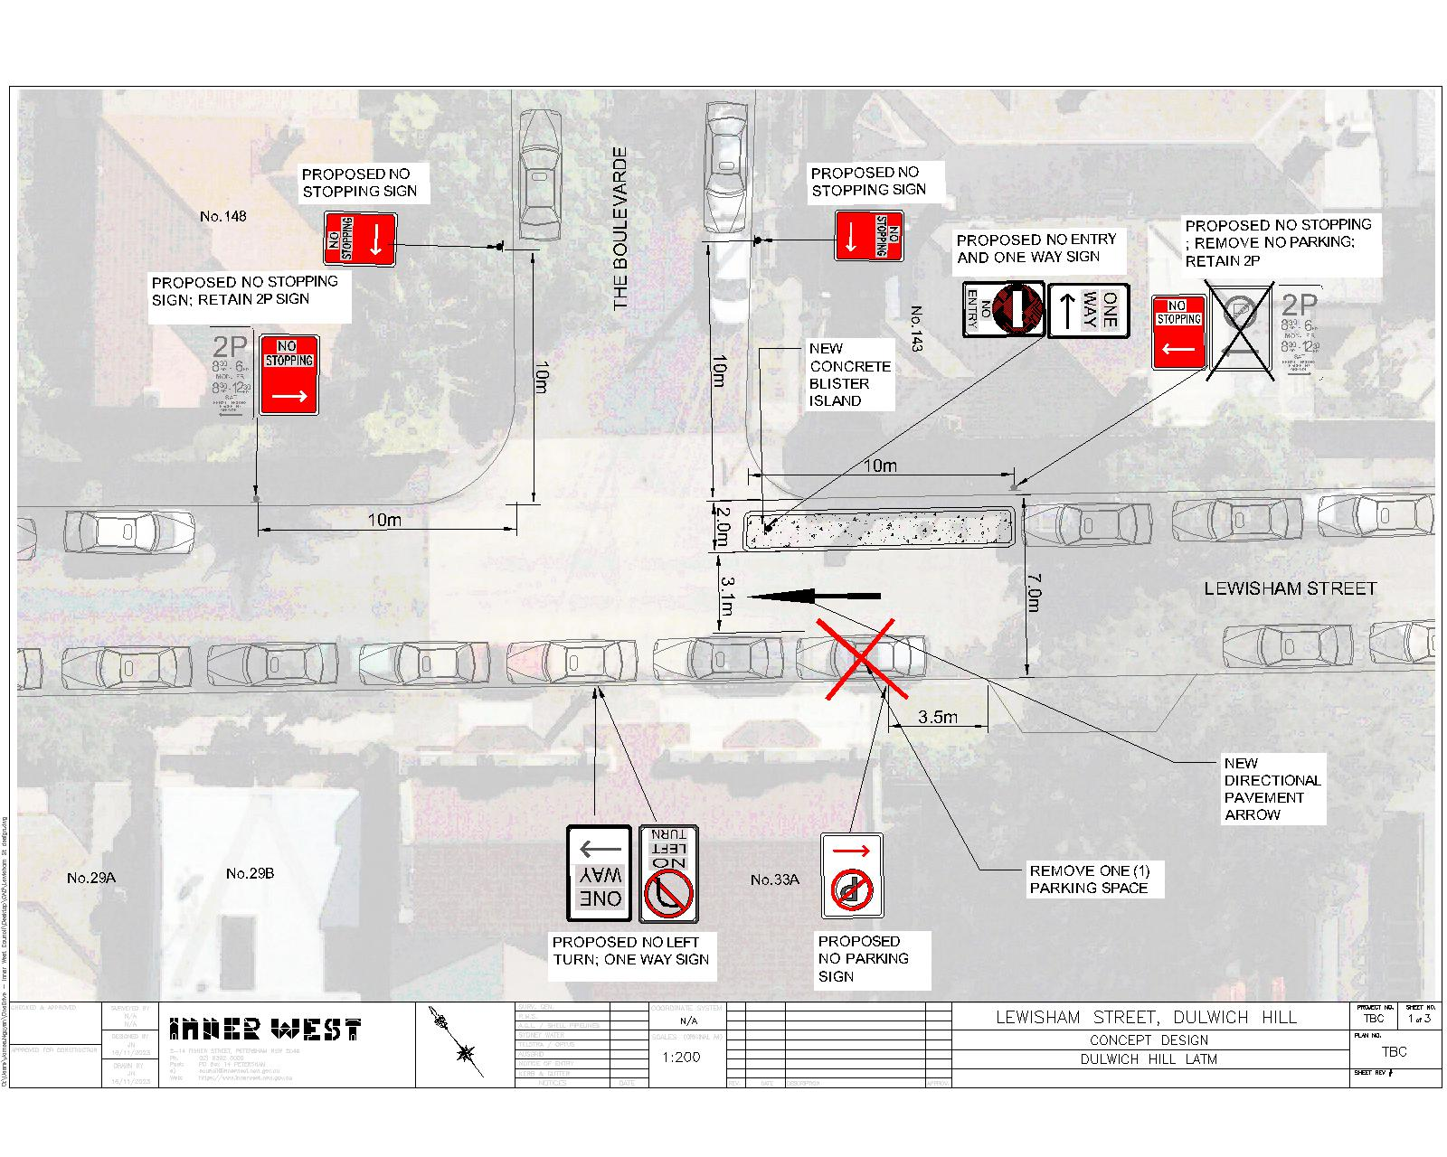

Have your say
Let us know your views on the proposal:
- Online at yoursay.innerwest.nsw.gov.au/localtraffic and click on the Lewisham Street, Dulwich Hill tile or scan the QR code below to head directly to the survey
- By post to Inner West Council, PO Box 14, Petersham NSW 2049 c/o James Nguyen
- By email to james.nguyen@innerwest.nsw.gov.au
- By phone contact James Nguyen on 9335 2278

Feedback closes on Wednesday, 6 March 2024.

What happens next?
A report, including feedback from the community, will be considered by the Local Traffic Committee. Everyone who provides feedback will be notified when the report is considered by the Committee.

More information
If you have any questions about this proposal, please contact Shirley Rodriquez on 9392 5705 or shirley.rodriquez@innerwest.nsw.gov.au.

Yours sincerely,
James Nguyen | Traffic Engineer

