Dear Resident/Business owner

HAVE YOUR SAY
Proposed alcohol-free zone at Loyalty Square, Balmain

Council is considering making Loyalty Square, Balmain an alcohol-free zone in response to community reports of anti-social behaviour.

On 21 November 2021, Council resolved to prepare a proposal to establish an alcohol-free zone at Loyalty Square, Balmain. The initial period for the alcohol-free zone is 12 months.

Have your say
Let us know your views on this proposal
- Online at: yoursay.innerwest.nsw.gov.au or scan the QR code below to head directly to the project page.
- By phone on 9335 2160
- By email Caroline.McLeod@innerwest.nsw.gov.au
- By mail to Inner West Council, PO Box 14, Petersham, 2049, attention to Caroline McLeod

Last day to provide feedback is Monday 19 February 2024

If you would like to receive a printed copy of the feedback form, please contact me on 9335 2160.
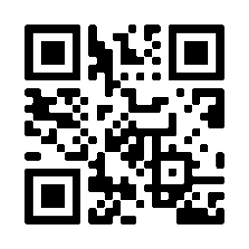

What happens next?
Council will consider a report including community feedback and decide whether to make Loyalty Square an alcohol-free zone.

Enquiries
If you have any questions about this proposal, please contact me by phone on 9335 2160.

Yours sincerely,

Caroline McLeod
Senior Manager Libraries and Community Wellbeing

