Aboriginal and Torres Strait Islander Procurement Strategy
September 2023
Council acknowledges the Gadigal and Wangal peoples of the
Eora Nation, who are the traditional custodians of the lands in which
the Inner West Local Government Area is situated. We celebrate the survival of Aboriginal and Torres Strait Islander cultures, heritage, beliefs and their relationship with the land and water.

We acknowledge the continuing importance of this relationship to Aboriginal and Torres Strait Islander peoples living today,
despite the devastating impacts of European invasion.
We express our sorrow for past injustices and
support the rights of Aboriginal and
Torres Strait Islanders to self-determination.
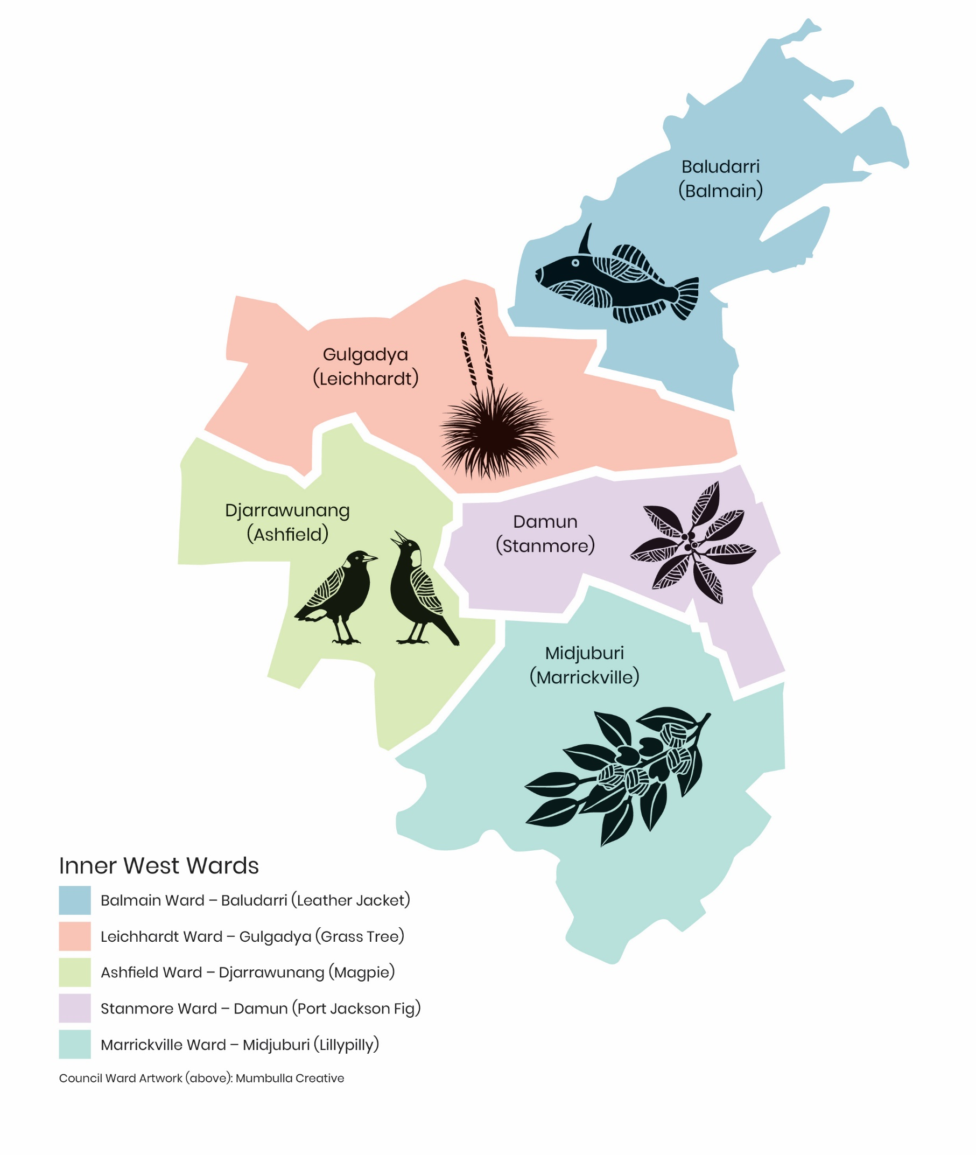

Aboriginal and Torres Strait Islander Procurement Strategy

Background:

Inner West Council (Council) is committed to supporting Indigenous communities and fostering economic development within the community, as evidenced in Council’s Aboriginal Economic Development Strategy and Reconciliation Action Plan. Council is keen to promote economic empowerment and building sustainable relationships with local Indigenous businesses and has prepared this strategy to outline how this will be achieved.

Our Purpose:

At Council our purpose is to be of service to our local community and make the Inner West a great place to be.

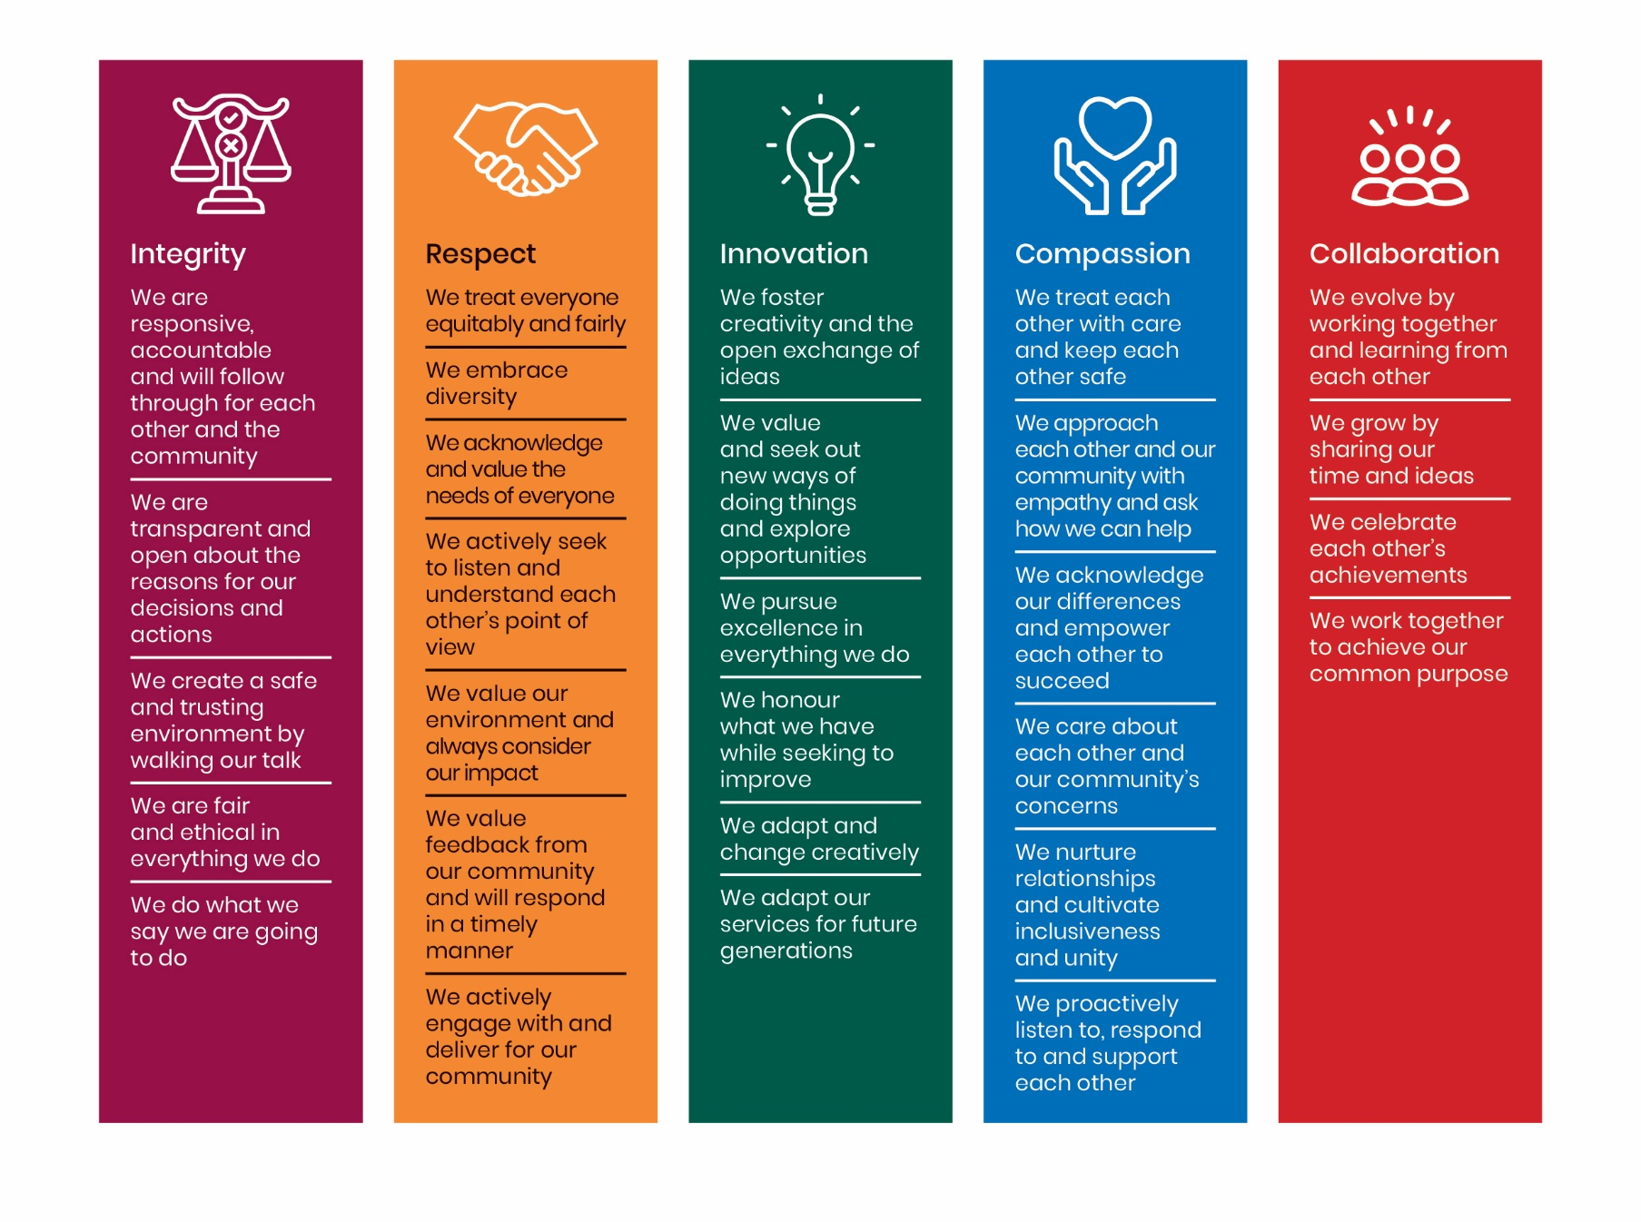
Our Values:

Community Engagement:
Council will engage with the local Aboriginal and Torres Strait Islander communities and the Metropolitan Local Aboriginal Land Council to understand their needs, aspirations, and priorities regarding economic development and procurement. Council will establish ongoing consultation mechanisms to ensure their voices are heard and supported through this strategy.

Capacity Building and Supplier Development:
Invest in initiatives that support the development and growth of Indigenous-owned businesses within the Inner West Council area. This will be achieved by working with and becoming members of organisations like Supply Nation and the Indigenous Chamber of Commerce. Our Procurement team will work closely with our Community Services & Cultural team to ensure we are communicating effectively with our local businesses.

Engagement Targets:
Set targets for Indigenous business participation in council procurement activities. These targets are realistic at 1% of total addressable procurement expenditure for verified Aboriginal or Torres Strait Islander Suppliers or products by 2025. In addition, inner West Council endeavour to have 1% of total contracts with Aboriginal and Torres Strait Islander businesses, considering the current market capacity and supplier base. Council will regularly monitor and report on progress toward meeting these targets, utilising tools like Supply Nation’s SpendTracker and Council’s dashboards.

Supplier Database:
Establish and maintain a database of Indigenous-owned businesses, including their capabilities, products, and services. A panel of suppliers will be created in VendorPanel and be identified in TechOne. This database will be easily accessible to council staff involved in procurement processes, enabling them to identify and engage Indigenous suppliers when relevant.

Awareness and Training:
The procurement team will conduct training sessions and awareness programs for council staff involved in procurement, highlighting the importance of Indigenous procurement and providing guidance on best practices. This education should encompass cultural sensitivity and understanding of Indigenous protocols and customs.
Partnerships and Collaborations:
Council will continue to foster partnerships and collaborations with other organisations and agencies that have expertise in Indigenous procurement, such as SSROC and Local Government Procurement. Collaborative efforts can help leverage resources, share knowledge, and amplify the impact of the strategy.
Monitoring and Evaluation:
Council will establish a robust monitoring and evaluation framework to assess the effectiveness of the Indigenous procurement strategy. Regularly review progress, identify areas for improvement, and celebrate successes. Council will use feedback from Indigenous businesses and the local community to refine and enhance the strategy over time.
Council will continue to seek feedback and input from Indigenous business owners and entrepreneurs to inform policy and program development.

Version Control – Strategy History:
Version | Amended By | Changes Made | Date | ECM Document #
1 | Marea Getsios  Manager Procurement & Contracts | New Strategy | September 2023
 | Endorsed by: | Notes: | Date | ECM Document #
1 |  |  | September 2023

