<8 November 2023>

HAVE YOUR SAY
Proposed permanent road closure Jaggers Lane, Balmain

Council has investigated pedestrian conditions in Jaggers Lane, Balmain. Jaggers Lane is a narrow lane and there is insufficient space for pedestrians and vehicles to safety pass each other.
Council is proposing a permanent closure of Jaggers Lane, between Duncan Street and Caroline Street, Balmain.
The proposed closure is expected to improve pedestrian safety.

What is included in this proposal?
The proposed closure will impact all vehicles including resident vehicle. Bollards at each end will be used to prevent car access and maintain existing connection for pedestrians and cyclist. The closure is outlined in the enclosed plan and is expected to improve road safety and pedestrian connectivity in the area.

Have your say
Let us know your thoughts on this proposal:
- Online via yoursay.innerwest.nsw.gov.au/localtraffic and click on Jaggers Lane tile or scan the QR code to overleaf head go directly to the survey

- By post to PO Box 14 Petersham NSW 2049 c/o Amir Falamarzi
- By phone on 02 9392 5627
- My email amir.falamarzi@innerwest.nsw.gov.au

Feedback Closes on Sunday, 10 December 2023.

What happens next?
A report, including feedback from the community, will be considered by Council’s Local Traffic Committee in early 2024. The Committee’s recommendations will then be considered by Council where a final decision will be made.

More information
If you have any questions about this proposal, please contact me by phone on 02 9392 5627.

Yours sincerely,
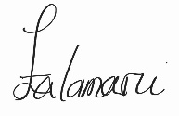

Amir Falamarzi | Traffic Engineer

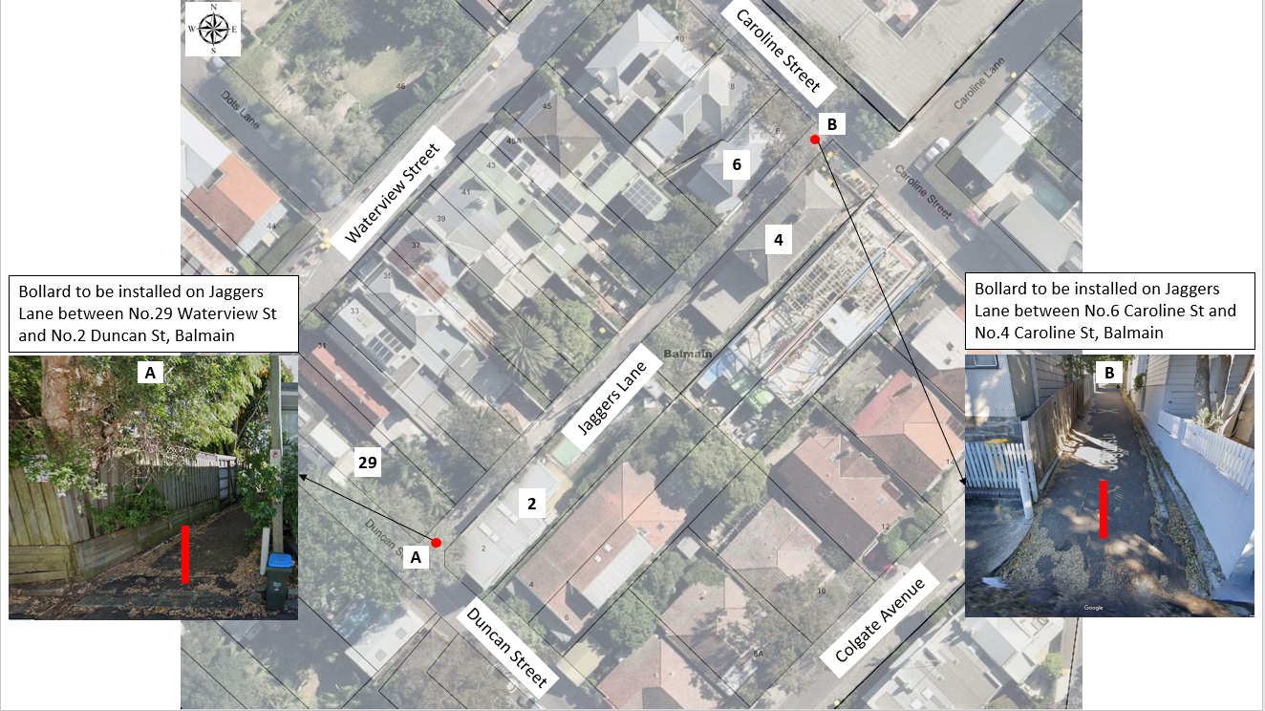
Proposed permanent closure of Jaggers Lane, Balmain

