Item No: C0823(1) Item 8
Subject: DRAFT ROZELLE PUBLIC DOMAIN MASTERPLAN - COMMUNITY CONSULTATION COMMENCEMENT
Prepared By: Daniel East - Acting Senior Manager Planning
Authorised By: Simone Plummer - Director Planning

RECOMMENDATION

1. That Council publicly exhibit the draft Rozelle Public Domain Masterplan for a period of 28 days and seek community feedback on the proposed Masterplan.

2. That following the conclusion of the exhibition period, the draft Rozelle Public Domain Masterplan be brought back to Council for consideration for adoption.

STRATEGIC OBJECTIVE

2: Liveable, connected neighbourhoods and transport

EXECUTIVE SUMMARY

The WestConnex Iron Cove Link tunnel is currently under construction and is expected to take approximately 50,000 vehicles a day off Victoria Road when it opens in late 2023. The Rozelle Public Domain Masterplan uses this opportunity to reimagine Victoria Road in Rozelle into an attractive boulevard and city gateway and further enhance the village atmosphere of Darling Street.

The Rozelle masterplan focusses on Victoria Road between Roberts Street and Terry Street (1.2km) as well as Darling Street between Cecily Street and Beatie Street (900m), which equates to a corridor area of almost 6 hectares.

Council officers are seeking to place the draft masterplan for community consultation.

BACKGROUND

In February 2023, early community engagement was conducted and an Engagement Outcomes Report has been prepared in Attachment 1. Early consultation included 4 pop up sessions that were attended by 460 people, 97 online survey responses.

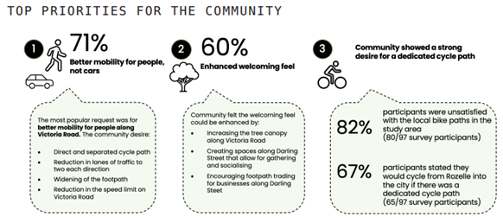
Figure 1: Key messages from community submissions were that there is strong support for creating an attractive village with an authentic character that is welcoming, vibrant and accessible to pedestrians with opportunities for street tree planting/ greenery.

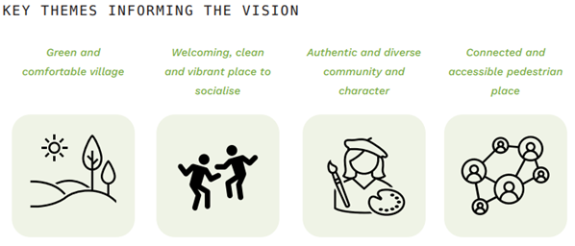
Figure 2: The Rozelle master plan has been developed in response to this engagement sentiment and key themes to inform the vision to address significant changes coming to the area, most significantly the WestConnex Iron Cove Link tunnel which is due to open in late 2023.

DISCUSSION

The draft master plan as contained in Attachment 2 proposes to create a platform for Council to advocate to TfNSW for changes in Rozelle that:

• Reducing Victoria Road to 2 lanes in each direction. Make safe and attractive pedestrian and cycle links along Victoria Road between Bays West and the Bay Run with new tree planting and water sensitive urban design (WSUD) infrastructure.

• improvements to Darling Street setting out expanded pedestrian spaces, new tree planting and a pedestrian oriented crossing of Victoria Road.

• reducing vehicle speed limits.

• improving pedestrian access through out.

• Various other improvements including active transport and gateway treatments.

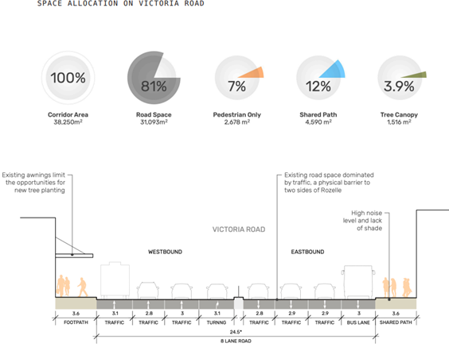
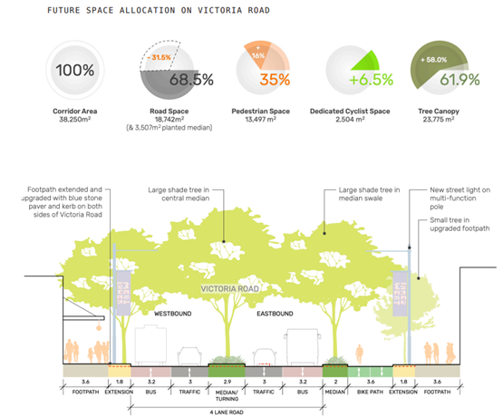
Figure 3 and 4: Existing and proposed road allocation space on Victoria Road.

This is demonstrated through applying the NSW Government Movement and Place policy and presenting sketch designs for an attractive streetscape that pedestrians are more willing to spend time within. The masterplan will inform the Transport for NSW (TfNSW) Road Network Performance Plan which, according to a WestConnex condition of approval, must be prepared prior to opening of the project at the end of 2023 and to current officer knowledge - has not been progressed to date. The scope of these changes are similar in ambition to many other places as seen across Sydney for example in Parramatta, George/Oxford Street and Circular Quay.

The masterplan also includes short term priorities that can be introduced relatively quickly when the Iron Cove Link opens as an interim measure before the full masterplan scheme is implemented including portable planter trees and barriers.

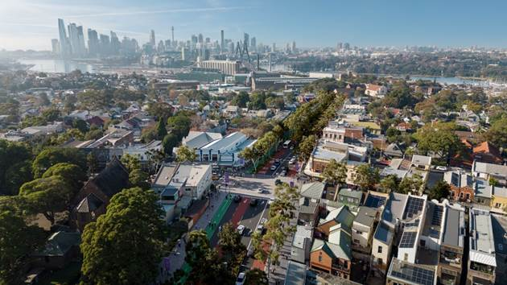

Figure 5: Photomontage of the proposed changes to Victoria Road looking east to the City.
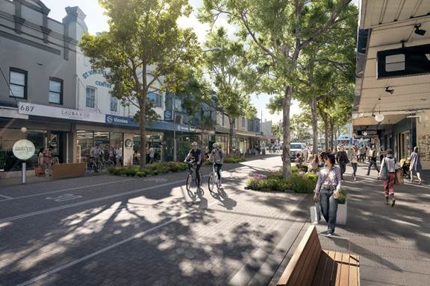

Figure 6: Photomontage of the proposed changes to Darling Street, Rozelle

FINANCIAL IMPLICATIONS

The Rozelle Public Domain Masterplan identifies the scope of long term capital improvements that may delivered by TfNSW, Council and private developers. The recommended master plan improvements will inform the future budget planning for Council’s capital works program.

