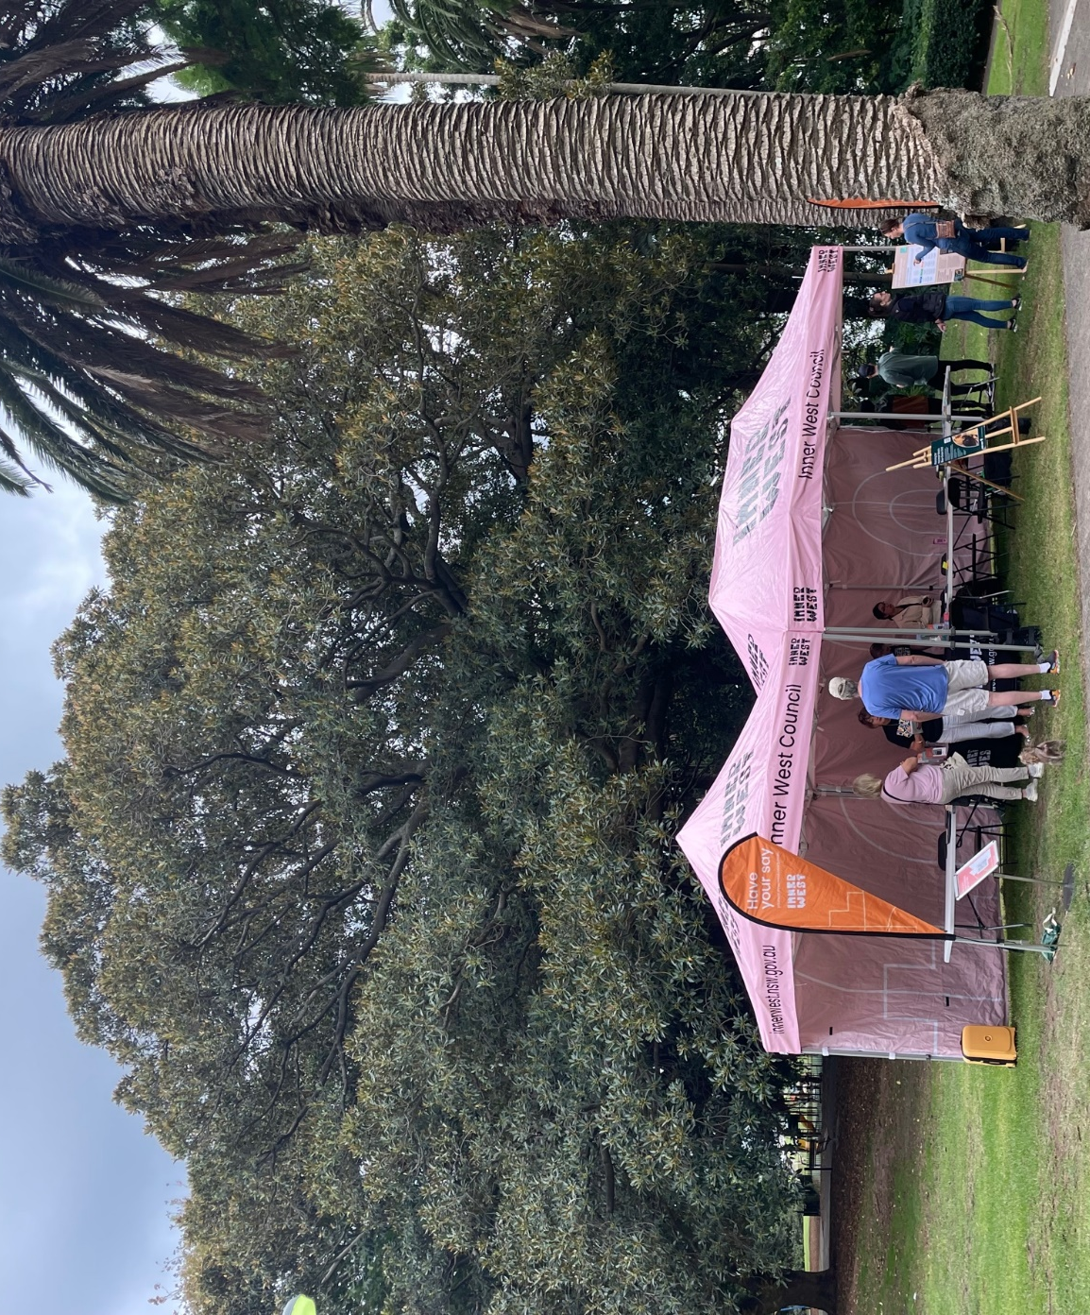

Engagement Outcomes Report

Blue-Green Grid Strategy

Stage 1 Community Consultation

Contents
Summary 3
Background 4
Promotion 4
Engagement methods 5
Engagement outcomes 6
Next steps 13

Summary
In line with the high level of support that was expressed by the community during the LSPS consultation, this project specific Blue-Green Grid consultation was warmly welcomed by all community members. At the highest level, the community praised the approach to increase the health of blue and green assets and broadly recognised that this network would provide a suitable opportunity for planning an efficient and effective active transport network.
The three most common themes captured across the engagement were:
1. Effective Active Transport Networks: Participants acknowledged the great work of delivering the network to date but wished to see pathways and active transport routes better equipped to handle capacity and diverse uses.
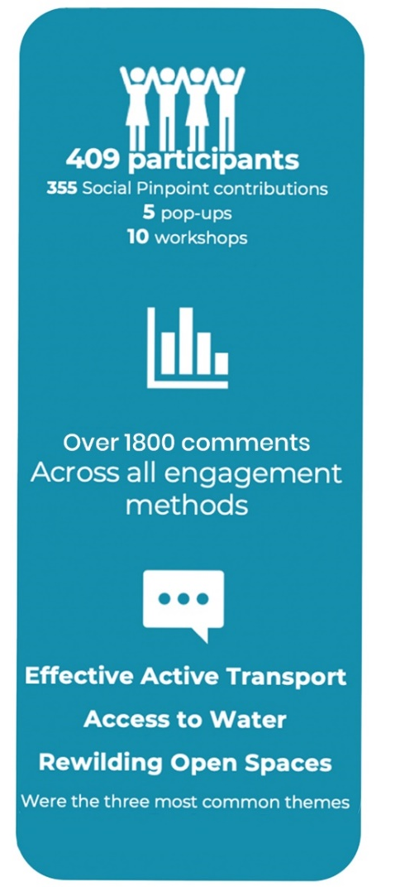
It was highlighted that speed was the number one barrier to encouraging new users to the network. Respondents stated that an effective network should identify the type of users that would utilise particular routes with the aim of catering for a broader range of needs through suitable separation or other safety measures.
2. Access to Water: Participants from all suburbs wished to see a long-term plan for enabling residents across the LGA to interact with the blue grid. In the short to medium term there is a common vision to naturalise the creeks and rivers in the LGA and activate the banks. In the long term, our community wish for more opportunities to swim within the Inner West.
3. Rewilding Open Spaces: Participants didn’t wish to simply see biodiversity increasing across the LGA but wanted the Strategy to take a considered approach on where and how these assets are delivered and maintained. The community want natural assets across the Inner West to remain for generations to come, despite our growing community. Our community commonly identified the opportunity for more dense and planned planting in open spaces that would not only increase biodiversity in our existing green spaces but enable the community to connect with nature.

Background
Inner West Council is developing a Blue-Green Grid Strategy (the Strategy) to create a network of blue and green connections across the Inner West to help improve accessibility, recreation, biodiversity and lifestyle for all. The Strategy will provide a plan for how Council can better connect areas of high environmental value, providing more viable areas of habitat and links to scenic landscapes.
The first stage of consultation took place between 16 March and 30 April 2023. Submissions from the community and stakeholder interest groups were received until 8 May 2023.
Community members, stakeholders and key collaborators were asked to provide comments and feedback through workshops, focus groups, pop-up sessions, interviews, online mapping tools and written submissions. The response level was inspiring, with the community presenting a clear set of values and priority directions to inform the next stage of the project.
The purpose of this report is to share the key insights and outcomes from the consultation activities that will be used to assist the project team with preparation of the draft Strategy.
Once drafted, Council will exhibit the draft Strategy for community feedback. It Is expected this will take place later in 2023.

Promotion
Community and stakeholders from across the Inner West and beyond Council's boundaries were informed of the Stage 1 engagement. Promotion was undertaken through:
- Council’s Social Media accounts (Facebook, Instagram, LinkedIn)
- QR Code corflute posters installed at open and green spaces across the LGA and along popular active transport routes
- Direct email to registered Your Say Inner West users
- Direct email to over 80 identified key stakeholders and community interest groups with an invitation to attend the focus groups
- Flyers distributed through Council’s Customer Service centres and at pop-up events held throughout the exhibition period

Engagement methods
This first engagement stage included a variety of engagement activities aimed at capturing input from a diverse representation of our community and interested stakeholders. Engagement activities included:
Engagement activity | Theme or location | Participation
Your Say Online Mapping Tool and Submissions | Your Say Inner West project page | 2,750 site views  1,154 visitors  94 participants making  355 contributions  25 written submissions
Drop-In Sessions | -Haberfield  - Marrickville  - Ashfield  - Balmain  - Camperdown | 158 attendees  372 Ideas and Insights for responding to Blue-Green Grid opportunities
Local Democracy Group Workshops | -Access Advisory Committee  - First Nations and Torres Strait Islander Advisory Committee  - Greenway Advisory Committee  - Environmental Advisory Committee  - All Local Democracy Group members interested in contributing to this project | 58 Participants  210 Contributions and In-depth discussion on responding to opportunities
Community Focus Groups | - Environmental Matters  - Active Transport and Recreation  - Arts, Culture and Community | 16 Participants  218 Identified places, spaces and ideas for investigation
Internal Council Staff Workshop | Face to Face | 24 Participants from Business Units across the Organisation  75 Partnership projects and initiatives identified
Collaborator and Partner Organisation Workshop | Online workshop with neighbouring councils, state departments, schools and infrastructure stakeholders | 41 participants  180+ Contributions and identified partnership opportunities

Engagement outcomes
Who did we hear from?
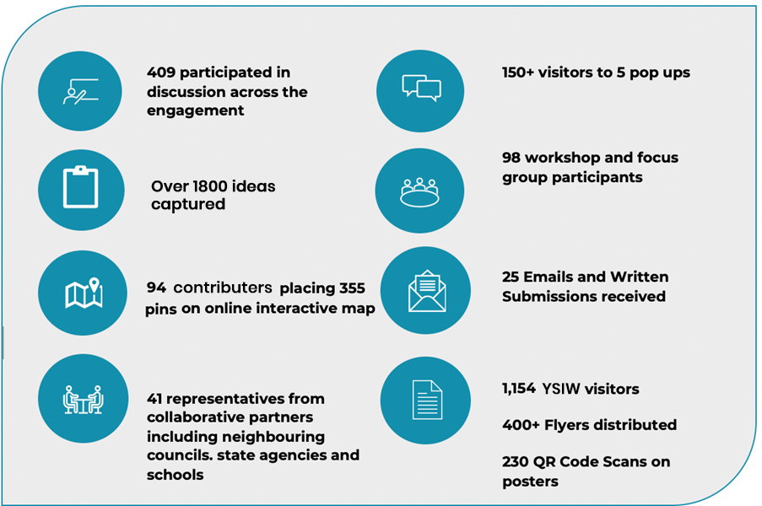

What did they say?
Your Say online mapping responses
The Your Say online mapping tool allowed the community to provide place-specific suggestions to be considered for the Blue-Green Grid. The suggestions provided by the community have been utilised in the development of Blue-Green Grid links and link opportunities.
Suggestions were broken down into five (5) categories: places you love, missing links, heat, environment/habitat and art and culture. The breakdown of online mapping comments illustrates the importance the community place on the Blue-Green Grid Strategy delivering mutually beneficial outcomes for both the environmental and active transport links in the LGA. A total of 55% of all pins placed on the map related to 'missing active transport links'.

Figure 1: Online mapping comments by pin category

Community Priorities – Emerging Opportunities
Participants were asked to explore how we can bring each of the eight Emerging Opportunities to life and the key concerns and considerations as we incorporate each into the draft Strategy. While the ideas varied greatly on how or where the emerging opportunities should be brought to life, the following opportunities were consistently highlighted as priorities.

The community and stakeholders consistently nominated a number of priorities in response to the eight Emerging Opportunities

Emerging Opportunity | Community Response
Provide more areas of natural habitat for native fauna | Engagement participants consistently reiterated the importance of considered planting of endemic species, not simply native species, to boost the ecology and health of natural habitats for native fauna.  Common areas for investigation included:  - Rewilding railways with native flora  - Identifying suitable plots within highly urbanised areas to create dense planting  - Upskilling community members to enable them to include native planting on private lands
Adapt to climate change – focusing on reducing urban heat and improving air quality | Engagement participants recognised the direct link between this opportunity and increasing tree canopy in the LGA.  Common areas for investigation included:  - Rewilding railway lines  - Focusing increased tree canopy efforts along active transport links  - Identifying opportunities for increased tree canopy in partnerships with local schools
Protect and enhance ecological communities | Engagement participants recognised weed control and bushcare knowledge as the key to succeeding in this priority. In addition, the need for limiting the human impact on vital ecological assets was widely recognised.  Common areas for investigation included:  - Identifying and protecting areas of particular ecology and biodiversity and limiting human interaction  - Community education and upskill programs on weed removal  - Upskill and education within Council’s maintenance team to assist in effective weed identification and removal  - Programming to increase Bushcare programs and their outreach
Increase access to recreational open space and waterways | Engagement participants consistently prioritised the opportunity to access green spaces in urban areas, and creating places to swim across the LGA. Participants wished to see urban greening projects prioritised in areas of higher density as a crucial element to increasing resident’s wellbeing. Those neighbouring the harbour wished to see greater access points while those within walking distance of the Cooks River wanted to see river health as a key focus to enable interactions within the water. Those without direct access wanted to see active transport links prioritised towards bodies of water.  Common areas for investigation included:  - Designating a harbour swimming site and providing appropriate infrastructure to enable access  - Increasing the health of the Cooks River to encourage interaction with the waterway  - Targeted delivery of green and open spaces in areas of high density  - Appropriate provision of off leash dog areas within public open spaces
Provide more routes for walking, cycling, and play along green leafy streets and pathways | Separated cycleways, roadways and footpaths was the number one priority captured across the entire engagement.  Participants recognised that the speed of cars was a crucial barrier to more people utilising cycling to travel across the Inner West.  Pedestrians recognised that the fastest user on any existing active transport route (including cyclists) was the greatest barrier for new users to feel safe on an existing pathway. Participants wished to see suitable separation between cycleways and roads, as well as creating separate cyclist and pedestrian pathways along common commuter cyclist routes.  Additionally, two of the top three most supported community comments highlighted the desire to see private developments extend and contribute to the green grid and active transport network. An example given by the community where this has been done well is within the Lewisham Flour Mills development.  Common areas for investigation included:  - Suitable separation of pedestrians and cyclists on shared paths  - Designated bike paths along streets greater than 40km/h  - Identifying key commuter routes for separated cycleways – as this removed the danger of cars from cyclists, and the danger of fast travelling bikes from pedestrian footpaths  - Crossing of Parramatta Rd and the WestConnex entry/exit points at both St Peters and Rozelle were two major barriers to creating a comprehensive network  - Widening of all current and future shared paths across the network  - Ashfield North, Marrickville, Leichhardt and Darling Street, Balmain were commonly identified key areas in need of new active transport links  - Continuing to leverage creek lines as green active transport corridors
Expand the urban tree canopy and areas of vegetation | Engagement participants commonly highlighted priority areas for increased tree canopy efforts. It was felt that the project should look to identify all possible areas across the Inner West that could accommodate significant tree planting in urban areas.  Common areas for investigation included:  - Partnerships with schools  - Identifying opportunities for verge gardens – creating a green trellis that spread from large open areas and green spaces, into the streets  - Identifying streets suitable for partial closure to create urban gardens  - Targeting the western and northern side of all active transport route to utilise increased tree canopy as a natural shade barrier for active transport users  - Targeting railway lines as green corridors
Incorporate more Water Sensitive Urban Design features into the landscape to better treat storm water, reduce flood risk and manage water quality | Engagement participants expressed a desire to re-naturalise creek lines and rivers across the Inner West.  Participants also wanted to see permeable surfaces included within urban areas to help in reducing flood risks and improve the health of waterways.  Common areas for investigation included:  - Naturalise waterways and canals across the Inner West, prioritising areas that intersect with open spaces and provide opportunities for the community to connect with the water  - Improving the health of the Cooks River by reducing dumping and increasing monitoring to identify run-off that is posing particular threat to the ecology of the river  - Naturalising the Hawthorne Canal  - Eliminating the use of pesticides in open spaces adjacent to waterways  - Increased recognition for restoring riparian zones and mangroves  - Address key flood zones along the Cooks River and Marrickville Golf Course
Promote art, cultural and scenic features | Engagement participants recognised that the Blue Green Grid was well placed to incorporate:  - First Nations Culture and Caring for Country  - Artists and arts sector  - The Inner West’s rich history, particularly highlighting the playful and interesting “tales” of residents and businesses from the past.  Participants wished to see the Strategy include a specific arts and cultural theme to help promote the area’s diverse range of arts and cultural offerings.  Common areas for investigation included:  - Engaging open space users into First Nations knowledge and learning  - Creating a focus on live performances at key points of interest included within the blue and green grid  - Embracing and emphasising the cultural practice of connecting to water and nature, and opportunities to do this through both play and tranquillity

Next steps
The feedback gathered from the first round of engagement will help to ensure that the planning and design of the Blue-Green Grid Strategy is grounded in community aspirations and values. The outcomes from the consultation will be used to inform and guide the technical project team as they work to create a first draft of the Inner West Blue-Green Grid map and Strategy.
The next step for the technical project team is to prepare detailed mapping of where the blue and green grid will connect to and from. The team will be giving valuable consideration to the community’s feedback in addition to a technical evidence base to assist with them with the mapping process. Once developed, the map will serve as the basis for development of a draft Strategy.
There will be further opportunities for the community to provide valuable feedback to Council on the identified routes and potential opportunities for route improvements as identified in the draft Strategy. It is anticipated that the draft Strategy including mapping will be placed on public exhibition later in 2023.

