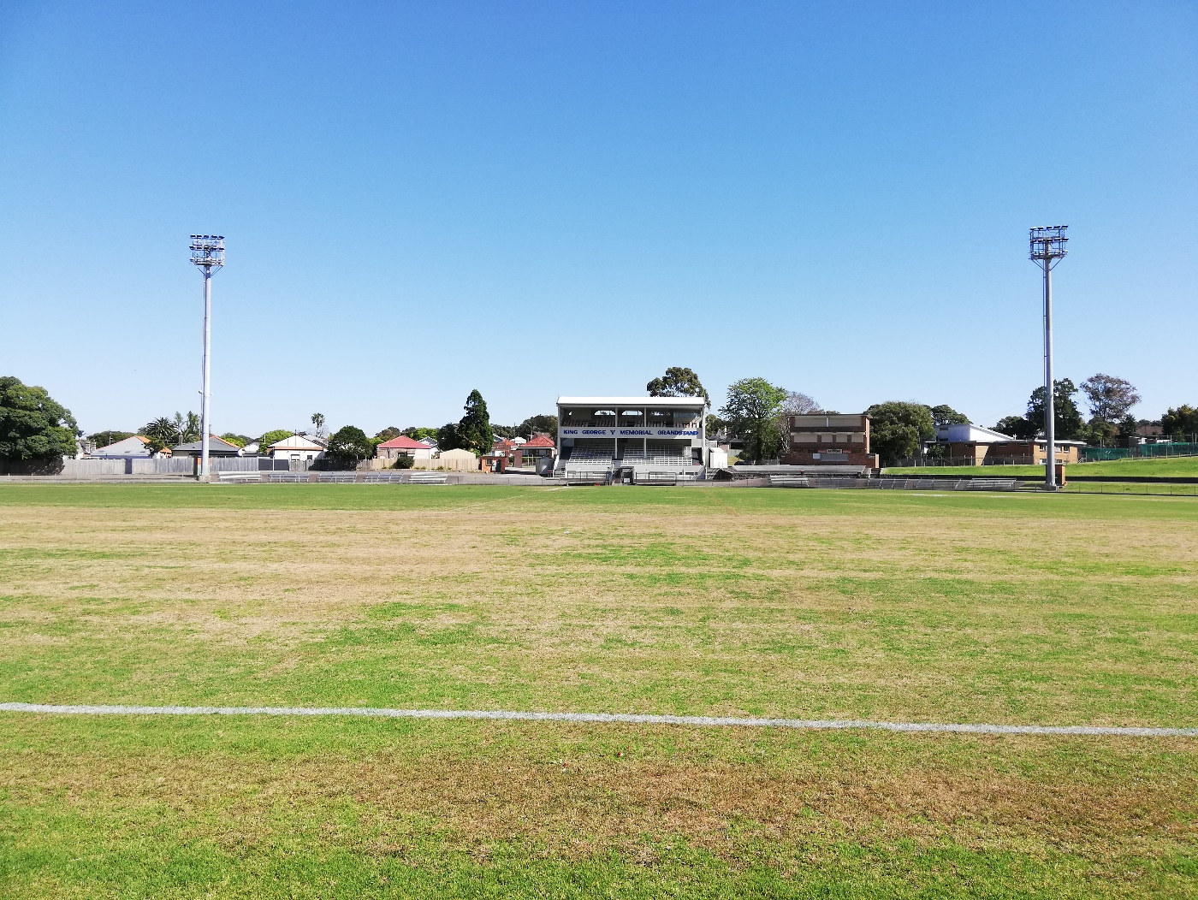

Engagement outcomes report

Henson Park Plan of Management

Contents
Summary 3
Background 3
Engagement Methods 3
Promotion 3
Engagement outcomes 4
Officer comments 5

Summary
The engagement was conducted by Council for the amendments proposed for the Henson Park Plan of Management which has been adopted by Council in 2021.
The engagement opened on Your Say Inner West Council's digital engagement platform on 10 August and closed on 22 September 2022.
There were 670 visits to the Henson Park project page, 130 downloads of the documents, and three written submissions made. Eighty seven and half percent (87.5%) of the visits to the page was direct visits by user entering the exact web address.

Background
The Henson Park Plan of Management was adopted by Council in 2021. Previous community engagement was undertaken for the preparation of the Plan of Management.
Due to proposed amendments, the Plan of Management was exhibited and community engagement was conducted again.
The two proposed amendments are:
- Authorisation of leases and licences for future potential sports use
- Protection of Amy Street footpath

Engagement Methods
- Online on yoursay.innerwest.nsw.gov.au

Promotion
- Your Say Inner West
- Council website
- Onsite posters

Engagement outcomes
- Online via yoursay.innerwest.nsw.gov.au
Three responses to the survey were received. Among the three submissions, one supported the amended plan, one did not support the amended plan, and one chose ‘unsure’.
Two of the three submissions were made as an individual, and one correspondent was on behalf of an organisation/ business.
Two of the submissions made comments, however the comments were not relevant to the amendments to the Plan of Management.

Officer comments in response to public exhibition

Number # | Submission Detail | Support/Non-Support | Council officer Response
1 | Noise Concerns  Could you please turn the horn down during games? The sound is extremely irritating and it goes all day and for the whole weekend sometimes. In real world, some of us work night shifts and it would be grateful appreciated of you could take this into consideration. | Non Support | This submission is an operational matter and does not relate to the amendments made by Council to the Plan of Management.  The horn is used by rugby league and AFL to signal the start and finish of playing periods. This is the practice at all games.  Council officers will request that the volume of the Horn is reviewed.
2 | Environmental Impacts  I see nothing addressing this from the Statement of Environmental effects: DRM considered that that the site contains contamination that could pose an unacceptable risk to human health and that further assessment and appropriate remediation is required to render the site suitable for ongoing use as Open Space Recreational land use. | No | This submission does not relate to the amendments made by Council to the Plan of Management.  Environmental management of the park during any approved construction works is subject to the conditions of Development Consent.
3 | No commentary | Yes | Support noted.

