11 August 2022
SJ:MW: 36682493

<First last name>
<Address 1>
<Address 2>
<Suburb NSW 1234>

Dear Resident/owner
Have Your Say – Improving safety and calming traffic in Tempe South
Re-exhibition of Local Area Traffic Management (LATM) Study
In January 2021 Council completed the public exhibition of the draft Tempe South Local Area Traffic Management (LATM) Plan to address key matters relating to traffic, walking and cycling in Tempe South. Using feedback from the earlier public exhibition, a revised version of the LATM report is ready for community comments.
Most of the proposals were generally supported by the community from the previous engagement and Council is seeking further feedback on three treatment proposals below.
- Left and right only treatment from Smith Street to Union Street proposal
Based on feedback from Union Street residents, Council proposes to impose a ‘soft closure’ of Union Street by signage from Smith Street to Union Street. This will minimise through traffic on Union Street. This will require northbound traffic from south of Princes Highway to be diverted to Holbeach Avenue or other streets in the area.
- Brooklyn Street – permanent road closure at laneway
The above proposal (1) also has potential to divert traffic to Brooklyn Street to access Union Street, hence a permanent road closure in Brooklyn Street is also proposed. This road closure could be implemented as a full road closure or a partial ‘exit only’ road closure. A road closure is recommended to be implemented together with the restrictions at Union Street.
- Traffic calming in Union Street
There are two options available for calming traffic in Union Street, these are:
- 10km/h Shared zone proposal (from Princes Highway to School Lane)
- Two (2) flat-top speed humps

Have your say
Let us know your views on the proposed draft Plan:
- Online at: yoursay.innerwest.nsw.gov.au
- By mail: addressed to Inner West Council, PO Box 14, Petersham, 2049. Please mark your feedback with reference – Tempe South Traffic Study 36682493.

Last day to provide feedback is Thursday 8 September 2022.

Further information
If you require a paper copy of the survey, plans or for further information please contact Mr Sunny Jo on 9392 5965 during business hours.
Sincerely,
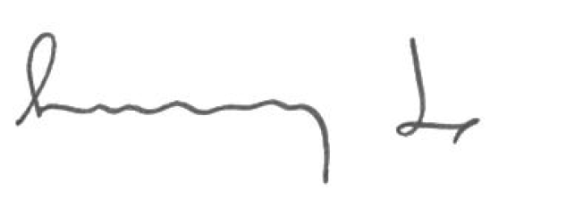
Sunny Jo
Coordinator Traffic Engineering Services

