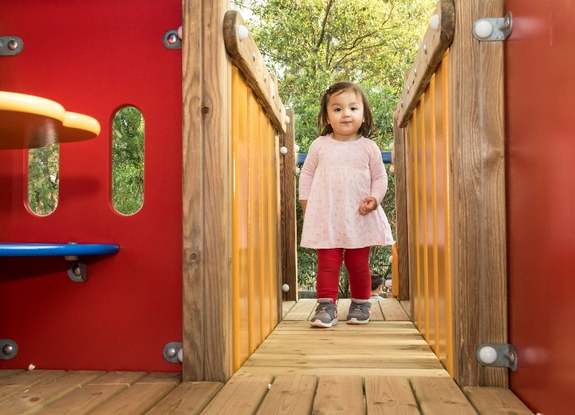

Engagement outcomes report

Gladstone Park Playground Upgrade

Contents
Summary 3
Background 3
Engagement Methods 3
Promotion 4
Engagement outcomes 5
Who did we hear from? 5
What did they say? 6

Summary

Feedback to upgrade Gladstone Park playground was sought from the community between 13 February and 14 March 2021.

The project was promoted via letters to residents surrounding the park, YSIW e-newsletter, onsite posters and Council’s website.

The community could influence the type of equipment in the playground. Insights about how often participants visit the playground, their own / their children’s age groups were also sought to ensure an age appropriate solution is chosen.

There are a total 680 visits to the Your Say Inner West project page, out of which 235 participated. There were 5 responses via email. All responses are included in this report.
Feedback demonstrated that this is a popular playground with most participants visiting weekly, with some daily during school days. Children of all ages use the playground with the most common age groups being 4-7 years old, followed by 0-3 years old and 8-12 years old.

- 4-7 (136 participants)
- 0-3 (128 participants)
- 8-12 (80 participants)
- 35-49 (16 participants)
- 13-17 (5 participants)
The top three play equipment options selected are:
- Multiplay unit (200 participants)
- Natural play (109 participants)
- Imaginative play (99 participants)

Background
Based on Park Assets prioritisation, Gladstone Park playgrounds are due for an upgrade. The current play areas are in two separate areas, near Eaton Street and Darvall Street. The Eaton Street equipment which are in good condition are proposed to be retained.

The swings and climbing blocks in the Eaton Street playground are proposed to be retained. We asked the community what kind of play opportunities they would like to see and to identify the type of equipment/play activities they would like for the two playground areas.

Engagement Methods
The community could provide feedback via:
- Your Say Inner West
- Email
- Phone (including via the National Relay Service for TIS National)

Promotion
The engagement was promoted through:
- Social media
- Direct email
- Resident letter drop
- Onsite posters
- YSIW E-newsletter
- Council website

Engagement outcomes
Who did we hear from?
There are 134 participants from Balmain, 47 from Rozelle, 29 from Birchgrove, 8 each from Balmain East and Lilyfield, 2 each from Ashfield, Marrickville, Drummoyne and Annandale, 1 from Petersham, Dulwich Hill, Glebe, Forest Lodge and Pyrmont.
Graph showing responses to the question about Suburb of residence.

The majority of participants identified as visiting the park weekly (171 respondents) or sometimes (a few times a month, 61 respondents). In total, only 8 participants identified as never coming to the park or rarely visiting.
Graph showing responses to the question ‘How often do you or your children visit Gladstone Park?’

What did they say?

When asked ‘how old are you or the children you take to Gladstone Park?’ the top responses were:
- 4-7 (136 participants, 2 email participants)
- 0-3 (128 participants, 2 email participants)
- 8-12 (80 participants, 2 email participants)
- 35-49 (16 participants)
- 13-17 (5 participants)

There is one user in each of the age groups of people in their mid-twenties to mid-thirties, fifties, and seventies.

Graph showing responses to the question ‘How old are you or the children you take to the playground?

When asked to choose three pieces of equipment that they would like to see at Gladstone Park, the top three were:
- Multiplay unit (200 participants)
- Natural play (109 participants)
- Imaginative play (99 participants)

Other popular play activities are:
- Climbing (90 participants)
- Slide (65 participants)
- Monkey Bars (52 participants)

Graph showing responses to the question ‘Choose three pieces of equipment you’d like to see in this playground’

Other feedback include:
- Water play (33 participants)
- Separated toddler’s area (7 participants)
- Trampoline (exercise suitable for all ages and abilities - 5 participants)
- Zipline (3 participants)
- Double slides (3 participants)
- More swings/swing for toddlers (3 participants)
- Toddlers see-saw/rocker (2 participants)
- Roundabout/spinner (2 participants)
- Sand play (2 participants)
- Sensory touch and play for toddlers (2 participants)
- Circuit for bike and scooters (2 participants)
- Open soft area for young children (2 participants)
- Teenager activities (3 participants)
- Lack of more challenging play elements for older children (4 participants)
- Retain/create diverse range of play equipment for different age groups (3 participants)
- Improve Darvall Street play area with shade and to include older children play activities (2 participants)
- Exercise equipment suitable for play (over 8 years old) eg. bars, climbing frames and steps (2 participants)
- Plant more trees (5 participants)
- More seats for parents and carers (3 participants)
- Rubbish bins (3 participants)
- Retain all the green space and keep new equipment in current playground areas (1 participant)

Officer comments
We will incorporate the ideas into the design brief where possible taking into account budget and practical considerations.

Issues raised that are beyond the scope of this project include:
- Fencing for toddlers play area (29 participants)
- Review the basketball areas (5 participants)
- Increase the footprint of the play areas as the volume of children using the playground after school is overwhelming for the playground (2 participants)
- Lighting (1 participant)
- More shade needed (9 participants). This will be noted for future shade sail reviews.
- Review of toilet amenities (16 participants). This will be passed to the Planning team for consideration.

