3 June 2021

Resident
Add
Add

INVESTIGATION OF RESIDENT PARKING SCHEME - ROZELLE
Last year Transport for New South Wales undertook a community engagement to seek residents’ view in a proposal to implement an area-wide Resident Parking Scheme (RPS) following concerns from residents regarding the parking situation exacerbated by WestConnex Rozelle Interchange works. The proposal did not receive support from majority of the residents and hence was not implemented.

Council has continuously received requests from residents in Foucart Street, Hutcheson Street, Alice Street, Denison Street in Rozelle to address concerns with long stay parking by non-resident vehicles near the WestConnex Rozelle Interchange work sites.

Parking occupancy surveys were undertaken in the precinct, bounded by Foucart Street on the west, O’Neill Street and Easton Street on the north, Denison Street on the east and Lilyfield Road on the south (as shown in the figure below) indicated high parking occupancy levels (above 85%).
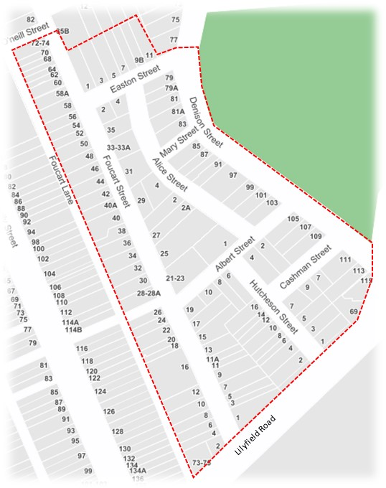

Subsequently, the precinct may benefit with the introduction of Resident parking Scheme (RPS). It is proposed to implement RPS with the parking restriction of ‘2P 8am-6pm Permit Holders Excepted Area R1’ in the local street and time-restricted parking in Denison Street frontage of Easton Park ‘2P 8am-6pm Mon-Fri, 4P 8am-1pm Sat’. The proposal is shown in the plan enclosed.

As part of the proposal, 10m ‘No Stopping’ zones must also be installed at all intersections (as per NSW Road Rules) if the restriction is not already existing. Existing parking restrictions such as mobility parking zone, time-restricted parking, No Parking and No stopping zones will remain in place.

Please note the following guidelines which are part of the Council’s Resident Parking Policy:
- A minimum of 50% support from properties in the subject section are required for consideration to implement a RPS. Each property will be entitled to a single preference only – please note that multiple submissions will be counted as one.
- Eligibility for resident parking permit is as follows:
No. of off-street parking* spaces on the property | No. of vehicles registered at the property | No. of resident parking permit eligible
0 | 1 | 1
 | 2 or more | 2
1 | 1 | 0
 | 2 or more | 1
2 or more | 1 or more | 0
- One visitor parking permit will be offered per eligible property.
- Dual occupancies, multi-unit dwellings and the strata subdivision of residential flat buildings approved after January 2001 are not allowed to participate in a RPS as off-street parking should be provided in accordance with Council’s parking development control plan (DCP).
- Parking permits are not available for boats (on trailers), box trailers, caravans, buses and trucks (i.e. vehicles greater than 3 tonnes GVM).

Have your say
Prior to making a decision, Council is seeking your views. Please provide your feedback:
- Online via yoursay.innerwest.nsw.gov.au/localtraffic.
- By post to PO Box 14 Petersham NSW 2049.
If you would like a paper copy of the feedback form mailed to you or provide your feedback over the phone, please contact me on (02) 9392 5238.

Feedback closes on 5pm Friday, 25 June 2021.

What happens next?
If supported, a report outlining feedback from the community will be considered by Council’s Local Traffic Committee. The Committee’s recommendations will then be considered by Council where a final decision will be made.

More information
Should you require any further information, please contact Council’s Traffic Engineer, Felicia Lau on (02) 9392 5238.

Sincerely,
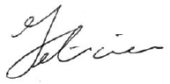
Felicia Lau | Traffic Engineer

