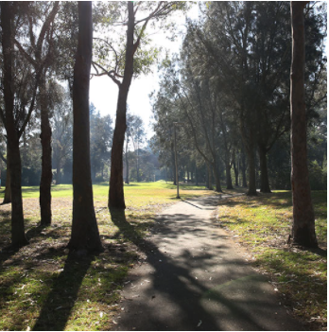

Engagement outcomes report

Making Whites Creek Valley Park accessible for all

Contents
Summary 3
Background 3
Engagement Methods 4
Promotion 4
Engagement outcomes 5
Who did we hear from? 5
What did they say? 7
Officer comments in response to public exhibition 7

Summary
Community feedback was sought between 21 May and 18 June 2021 regarding a proposal to reclassify the off-leash area of Whites Creek Valley Park.
The following community input was received over a four week period:
- Online by filling in the feedback form - 187
- Emailing the Coordinator Parks Planning – 1
- Emailing the Engagement Coordinator - 1
- Mailing the Coordinator Parks Planning – 0
- Telephoning the Coordinator Parks Planning including free interpreter or National Relay Services – 0

The project page on YSIW received 504 visits, 281 people performed a further action on the page such as downloaded a document and 187 submissions were received.

Of those who submitted online, 159 were in support of reinstating the open space section of the park between Piper Street to Brenan Street to off- leash, 22 were against the proposal and 6 were not sure/neutral.

One email received was in support of maintaining the area as on leash rather than reverting part of the park back to off leash.

Emails were sent from one resident to Council’s Engagement coordinator with ‘concerns the community’s preference is not being acknowledged’ and concerns about the engagement process throughout the timeline of the issue.

Background

In October 2020 Council resolved in a confidential session to revoke the existing declaration in respect of the public off-leash walkway (in Whites Creek Valley Park) which runs the length of Piper Street to Brenan Street and reinstate this area as an on-leash walkway.
Concerns were originally raised about the impacts of walkway of the park being used as an off-leash area including that it may discriminate against a resident with dogs whose property adjoins the off-leash area. Additional details of the complaint were provided in a Confidential Attachment to the original report in October 2020.
Subsequently Council received a petition of 988 signatories requesting that Council reconsider this issue and revert the entire area back to an off-leash area for companion animal exercise and socialisation.

Compromise Option
Council officers carefully reviewed the companion animal restrictions in this area of the park and recommended that a compromise resolution to this issue is adopted whereby the adjoining open space which runs adjacent to the path area is designated as off leash up to the point where the pathway joins the open space and this area is retained as on leash.
This compromise position addresses in part the issues highlighted by the petition signatories while ensuring that Council is complying with its obligations under the Disability Discrimination Act as the area immediately adject to the housing zone is maintained as on leash.
Council officers discussed the proposed reclassification with the resident who raised the concerns and have been advised that they are supportive of the proposed changes and recognises that a compromise is required to address community concerns.
On 9 March 2021 Council resolved to engage the community on the comprise solution.

Engagement Methods
The community was invited to provide feedback via:
- Your Say Inner West through an online feedback form
- Email
- Phone (including via the National Relay Service for Translating and Interpreting Service)
- Mail

The community was provided access to a Report to Council – 9 March 2021 and map of the Proposed Companion Animal Zones Whites Creek Valley Park. The community was also notified they could obtain a hardcopy of the proposed map and provide feedback by contacting a named officer.

Promotion
The engagement was promoted through:
- Council website
- Onsite posters
- Resident letterbox drop
- Council e-newsletter
- Inner West Pets Facebook group (run by Council’s Companion Animal Services team).
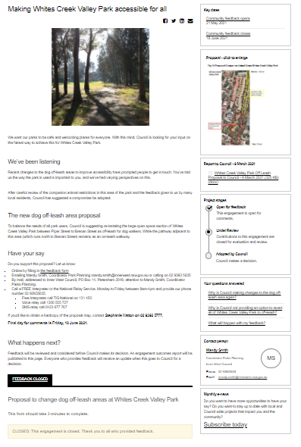

Engagement outcomes

Who did we hear from?
Of those who contributed to the survey, 137 were residents with a companion animal, 43 residents, 8 visitors to the park and 3 did not specify their relationship to the area.

What did they say?
- Online via yoursay.innerwest.nsw.gov.au

Of the 187 participants on the online survey, 159 were in support of the open space section of Whites Creek Valley Park between Piper Street to Brenan Street be reinstated as off leash for dogs. 22 were opposed to the change and 6 were not sure or neutral in their response.
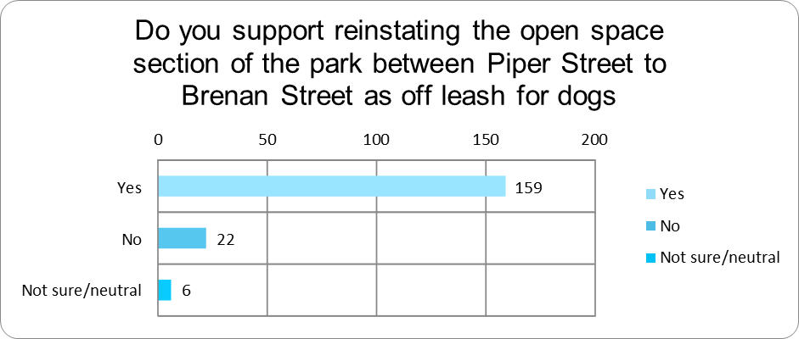

Support analysed by identifying category
Do you support the proposal? | Resident with companion animal | Resident | Visitor
Yes | 125 | 26 | 7
No | 11 | 10 | 1
Neutral/unsure | 2 | 4

Comments
In total, 104 people out of 187 provided comments in the survey.
Key themes:
Comments from those in support of proposal:
- Would like to revert to the original status of the whole of Whites Creek being off-leash (19 respondents).
- Believed the compromised proposal was a pragmatic solution (14 respondents).
- Think there should have been community consultation before the initial change (12 respondents).
- Are concerned that not all perspectives were heard before Council’s decision was made (5 respondents).

Comments from those not in support of the proposal:
- Would like clear signage to indicate the change to off/on leash areas within the park (4 respondents).
- Worried about public safety particularly for young children, elderly or those with disabilities when dogs are allowed off-leash (4 respondents).
- Think the off-leash areas should be fenced off (3 respondents).
- Feel safer when walking or cycling along the pathway knowing dogs would be on-leash (3 respondents).
- Believe when dogs are allowed to roam freely owners are less likely to clean up the dogs’ mess (3 respondents).
- Believe there are too many parks in the Inner West dominated by dogs and don’t feel there is enough space for free exercise or other leisure activities (3 respondents).
- Worried about the threat to native wildlife posed by dogs roaming freely (3 respondents).
- Concerned about the safety of smaller/more timid dogs in off-leash areas (1 respondent).

In addition, comments were raised about the need for:
- Better lighting along the Whites Creek pathway to improve safety (2 respondents).
- Council enforcement of the on/off-leash areas (3 respondents).

Officer comments in response to public exhibition

A compromise position is recommended which addresses in part the issues highlighted by the majority of respondents while ensuring that Council is complying with its obligations under the Disability Discrimination Act. This being that the large area of adjoining open space remains off leash while the pathway that joins the open space is retained as on leash.
The overwhelming response of residents was that the open space section of Whites Creek Valley Park between Piper Street to Brenan Street should be reinstated as off leash for dogs.
In response to the specific points raised in the survey commentary:

You said | Council Officer Response
Community consultation  Council should have consulted with the local community prior to making the recent decision to make the park on-leash | Council officers note that the original report submitted to Council contained advice which was confidential in nature and contained legal advice.  Community consultation was undertaken at as part of the updated review process and the public were invited to have their say on the proposed changes to the parkland.
Fencing  Would like the off-leash component of the park fenced off | This section of the park is highly valued by the community at large and has not been set aside as “dog park” The area is set aside for recreational use by the whole community and as such fencing is not advocated. Companion Animal owners have a legal responsibility to keep their dogs under effective control at all times.
Signage  Expect clear signage of the designated on and off-leash areas of the park | Subject to any adopted changes in companion animal access, clear signage will be developed for this area of the parkland.
Lighting  Would like more lighting to improve safety | Council has noted this request and lighting will be reviewed as part of any future path upgrade works.
Enforcement  Would like to know how the off/on leash areas will be enforced by Council | Regular patrols on a weekly basis will be undertaken by Council compliance section.

