Item No: C0321(2) Item 4
Subject: Whites Creek Valley Park-Reclassification of Park Area as Off Leash
Prepared By: Aaron Callaghan - Parks and Recreation Planning Manager
Authorised By: Elizabeth Richardson - Chief Operating Officer, Director Development and Recreation

RECOMMENDATION

THAT Council revoke the on-leash provisions in the Section of Whites Creek Valley Park between Piper Street to Brenan Street and reclassify the large area of open space adjacent to the pathway as off leash while maintaining the walkway area (which runs north to Brenan Street) as on-leash walkway.

DISCUSSION
In October 2020 Council resolved in a confidential session of Council to revoke the existing declaration in respect of the public off-leash walkway (in Whites Creek Valley Park) which runs the length of Piper Street to Brenan Street and reinstate this area as an on-leash walkway.

Council will recall that concerns were originally raised about the impacts of walkway of the park being used as an off-leash area including that it may discriminate against a resident with dogs whose property adjoins the off-leash area. Additional details of the complaint were provided in a Confidential Attachment to the original report in October 2020.

Council has recently received a petition of 988 signatories requesting that Council reconsider this issue and revert the entire area back to an off-leash area for companion animal exercise and socialisation.

Compromise Option
Council officers have carefully reviewed the companion animal restrictions in this area of the park and recommend that a compromise resolution to this issue is adopted whereby the adjoining open space which runs adjacent to the path area is designated as off leash up to the point where the pathway joins the open space and this area is retained as on leash (as highlighted in Fig 1.0).

This compromise position addresses in part the issues highlighted by the petition signatories while ensuring that Council is complying with its obligations under the Disability Discrimination Act as the area immediately adject to the housing zone is maintained as on leash.

Council officers have discussed the proposed reclassification with the original proponent and have been advised that the resident who raised the discrimination concerns is supportive of the proposed changes and recognises that a compromise is required to address community concerns.

Fig 1.0 Proposed Companion Animal Zones Whites Creek Valley Park

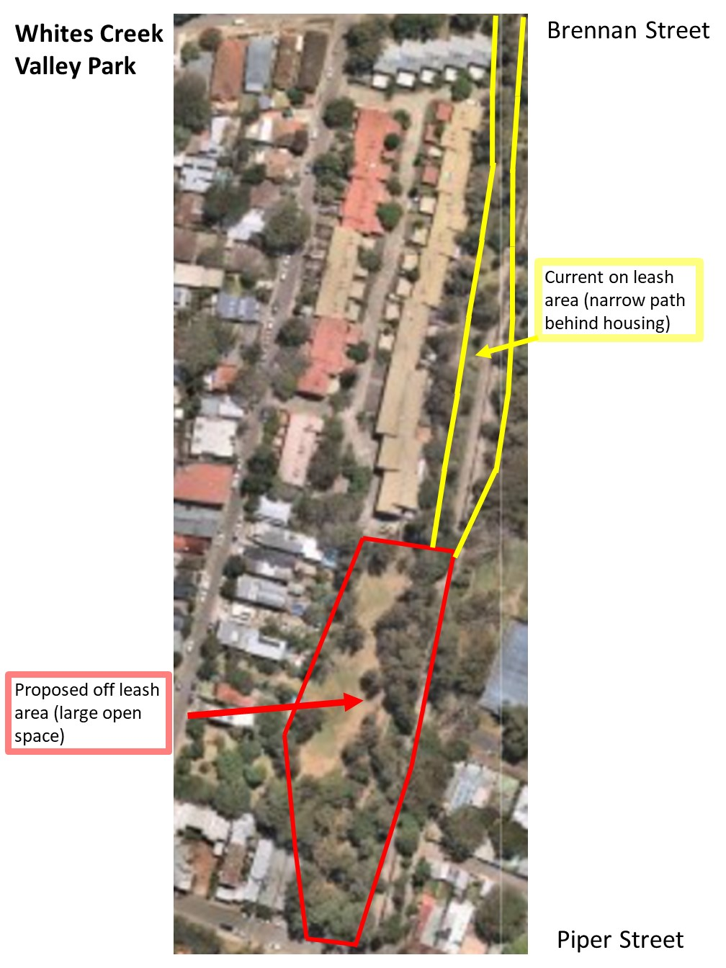

FINANCIAL IMPLICATIONS
Nil

ATTACHMENTS
Nil.

