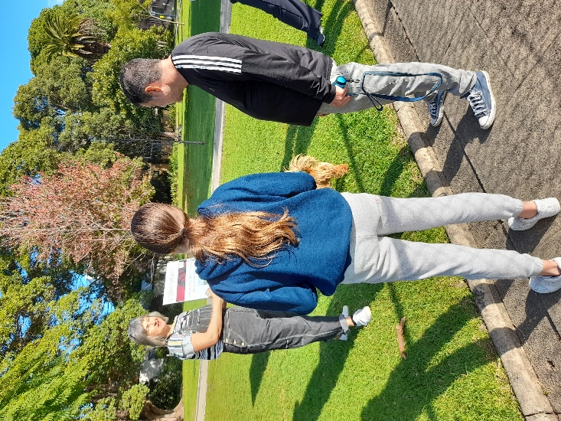

Petersham Park Grandstand Art Project Engagement outcomes report

Contents

Summary 3
Background 3
Engagement methods 3
Promotion 4
Engagement outcomes 4
Who did we hear from? 4
What did they say? 4
Next steps 5

Summary

Community engagement for new artwork on the water tank at Petersham Park Grandstand was carried out from 10 May to 27 May 2021 via the online engagement platform Your Say Inner West (YSIW) and through a face-to-face ‘Meet the artist’ session at the park on Saturday 22 May 2021.
The YSIW project page received 93 visits. Of those visitors, 8 contributed their ideas for artwork designs. They were prompted to suggest ideas of local plants and wildlife to be included in the water tank artwork design.
The face-to-face session attracted ten visitors (predominantly local residents) who showed overwhelming support for the overall artwork design featuring famed local cricketing great, Mollie Flaherty and also provided suggestions for local wildlife

Background
Inner West Council commissioned GML Heritage Pty Ltd (GML) to develop two interpretive concepts at Petersham Grandstand, Petersham. Council requested that interpretation concepts be developed to comply with the conditions of the development application. The interpretation addressed the history of the site, including its association with various sporting clubs that have used the grandstand, such as Randwick Petersham Cricket Club and the Petersham Pete’s Baseball Club.
Details of an interpretive proposal were submitted for approval during the works and will be implemented prior to the issue of an occupation certificate to the satisfaction of Council’s Heritage and Urban Design Advisor. The interpretive proposal was formulated by an experienced heritage consultant, based on the history of the grandstand and Petersham Park in 2007 CMP.
Through its public street art program, Perfect Match, Inner West Council commissioned locally renowned artist Kelly Wallwork to produce the heritage-inspired artwork and looked for input from the community into elements of the design.

Engagement methods

The main method of engagement was an ‘ideas board’ online via the Your Say Inner West page and the face-to-face ‘Meet the artist’ session at Petersham Park.

Promotion
The engagement was promoted through:
- Letterbox drop to local residents
- Council’s website
- Posters in Petersham Park
- Inner West Council social media platforms (Facebook and Instagram) and
- Emails to key stakeholders and community groups such as the Arts & Culture, Planning & Heritage Advisory Committees

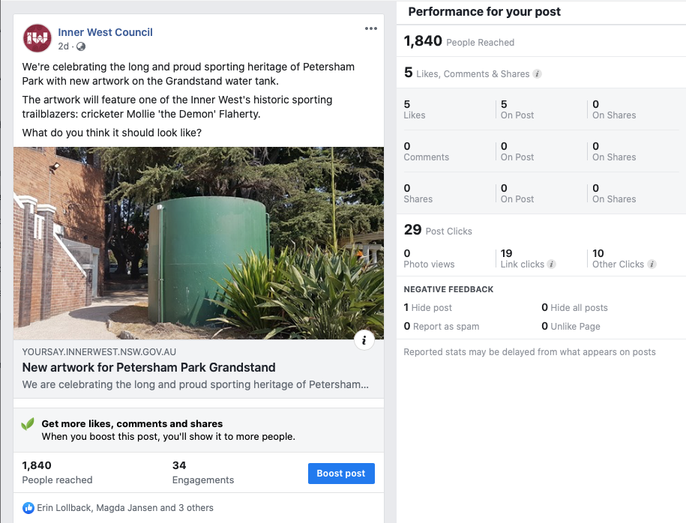

Engagement outcomes

Who did we hear from?
Residents were the primary group of respondents and provided their feedback through the face-to-face session in the park. In addition, one local resident also provided input by calling Council Customer Service directly.

What did they say?
In total, eight ideas/comments were provided via the ideas board on the YSIW page. Other comments were captured at the ‘Meet the artist’ session.

Artwork suggestions:
- Kookaburras
- Bandicoots
- Lorikeets
- Fig birds
- Magpies
- Ibis
- Wangal totem

One local resident also shared a picture of Petersham Park lorikeets.
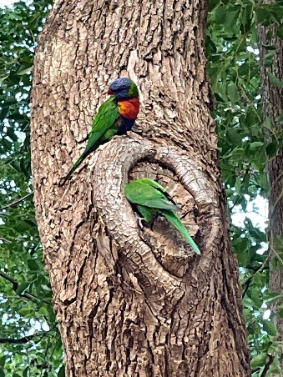

Additional comments were made stating that it would have been good to move the water tank underground and one comment received mentioned disappointment that a sporting personality would feature in the artwork.

Next steps

All feedback provided as part of the Engagement process will be compiled and provided to the artist for consideration and inclusion in the final design. It is anticipated that the artwork will be completed by end July 2021 (weather permitting).

