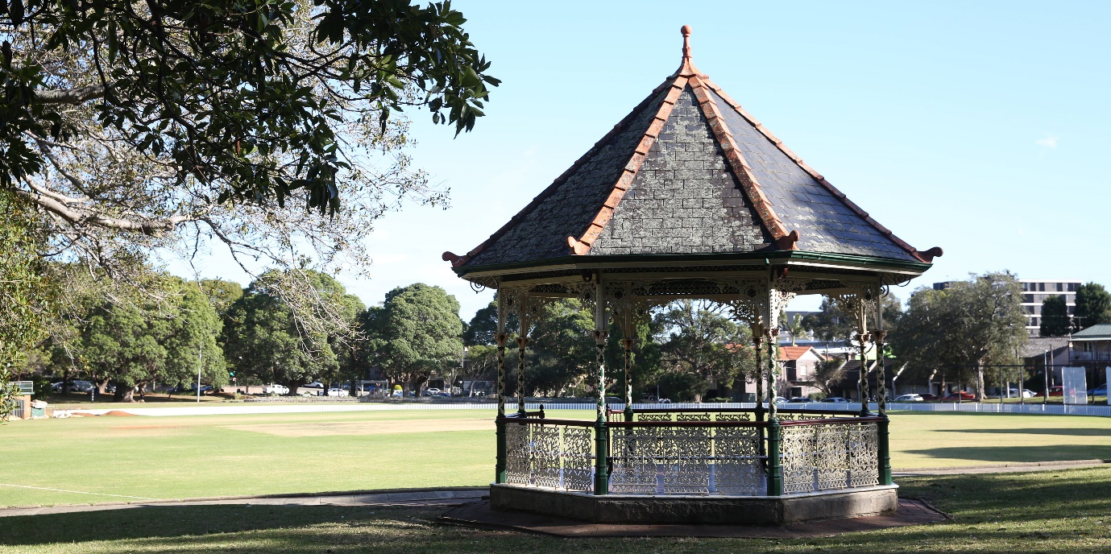

Have your say on new artwork at Petersham Park Grandstand

Petersham Park has a long and proud sporting history in the Inner West spanning over one hundred years. The home to local cricket and baseball clubs for generations, three Australian Test cricketers hailed from the Inner West—Mollie ‘the Demon’ Flaherty, Hazel ‘Girl Bradman’ Pritchard and Amy Hudson.

Council will honour this local sporting heritage through public art on the grandstand water tank.
As part of Council’s Perfect Match Street Art Program, the community now has a chance to contribute to the design before painting begins. You can also meet with the artist in person.

Have your say
Share your knowledge of the Park’s plants and wildlife to include in the design at yoursay.innerwest.nsw.gov.au
or
Meet the artist, Kelly Wallwork, at the grandstand water tank on Saturday 22 May 2021, 1-3pm.
Come chat with Kelly about the inspiration for the artwork and her design process.
Last day for community feedback is 24 May 2021
Contact: Stephanie Hatton
engagement@innerwest.nsw.gov.au

