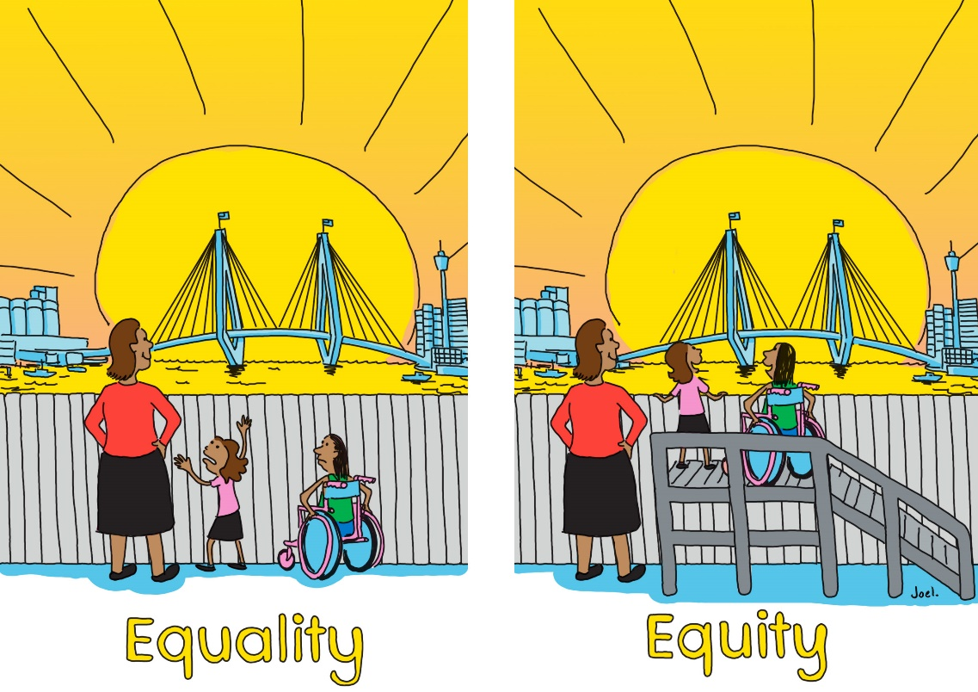

Engagement outcomes report

Draft Gender Equity Strategy

Contents
1
Summary 3
Background 3
Engagement Methods 3
Promotion 4
Engagement outcomes 7
Officer comments in response to public exhibition 11

Summary
The Draft Gender Equity Strategy 2021-25 and Action Plan was placed on public exhibition from 13 May to 10 June 2021. The community could provide feedback on the priorities and actions for Inner West Council (IWC) over the next four years.
It was placed on ‘Your Say Inner West (Draft Gender Equity Strategy | Your Say Inner West (nsw.gov.au). The feedback form was designed to gauge level of support and feedback on each priority and its respective actions.
There were 285 visitors to the page with 68 document downloads and 23 community members providing feedback.
Overall, the responses were mixed - those who support the strategy indicated this is an important step in striving for equality however, more must be done via quotas or measurements and language which demonstrate inclusiveness for all genders. In contrast, those who disagreed with the strategy believed Gender Equity shouldn’t be a priority for Council.

Background
Inner West Council prides itself on being a progressive and inclusive Council, one that strives for an equitable and fair community. An organisation and community that works towards gender equity will not only enhance the economy and social capital but see the reduction of domestic and family violence.
Council has developed initiatives and programs which aim to challenge gender inequality. This draft Gender Equity Strategy and Action Plan provide a strategic vision and path in enhancing equity for our community. This Strategy is in accordance with research and best practice drawn from work internationally and locally.
The Draft Strategy and Action Plan have been developed in collaboration with internal stakeholders from across the various business units and external stakeholders including – Inner West Domestic Violence Liaison Committee, Inner West Council Domestic Family Violence Reference Group and Peak Bodies including Domestic Violence NSW, ACON and LGNSW.

Engagement Methods
During public exhibition the community could provide feedback:
- Online on yoursay.innerwest.nsw.gov.au via the organisation or individual feedback form
- Direct email to the project lead
- Call to the project lead, including via an interpreter (TIS) or National Relay Service

Promotion
The engagement was promoted via:
- Social media
- Council’s e-news including YSIW
- Direct email to Local Democracy Groups via conveners
- Council website
- Interagency and networks

Engagement outcomes
Who did we hear from?
There were 23 participants from the Inner West community.
What did they say?
The draft Gender Equity Strategy and Draft Action Plan was downloaded 68 times, and 23 community members provided feedback online. All participants had responded as anonymous and all submission were done individually.
Each question was framed around a priority from the draft Gender Equity Strategy to gauge the extent participants agree with the priority and an open comment box for them to explain their response.

Priority 1: Leadership: creating a council that champions gender equity and positive change
Participants were asked ‘to what extent do you agree with this priority?’
- 5 completely agree. Council has an opportunity to lead by example through its planning, initiatives, and discussions.
- 7 very much agree. Participants had acknowledged the importance of this priority, however, there needs to be quotas to demonstrate stronger leadership from Council and a recognition of all genders (incl. nonbinary, agender, and other gender groups)
- 1 moderately agree. Clearer language around gender equity, the use of sex instead of gender to outline ending discrimination
- 3 slightly agree. An indication that the main priority should be to Council services (i.e. rates and rubbish)
- 7 don’t agree at all. Participants disagreed with the strategy conceptually, particularly on the notion of equity as means to achieve equality

Priority 2: Building capacity: empowering Council staff and the community to enhance gender equity
Participants were asked ‘to what extent do you agree with this target?’
- 6 completely agree. Participants acknowledged the importance of training and supporting staff to achieve gender equality
- 6 very much agree. Clarity on how this will be achieved – such as quotas or measurements to be embedded in this strategy.
- 2 moderately agree. Participants expressed that gender inequality cannot be addressed via a strategy
- 1 slightly agree.
- 8 don’t agree at all as this is in opposition to Council’s primary, and a strategy that presupposes equity is in actuality excluding the broader community

Priority 3: Partnership: working with the community and key stakeholders to work towards gender equity
Participants were asked ‘To what extent do you agree with this target?’
- 8 completely agree. Overall participants indicated their support in this priority; however, greater emphasis needs to be main on men taking an active role in working with women to achieve equality
- 4 very much agree. The strategy needs to recognise and makes explicit all genders
- 1 moderately agree.
- 1 slightly agree.
- 8 don’t agree at all. Participants were in opposition to the notion of gender and that the strategy will negatively impact on women.

Officer comments in response to public exhibition
The Gender Equity Strategy and Action Plan invited a variety of feedback and comments from the community.
Theme | Response/Amendments
Embedding measurement and quotas to ensure gender equity continues to be prioritised | In the Action Plan, the first year focuses on collecting baseline data which will be used to determine measurements.
Language is not inclusive of the LGBTIQ community. | Amended the draft to include language, information and statistics around the LGBITQ community.
The intersectional nature of gender inequality, that it impacts on all facets of the community | The Action Plan considers the intersectional nature of gender inequity by proposing further tailored engagement with community groups, which will determine measurements and future directions.
Opposition to the use of equity to address inequality | Focusing on gender equity allows Council to systemically address the drivers of inequality.  Equality means that we give everyone the same resources, regardless of their circumstances.  Equity is about tailoring these resources so that they are appropriate for specific circumstances. The illustration on the cover of this report visualises this concept.

