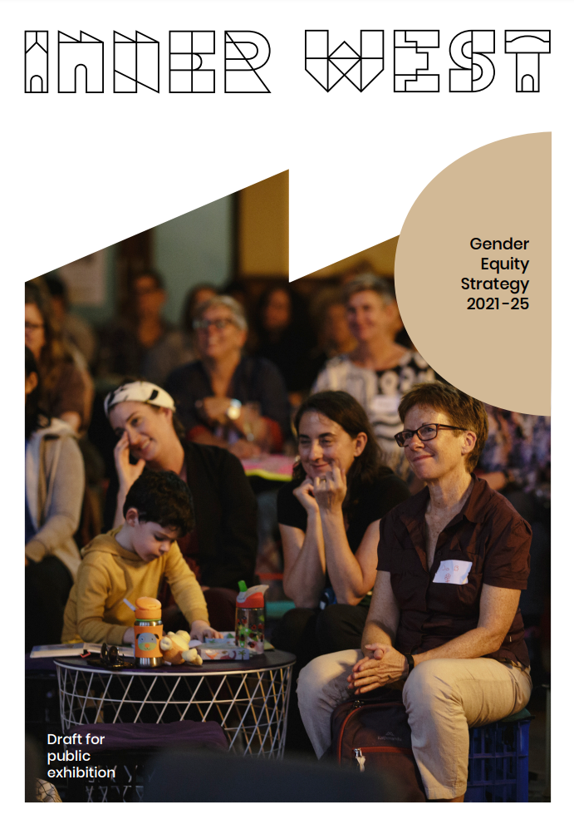

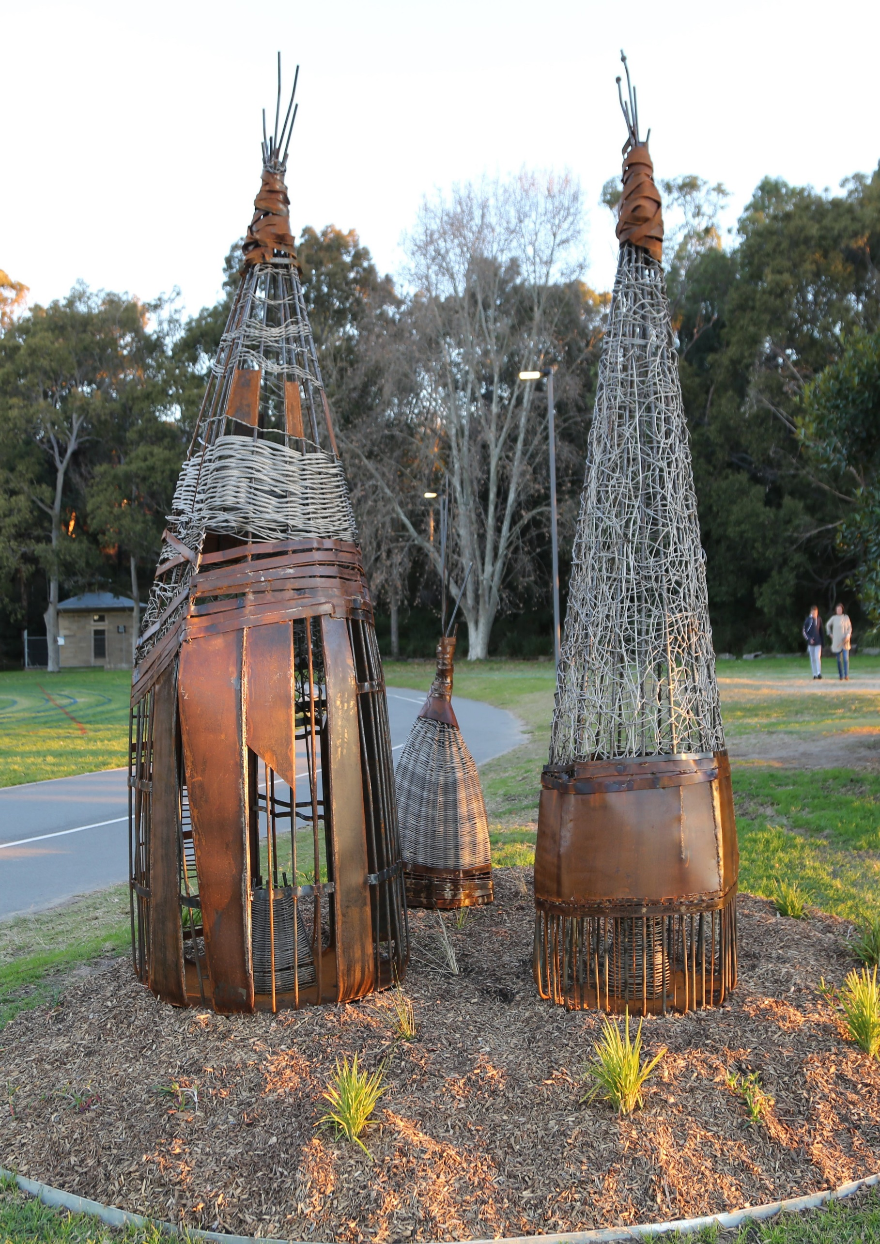

Aboriginal and Torres Strait Islander Statement
Inner West Council acknowledges the Gadigal and Wangal peoples of the Eora Nation, who are the traditional custodians of the lands in which the Inner West local government area is situated.

We celebrate the survival of Aboriginal and Torres Strait Islander cultures, heritage, beliefs and their relationship with the land and water. We acknowledge the continuing importance of this relationship to Aboriginal and Torres Strait Islander peoples living today, despite the devastating impacts of European invasion. We express our sorrow for past injustices and support the rights of Aboriginal and Torres Strait Islanders to self-determination.

Inner West Council understands our responsibilities and role in working with the Aboriginal community to promote cultural heritage and history, address areas of disadvantage, and protect and preserve the environment as well as sites of significance to Aboriginal peoples. In doing so, we acknowledge that Aboriginal cultures continue to strengthen and enrich our community.

Fish Traps – by Clarke & Edwards King George Oval (Callan Park)
Photo – Barbara Becker
Table of Contents

Aboriginal and Torres Strait Islander Statement 2
Glossary of terms 4
Vision Statement 5
Outcome statement 5
Principles of the Strategy 5
Executive summary 6
Introduction 7
What is Council’s role? ………………………………………………………………………………8
What is Gender Equity? 9
Our Journey to achieve Gender Equity 10
Developing the Gender Equity Strategy: a consultative process 10
The evidence for a Gender Equity Strategy 11
Looking beyond the gender binary and understanding its roots 13
Gender Equity: strategic priorities to achieve 14
Implementation of the Gender Equity Strategy…………………………………………………..16
Support Services: what support services are available 16
Appendix 17

Glossary of terms

Gender-diverse | The umbrella term for the diverse gender identities (beyond male and women)
Gender binary | The gender binary describes the most common genders, male and women
Gender Equality | Providing everyone with the same access, resources, opportunities
Gender Equity | The process undertaken to achieve Gender Equality.
LGBTIQ | An acronym for Lesbian, Gay, Bi-sexual, Transgender, Intersex & Queer
Intersectional | The way different forms of social discrimination or privilege, based on social variables, combine and compound oppression or power advantage.
Non-binary | An umbrella term for any number of gender identities that sit within, outside of, across or between the spectrum of the male and women binary. A non-binary person might identify as gender fluid, trans masculine, trans feminine, agender, bigender
Normative | Relating to an accepted standard in society

Vision statement
To create a community that promotes:
- gender equity and healthy relationships
- a safer community and active bystanders
- active participation in all aspects of community life, employment and economy.

Outcome statement
A safe, inclusive and equal Inner West community where we share a culture that respects the rights of women; and where all members have access to equal power, resources, opportunities and are treated with respect and fairness.

Principles of the strategy
Principles and beliefs that underpin the strategy:
- Women should be able to move freely and safely in the community.
- Residents should be able to participate in Council activities.
- Residents see themselves reflected in all aspects of Council and community life.
- Women experience different levels of inequity.
- Multiple inequities are experienced by Aboriginal and Torres Strait Island, Culturally and Linguistically Diverse Communities, LGBTIQ, older people/women (seniors), women and people with disability.
- Gender equity is a key component of reducing domestic and family violence, and a foundation of a building a safe, respectful and inclusive community.
- Gender inequality is a key driver of domestic and family violence.

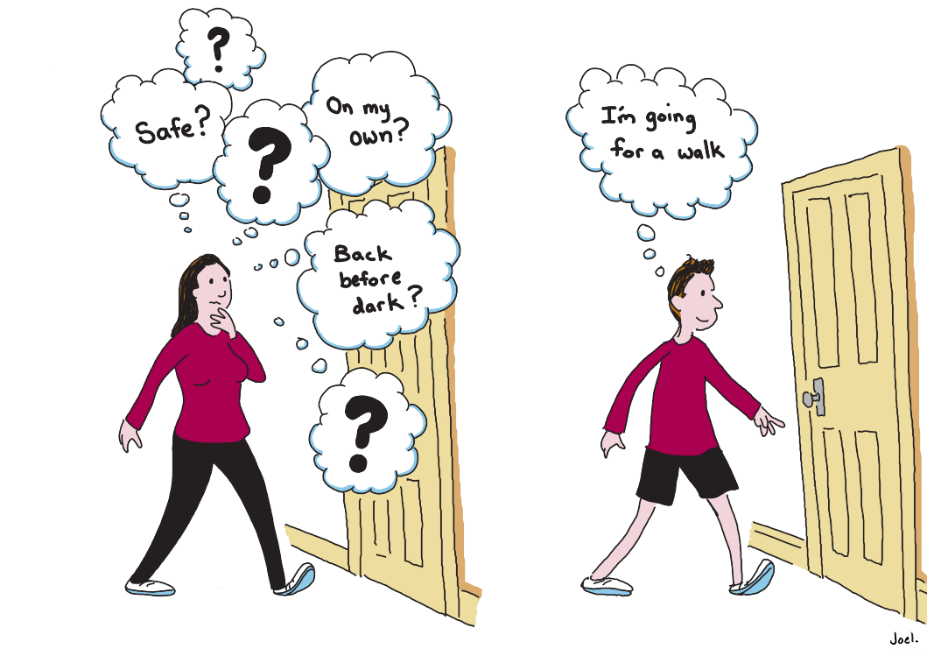

Executive summary
Inner West Council and our community have a longstanding and demonstrated commitment to social justice, inclusion, advocacy and diversity.
There is strong evidence linking gender inequality, and domestic and family violence. Within this context, the Gender Equity Strategy 2021 - 2025 aims to ensure that gender equity is built into Council’s existing operational systems, recruitment, planning, policy, and strategy work.
The strategy prioritises leadership, capacity building and partnership to drive gender equity in the Inner West. The focus is on enhancing the profile of our community, working collaboratively, and leveraging the skills and expertise of our members and partners.
The strategy is based on best practice and evidence, and engagement with stakeholders in the community and Council. The strategy focuses on delivering across three priority areas:
- Leadership: creating a council that champions gender equity and positive change
- Building capacity: empowering Council staff and the community to enhance gender equity
- Partnership: working with the community and key stakeholders to work towards gender equity.

Introduction
In August 2020, Council endorsed the development of a gender equity strategy to ensure it works to address gender inequality, a key driver of domestic and family violence.
Domestic and family violence continues to permeate all facets of our community, its prevalence remains at unacceptable levels with at least one woman a week, killed by a partner or former partner in Australia. Despite ethnicity, cultural or socio-economic background, domestic and family violence contributes to more death, disability and illness than any other preventable risk factor.
There is growing recognition that domestic and family violence is not only physical. The NSW Government has established an inquiry into coercive control to examine controlling behaviours, which are now recognised as a form of domestic and family violence.
Inner West Council is well placed to influence and address structural foundations of inequality, to provide leadership and commitment to action, and to affect positive change in our workplace and in our community.
Council has supported a range of initiatives to prevent domestic and family violence, and to celebrate the important contribution of women in our community. However, these efforts have been delivered independently from one another without factoring the causal link between gender inequality, and domestic and family violence.
Council investment and support has included:

- respectful relationship education
- advocacy and campaigns aimed at the prevention of domestic violence
- allocation of Community Grants for local initiatives targeting prevention of domestic violence and supporting women and children
- hosting ‘how to be an active bystander’ workshops
- developing a Domestic and Family Violence Protocol for Council staff
- actively supporting the Inner West Domestic Violence Liaison Committee
- establishing Inner West Domestic Violence Liaison Committee newsletter
- establishing the Inner West Council Women’s Committee
- providing LGBTIQ Inclusivity Training for professionals working with clients experiencing domestic and family Violence
- training local facilitators to deliver respectful relationship education
- establishing the Respectful Relationship project
- undertaking research into gender norms and identity among young people
- hosting webinars and forums including Keeping Women and Children Safe Forum.

These initiatives focused on an early intervention and/or secondary prevention approach to domestic violence.
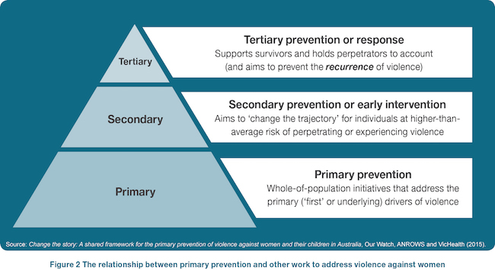
What is Council’s role?
Inner West Council recognises its responsibility to advance gender equity among our community; and to challenge gender stereotypes and power imbalances at structural, cultural and individual levels.
The aim of the Gender Equity Strategy 2021 - 2025 is to work towards an integrated, whole-of-Council approach to ensuring that gender equity is considered and prioritised in all Council planning, policy, strategies, service delivery and practice.
The Community Strategic Plan (CSP) Our Inner West 2036 guides Council to achieve the outcomes that the Inner West community has identified as priorities. The CSP belongs to the community and is facilitated by Council on their behalf. The CSP aims to:
- inform our strategic decision-making that will shape our future community, economy and environment
- protect and enhance the community’s values and heritage
- pave the way for the future through proactive planning for the impacts of change
- strive for inclusivity, sustainability, resilience, accountability and innovation.

What is gender equity?
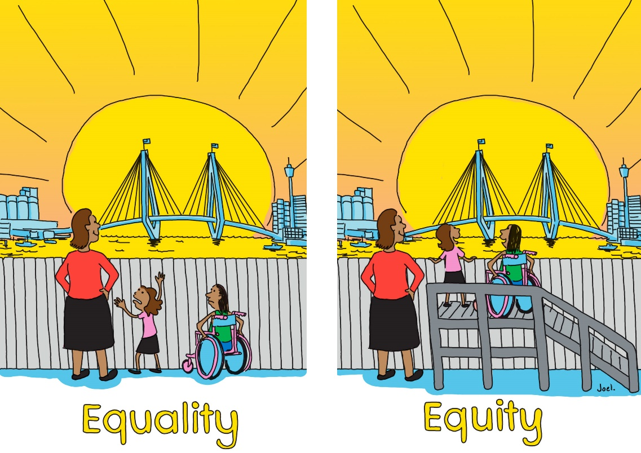
There is an important distinction between ‘gender equality’ and ‘gender equity’.
Gender equality focuses on the equal distribution of resources and opportunities. Distribution of resources can lead to vastly different outcomes for women depending on their circumstances.
Gender equity focuses on the needs and barriers that women and gender diverse people face, and aims to reduce these barriers through a systemic approach. Gender equity recognises that people’s experience in the community can be different depending on their circumstances and social position.
Put simply, gender equality is about ‘sameness’ and gender equity focuses on ‘fairness’

Our journey towards achieving gender equity
Developing the Gender Equity Strategy: a consultative process

The development of the Gender Equity Strategy has been undertaken in consultation with upwards of 100 Inner West Council internal stakeholders from various business units and external stakeholders including– Inner West Domestic Violence Liaison Committee (36 agencies – government and non-government), Inner West Council Domestic Family Violence Reference Group (seven domestic and family violence specialists) and Peak Bodies (i.e. ACON, DVNSW, LGNSW).

The evidence for a Gender Equity Strategy

International and National evidence
Current International evidence, outlined in Change the story: a shared framework for the primary prevention of violence against women and their children in Australia, tells us that higher levels of violence against women are consistently associated with lower levels of gender equity in both public life and personal relationships.
The research further supports that countries with higher levels of gender equality have an array of benefits for the community, such as economic benefits and productivity, social benefits as well lower levels of gender-based violence.
The following statistics highlights some of the key gender inequalities in Australia:
- The national pay gap between women’s and men’s fulltime weekly earnings shows that women’s average weekly ordinary full-time earnings across all industries and occupations was $1,562 compared to men’s $1,804.02. Women in general, earn on average $242.20 per week less than men.

- When employed, women are more likely to work part time or in casual roles than men. This attributed to a variety of factors – such as full-time work entailing long and inflexible hours, lack of appropriate flexibility at their workplace, social expectations about women’s roles etc.

- There is a gender gap in retirement income and savings, with the average superannuation balances for women at retirement being 47% less than men, yet women live on average five years longer.

- There are visible gaps in representation of women in leadership positions, particularly in the private sector.

- In 2019, women comprised of 25.5% of parliamentary (lower house) seats and 21.2% of ministerial positions

- In Australia, 44% of women with disabilities are employed, compared 53% of men with disabilities .

- Migrant women are at least 7 % less likely to be employed than women born in Australia

Gender inequality often intersects with other forms of inequality and disadvantage. Research suggests some population groups are more at risk of violence including Aboriginal and Torres Strait Islander people, LGBTIQ people, culturally and linguistically diverse (CALD) people, children, and people with disabilities.

Domestic violence workers report that one of the most common reasons that women stay in violent relationships is the fear of poverty and homelessness. When women earn less, work in less secure jobs, have less savings and lower superannuation balances they do not have the economic security they need to protect themselves and their children.
The NSW Homelessness Strategy 2018-2023 notes the trend for women to become homeless for the first time in later life: between 2013/14 and 2016/17 there was an 88% growth in women over 55 accessing homelessness services. These women are more likely to be homeless over a longer period of time. The Strategy also notes that women and children leaving domestic and family violence is a leading cause of homelessness among women and children.
COVID-19 and rising inequalities
COVID 19 has intensified pre-existing gendered social and economic inequalities:
- The over-representation of women in casual and insecure employment means they are more likely to have lost their jobs.

- Women already make up the majority of unpaid carers, and have taken on a greater share of additional care responsibilities for children, other family members and at-risk community members during self-isolation. The ABS Household Impacts of COVID-19 survey shows that women are almost three times as likely as men to have been looking after children full-time on their own (46% compared with 17%) and are more likely to have provided unpaid care or assistance to a vulnerable person outside their household (16% compared with 10%).

- The fall in the women labour force participation rate was almost 50% larger than the fall in the male participation rate in April 2020, most likely reflecting the greater share of additional caring responsibilities that women have taken on .

- The frequency and severity of intimate partner violence also increases during and after emergencies, with confinement to the home creating additional risks.
Local evidence: Inner West Council area Profile
Demographic analysis of gender equity in the Inner West Council area has been undertaken by Id Consulting (Gender Equity in the Inner West report is contained in attachment 1). This report identifies gender differences across a range of socioeconomic characteristics and concludes that Inner West women are more disadvantaged than males. Detailed breakdown of the socio-economic characteristics in the Inner West population that contribute to this inequity are outlined in attachment 1 and include:
- disability: higher proportion of women requiring assistance due to disability
- living alone: higher proportion of older lone person households being women
- employment: lower proportion of women being in full-time employment
- income: lower individual income for women
- unpaid care: higher proportion of women providing unpaid care/assistance
- housing stress: higher proportion of one parent households with women lone parents experiencing housing stress than males

Looking beyond the gender binary and understanding its roots
Inner West Council acknowledges that the origins of constrained gender binaries, which are widely prevalent in our contemporary world, are rooted in colonisation. Through the process of colonisation of First Nations lands, colonisers have imposed Victorian era gender understandings based on binary ideologies and labelled Indigenous people as racially inferior, dismantling gender diversity within their cultures in the process. These imposed ideologies have asserted men and women as the norm and excluded all others, perceiving gender diversity as inferior and in moral opposition. In fact, the first colonisers used gender diversity in Indigenous culture as a justification for the genocide of First Nations peoples, with ongoing impact still present today.
Inner West Council respects and includes diversity of expression beyond the commonly accepted western male/women gender binary framework which is usually linked to anatomy at birth. We understand that people may identify differently to the sex they were assigned at birth and that gender identity is a valid perception of self.
To authentically engage in a process of gender equity, it will be necessary to recognise and include gender diverse, non-binary and people of marginalised genders in our efforts to advance gender justice, reconciliation and decolonisation.

Gender equity: strategic priorities to achieve equity

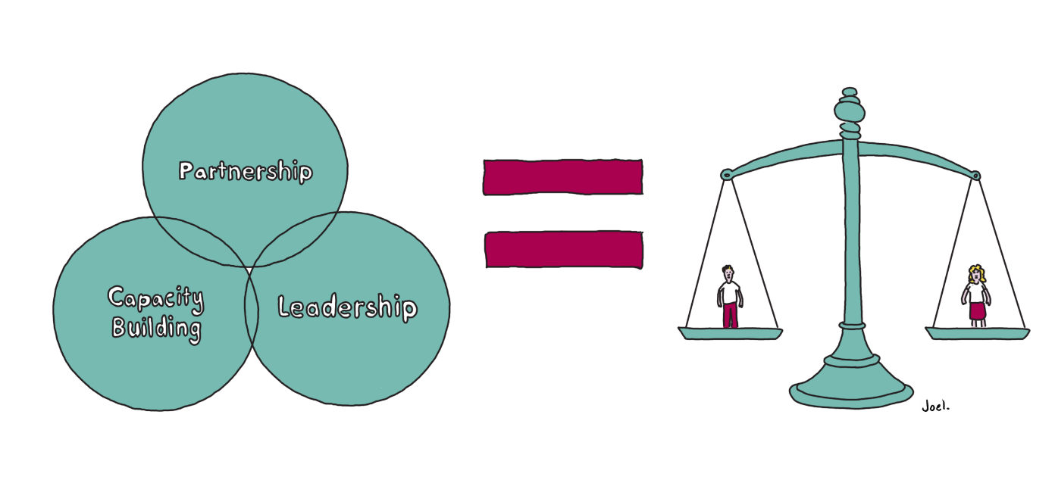
To achieve gender equity, it is important that Council’s priorities are focused towards enhancing participation from all parts of our community. The following priorities recognise the complexity and diversity of the Inner West Council local government area. The priorities are supported by initiatives detailed in the Gender Equity Strategy Implementation Action Plan – 2021 – 2022.
- Leadership: An Inner West Council that champions for gender equity and positive change
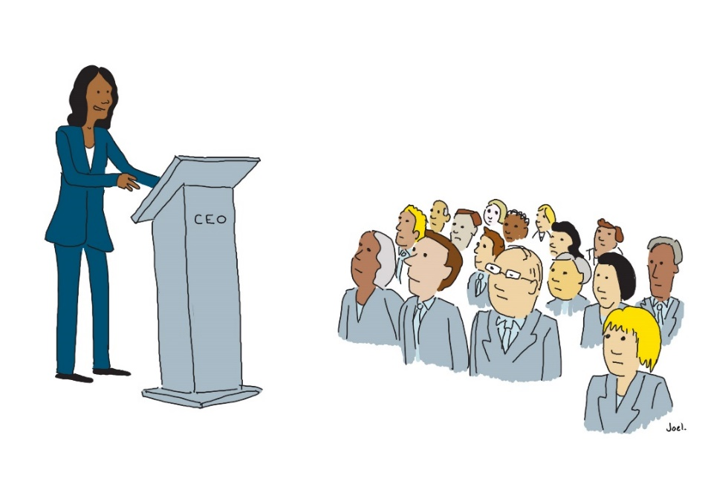
Council is focused on promoting and enhancing gender equity within the organisation, as well as the community. When we empower our community, such as encouraging diversity in leaders and decision-makers, we all benefit – having more diversity in positions of power promotes gender equality.
Women and gender diverse people continue to be underrepresented at leadership and management levels in Australian workplaces. Progress towards gender equality must look for opportunities to celebrate the diversity and differences that exist across our community. For example, Inner West Council celebrates International Women’s Day on 8 March, to acknowledge women in our community, to celebrate the achievements of women leaders, past and present, and to create role models for the next generation of leaders.
Council can demonstrate its leadership through a variety of ways including championing gender equity, challenging traditional gender norms/stereotypes, encouraging respectful relationships, and advocating for women’s independence and decision making.
- Building capacity: empowering staff and the community to enhance gender equity
Building the capacity of staff and the community to act on gender equity is a priority for Council to ensure a sustainable and whole-of-community approach towards gender equality.
An important way to advance gender equity is to increase access to professional and leadership development opportunities. Local government can deliver relevant training and development programs (including mentoring, sponsorships, secondments, conference attendance), and similar opportunities can be provided to the community.
- Partnership: working alongside the community and key stakeholders to work towards gender equity
Inner West Council is in a position to work for change to gender equity, particularly through its role in planning and managing community facilities, public spaces, events, programs, grant distribution, service delivery and partnerships.
Council will not be able to realise the aspirations in this strategy without the support of local networks, community groups and organisations. Collaboration between Council, community agencies, the government sector and community members will play a key role in working towards gender equity in the Inner West.

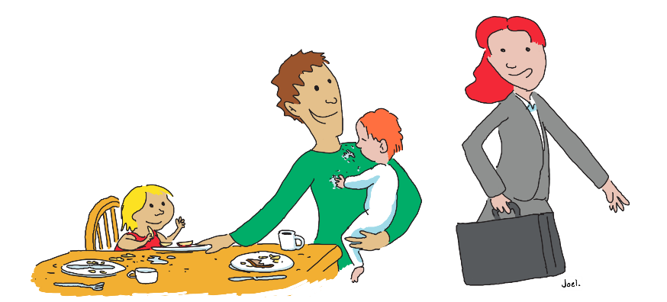
Implementation of the Gender Equity Strategy
Implementation of the Gender Equity Strategy will be embedded in Council’s Integrated Planning and Reporting Framework and timelines to ensure that priorities are included in the long-term planning and short-term delivery of Council’s projects and programs.
Longer-term outcomes will be in the Delivery Program, which is a four-year document that aligns with the term of the elected Council. Each year, priorities will be detailed in Council’s one-year Operational Plan, and these will be reported to Council and the community through the Quarterly Reporting process.
Council will also create measures and targets that will be used to demonstrate its progress against service delivery, and determine Council’s movement towards or away from the communities’ priorities outlined in the Community Strategic Plan – Our Inner West 2036.

Support services: where to seek support?
If this report raises any issues for you, these services can help:
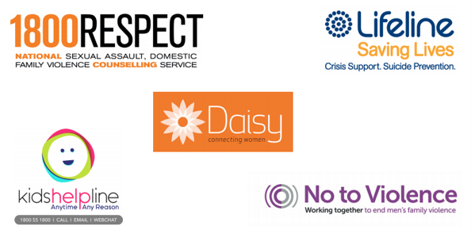

Appendix(s)
Attachment 1

Gender Equity in the Inner West
April 2021

Demographic Analysis
Prepared for Inner West Council by .id – informed decisions

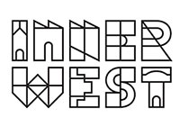
Table of contents
1. Project Background 4
2. Executive Summary and key findings 5
3. Population and age structure 7
4. Need for assistance due to disability 11
5. Employment status 14
6. Industry of employment 15
7. Individual income 17
8. Hours worked 20
9. Average hourly rates by occupation 22
10. Disengagement 25
11. Provision of unpaid care 27
12. Provision of childcare 29
13. Proficiency in English 32
14. Highest level of secondary schooling 34
15. Education qualifications 36
16. One parent families 38
17. One parent families in housing stress 39
18. Lone person households 41
19. Residents in non-private dwellings 44
20. Residents living in temporary accommodation 47
21. Summary of findings 49
22. About .id 51
23. Disclaimer and Copyright notice 52
23.1 Disclaimer 52
23.2 Copyright Notice 52

Project Background
The Inner West Council is developing a “Gender Equity Strategy”. This strategy will help identify current and developing gaps in demographic, socioeconomic and other domains. By creating this strategy, the Council will have an informed view of the challenges and opportunities at hand when dealing with gender equity. The Council is particularly interested in developing a baseline of information about women and social disadvantage. This report will assist the development of the strategy by providing the Inner West Council with demographic information about women and males in the local government area (LGA).

Although both gender equality and equity promote fairness, gender equality achieves this through treating everyone the same regardless of need, while gender equity achieves this through treating people differently, dependent on need. The New South Wales’ Public Service Commission states that “gender equity is achieved when people can access and enjoy the same rewards, resources and opportunities regardless of their gender”. Although the Commission’s focus is on workplace gender equity, this definition of the gender equity goal can be extrapolated to other areas of life for all residents and all genders.

This report collects selected demographic and socioeconomic measures from the 2016 Australian Census of Population and Households. The selected information is presented in a way that allows for comparison of women and male statistics for identical metrics in the Inner West Council Area. The analysis allows for gaps and differences between women and male residents in the Inner West Council area to be identified. Please note that the Australian Bureau of Statistics (ABS) refers to binary gender definition as “sex”. For consistency of data being reported on, this report will reference “sex” rather than gender when discussing differences between women and male statistics.

Along with a comparison within the Inner West Council area, a second comparison of statistics will assess the results of women Inner West residents to those of Greater Sydney women and identify similarities and differences between their statistics.

Executive Summary and key findings
The demographic characteristics of women and males in the Inner West Council area show that women are different to males for many socioeconomic metrics and, in several cases – less well off or disadvantaged. However, when Inner West women residents are compared to those of women in Greater Sydney, many metrics indicate that women in the Inner West Council area are better off than the Greater Sydney benchmarks.

The women population in the Inner West Council area makes up 51.3% of the population, with a more significant proportion of older women than males. This is expected given women have longer life expectancies in most parts of Australia. Longer life expectancies and more significant proportions of women in older age groups also result in a higher proportion of women needing assistance due to disability. Age is also a factor in household composition statistics where women make up a larger proportion of older lone person households than males.

From an employment perspective, a lower proportion of Inner West women are employed full-time than their male counterparts; however a lower proportion of women than males are unemployed. When compared to Greater Sydney, a higher proportion of Inner West women are employed full-time.
Women are more likely to be employed in industry sectors such as “Health care and social assistance” than males, whereas industries such as “Retail trade” or “Accommodation and food services” had almost equal participation of women and males in the Inner West Council area.

Individual incomes for women were considerably lower than for males in the Inner West Council area, with the median weekly gross individual income being $855 for women and $1,070 for males. While this is partly related to a higher proportion of women working in part-time employment and working fewer hours, another way of assessing income by looking at hourly rates for both sexes by industry sector, revealed that women were receiving less in terms of hourly income in the same employment sectors as males.

Income levels for women in the Inner West Council area were significantly higher than the income levels of women in Greater Sydney overall. This information, however, does not account for possible higher living expenses in the Inner West Council area, which could reduce some of these income advantages of Inner West women over the Greater Sydney average.

The level of disengagement, a measure of participation in education and employment in the Inner West Council area, is higher for women than males and differs by age. As expected, a significant proportion of all residents over the age of 65 are “disengaged” from employment or education as they are retired. In the Inner West Council area, this proportion is higher for women than males, suggesting that males perhaps remain employed longer. Disengagement for women is also higher in the 25-54-year-old cohort, reflecting that more women are disengaged from employment or education as they take on unpaid tasks such as unpaid care of childcare. Compared to Greater Sydney, Inner West women are less disengaged overall and in the under 65 age groups.

Disengagement and provision of unpaid care and childcare are related. A larger proportion of women than males provide unpaid care/assistance in the Inner West Council area, and these proportions are like those of women in Greater Sydney. Only a slightly more significant proportion of women provided childcare in the Inner West Council area than males. For both sexes, the proportion providing unpaid childcare was lower than the Greater Sydney average. Most childcare provided was for the individual’s own children, and a markedly larger proportion of women provided care to others’ children compared to males in both the Inner West Council area and Greater Sydney.

Women and male proficiency in English was similar in the Inner West Council area, with most residents speaking English only and just a small proportion of women and males with poor English proficiency. Compared to Greater Sydney, a higher proportion of women in the Inner West Council area spoke English only, and a lower proportion had poor proficiency in English.

From an education perspective, similar proportions of Inner West women and males completed Year 12 as their highest level of schooling. However, a higher proportion of Inner West women completed Year 12 than women in Greater Sydney. A higher proportion of Inner West women have a “Bachelor or Higher degree” qualification than males. Women in the Inner West Council area have better qualifications levels than women in Greater Sydney overall, and the proportion of women with no qualification is also much lower in the Inner West Council area than for women in Greater Sydney.

Household composition statistics reveal that one-parent households are predominantly formed with women as the lone parent in both the Inner West Council area and Greater Sydney. One parent households sometimes experience difficulties with financial stability or other socioeconomic challenges. One measure of those challenges identified in this report is housing stress, a measure of socioeconomic wellbeing where a significantly higher proportion of one parent households with women lone parents experienced housing stress than males.

In terms of non-private dwellings and temporary accommodation, a much larger proportion of older Inner West women live in non-private dwellings such as aged care facilities, compared to males. This is an occurrence again related to age. Males predominantly occupy temporary accommodation such as hostels for the homeless, night shelters, refuges or other welfare institutions.

Overall, women in the Inner West Council area are more disadvantaged than males from many socioeconomic perspectives. The findings of this report provide awareness of areas that may need attention from a gender equity perspective. Compared to statistics of women in Greater Sydney as a whole, however, the socioeconomic characteristics of women in the Inner West Council area are often much better.

Population and age structure
The Inner West Council area’s population has become younger over time as trends such as the increased net migration of younger residents to the area skew the age structure towards younger age groups. On the next page is a table illustrating the median age of women and males in the Inner West Council area since 2016 and the “working-age population”, which is the proportion of the population aged 15-64 years.

Note – this simple measure does not assess whether the proportion of women and males aged 15-64 years is actually in the labour force nor does it account for some recent trends in employment where older residents over the age of 65 tend to work for longer but is more of an estimate of potential.

 | 2016 | 2017 | 2018 | 2019 | Difference 2016-2019
Median Age – Women | 36.8 years | 36.7 years | 36.6 years | 36.6 years | -0.2 years
Median Age – Males | 36 years | 35.9 years | 35.8 years | 35.8 years | -0.2 years
Working age population - Women | 12.7% | 12.8% | 12.9% | 13.4% | +0.7%
Working age population - Males | 11.2% | 11.3% | 11.3% | 11.4% | +0.2%

Table 1 – Recent age statistics for Inner West Council area residents based on the estimated resident population

 | 2016 | 2017 | 2018 | 2019 | Difference 2016-2019
Median Age – Women | 36.6 years | 36.5 years | 36.5 years | 36.6 years | No change
Median Age – Males | 35.1 years | 35.0 years | 35.1 years | 35.1 years | No change
Working age population - Women | 14.5% | 14.6% | 14.8% | 15.0% | +0.5%
Working age population - Males | 12.6% | 12.7% | 12.8% | 13.0% | +0.4%

Table 2 – Recent age statistics for Greater Sydney residents based on the estimated resident population

The key changes over time and differences between the Inner West Council area and Greater Sydney are:
- Both the women and male median age have decreased in the Inner West Council area over time, indicating net migration gain of younger residents and net migration loss of older residents. In the latest figures from 2019, the male median age is lower than that of women, 35.8 years compared to 36.6 years. Compared to Greater Sydney, the women median age is identical, whereas the Greater Sydney male median age in 2019 is slightly lower (35.1 years).
- The Inner West Council area’s women “working population” is higher than for males, 13.4% compared to 11.4%. Both measures for the Inner West Council area (as of 2019), are lower than the Greater Sydney “working population”, which is higher for both women (15%) and males (13%). The proportion of Inner West women and males of “working age” has been increasing since 2016, as is also the case for Greater Sydney.

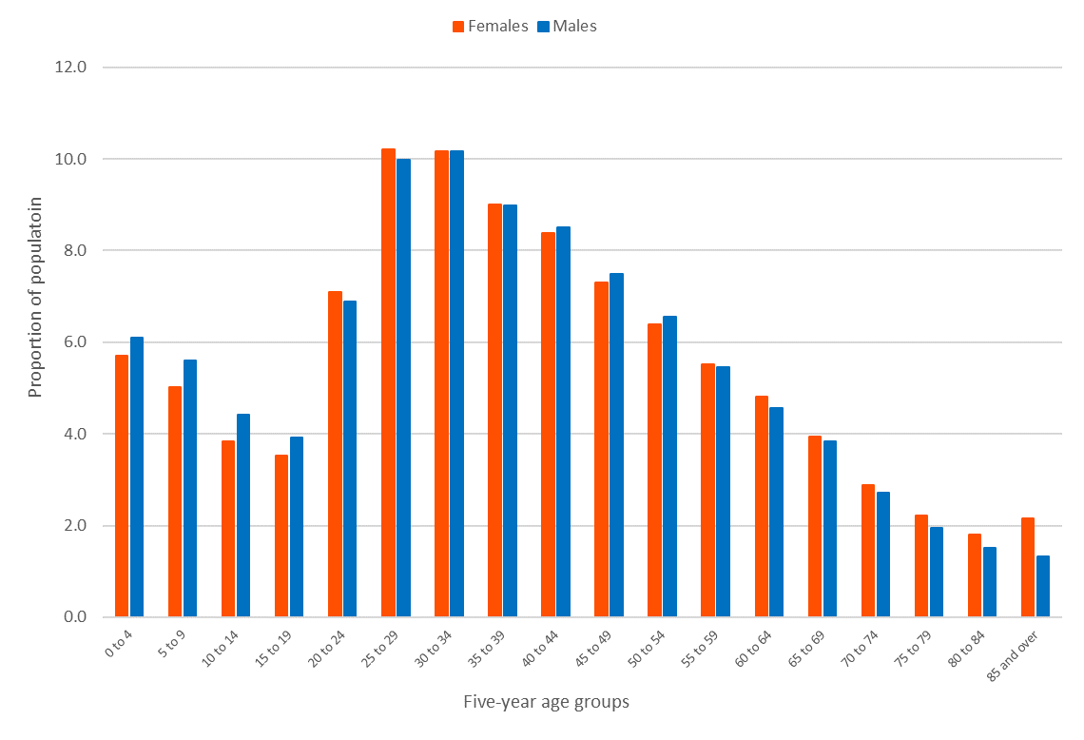
Chart 1 – Age structure of women and males in the Inner West Council area, 2016

- The age structure of women and males in the Inner West Council area is relatively similar. For both sexes, a large proportion of the population is aged 25-34 years.
- A higher proportion of males than women is aged under 19 years, with 20% of the male population and 18% of the women population aged under 19 years.
- The Inner West Council area has a slightly higher proportion of 20–34-year-old women than males, with 28% compared to 27%.
- In older age groups, the women population tends to have a slightly higher proportion of the population in all age groups over 55, however, the difference is most visible in the proportion of 85+-year-olds, where 2.1% of the women population (2,004 women as at 2016) and 1.3% of males (1,168 residents) are aged over 85 years.

- Australian women have a longer life expectancy at birth than males. In Australia, the life expectancy for women was 85.0 years and 80.9 years for males (2017-2019 ABS Life tables). Therefore, a higher proportion of women in older age groups is expected almost everywhere.

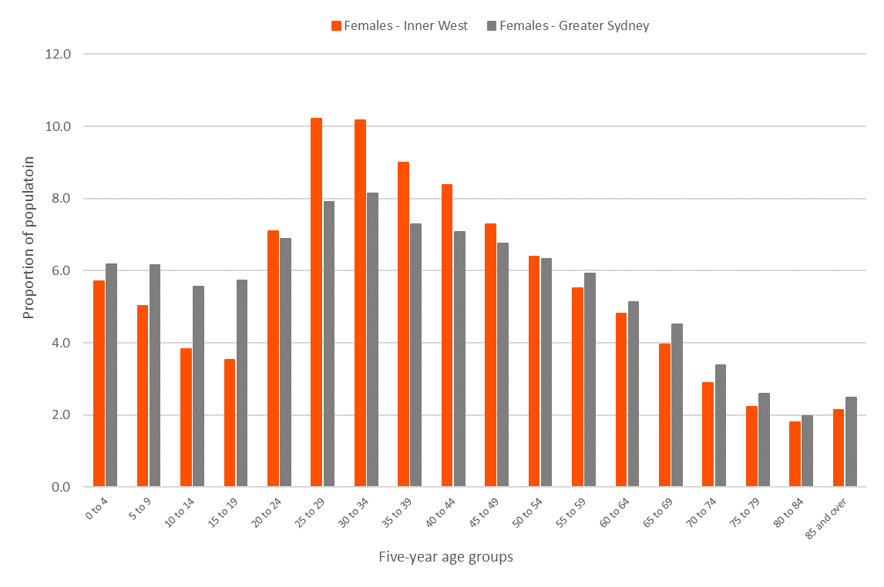
Chart 2 – Age structure of women in the Inner West Council area compared to Greater Sydney, 2016

- Compared to women in Greater Sydney, the Inner West Council area has a higher proportion of women aged 25-34 years with 20% of Inner West’s women population in this age group compared to 16% of Greater Sydney’s women population.
- A higher proportion Greater Sydney’s women population is aged 0-19 years, 24%, compared to 18% in the Inner West Council area. This is partly related to the role and function of the Inner West Council area, where there is a lower proportion of families compared to Greater Sydney and, therefore, fewer households with young adults and children. In 2016, 33% of Inner West households were couple families with children or one-parent families, compared to 45% of Greater Sydney’s households.
- For older age groups, the proportion of women in both the Inner West Council area and Greater Sydney is similar. Greater Sydney has a slightly higher proportion of women aged over the age of 55 than the Inner West Council area. For the 85+ age group, 2.1% of Inner West’s women are aged over 85 years compared to a higher 2.5% in Greater Sydney as a whole.

Need for assistance due to disability
Need for assistance due to disability relates to the Census questions pertaining to the respondent requiring assistance from someone else for self-care, body movement, or communication activities. In 2016, 8,168 people (or 4.5% of the population) in the Inner West Council area reported needing help in their day-to-day lives due to disability. This was a similar percentage to 2011.

 | % needing assistance due to disability
Sex | Inner West Council | Greater Sydney
Women | 5.0% | 5.3%
Male | 3.9% | 4.4%
Total Population | 4.5% | 4.9%

Table 3 – Comparison of “Need for Assistance due to disability” statistics in the Inner West Council area and Greater Sydney, 2016

- A slightly lower proportion of Inner West residents needed assistance due to disability than Greater Sydney, 4.5%, compared to 4.9% of Greater Sydney residents.
- Compared to the male population, a higher proportion of women needs assistance due to disability, 5% compared to 3.9% of males. In Greater Sydney, the proportions were higher for both sexes.
The need for assistance is strongly related to age, so as there are more older women in the Inner West Council area, the proportion requiring assistance reflects that. Chart 3 illustrates the increase in the need for assistance due to disability with age and compares the women and male results for the Inner West Council area.

- Need for assistance proportions by age for women and males are relatively similar in the 0-65 years age groups. However, beyond this, the proportion of women is overrepresented in the statistics, especially in the 80+ age groups, where a much higher proportion of women require assistance due to disability than males.

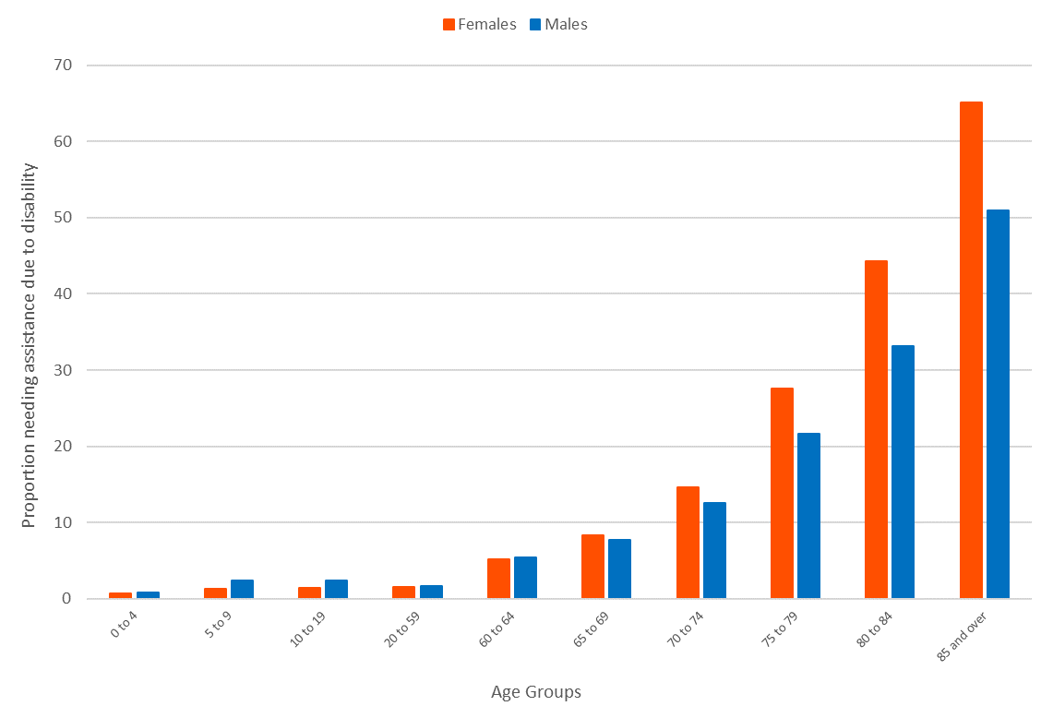
Chart 3 – Need for assistance due to disability by sex, for the Inner West Council area, 2016

- Compared to Greater Sydney, the proportion of Inner West women with a need for assistance due to disability is much higher. For ages below 69 years, the proportions are similar, however, beyond the age of 70, the proportion of Inner West women requiring assistance due to disability is notably higher.
- Over 44% of Inner West women aged 80-84 require assistance compared to 33% of Greater Sydney women.
- Over 65% of women aged 85+ years in the Inner West Council area require assistance due to disability, compared to 55% of Greater Sydney women.

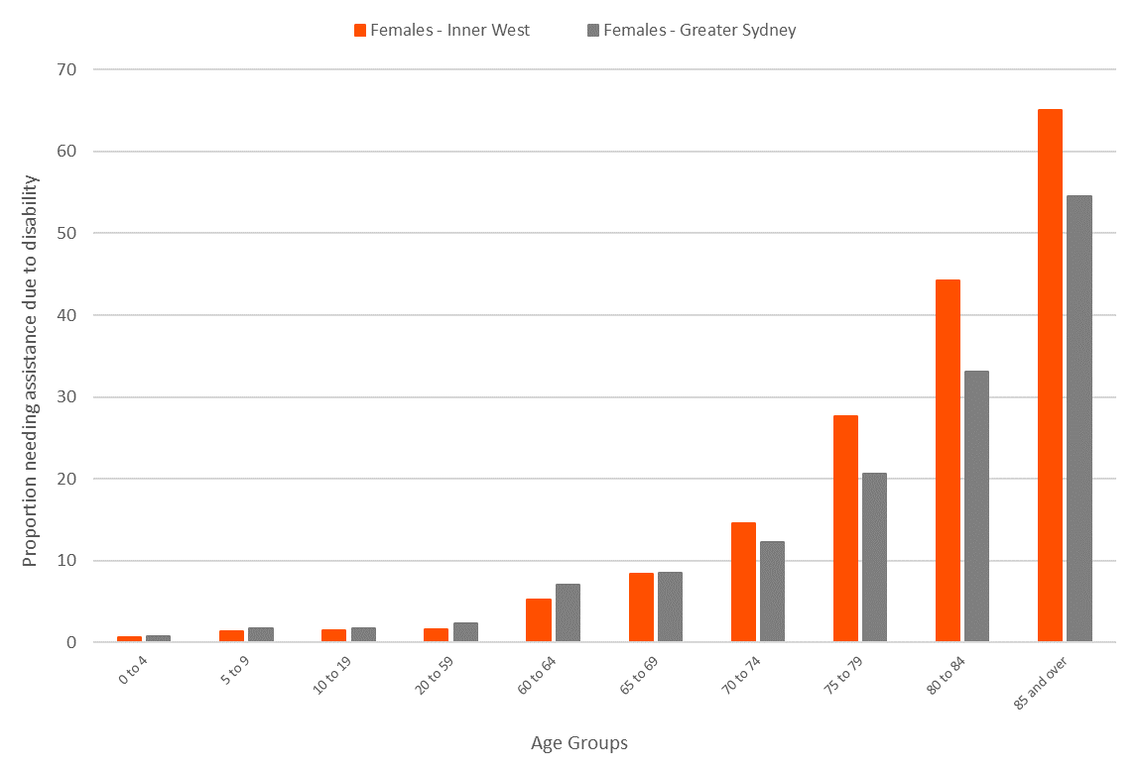
Chart 3 – Comparison of need for assistance due to disability for Inner West and Greater Sydney women, 2016

Employment status
Understanding employment characteristics of women and males in the Inner West Council area provides insight into the differences in the type of employment and how these differences could affect socioeconomic wellbeing, financial stability or gender equity. The analysis in this section provides information about Inner West residents who are employed “full-time” and “part-time” and which residents included in the labour force are not employed.

In this report, the focus was on part-time employment, as women have traditionally had a higher representation in part-time employment than males.

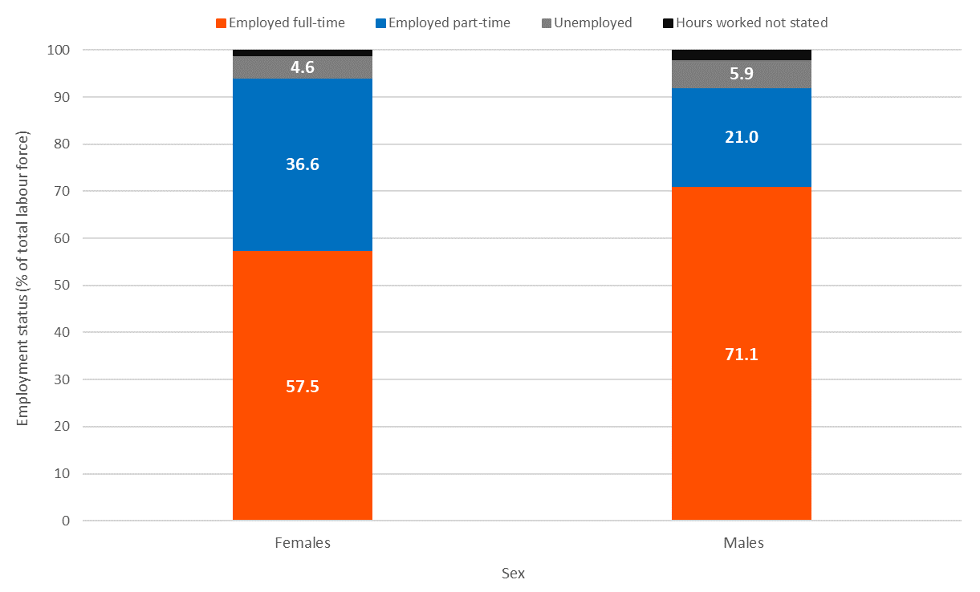
Chart 4 – Comparison of women and male employment status in the Inner West Council area, 2016

- In the Inner West Council area, a higher proportion of women than males are employed, 95.4% of women, compared to a marginally lower 95% of males.
- The employment status breakdown for women and males shows that a lower proportion of women (57.5%) are employed full-time than males at 71.1%. Conversely, a more significant proportion of women are employed in part-time employment than males, 36.6% compared to 21% of males. These figures directly affect the results in section 8 – “hours worked”.
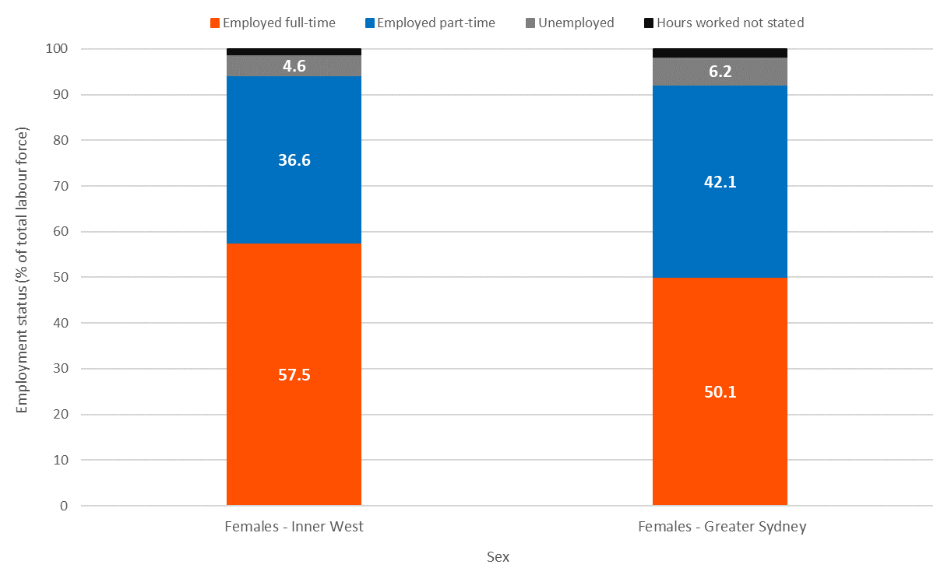
Chart 5 – Comparison of women employment status in the Inner West Council area and Greater Sydney, 2016

- Compared to the employment status of women in Greater Sydney, a higher proportion of Inner West women are employed full-time, with 57.5%, compared to 50.1% for Greater Sydney women in the labour force. This conversely affects part-time employment figures, where Greater Sydney women have a higher representation in part-time employment.
- Unemployment of women in Greater Sydney is higher than that of women in the Inner West Council area - 6.2% compared to 4.6%.

Industry of employment
Comparison of employment of women and male residents by industry of employment highlights industries where there may be an overrepresentation of a particular sex. Four main industries of employment were selected for analysis in this report:

- Accommodation and Food Services
- Administrative and Support Services
- Health Care and Social Assistance
- Retail Trade
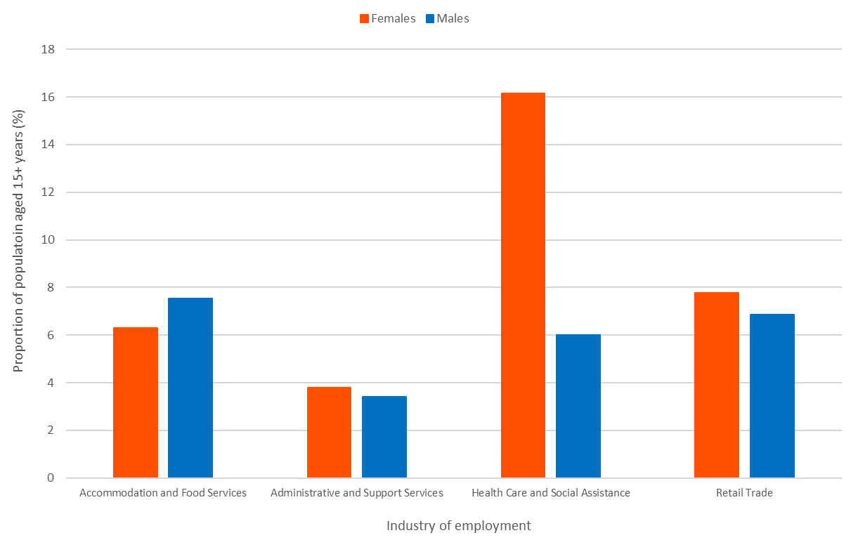
Chart 6 – Comparison of women and male employment by selected industry of employment, Inner West Council area, 2016

- The industry sector with the highest proportion of employed women is “Health Care and Social Assistance”, with 16.1% of all employed women aged 15+ in this industry, compared to only 6% of males.
- “Retail trade” employs 7.8% of employed women in the Inner West Council area and 6.8% of males. Similar proportions are recorded for “Accommodation and Food Services” with 6.3% of employed Inner West women in this industry compared to 7.5% of males.
- Finally, the “Administrative and Support Services” industry employs 3.8% of employed Inner West women and 3.4% of employed males.

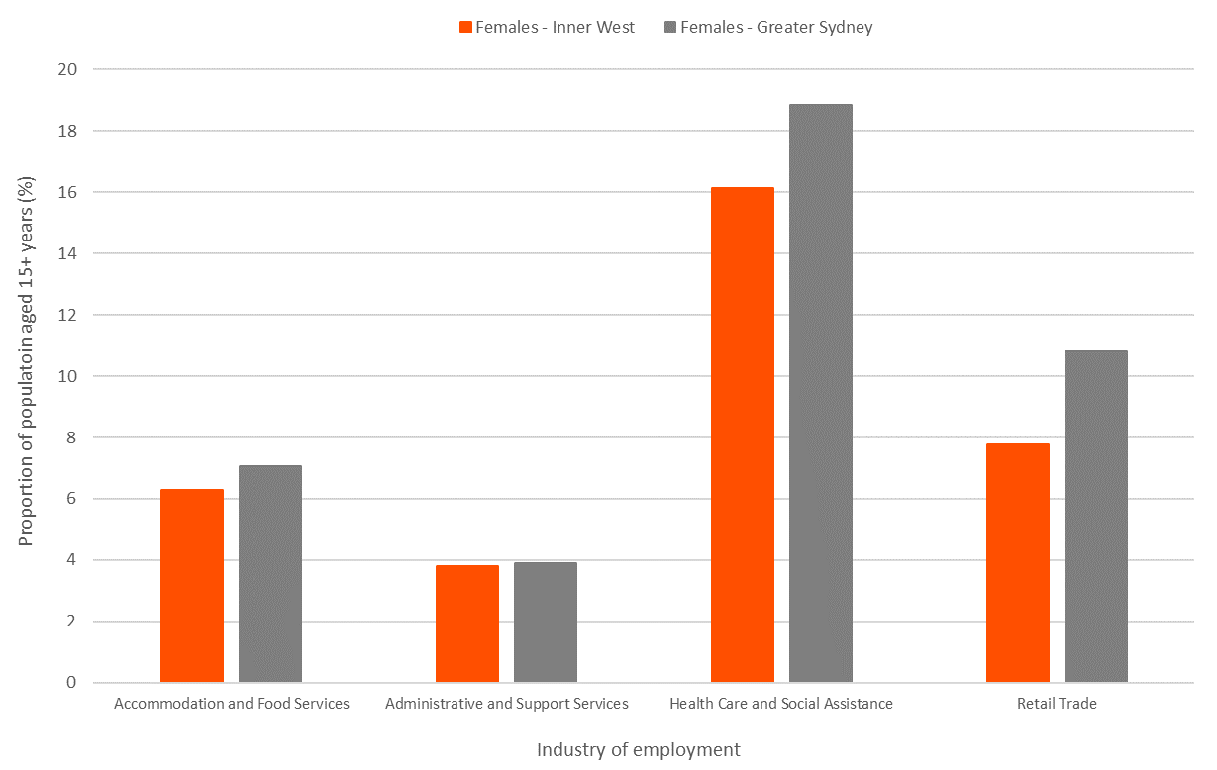
Chart 7 – Comparison of women and male employment by selected industry of employment, Inner West Council area, 2016

- Compared to employed women in Greater Sydney, the Inner West Council area has a lower proportion of women employed in all four selected industries than Greater Sydney. Most notably, the “Health Care and Social Assistance” industry employs 18.8% of Greater Sydney’s women and is the highest employing industry for women.

Individual income
Individual income statistics are an indicator of socioeconomic status and help tell the story of the Inner West Council area's economic opportunities and socioeconomic status. The amount of income an individual receives is linked to several factors, including employment status, age (for instance students and retirees often receive a lower income), qualifications and type of employment. For women and males, the information in this section is strongly related to the previous section (Employment Status) and also needs to be utilised in conjunction with the next two sections, which relate to the hours worked by women and males as well as our way of “normalising” income by making calculations about median hours worked to calculate an “average hourly rate” for women and males, by industry of employment.
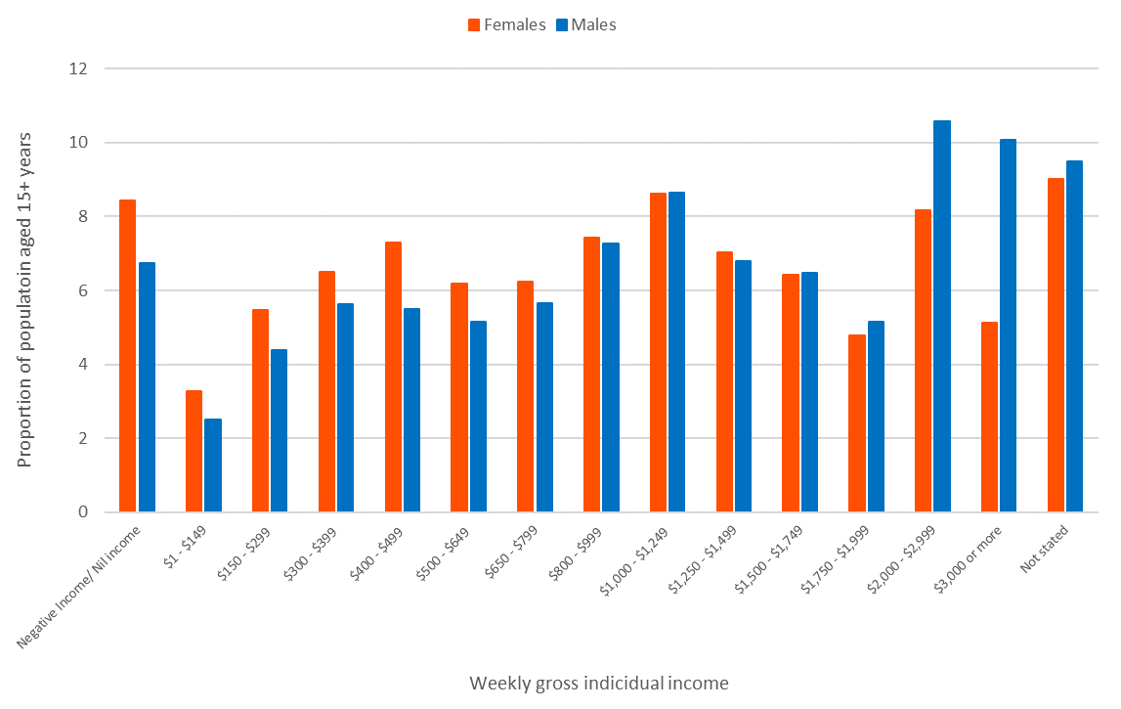
Chart 8 – Individual income statistics for women and males in the Inner West Council area, 2016

- In terms of gross individual income, women in the Inner West Council area have lower individual incomes than males. The median weekly gross individual income for women in 2016 was $855, whereas for males, the median was $1,070.
- Almost 51% of Inner West women’ individual incomes are less than $1,000 per week, compared to 43% for Inner West males (aged 15+).
- Similar proportions of Inner West women and males received an individual income between $1,000 and $1,999 per week.
- In higher personal income bands, males are represented much more than women and this could be related to the proportion of males working in full-time roles among other things such as industries of employment as well as issues such as gender-based income inequality.
- Only 13% of Inner West women aged over 15 receive a weekly income of $2,000 or more compared to 21% of Inner West males. The highest reported income category, $3,000 or more per week includes almost twice the proportion of males as women, 5.1% compared to 10.1% for males.

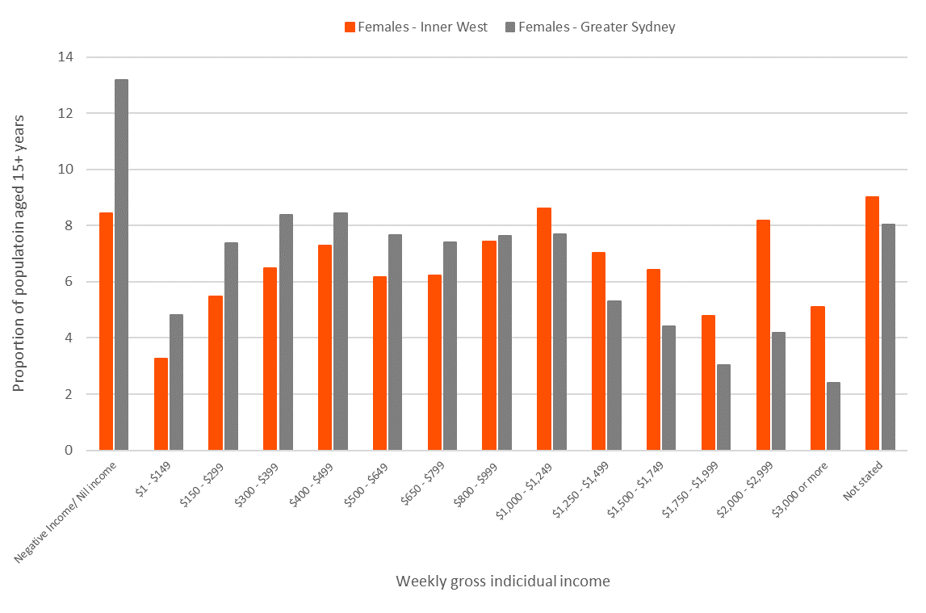
Chart 9 – Individual income statistics for Inner West women compared to Greater Sydney women, 2016

- Compared to women residents (aged 15+) in the Inner West Council area, a significantly more significant proportion of women in Grater Sydney received negative or nil income. Nil/negative income refers to either people who earn no income or technically have a negative income. Negative income in the Census includes people who own their own business and report negative income due to losses or negative gearing of rentals. In Greater Sydney, 13.2% of women were in this category compared to 8.4% in the Inner West Council area. It is acknowledged that this Census category could be improved where nil and negative are separated as it is more likely to be “well-off” residents who are counted in the “negative income” category.
- A lower proportion of women in the Inner West Council area received a weekly individual income of less than $1,000, with 51%, compared to 65% of Greater Sydney women who receive less than $1,000 per week.
- The Inner West Council area has a higher proportion of women with individual incomes above $2,000 per week, an indication of the roles and professions Inner West women are in and the hours worked (see next section). Over 13% of Inner West women received a weekly income of more than $2,000 compared to 6.5% of women in Greater Sydney.

Hours worked
Assessment of “hours worked” statistics provides further insight into women residents' employment characteristics and income sources. Along with individual income statistics, “hours worked” should also be assessed in conjunction with unpaid care and childcare, tasks and jobs that are not counted as traditional employment but sometimes disproportionately taken on by women, thus impacting their financial wellbeing. Hours worked includes the number of hours worked in all jobs held during the week before Census night and excludes any time off but includes overtime and extra time worked.
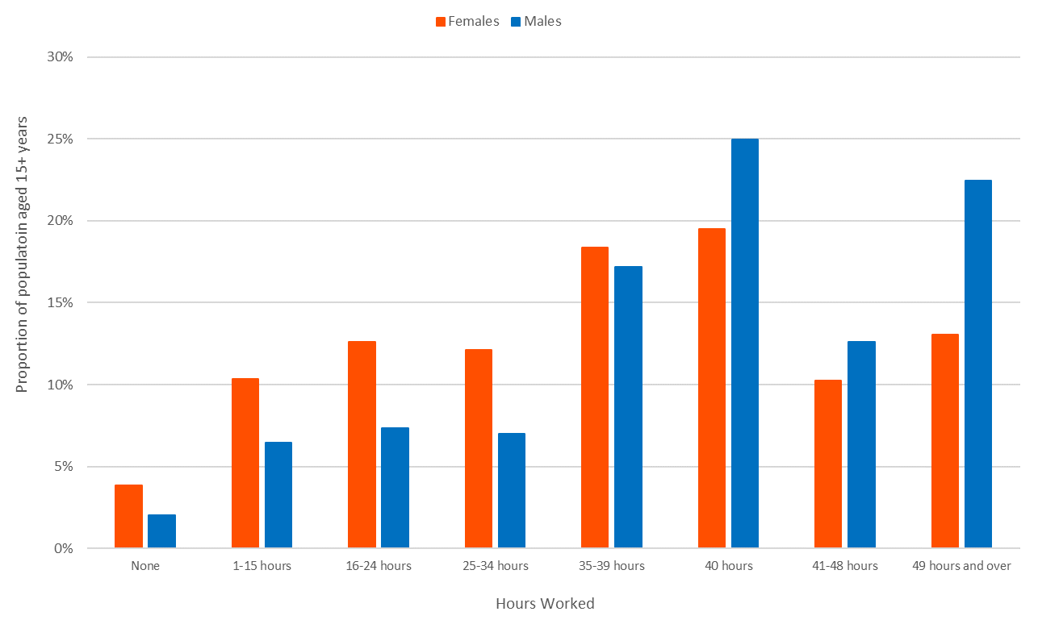
Chart 10 – Hours worked per week for employed Inner West women and males, 2016
- Almost 4% of employed Inner West women did not work any hours in the week leading up to Census night in 2016 compared to only 2% of employed males.
- A much higher proportion of employed women worked less than 40 hours per week than males, with 53% of women and 38% of males in this category. This is related to the proportion of women in part-time employment described in section 6.
- A lower proportion of women worked 40 hours per week, the most typical weekly total, with 19.5% of employed Inner West women in this category compared to 25% of males.
- For the “hours worked” categories above 40 hours, Inner West women were also lower in proportion, especially in the category of 49 hours and over with 13.1% of women and 22.4% of males.
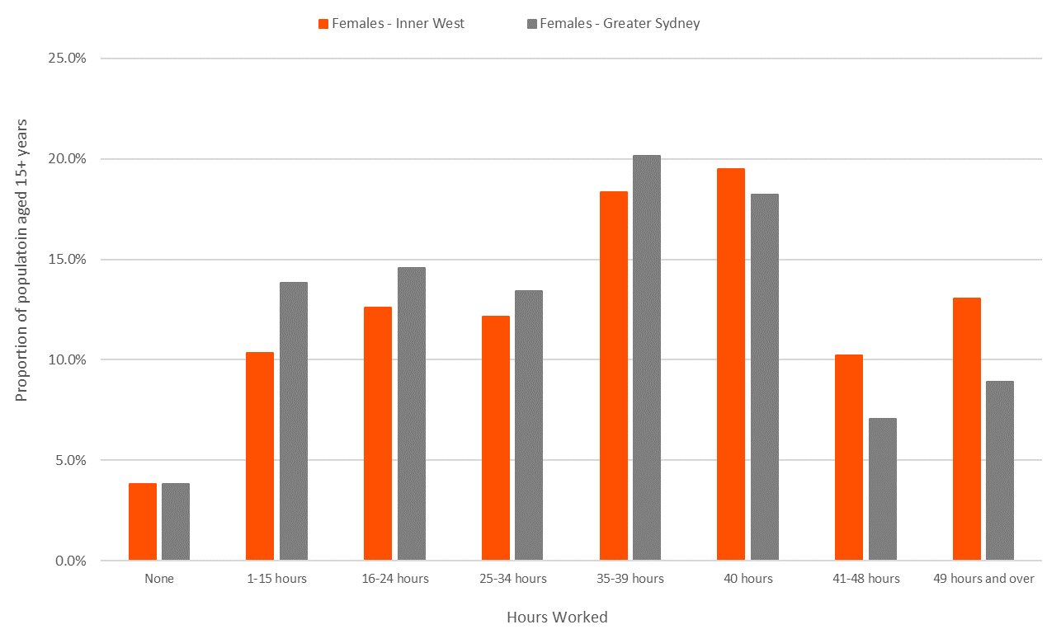
Chart 11 – Hours worked per week for employed Inner West women compared to Greater Sydney women, 2016

- The same proportion of both Inner West Council area and Greater Sydney women did not work any hours in the week leading up to Census night in 2016, with 3.8% of both groups in this category.
- A lower proportion of Inner West women worked less than 40 hours per week, with 53%, compared to 62% of Greater Sydney women who worked less than 40 hours. This is again related to part-time employment and the fact that a more significant proportion of Greater Sydney women worked in part-time employment (see chart 7).
- Almost 20% of Inner West women worked 40 hours per week, compared to 18% in Greater Sydney as a whole.
- A significantly higher proportion of Inner West women worked more than 40 hours per week than Greater Sydney - 23% compared to 16% in Greater Sydney.

Average hourly rates by occupation
Assessment of total individual income and hours worked are affected by employment status and whether an individual is employed part-time or full-time. Naturally, if more women are employed in part-time roles than males, their individual income statistics and hours worked will reflect this and hinder any comparison or ability to conclude equity or potential wage gaps.

An analysis technique that overcomes this issue is to compare the median salary and median hours worked of women and males in particular industries of employment. By creating a median “average hourly rate” per industry of employment for women and males, a comparison of income per hour worked is possible. This analysis is possible by creating an “hourly rate” with median personal incomes by industry per sex and median hours worked by industry per sex. The ten industries selected for this analysis represent 74% of Inner West’s total employed persons, that is – 81.5% of employed Inner West women and 73.9% of employed Inner West males.

Below are the results of this analysis for women and males in the Inner West Council area and a comparison of average hourly rates between Inner West women and Greater Sydney women.
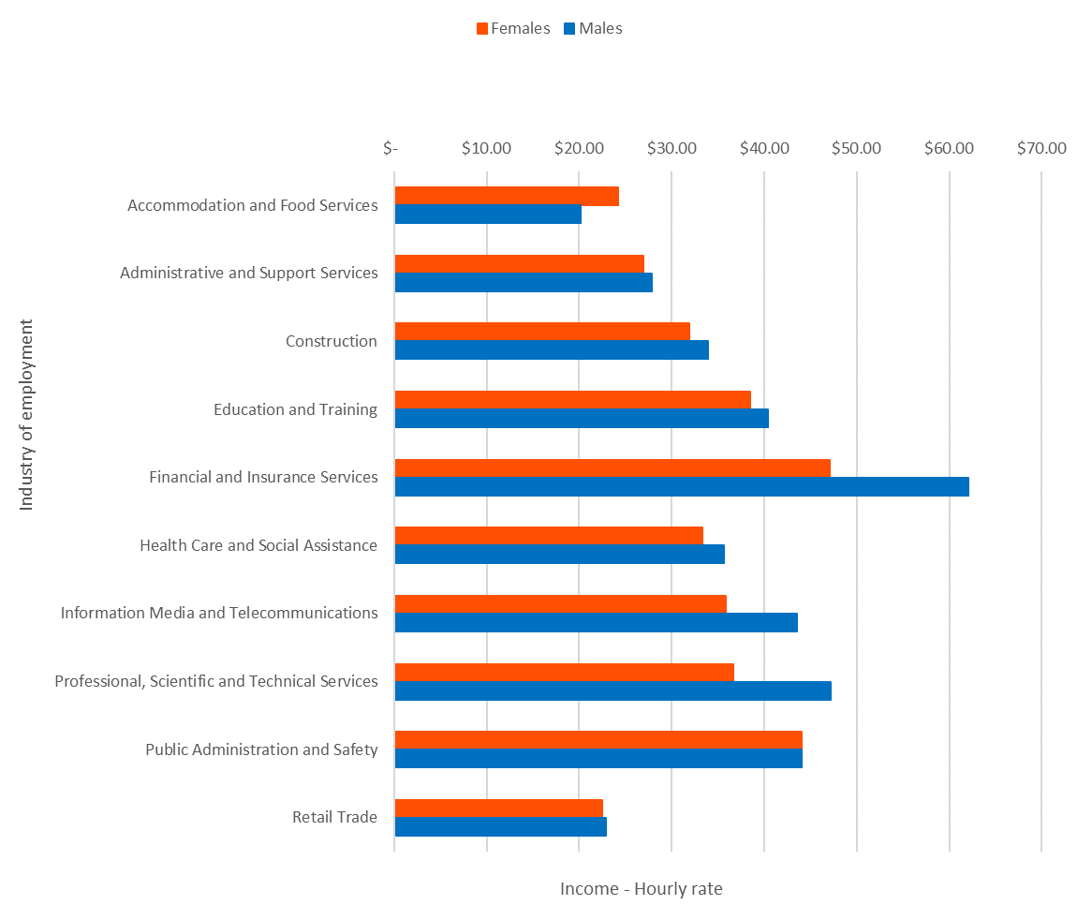
Chart 12 – Calculated hourly rates of income by industry for Inner West women and males, 2016
- Males receive a higher hourly rate than women in almost all employment industries in the Inner West Council area. The largest difference is in “Financial and Insurance Services” where employed Inner West male residents receive $62.03 compared to $47.08 for women, perhaps indicating that the job types within this industry are very different for women and males (e.g. employed males may be in higher, senior positions).
- Two other industries where the difference in women and male average hourly rates is significant are “Information, Media and Telecommunications” and “Professional, Scientific and Technical Services”. For more insight into the jobs included in these industry sectors, please visit: https://economy.id.com.au/inner-west/employment-by-industry.
- For many of the other selected industry sectors, employed male residents receive a higher hourly rate of income, but the differences are only between $1 and $2 per hour.
- The only selected industry where women receive higher average hourly rates than employed males is “Accommodation and Food Industry” with employed women receiving $24.20 per hour, compared to $20.16 for males.
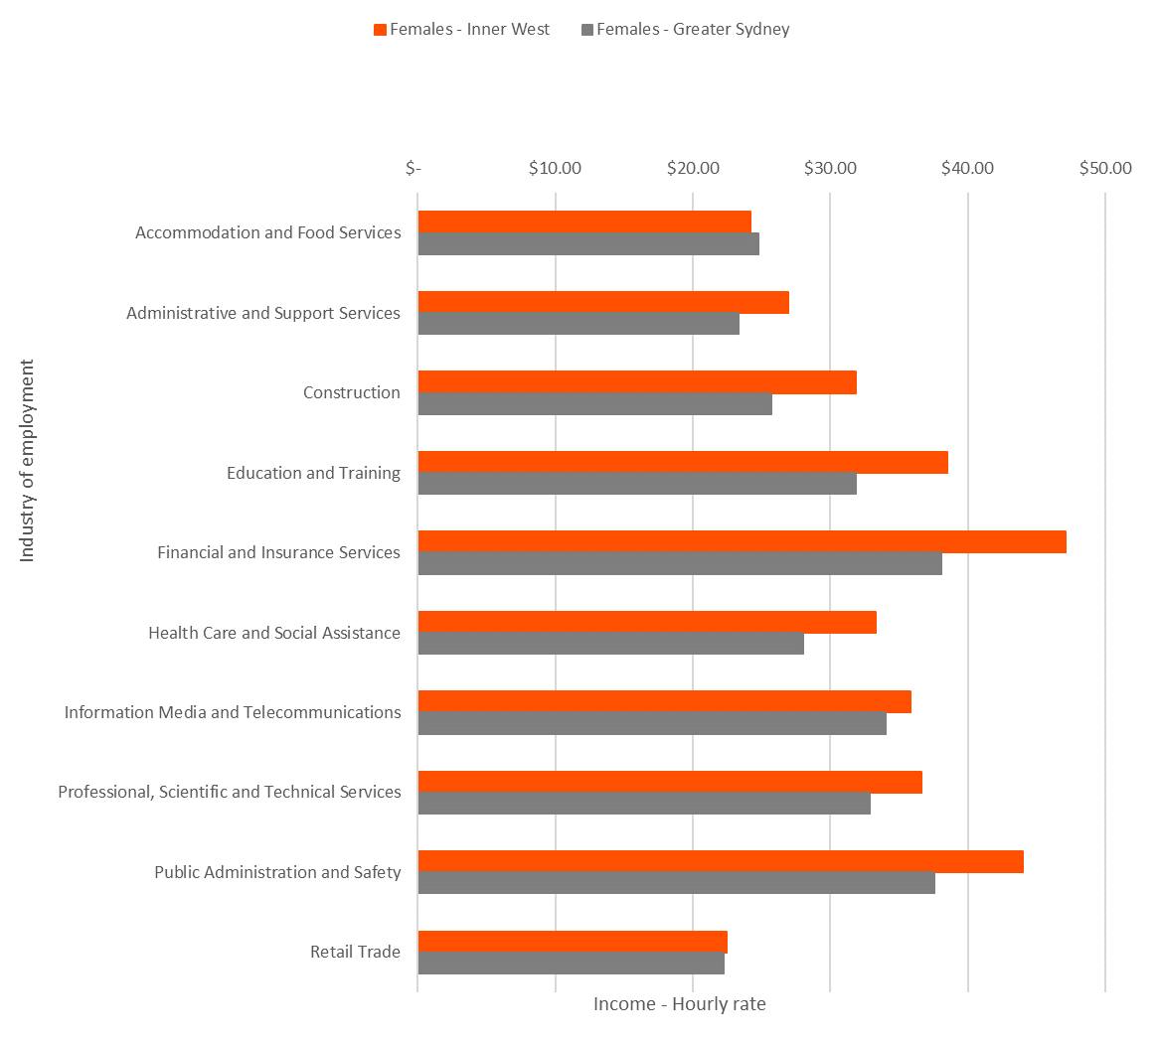
Chart 13 – Calculated hourly rates of income by industry for employed Inner West women compared to Greater Sydney women, 2016
- When comparing the average hourly rates of income of Inner West women and Greater Sydney women, Inner West women have higher hourly rates of personal income in almost all selected industries.
- The most significant differences are in the “Financial and Insurance Services”, “Education and Training”, “Public Administration and Safety” and “Construction” industries, where Inner West women receive, on average, $7.04 more per hour than women in those industries across Greater Sydney.
- The “Accommodation and Food Industry” is the only instance where Greater Sydney women receive a higher hourly rate than Inner West women, $24.75 per hour compared to $24.20 per hour for Inner West women.
- It should be noted that although Inner West women may receive higher hourly rates of individual income than Greater Sydney in most of the selected industries, this analysis does not consider expenses or any higher costs of living which Inner West women may have that could reduce some of the financial advantages.

Disengagement
Engagement in employment and education looks at the level of participation by age and sex of the labour market or full or part-time education. A full-time employed or full-time student would be "Fully engaged", while part-time students may be fully engaged if they are also employed or partly engaged if they are not working. Engagement in the labour and education market is highly dependent on age. Retirees are generally disengaged, while stay-at-home parents are also likely to be disengaged, by this definition. The rate of engagement, particularly in the younger and working age groups, can be affected by access to strong employment and education markets and a measure of socioeconomic status and welfare dependency in an area.

This section of the report assesses disengagement of Inner West women and male residents by age and focuses on youth disengagement.
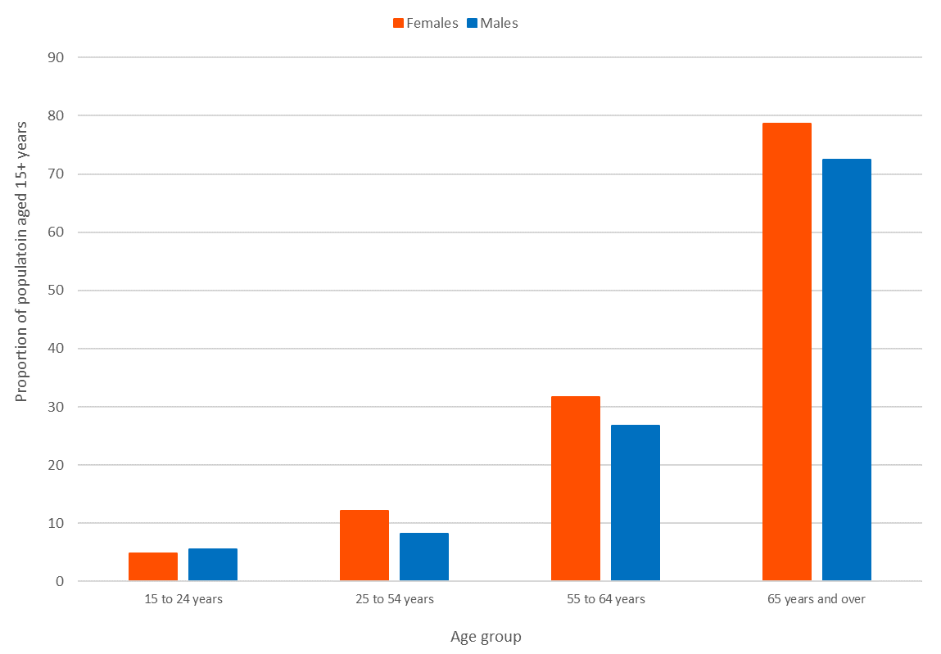
Chart 14 – Disengagement by age for Inner West women and male residents, 2016

- Overall, a higher proportion of women than males are disengaged in the Inner West Council area, with 24% of women aged 15+ years and 19% of males.
- Unsurprisingly, disengagement for both sexes is highest in the 65+ age group, as by definition, many retirees would be considered “disengaged”. Women, however, have a slightly higher representation in this age group, 79% compared to 73% for males, suggesting perhaps that some males remain in the workforce beyond 65 years of age.
- For younger age groups, disengagement is higher for males than women in the 15-24-year-old age group and higher for women in the 25-54 and 55-64 age groups. Disengagement in younger age groups is a concern, as it shows a lack of participation in the workforce or formal education. Large numbers of people in this category can indicate a lack of access to employment or education facilities or a population in need of targeted services to assist them in gaining a foothold in society.
- Disengagement of women aged 25-54 years is likely related to parental leave or disengagement from the workforce due to home childcare. Section 12 looks at childcare by sex in more detail.
- Higher disengagement of women aged 55-64 years could suggest difficulty in remaining in the workforce for women of this age.

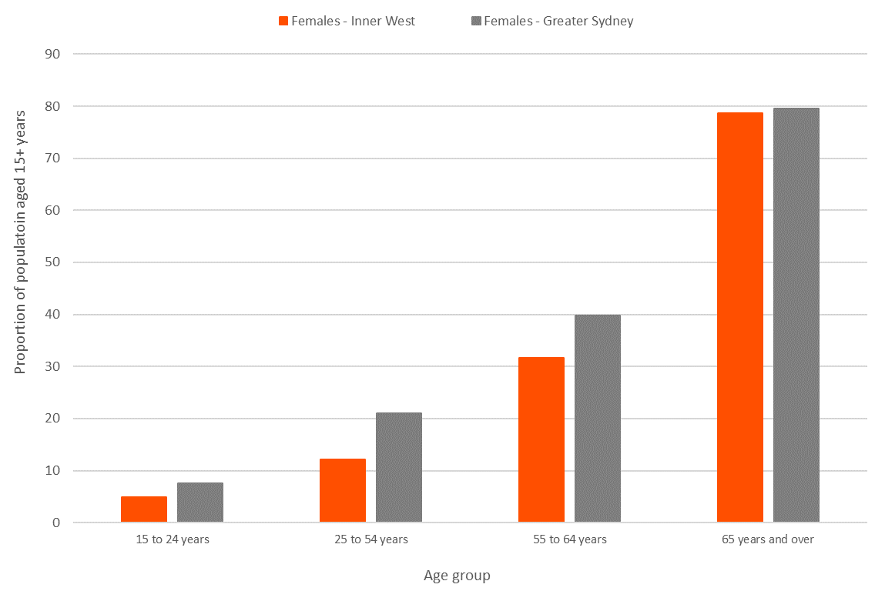
Chart 15 – Disengagement by age for Inner West women compared to Greater Sydney women, 2016

- Compared to Greater Sydney, Inner West women have a lower level of disengagement in the younger age groups and a similar level of disengagement in the “65 years and over” age group as Greater Sydney.
- In particular, disengagement of 25-54-year-old women in the Inner West Council area is much lower than that of women in Greater Sydney as a whole, with 12% of Inner West 25-54-year-old women disengaged, compared to 21% of women in Greater Sydney as a whole.

Provision of unpaid care
Unpaid care refers to the proportion of people aged 15 years and over providing unpaid care for the aged and disabled. It is an essential indicator of the value of unpaid work in the Inner West Council area and the potential level of demand for the government's aged and disability care services. An increasing proportion of carers among the population may indicate inadequate aged care provision, or the need for in-home support, or support for the carers themselves.

Provision of unpaid care | Women (total) | Males (total) | Women (%) | Males (%)
Provided unpaid assistance | 9,329 | 6,254 | 11.7% | 8.4%
No unpaid assistance provided | 63,649 | 61,271 | 79.8% | 82.3%
Not stated | 6,734 | 6,900 | 8.4% | 9.3%

Table 4 – Provision of unpaid assistance, Inner West women and males aged 15+ years, 2016

- A higher proportion of Inner West women than males provided unpaid assistance, with 11.7% of women and 8.4% of males aged over 15 years.

Provision of unpaid care | Women –  Inner West (%) | Women –  Gr. Sydney (%)
Provided unpaid assistance | 11.7% | 13.0%
No unpaid assistance provided | 79.8% | 79.2%
Not stated | 8.4% | 7.8%

Table 5 – Provision of unpaid assistance, Inner West women compared to Greater Sydney women (aged 15+ years), 2016

- A slightly higher proportion of Greater Sydney women provided unpaid assistance than Inner West women - 13%, compared to 11.7%.
- A lower proportion of Greater Sydney women provided “not stated” answers in the 2016 Census, hence why the “No unpaid assistance provided” proportions are similar for the two groups.

Provision of childcare
Many different factors determine the role of unpaid childcare. For example, areas with high levels of unpaid childcare may have a dominance of single-income families with one significant earner. There could be a lack of provision of paid childcare in the area. The Census question asks explicitly respondents to differentiate between caring for their own children and caring for others’ children. The level to which people care for others’ children can also indicate extended family roles (e.g., grandparents caring for grandchildren, family daycare).
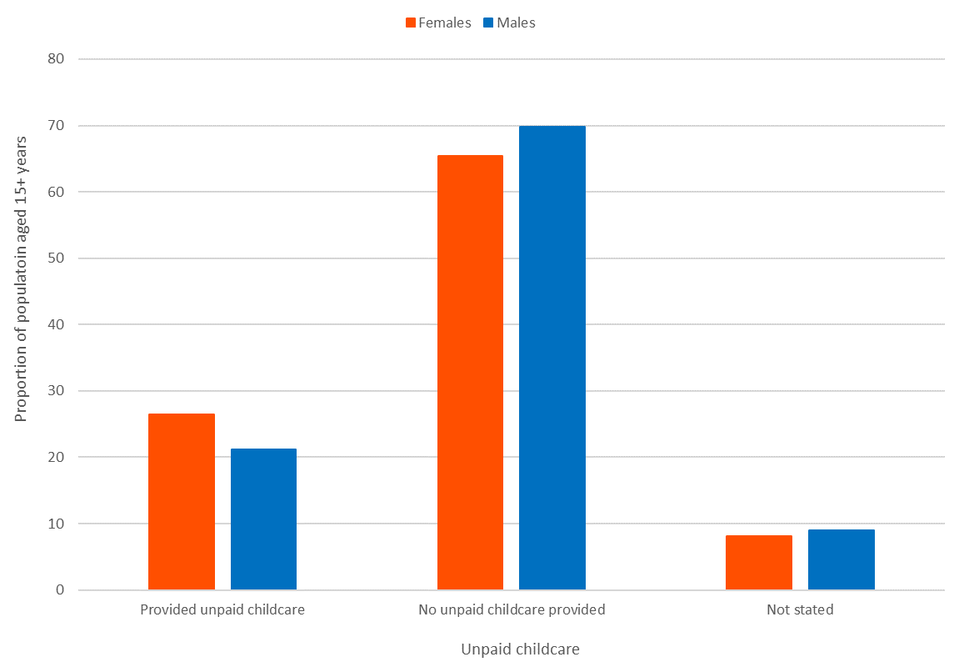
Chart 16 – Provision of childcare by women and males age 15+ in the Inner West Council area, 2016

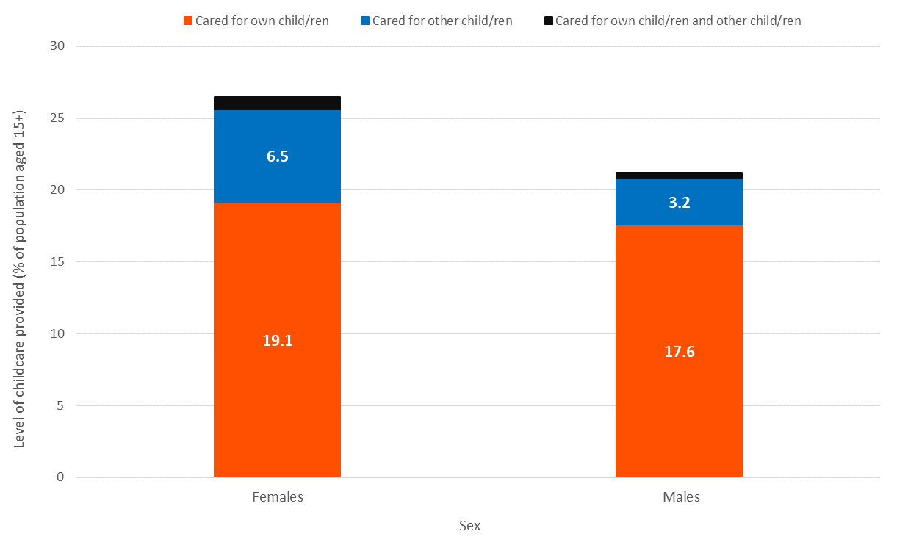
Chart 17 – Level of childcare provided by Inner West women and males, 2016

- A more significant proportion of women provided childcare in the Inner West Council area, with 27% of all women aged 15+, compared to 21% of males.
- The most common type of childcare for both women and males is caring for their own children, with 19.1% of Inner West women and 17.6% of all males aged over 15 years providing childcare for their own children.
- A notably higher proportion of women provide childcare for other child/ren. This includes grandmothers, aunties, women guardians or even women non-family members who provide childcare for other people’s children. A much smaller proportion of males provides care for others’ children.
- A very low proportion of Inner West women and males provide childcare for their own and others’ children.

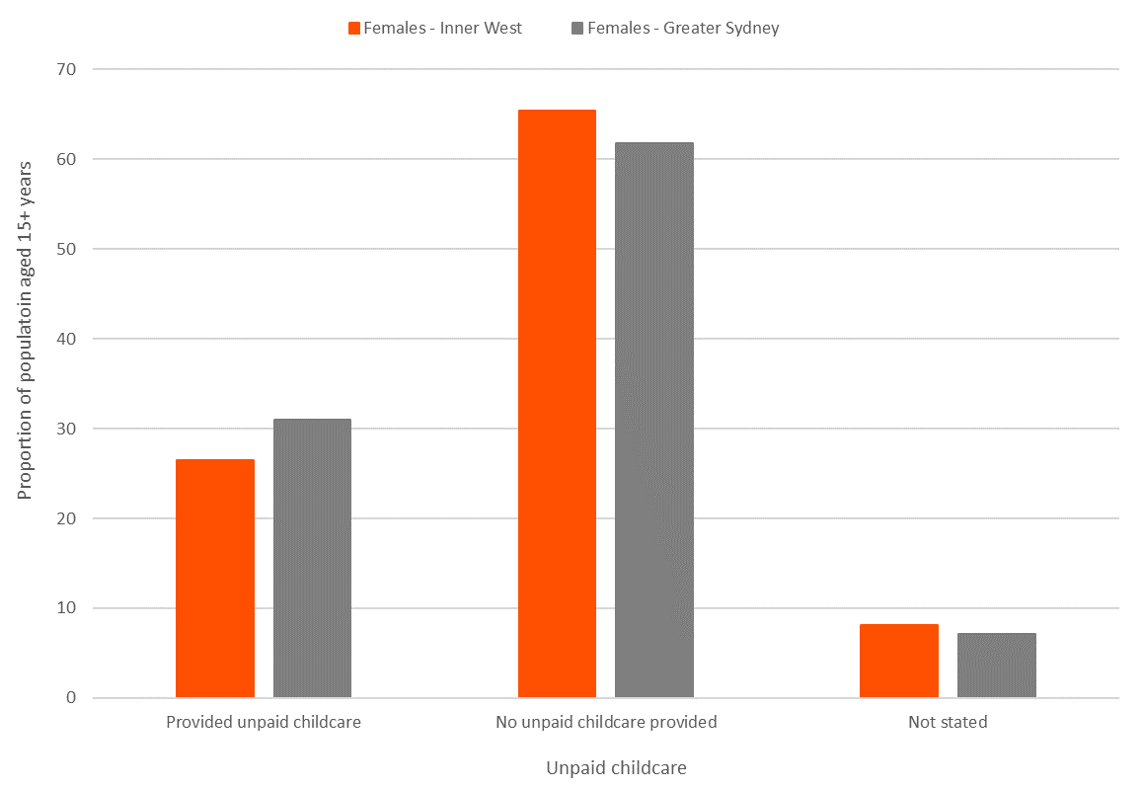
Chart 18 – Provision of childcare by Inner West women compared to Greater Sydney women, 2016

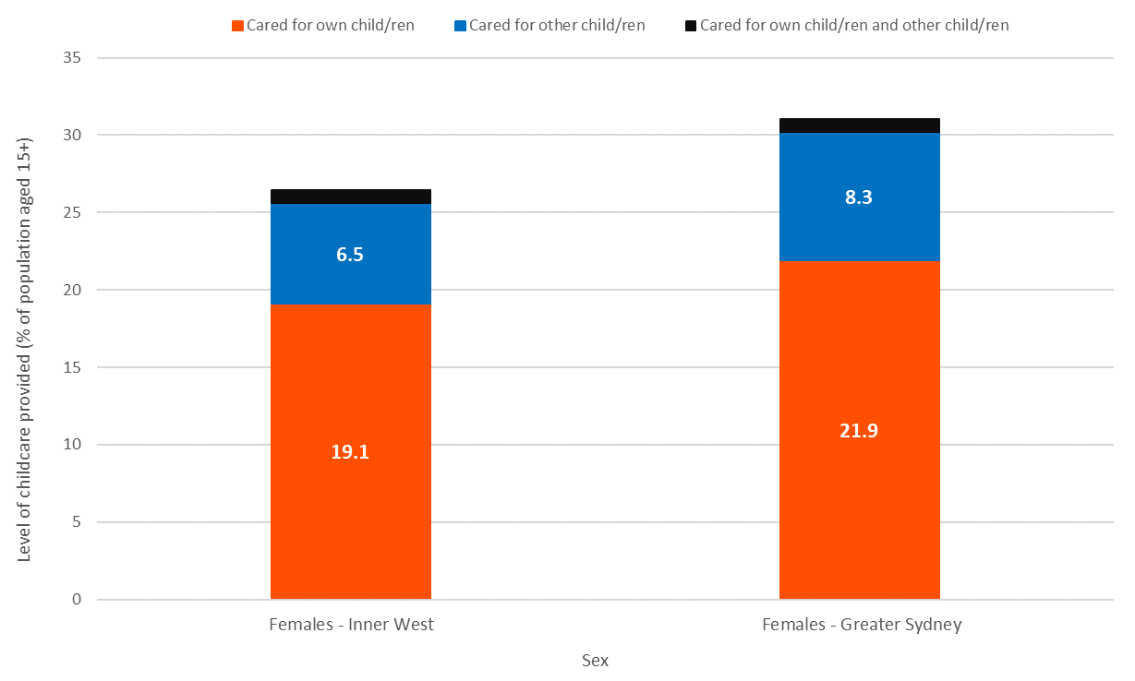
Chart 19 – Level of childcare provided by Inner West women compared to Greater Sydney women, 2016

- Childcare characteristics of Inner West women are similar to those of Greater Sydney women. A similar proportion provides childcare – 27% of Inner West women and 31% of Greater Sydney women.
- A slightly higher proportion of Greater Sydney women provided childcare for their own child/ren than Inner West women and provided childcare for other child/ren.

Proficiency in English
Proficiency in English measures the self-assessed proficiency in spoken English of people who speak a language other than English at home. This kind of information helps service providers determine whether they need to communicate with the local population in languages other than English. When assessed through a gender/sex lens, this information can show if one sex could be experiencing more disadvantage or difficulty communicating if their English proficiency differs significantly from the other sex.

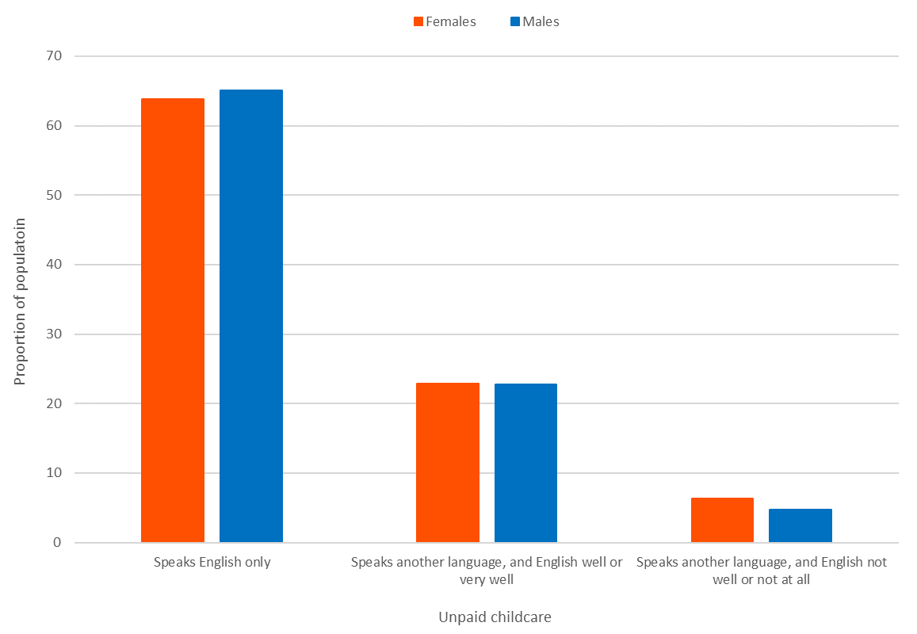
Chart 20 – Proficiency in English for Inner West women and males, 2016

- A very similar proportion of women and males speak English only in the Inner West Council area, with 64% of women and 65% of males. A very similar proportion also speak another language and also speak English “well or very well”.
- The only notable difference is in the category of residents who speak another language and do not speak English well or at all, with 6.4% of women and 4.7% males.

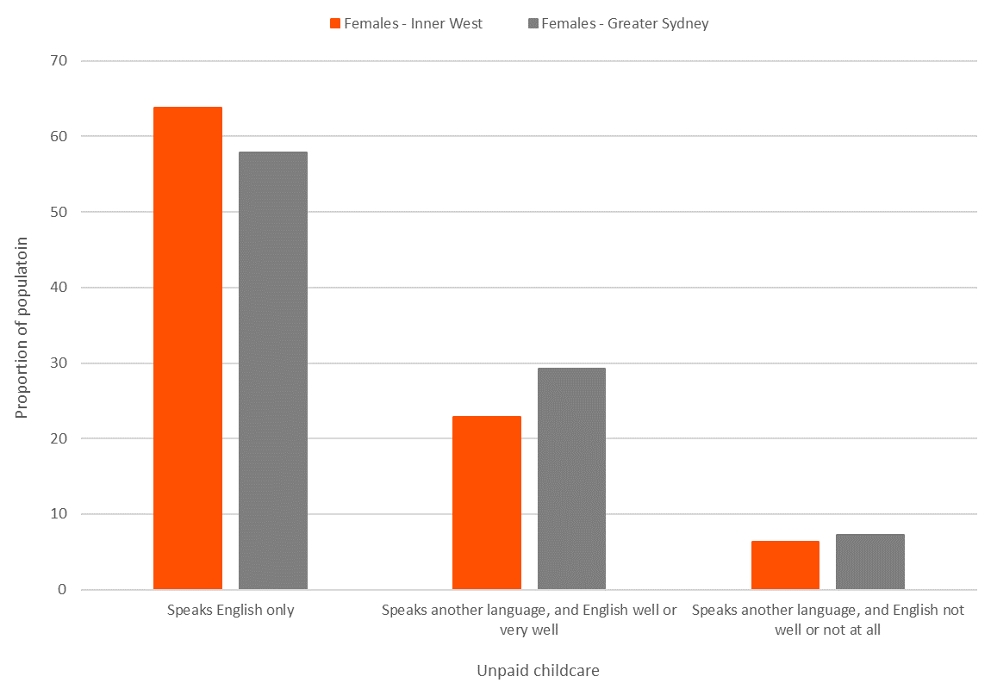
Chart 21 – Proficiency in English for Inner West women compared to Greater Sydney women, 2016

- Compared to Greater Sydney, a higher proportion of Inner West women speak English only, with 64% compared to 58% of Greater Sydney women.
- A lower proportion of Inner West women speak another language and English well or very well – 23% compared to 29% for women in Greater Sydney as a whole.
- A similar proportion of Inner West and Greater Sydney women speak another language and English not well or not at all – 6.4% compared to 7.2% for Greater Sydney.

Highest level of secondary schooling
School completion data is a valuable indicator of socioeconomic status. The information advises planners and decision-makers about people's ability to access services. Combined with Educational qualifications (next section) it also allows assessment of the skill base of the population. Evaluation of this information by sex could reveal some discrepancies and differences which may need to be addressed.

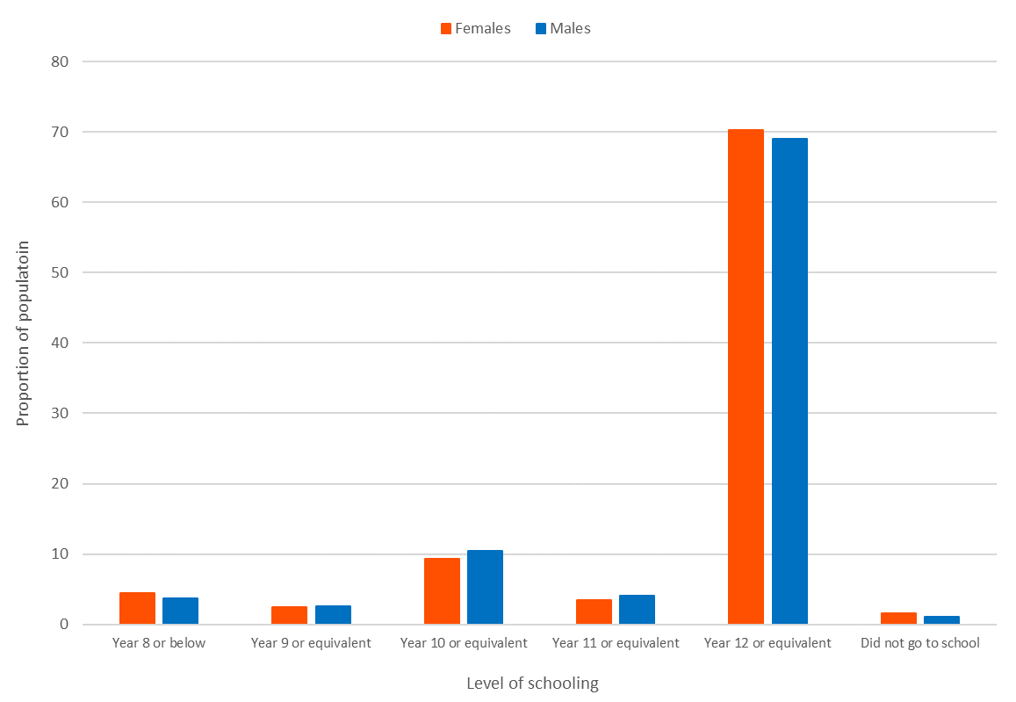
Chart 22 – Highest level of schooling for Inner West women and males, 2016

- The highest level of schooling statistics for Inner West women and males are quite similar. An almost identical proportion of women and males completed Year 12 – 70% of women and 69% of males.
- Almost 20% of women and 21% of males in the Inner West Council area have the highest level of secondary schooling below Year 12.
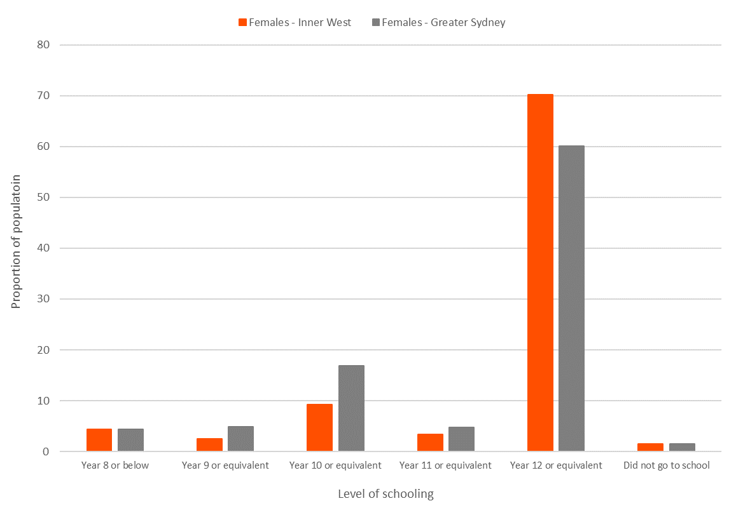
Chart 23 – Highest level of schooling for Inner West women compared to Greater Sydney women, 2016

- Compared to Greater Sydney, a higher proportion of women in the Inner West Council area have Year 12 as their highest level of secondary school completion, 70% compared to 60% for Greater Sydney.
- Although the second-highest level of secondary school completion for both the women residents of Inner West and Greater Sydney is Year 10, the proportions are quite different. Only 9% of women in the Inner West Council area stated Year 10 as their highest school completion level compared to 17% for Greater Sydney.
- Overall, a significantly higher proportion of women in Greater Sydney had the highest levels of secondary schooling below Year 12, with 31%, compared to 20% in the Inner West Council area.

Education qualifications
Educational qualifications relate to education outside of primary and secondary school and are among the most important indicators of socioeconomic status. With other data sources, such as employment status, income and occupation, educational qualifications, help evaluate the area's economic opportunities and socioeconomic status and identify skill gaps in the labour market. As with the previous section, assessing this information by sex could reveal some discrepancies and differences that may need to be addressed.

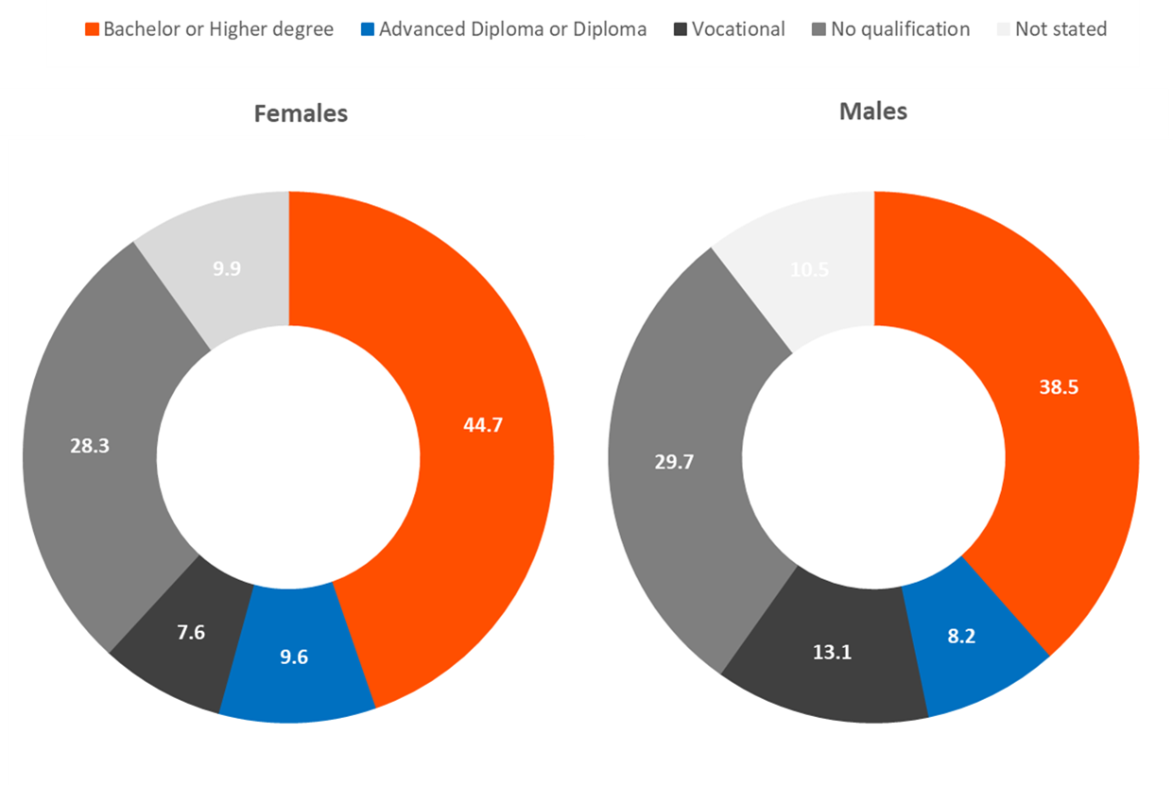
Chart 24 – Education qualifications for women and males in the Inner West Council area, 2016

- Women are more highly educated than males in the Inner West Council area. Almost 45% of women aged 15+ have a Bachelor or Higher Degree qualification compared to 38.5% of males, and almost 10% of women have an Advanced Diploma/Diploma, compared to 8.2% of males.
- A higher proportion of male residents have Vocational qualifications than women in the Inner West Council area, with 13.2% of males and 7.6% of women in this education qualifications category.
- Lastly, a similar proportion of women and males are represented in the “No qualifications” category, which includes anyone over the age of 15 who is currently in the process of obtaining a qualification as well as those residents over the age of 15 who have not gained any qualifications.

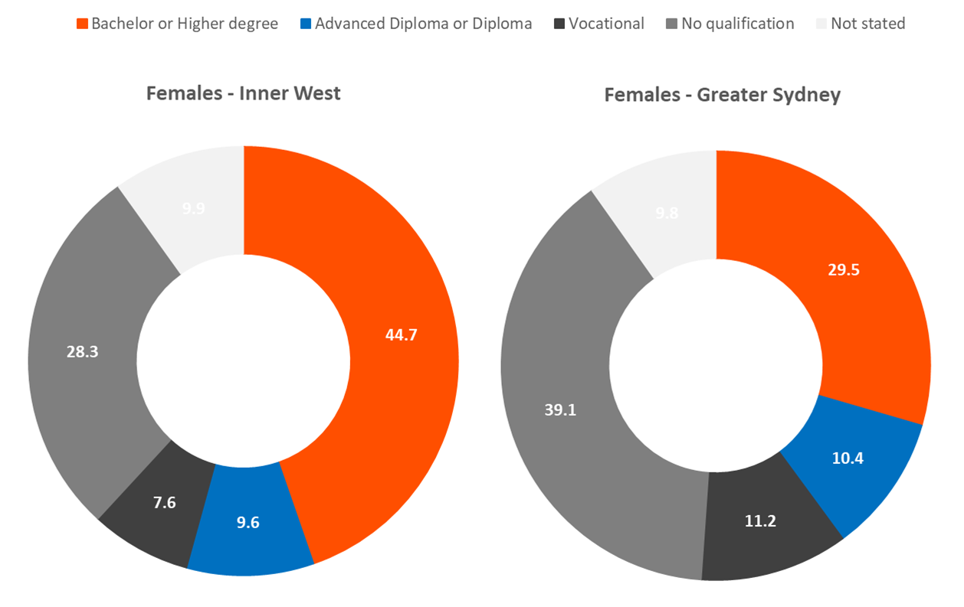
Chart 25 –Education qualifications for women in the Inner West Council area compared to Greater Sydney, 2016

- A significantly higher proportion of women in the Inner West Council area have Bachelor or higher degree qualifications than Greater Sydney overall, with 44.7% in the Inner West Council area than 29.5% in Greater Sydney.
- A similar proportion of women in the Inner West Council area and Greater Sydney have Advanced Diploma/Diploma qualifications. In contrast, a higher proportion of women in Greater Sydney have Vocational qualifications, 11% compared to almost 8% in the Inner West Council area.
- A significantly higher proportion of women in Greater Sydney have no qualification, with 39% in this category, compared to just over 28% of women aged 15+ years in the Inner West Council area.

One parent families
One parent families are a household type that may experience challenges with socioeconomic wellbeing, income levels or childcare. As a whole, 7.9% of Inner West’s households are one-parent families. This is slightly lower than the Greater Sydney proportion, which is 10.4% of all households. Women as parents are overrepresented in this household type. Along with some other disadvantageous demographic characteristics, such as lower personal incomes, this data can highlight precisely how different one parent family makeup is in the Inner West Council area and how that compares to Greater Sydney.
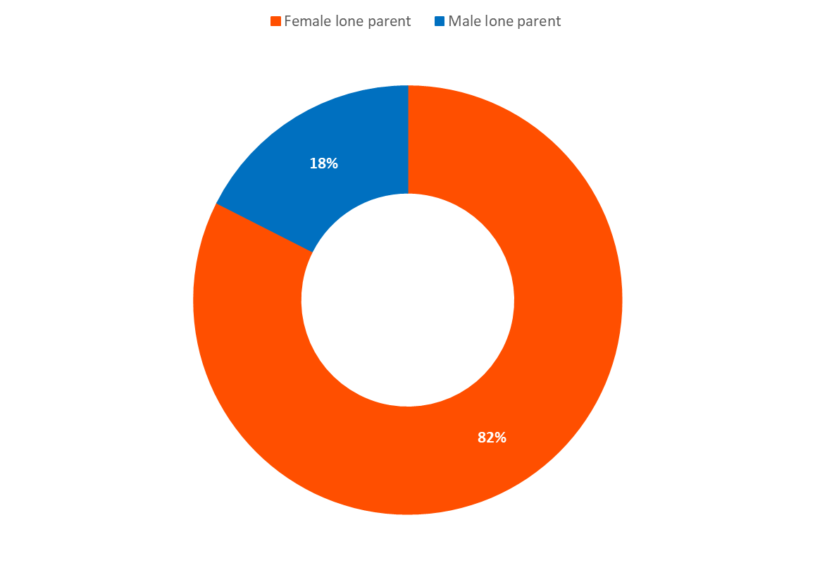
Chart 26 –One parent families by sex of the lone parent, Inner West Council area, 2016

- In 2016, over 5,000 (5,042) one parent families had a women as the lone parent and 1,071 had a male as the lone parent. This equates to 82% of one-parent households with women as parents, a significantly more significant proportion of all one-parent households than males.

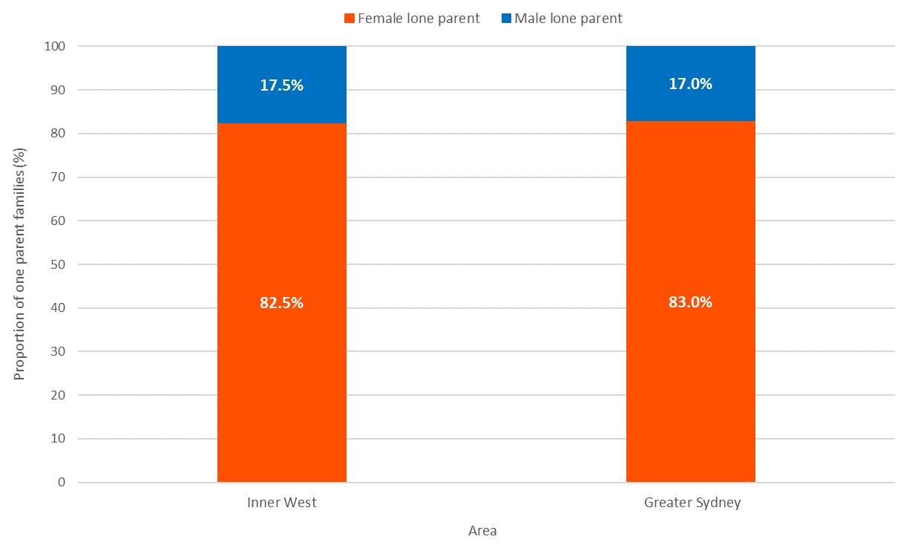
Chart 26 –One parent families by sex of lone parent in the Inner West Council area compared to Greater Sydney, 2016

- The proportions of one-parent families who are women are almost identical in the Inner West Council area in Greater Sydney. Both places record significantly higher proportions of one-parent families who are women.

One parent families in housing stress
A potential disadvantage for one parent families' is housing stress, which is defined as households in the lowest 40% of incomes who are paying more than 30% of their usual gross weekly income on housing costs. These housing costs include payments on home loans or paying rent.

Overall, housing stress levels in the Inner West Council area are lower than that of Greater Sydney, with 8.7% of Inner West households experiencing housing stress (as at 2016), compared to 11.8% of Greater Sydney households. This section assesses housing stress for one-parent families, by sex of the lone parent.

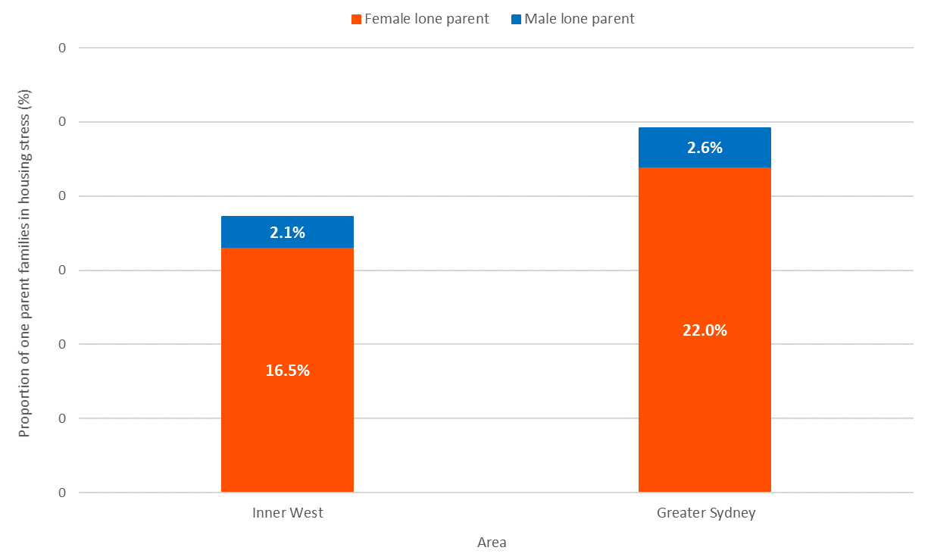
Chart 27 – One parent families in housing stress, by sex, for the Inner West Council area and Greater Sydney, 2016

- In 2016, there were 1,096 one parent families experiencing housing stress in the Inner West Council area. This represents 19% of all one-parent families.
- One parent families with women parents experiencing housing stress represented 16.5% of all one-parent family households. This was a much more significant proportion than one-parent families with male parents experiencing housing stress, making up only 2.1% of all one-parent families.
- In Greater Sydney, 22% of all one-parent families were composed of one parent families with women parents experiencing housing stress, a higher proportion than in the Inner West Council area.
- In both the Inner West Council area and Greater Sydney, women one-parent families were significantly overrepresented in housing stress statistics.

Lone person households
Lone person households are a household type that has different implications depending on age. Younger lone person households may be students or young professionals renting an apartment with no socioeconomic disadvantage. However, older lone person households may be living alone if a partner has passed away and could be experiencing some difficulties with daily tasks, financial difficulties, or other challenges. As women live longer than males, it is expected that a large proportion of lone person households in the older years are women. This section compared the total lone person household figures by sex for the Inner West Council area, compares them to Greater Sydney and then assessed the proportion of women and male lone person households by age.

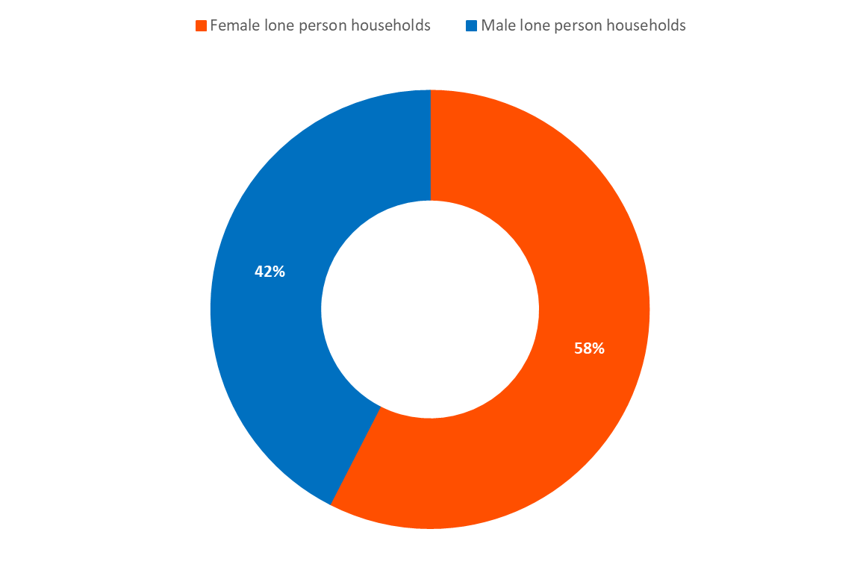
Chart 28 – Lone person households for women and males in the Inner West Council area, 2016

- Almost 60% of lone person households are occupied by women residents in the Inner West Council area. In absolute terms, this was 11,678 households in 2016, compared to 8,619 male lone person households.
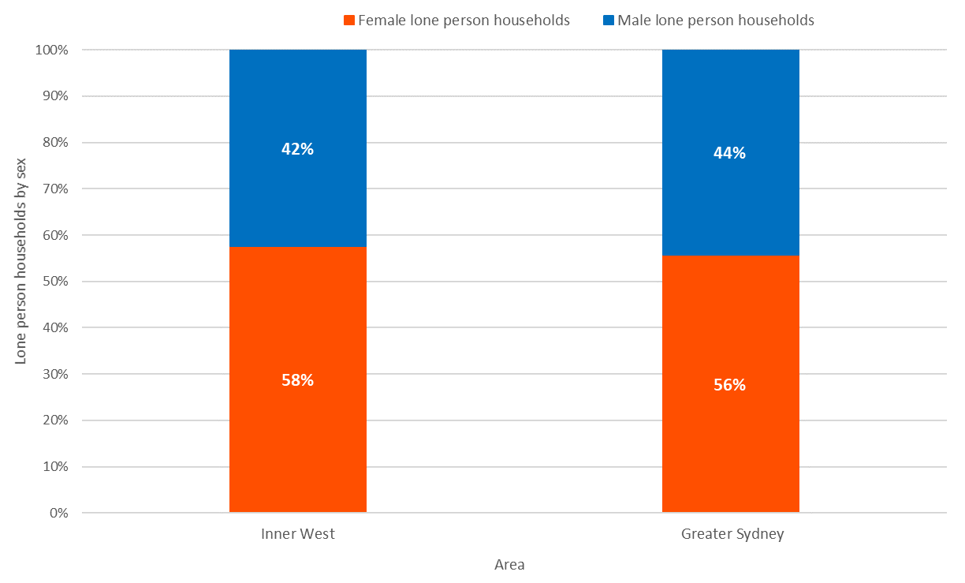
Chart 29 – Lone person households for women and males in the Inner West Council area compared to Greater Sydney, 2016
- The proportions of lone person households with women compared to male residents are similar in the Inner West Council area and Greater Sydney.
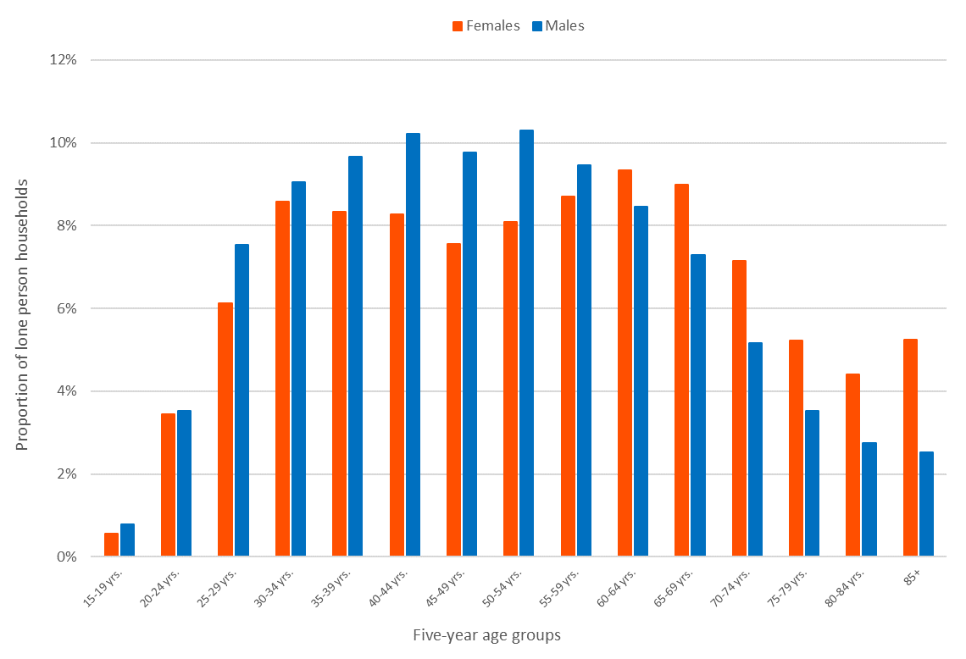
Chart 30 – Lone person households by age and sex, Inner West Council area, 2016
- Chart 30 illustrates the proportion of lone person households by age group and sex. In younger age groups, especially 35-54, a larger proportion of males live in lone person households than women. Slightly more than 10% of male lone person households have residents aged 50-54 years, for example, compared to 8% of women lone person households in this age group.
- In older age groups, namely above the age of 65, there is a higher representation of women, with 31% of all women lone person households having residents older than 65 years, compared to 21% of males.
- The proportions are most noticeable in the 85+ age group, where 5% of all women lone person households are in this age group, compared to 3% for male lone person households.

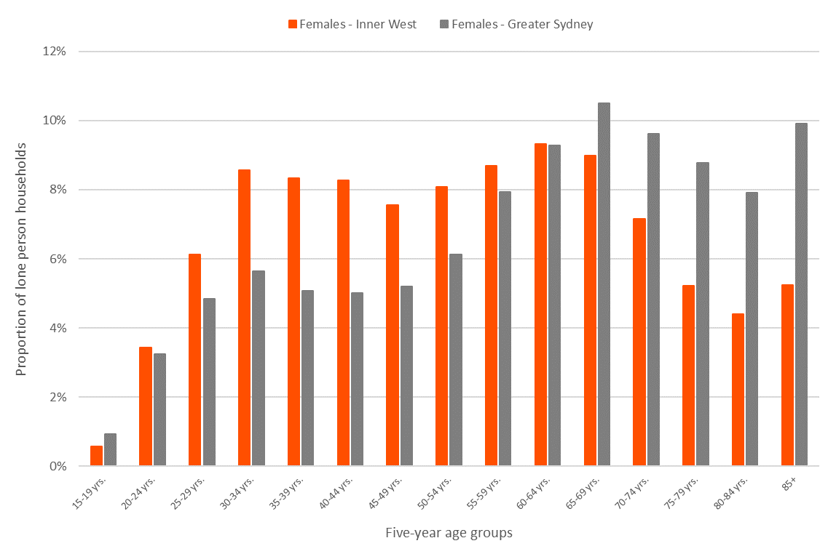
Chart 31 – Lone person households by age for women in the Inner West Council area compared to Greater Sydney, 2016

- Compared to Greater Sydney, there is a much higher proportion of younger lone person households in the Inner West Council area, with 69% of all women lone person households having residents younger than 65 years as occupants. In Greater Sydney, this proportion is 53%.
- On the other hand, Greater Sydney has a much higher proportion of older women lone person households, with 47% of all women lone person households having residents older than 65 years as occupants, compared to 31% in the Inner West Council area.
- The oldest age group of 85 years and over contains only 5% of all Inner West women lone person households, whereas in Greater Sydney, 10% of all women lone person households have residents of this age as occupants.

Residents in non-private dwellings
Non-private dwellings, in statistical terms, refer to dwellings that provide a communal form of accommodation such as hotels, motels, prisons, nursing homes, hospitals, army barracks, staff quarters, boarding houses, homeless shelters, youth hostels and ski Lodges. In most areas, non-private dwellings statistics refer to residents living in boarding houses (if younger) and in nursing homes (if older).

Assessment of non-private dwelling statistics for the Inner West Council area by age and sex reveals whether there are any over-representations of women or males living in non-private dwellings. In the Inner West Council area, 2.5% of women (2,346 residents) and 3.4% of males (3,018 residents) live in non-private dwellings. In Greater Sydney, the proportions of residents living in non-private dwellings are slightly higher, with 3% of women and 3.5% of males living in non-private dwellings.

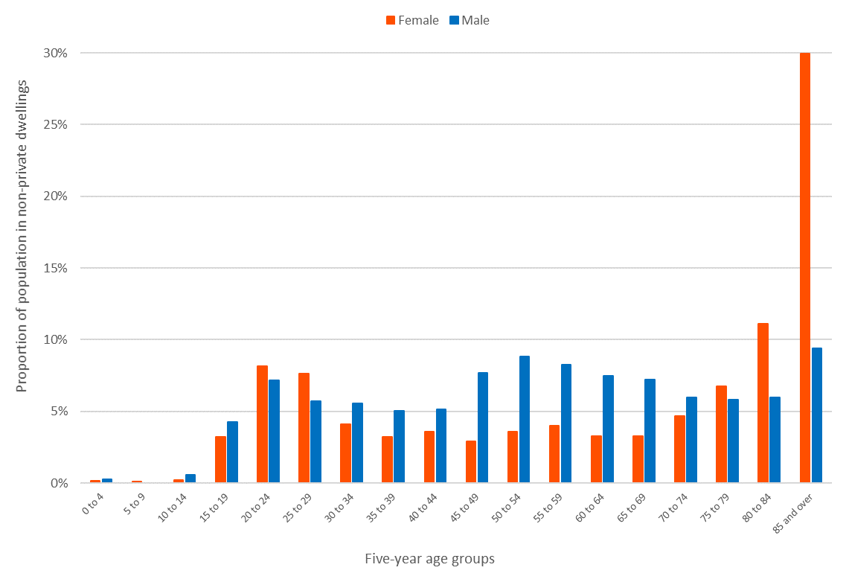
Chart 32 – Population in non-private dwellings by age and sex, Inner West Council area, 2016

- Most women living in non-private dwellings are older women aged 80 years and over and represent people living in nursing homes/aged care facilities. A total of 41% of women living in non-private dwellings are aged 80 years and over, compared to 15% of males living in non-private dwellings. This is closely related to the age structure of women and the fact that women live longer than males. Another likely reason for a significantly higher proportion of older women living in nursing homes/aged care facilities is that older lone women will move into aged care if their male partners pass away.
- Most male residents of the Inner West Council area who live in non-private dwellings are aged 45-64 years, with 32% of all males in non-private dwellings in this age cohort, compared to only 14% of women.

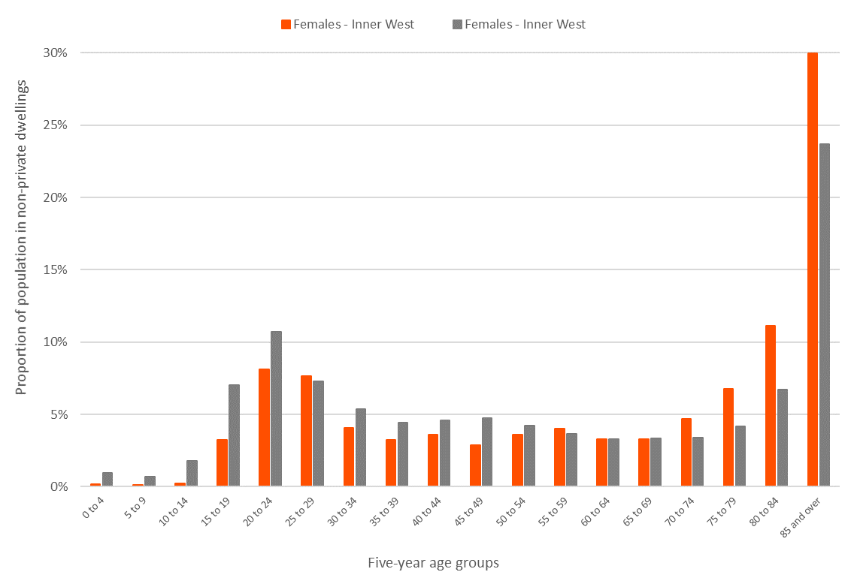
Chart 33 – Population in non-private dwellings by age for women in the Inner West Council area compared to Greater Sydney, 2016

- The statistics for women aged 15-24 years living in non-private dwellings show a higher proportion for Greater Sydney than the Inner West Council area, with 18% of Greater Sydney women living in non-private dwellings being of this age, compared to 11% in the Inner West Council area. This is related to tertiary education and the uptake of student accommodation and/or student boarding houses.

- Compared to Greater Sydney, Inner West women living in non-private dwellings have a higher representation in older age groups. This is not related to the age structure. As illustrated in section 3, Greater Sydney has a higher proportion of the women population aged over 80 years than the Inner West Council area. This higher “uptake” of nursing homes/aged care facilities by women in the Inner West Council area could be related to the ability to afford such accommodation and also perhaps availability of and proximity to several nursing aged care facilities in the area, thus making living in aged care facilities more accessible to Inner West women.

Residents living in temporary accommodation
Understanding the proportion of residents who live in temporary accommodation, hostels for the homeless, night shelter or other refuges helps understand if this is a significant problem in the area and for this project – if one sex is more highly represented in the statistics than the other.

In 2016, 340 Inner West Council area residents were recorded as living in hostels for the homeless, night shelters, refuges and other welfare institutions. While this number represents only 0.2% of the Inner West Council area’s population as of 2016, there are significant differences in the women and male breakdowns.

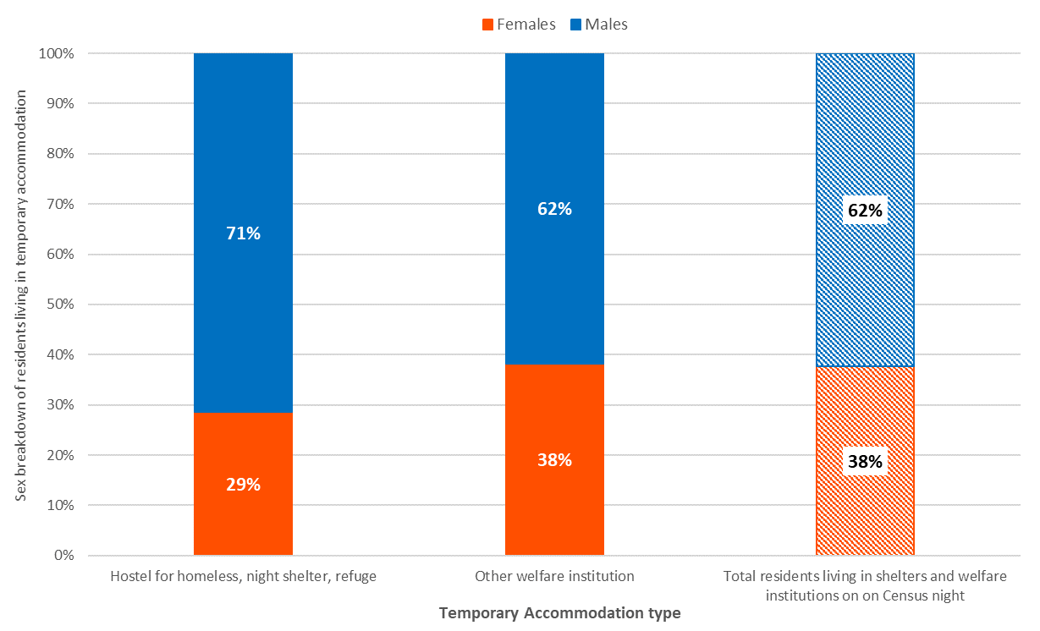
Chart 34 – Residents living in temporary accommodation, for women and males in the Inner West Council area, 2016.

- Most Inner West Council area residents who live in different types of temporary accommodation are males. For all types of temporary accommodation, 62% of residents are male and 38% women.

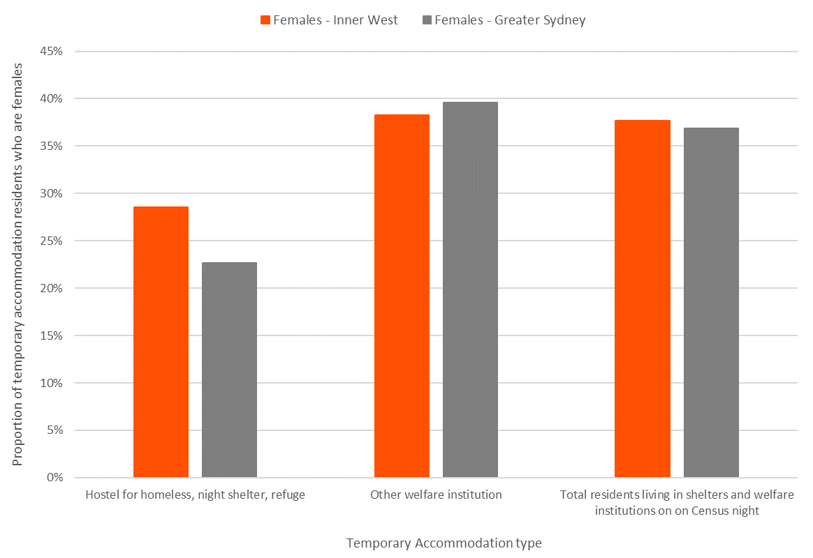
Chart 35 – Comparison of women temporary accommodation residents in the Inner West Council area compared to Greater Sydney, 2016

- An almost identical proportion of temporary accommodation residents are women in the Inner West Council area than in Greater Sydney. The most considerable difference is in the sex makeup of people who live in hostels for the homeless, night shelters of refuges – where in the Inner West Council area, 29% of residents in this temporary accommodation are women compared to 23% in Greater Sydney.

Summary of findings
Research into the differences between women and males in the Inner West Council area, from a socioeconomic and demographic perspective, reveals that women here are more disadvantaged than males in most cases. On the other hand, when compared to women in Greater Sydney as a whole, the socioeconomic statistics of Inner West women are better and show a higher level of advantage. As explained several times, however, many factors, including the cost of living in the Inner West Council area are not considered and may reduce some of these apparent advantages.

Compared to males in the Inner West Council area, women residents are:
- Older,
- More likely to need assistance due to disability (especially in older age),
- Less likely to be employed full-time,
- Less likely to work more than 40 hours per week,
- More likely to be employed in sectors such as “Health care and social assistance”,
- Less well-off from both an individual income and hourly rate perspective,
- More disengaged from employment and education,
- More likely to provide unpaid assistance/care and
- More likely to provide unpaid childcare to their own children as well as others’ children,
- No more diverse from an English proficiency perspective,
- More educated with larger proportions having higher tertiary qualifications,
- Much more represented in one-parent family statistics and
- More likely to be experiencing housing stress as a lone parent,
- More likely to be living in non-private dwellings at an older age and
- Less likely to be living in temporary accommodation.

However, when compared to women in Greater Sydney overall, Inner West women are:
- Younger,
- Almost as likely to need assistance due to disability,
- More likely to be employed full-time,
- More likely to work above 40 hours per week,
- Less likely to work in industries such as “Retail trade” or “Health care and social assistance”,
- More well-off, from both an individual income and hourly rate perspective,
- Less disengaged from employment and education, especially in the younger age groups,
- Less likely to provide unpaid assistance/care and
- Slightly less likely to provide unpaid childcare to their own children as well as others’ children,
- Less diverse from an English proficiency perspective,
- More educated at high school and higher education levels,
- Equally represented in one-parent family statistics and
- Less likely to be experiencing housing stress as a lone parent
- More likely to be living in non-private dwellings, especially at an older age and
- As likely to be living in temporary accommodation.

The findings from the comparison of demographic and socioeconomic characteristics of women and males will assist Inner West Council with creating the “Gender Equity” strategy and allow for informed decisions to be made.

About .id
.id’s team of population experts combine an in-depth knowledge of people and places with interactive web applications to help organisations decide where and when to locate their services to meet changing needs.
The .id team have an incredible curiosity and knowledge about the way in which people organise themselves into communities and cities. We are driven by a strong desire to contribute to the development of a good society where everyone has access to housing, education, employment, social & political inclusion, culture, health, recreation and information.

Because of our passion for society, we are excited by the projects we engage in, and genuinely interested in the outcomes. This means we work very closely with our clients on scoping projects. We design projects that are pointy, practical and achievable. We draw meaning from data to provide insights that inject conﬁdence into the decision-making process.

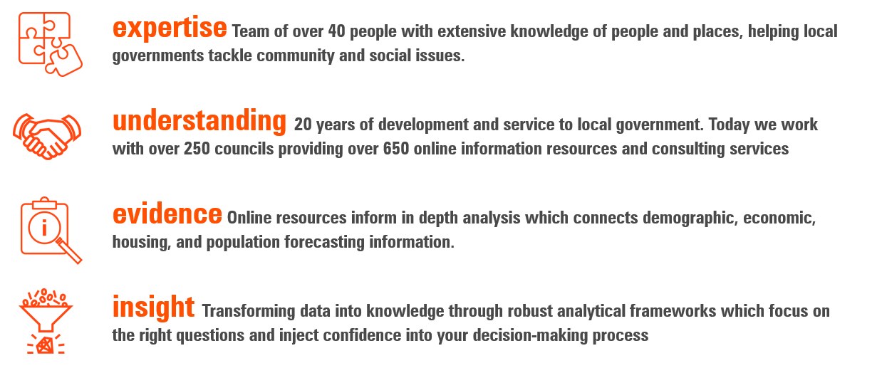

Disclaimer and Copyright notice

Disclaimer
This Report is prepared only for use by the person/entity who commissioned the Report and may only be used for the purpose for which it was commissioned. .id accepts no liability in connection with the recipients use or reliance on the Report.

The content of much of this Report is based on ABS Data. ABS Data and the copyright in the ABS Data remains the property of the Australian Bureau of Statistics. The source ABS Data may be accessed from www.abs.gov.au, and may be used under license on terms published on the ABS website. In relation to ABS Data .id accepts no liability with respect to the correctness, accuracy, currency, completeness, relevance or otherwise of the ABS Data.

Some content in this Report is based on Third Party Content, which .id interprets, transforms and/or reconfigures for the Report. In relation to the Third-Party Content, .id gives no warranty nor bears any liability whatsoever with respect to the correctness, accuracy, currency, completeness, relevancy or otherwise of the Third-Party Content.

Copyright Notice
This Report and all material contained within it is subject to Australian copyright law. Copyright in all such material [excluding ABS Data & other data or information where ownership by a third party is evident] is owned by .id Consulting Pty Ltd ACN 084 054 473. Other than in accordance with the Copyright Act 1968 or as specifically agreed between .id and the Client, no material from this Report may, in any form or by any means, be reproduced, stored in a retrieval system or transmitted, without prior written permission from .id. Any enquiries regarding the use of this Report should be directed to info@id.com.au or 03 9417 2205.

copyright © 2021 .id Consulting Pty Ltd ACN 084 054 473 All rights reserved.

Our Watch (2015). Change the story: a shared framework for the primary prevention of violence against women and their children
Dhatt, R, Theobald, S. Buzuzi, S., Ros, B, Vong, S., Muraya, K, Molyneux, S., Hawkins, K. Gonzalez-Beiras, C., Ronsin, K., Lichtenstein, D., Wilkins, K., Thompson, K., Davis, K., Jackson, C. (2017). The role of women's leadership and gender equity in leadership and health system strengthening. Women in Global Health, 2(8).
Our Watch (2015). Change the story: a shared framework for the primary prevention of violence against women and their children
Workplace Gender Equality Agency (2021). Australia's Gender Pay Gap Statistics 2021.
the Office for Women’s Policy NSW Department of Premier and Cabinet (2010). Profile of Women’s Employment in NSW: Trends and Issues (final Report)
Workplace Gender Equality Agency (2021). Australia's Gender Pay Gap Statistics 2021.
World Economic Forum (2020). Global Gender Gap Report 2020.
Australian Government (2017). Workforce participation rates for women with disability. Department of Employment
J Syed and P Murry, Combating the English Language Deficit: the labour market experiences of migrant women in Australia” (2009) 19 (4) Human Resource Management Journal, p 416
Workplace Gender Equality Agency (2021). Australia's Gender Pay Gap Statistics 2021.
Workplace Gender Equality Agency (2021). Australia's Gender Pay Gap Statistics 2021.
Australian Government (2020). Women’s Economic Security Statement 2020.
Hunt, S. (2018). Embodying Self-Determination: Beyond the Gender Binary. In: Greenwood, M., De Leeuw S, Lindsay SM Determinants of Indigenous Peoples' Health, . 2nd ed. Toronto: Canadian Publishers. p22-26.
Victorian Government (2021). Gender equality in leadership, empowerment, and cultural change
Workplace Gender Equality Agency (2021). Women in Leadership.
Local Government Victoria (2018). Best practice guide for gender equity in local government
Our Watch (2014). An emerging theory of change
Deloitte Access Economics, Toward Gender Parity: Women On Boards Initiative (Research Report) (October 2016)

