<1 March 2021>

<First last name>
<Address 1>
<Address 2>
<Suburb NSW 1234>

Proposed temporary ‘No Left Turn’ restriction
Intersection of Moodie Street and Victoria Road, Rozelle

Council is aware of traffic congestion at the intersection of Moodie Street and Victoria Road. Residents raised their concerns with Council prior to the temporary road closure for WestConnex construction works. Once works are complete at the WestConnex Rozelle Interchange, the temporary road closure will be removed.

Council is proposing to:
- Install a temporary ‘No Left Turn’ restriction from Moodie Street into Victoria Road
- Install three ‘No access to Victoria Road’ signs to notify drivers
- Monitor the traffic conditions with a detailed Local Area Traffic Management Study after twelve months of the restriction being in place. This work will result in a plan to maintain and improve access and traffic flow in the area.

A map of the proposals is included with this letter.

Have your say
You are invited to provide feedback:
- Online via yoursay.innerwest.nsw.gov.au/localtraffic
- By post to PO Box 14 Petersham NSW 2049.
If you would like a paper copy of the feedback form mailed to you or provide feedback over the phone, please contact me on (02) 9392 5739.

Final day for comments is Friday, 21 May 2021.

Questions
If you have any questions about this proposal please contact Council’s Traffic Engineer, David Yu on (02) 9392 5739.

Yours sincerely,

David Yu | Traffic Engineer

Image 1: Google satellite view showing an eight-car queue attempting to turn left from Moodie Street onto Victoria Road.
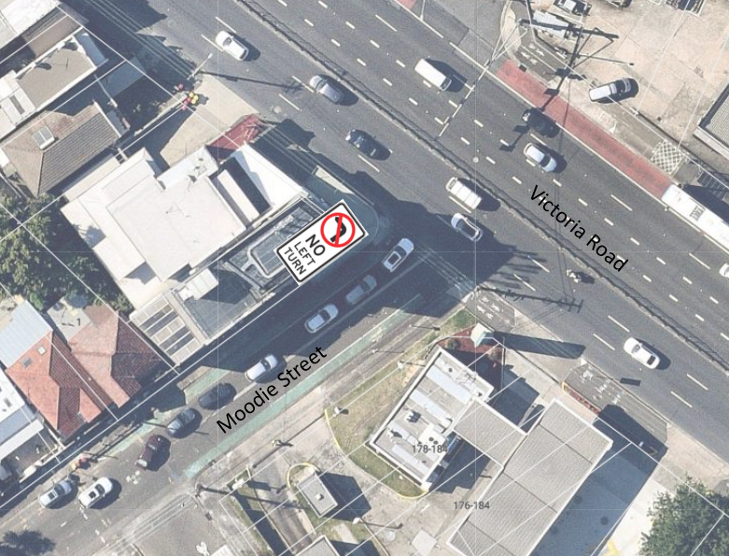
Image 2: Map showing the location of three ‘No Access to Victoria Road’ signs on Cambridge Street, Moodie Street and Waterloo Street.
