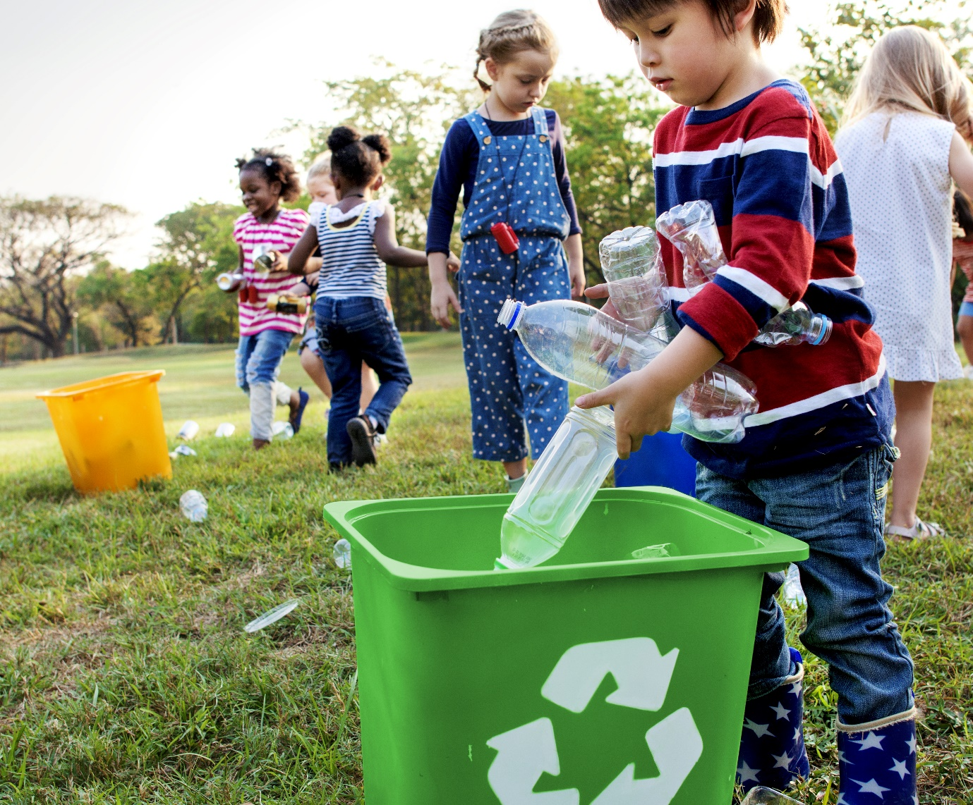

Engagement outcomes report

Draft Zero Waste Strategy

Contents
Summary 3
Background 3
Engagement Methods 4
Promotion 4
Engagement outcomes 5
Who did we hear from? 5
Officer comments in response to public exhibition 9

Summary
The Draft Zero Waste Strategy 2021-36 was placed on public exhibition from 2 May to 2 June 2021. The community could provide feedback on the priorities and targets for Inner West Council (IWC) over the next 15 years.
It was placed on ‘Your Say Inner West (Draft Zero Waste Strategy | Your Say Inner West (nsw.gov.au). The page included an explainer video with transcripts in community languages and the draft Strategy. The feedback form was designed to gauge level of support and feedback on each priority and its respective targets and actions.
There were 289 visitors to the page with 79 document downloads, 41 explainer video views and 40 community members provided online feedback via the form.
Overall, the responses indicate strong support of the draft Zero Waste Strategy priorities and targets. Most feedback requested easier access to recycling, reuse and repair opportunities within the Inner West. Those who indicated lower levels of support commented that the targets were ambitious without legislation, wider social appetite, or satisfaction with existing services.

Background
The Draft Zero Waste Strategy sets a vision for IWC and our community to transition our waste management to the circular economy (resource recovery). In 2019/20 an independent research company managed a telephone survey and focus groups to understand our community’s knowledge and attitudes towards thinking of waste as a resource. Participants were randomly sampled and representative of the Inner West community by gender, age, language spoken at home, household size, dwelling type, ownership, and geographical location.
- Phone survey 600+ residents
- Focus groups - 30+ residents participated in the focus groups to probe further into the findings from the telephone survey, including one focus group in Mandarin
Inner West residents were most concerned about the amount of waste generated by our community, with those displaying the greatest knowledge showing the highest level of concern. Many flagged food waste as an issue, with many unsure about what action they could take to reduce food waste at home. The key opportunities identified by the community through this engagement were:
- Improved and targeted waste and recycling information (to improve recycling and reuse services).
- Food waste avoidance, reuse, and recycling initiatives (38% already composted at home).
- Community recycling/drop-off centres for hard to recycle items, reuse, and safe disposal.
These insights were combined with other information and used by Council staff to prepare the draft Zero Waste Strategy. The IWC Environment Advisory Committee peer reviewed the draft strategy in March 2021. This resulted in strengthening and changing the timeframe of some targets and including a stronger focus on circular economy.

Engagement Methods
During public exhibition the community could provide feedback:
- Online on yoursay.innerwest.nsw.gov.au via the organisation or individual feedback form
- Direct email to the project lead
- Call to the project lead, including via an interpreter (TIS) or National Relay Service

Promotion
The engagement was promoted via:
- Social media
- Direct email including from the Green Living Centre (Environment and Sustainability) and Council’s e-news including YSIW
- Direct email to Local Democracy Groups via conveners
- Council website
- Explainer video on YSIW

Engagement outcomes
Who did we hear from?
Responses were received from residents in 14 suburbs across the Inner West.
Suburb | Total of participants
Annandale | 1
Ashfield | 3
Camperdown | 2
Croydon | 2
Dulwich Hill | 4
Haberfield | 3
Leichhardt | 4
Lewisham | 1
Marrickville | 9
Newtown | 1
Petersham | 1
Rozelle | 3
Stanmore | 3
Summer Hill | 2
Most participants identified as living in a house (33 people) and owning their premises (30 people). There were six participants living in an apartment and nine renters.
Participants were asked if they speak a language other than English at home, of which four indicated ‘yes’. Only one person requested information in another language.

What did they say?
The draft Zero Waste Strategy was downloaded 79 times, the explainer video was viewed 41 times and 40 community members provided feedback online.
Each feedback form question was framed around a priority and target from the draft Zero Waste Strategy to gauge to what extent participants agree with the target and an open comment box for them to explain their response.

Council’s role and changing the model
Participants were asked ‘To what extent do you agree with Council transitioning to the circular economy?’
- 27 strongly agree, reasoning included sustainability, mitigating climate change impacts and finite resources of the earth. Participants want to avoid landfill and manage resources better.
- 5 agree, with some doubt around what happens to recycling and the need to focus on most sustainable outcomes at reasonable cost
- 2 were neutral stating that they see too much wastage.
- 2 disagreed. As financials were not provided to enable an informed decision.
- 4 strongly disagree. Comments included dislike of drop-off and insufficient financial information.

Priority 1: Avoiding waste generation
Participants were asked ‘to what extent do you agree with this target?’
- 19 strongly agree because as consumers everyone needs to avoid landfill and increase reuse, repair, and recycling for a better future.
- 13 agree. Seven of the comments suggested the target should be higher. We should all reduce and reuse and make it easier for those without cars.
- 4 were neutral. Comments included the need to target manufacturers of single use plastics, concern that the target doesn't reflect population increase and lacks details of how this would be achieved.
- 1 disagrees stating that the target was ambitious without legislation around types of products available to consumers.
- 3 strongly disagree, stating that the target was ambitious without legislation around types of products available including single use plastics to consumers.

Priority 2: Reduce organic waste
Participants were asked ‘to what extent do you agree with this target?’
- 22 strongly agree. Two wanted stronger targets and most commented organics management was critical to avoid it entering landfill, with many already composting at home or expressed interest in food recycling services.
- 9 agree. Six wanted stronger targets and to provide easier options for residents.
- 3 were neutral. One requested more detail, and another wanted organics collections for houses.
- 3 disagree. One said the target was too ambitious, another wanted a higher target. Two thought food collection services would be preferable to home composting.
- 3 strongly disagree. One comment preferencing organics service over home composting for houses.

Priority 3: Recycle and buy recycled
Participants were asked ‘To what extent do you agree with this target?’
- 20 strongly agreed. One suggested a stronger target. Most comments around community education and accessibility to increase reuse and recycling.
- 11 agreed with two suggesting a stronger target was possible. Comments included need for education and increased reuse and recycling to support this target.
- 3 were neutral. One suggested a stronger target, another noted the waste is from supermarket purchases more than IWC buying power. Another suggesting a lack of detail in practice.
- 1 disagreed and suggested a stronger target and mentioned buying recycled doesn't make it sustainable (e.g. lifecycle impacts).
- 4 strongly disagreed. Recycling services should include difficult to recycle items.
- 1 did not rate this item, commenting that the target should be higher

Priority 4: Problem Wastes
Participants were asked ‘To what extent do you agree with this target?’
- 20 strongly agreed. One suggested a stronger target. Most comments mentioned obsolescence, manufacturer responsibility, easy options for the community, increased reuse, repair, and recycling options.
- 13 - Agreed. 3 suggested stronger targets and one mentioned these items are hard to recycle without a car.
- 3 (1 duplicate discounted) - Neutral. One suggested the target was ambitious.
- 0 - Disagreed.
- 4 - Strongly Disagreed. Difficulty in recycling these items expressed.

Priority 5: Collaboration and advocacy
Participants were asked ‘To what extent do you agree with this target?’
- 1- Unknown. Didn't understand the targets.
- 22 - Strongly Agreed. Education and making it easier for the community to recycle, reuse and repair is key.
- 2 - Neutral. One noted a lack of detail and another didn't understand the target.
- 2 - Disagreed. One suggested the target should be 2025. One didn't understand target.
- 4 - Strongly Disagreed. Concerns about what happens post-collection.

General comments:

Overall, how satisfied are you with our approach to zero waste?
The general comments were overwhelmingly positive and in support of the Zero Waste Strategic direction. A few comments were concerned with how initiatives would be funded. One noted that Council should include not supporting MWOO (organic output from garbage). A few also mentioned the need for greater access to additional recycling opportunities such as soft plastics and more local drop-offs to make it easier for residents.

Other responses from individuals
One resident contacted staff requesting to see the ten-year financial model Council developed that sets its domestic waste management charge (including all of the programs and services), but due to the confidential nature of the data this could not be provided.

Petitions
A resident undertook an online petition for Council to provide a cloth nappy rebate. It received 60 signatures, 13 of whom identified as living in the Inner West. Many identified as living in Sydney, Australia.
Petition · Cloth nappy rebate for the Inner West · Change.org

Officer comments in response to public exhibition
The submissions were reviewed and general themes from each question addressed in the following ways:

Council’s role and changing the model - transitioning to the circular economy?
Outcome: No change to Draft Zero Waste Strategy focus.
The majority (32) of respondents agreed with council transitioning to a circular economy and two were neutral. Concern around the ten-year financial model has been addressed under ‘other comments’ and a dislike of drop-offs has been addressed in ‘overall’ comments.

Priority 1: Avoiding waste generation
Outcome: No change to Draft Zero Waste Strategy.
32 agreed and 4 were neutral and felt reuse, repair and recycling should increase. 4 noted that the target was too ambitious without legislation and dealing with producers and manufacturers. Individual comments to increase or reduce the target balanced each other out.

Priority 2: Reduce organic waste
Outcome: 10% increase in target in Draft Zero Waste Strategy.
New Target: to reduce food and organic waste disposed in landfill by 60% by 2030.
Eight suggested stronger targets and one said the target was too ambitious.
IWC aims to implement a range of kerbside and local/home composting options to achieve this target.

Priority 3: Recycle and buy recycled
Outcome: 10% increased target in Draft Zero Waste Strategy.
New Target: divert 60% of recyclables from the garbage bin by 2036.
All comments about the target suggested a stronger target and to increase education and accessibility to reuse and repair and expanding to range of options for difficult to recycle items.

Priority 4: Problem Wastes
Outcome: No change to Draft Zero Waste Strategy.
The targets were accepted by the community, with the most feedback being around council providing more opportunities for reuse, repair and recycling and improving access to drop offs.

Priority 5: Collaboration and advocacy
Outcome: No change to Draft Zero Waste StrategyGenerally supported but IWC needs to focus on education (including transparency around what happens to materials once collected) and access to repair, reuse and recycling in its actions, which is already a focus.

Domestic Waste Financial Model
The ten-year detailed financial model that determines the annual domestic waste charge is not publicly available due to the highly confidential information around contracts and pricing. Council’s model is robust and includes expected service and education costs.
iPart is standardising use of the DWMC across councils, including appropriate charges and aligned overheads. NSW auditors will be reviewing outlying councils DWM expenditure to determine appropriate and efficient use of DWMC funds.

Nappy Rebate Petition
A rebate for a specific waste stream was reviewed previously and due to the high level of administration required by officers and variance of waste streams where reusable options are available it was determined that a user-pays waste charge would be more equitable so that households could reduce the amount of waste they generate by targeting actions relevant to them, in turn paying a lower waste charge. Equally a household creating more waste would pay a higher charge.
Outcome: No change to the Draft Zero Waste Strategy - The domestic waste charges allows for household waste avoidance through variable waste charges by bin size; small (55/80 litre), standard (120 litre) and large (240 litre) garbage bin sizes.

Additional strategic directions released by NSW in June 2021 resulted in further updates to Council’s Zero Waste Strategy
On 15 June 2021, NSW Department of Planning, Industry and Environment released the NSW Waste and Sustainable Materials Strategy 2041 – Stage 1 2021-27 and NSW Plastics Action Plan.
The key targets in the NSW strategy align with IWCs’ Zero Waste Strategy.
NSW commits to the National Waste Policy Action Plan targets:
- Reduce total waste generated by 10% per person by 2030.
- Have an average 80% recovery rate from all waste streams by 2030
- Significantly increase the use of recycled content by governments and industry
- Phase out problematic and unnecessary plastics by 2025
- Halve the amount of organic waste sent to landfill by 2030
NSW builds on these national targets with:
- Litter reduction target of 60% by 2030 and a plastic litter reduction targets of 30% by 2025 as set out in the NSW Plastics Action Plan
- Triple the plastics recycling rate by 2030 as set out in the NSW Plastics Action Plan
- Net zero emissions from organic waste by 2030 as laid out in the NSW Net Zero Plan Stage 1 2020-2030
- Establish new indicators to help track progress on infrastructure investment and the cost of waste services
- Develop a measure of the emissions performance of our waste and materials management to help track performance across the lifecycle of materials
Outcome: Update to Draft Zero Waste Strategy to include NSW litter reduction targets.
IWC targets exceed NSW and federal targets for its areas of influence such as organics and waste avoidance.

