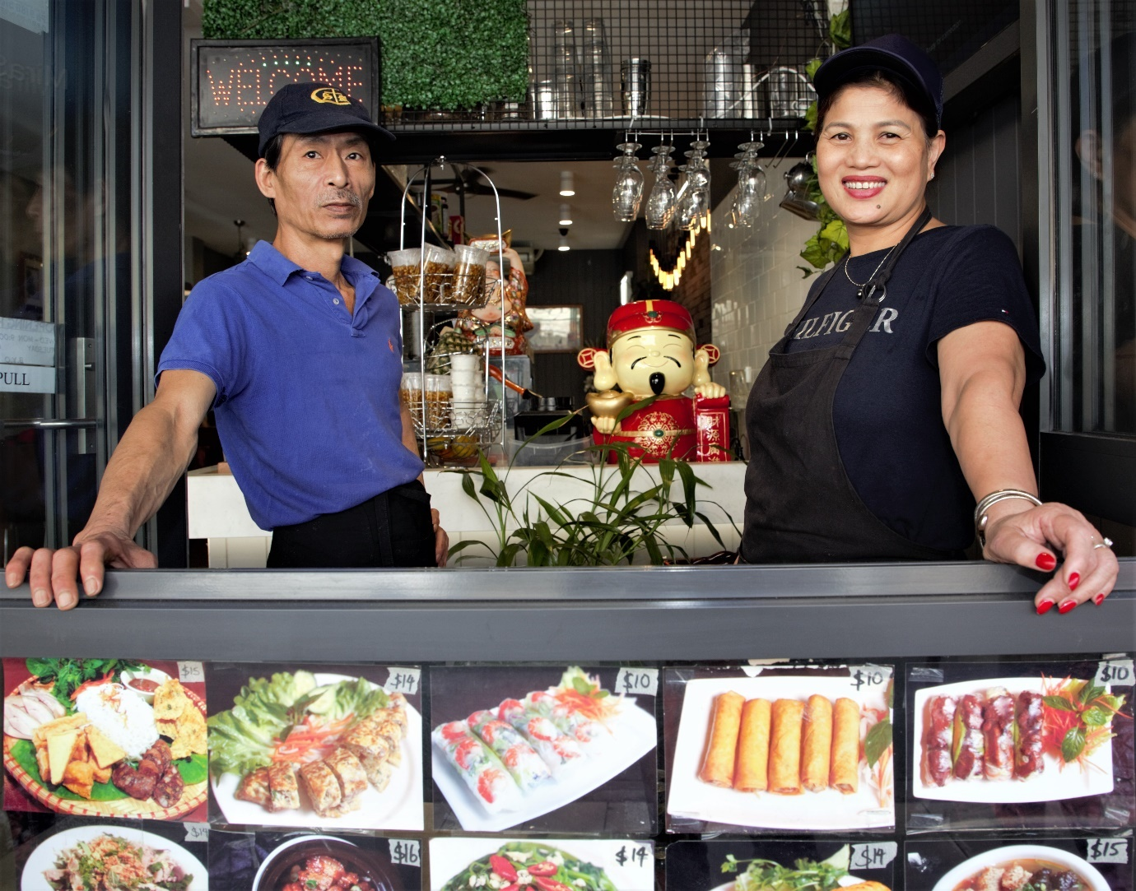

Engagement outcomes report

Identifying a Vietnamese precinct

Summary
Between 19 April and 17 May 2021, the community could provide feedback on identifying a Vietnamese precinct along Illawarra Road in Marrickville. Participants could influence an appropriate name and location for the precinct and indicate if they’d like to contribute material to the local history collection.
Overall, 555 people participated in the engagement. The bi-lingual Your Say Inner West (YSIW) project page received 1,900 unique visits. The opportunity to provide feedback was promoted and received via analogue and online methods:
Engagement method | Responses
Bi-lingual feedback form on YSIW: completed Vietnamese | 89 responses
Bi-lingual feedback form on YSIW: completed by participants in English | 153 responses
Bi-lingual paper feedback form completed in Vietnamese | 224 responses
Bi-lingual paper feedback form completed in English | 8 responses
A COVID-Safe workshop for the Vietnamese community with an accredited interpreter on Friday, 6 May 2021 | 29 attendees
Saturday 7 May, staff walked Marrickville and Illawarra Roads with an accredited interpreter for three hours collecting feedback from the community | 50 conversations
Responses received from community members via email/phone | 2 responses
Total community responses | 555

We also received two phone calls/emails from peak Vietnamese community associations and a letter from the Consulate General of Vietnam in Sydney

Theme summary
Overall, 360 participants (65%) supported the proposed name, ‘Little Vietnam’. This name was considered neutral and inclusive of the experiences of all Vietnamese people, regardless of if they are from the Northern, Central or Southern regions of Vietnam.
Overall, 131 participants (24%) do not the support the proposed name. The most popular alternative suggestion was ‘Little Saigon’ (96 participants) because it represents the historic struggles of refugees. However, other participants felt this wouldn’t be appropriate because there is already ‘Saigon Plaza’ in the Canterbury Bankstown area and focussing on one city may potentially create an unhealthy public political divide within the Vietnamese community.
There were 11 people who were unsure about the name because they felt the Vietnamese community should come up with a name or have the most say. There were 53 participants who chose not to comment on the name.
Participants were also asked which streets they thought the precinct should start and end at. The preferred starting point is Marrickville Road (291 participants). Some participants wanted to ensure everyone was included, not just the main business district. Those who shared this sentiment indicated support for Sydenham Road (82 participants, which was the second top response) or Addison Road (18 participants).
The preferred end point is Warren Road (139 participants). Some participants chose ‘Woolworths’ as the end point before being asked specifically which street (Renwick or Warren) they would prefer. Combining the sentiment for both Renwick and Warren Streets (as they are adjacent) brings the total to 204 participants who would like the precinct to end in this block. Comparatively, the second highest response was the Cooks River, which was supported by 109 participants.

Table summarising top responses to ‘which street should the precinct end at?’:
Street name | Total
Warren Road | 139
Cooks River | 109
Renwick Street | 65
Marrickville Train Station | 51
The Consul General of Vietnam in Sydney expressed their support for the project and for the proposed name. They did not comment on the location but offered to provide further assistance if required.

Issues/concerns/comments
Common issues/comments raised throughout the project included:
- Concern that the project could divide rather than build community. People were worried that the precinct could provoke anti-Asian sentiment or a divisive use of flags by Council or businesses. People also expressed the need for a neutral name to include the experiences of all in the Vietnamese community.
- There was minimal awareness of the other precincts in the program, resulting in the perception that ‘Little’ meant small, trivial or insignificant when it is interpreted into Vietnamese language due to cultural and language sensitivity After explaining, participants appreciated that including ‘Little’ was not a judgement, but rather brought consistency with other precincts identified in the Inner West.

Background
At the Council meeting on Tuesday, 9 February 2021, the elected Council voted to engage on identifying a Vietnamese Precinct along Illawarra Road, Marrickville.
This precinct continues efforts to recognise the significant contribution that migrant communities have made to the Inner West and society more broadly. In 2019, following approval from the Geographical Names Board, a Portuguese Precinct was identified in Petersham and in 2020 an Italian Precinct was identified in Leichhardt. The application for the Greek Precinct in Marrickville is currently with the Geographical Names Board for approval. This precinct will be the first to recognise a non-European community in the Inner West.

Engagement Methods
The community could provide feedback through the following methods:
- Your Say Inner West feedback form: participants could choose to provide feedback in Vietnamese or English. Responses in Vietnamese were translated by an accredited interpreter.
- Bi-lingual paper feedback forms were distributed to over 200 businesses and electronically to community organisations to assist with collecting feedback
- The Consul General of Vietnam was sent a letter via email
- Covid-Safe workshop with an accredited Vietnamese interpreter
- Email or direct call to the project officers
- Street engagement with an accredited Vietnamese interpreter

Promotion
- Social media
- Direct email to business chamber and identified Vietnamese organisations
- Media release to mainstream and community media organisations
- Letter to Consul General of Vietnam
- YSIW and Council fortnightly e-newsletter
- Networked promotion via community organisations with direct links to the community

Engagement outcomes
Who did we hear from?
We heard from the Consul General of Vietnam, current residents and business owners, people who visit the area and/or identify as former residents or business owners, and members of Vietnamese Community Organisations. Most respondents identified with more than one of these categories. Therefore, responses have been reported based on based on sentiment.

What did they say?

Support for the name ‘Little Vietnam’
Overall, 555 participants were asked this question. Of these, 360 participants (65%) support the name ‘Little Vietnam. This name was considered neutral and inclusive of all experiences of the Vietnamese people, regardless of if they are from the Northern, Central or Southern regions of Vietnam.

Comments relating to supporting the name include:
- It recognises that there are a lot of Vietnamese people living, working and contributing to the area culturally and economically.
- Bankstown already has ‘Saigon Plaza’ and want to go with something different

Comments related to supporting the project overall, such as:
- Heritage/recognition must be neutral with further consultation with leading organisations on how best to celebrate
- Strong sense of pride in their connection to Vietnam and Australia, they felt it was important to have a Vietnamese precinct like the others.
- Gratitude for the project and a confidence boost to continue contributing to the community.
- Expressions of support for the Vietnamese community and their contributions via business, culture and food
- Continues to recognise the contributions of our diverse, multicultural community.
- Expressions of gratitude for staff involved and community leaders
- Suggestion for bi-lingual signage and communications to continue

Opposition to the name ‘Little Vietnam’
Overall, 131 participants (24%) do not support the name ‘Little Vietnam’. Unlike those who saw Vietnam as a unifying name, these participants felt it was a reminder of the Vietnam war, the communist invasion and that they do not associate themselves with Vietnam anymore.
Other suggestions were provided, including variations of similar names that referenced Hanoi, Freedom and replacing ‘Little’ with town, place or ville. The most frequently suggested alternative was ‘Little Saigon/ Saigon Town’ because it represents the historic struggles of refugees in the community (Saigon was renamed Ho Chi Minh City after the war ended in 1975).
However other participants felt ‘Saigon’ would not be appropriate for two main reasons:
- Canterbury Bankstown has ‘Saigon Plaza’
- Naming after a specific city could potentially stir up an unhealthy, public political divide within the Vietnamese community
It was also suggested that:
- The precinct was a tokenistic exercise and to name it after the whole country isn’t enough to be representative. Instead, Council should use a Vietnamese name.
- It would be confusing to have ‘Little Vietnam’ in the Inner West (referring to the whole country) and ‘Saigon Plaza’ in Canterbury Bankstown (referring to a city).
Unsure
There were 11 participants who were unsure about the proposed name. Most who shared this sentiment believed that the Vietnamese community should choose a name or have the most say about the proposed name.
Others reflected the concerns previously shared about whether it was appropriate use ‘Little’, if Vietnam was too all encompassing and the hope for a neutral name.
Opposition to the whole project
There were five participants who explicitly voiced opposition to identifying a Vietnamese precinct. Participants who felt this way stated that it’s discriminatory to name a precinct based on a cultural group and that the approach to naming precincts lacked imagination; that recognising the Vietnamese community’s contribution could be achieved more effectively in other ways. There was concern about the rise of racism, in particular Anti-Asian sentiment during the pandemic and the risks of community violence if this precinct went ahead at this time.
A handful who responded that they opposed the name also expressed opposition to the whole project in the comments. They felt that recognition of diversity could be better achieved through community-led artwork, especially as they believed momentum for other precincts had withered. Another felt that cultural precincts were too permanent when demographics change, prohibiting business diversity and suggested a food precinct would be more sustainable.
There was also concern that the precinct may not have positive community building outcomes. Specific concerns were about the use of the flag/s, especially in local businesses which had created unease in the community.
Table showing total responses to the question ‘Do you support the name
‘Little Vietnam’?
Response | Total | Percentage of total response to question
Support | 360 | 65%
Do not support | 131 | 24%
Unsure | 11 | 2%
Did not answer | 53 | 9%
Total | 555 | 100%

Location
Participants across most of the engagement methods were asked which streets they would like the precinct to start and finish at along Illawarra Road, resulting in 415 responses (or 75% response rate) to this question. Where restaurant or points of interest were listed instead of streets, it was quantified against the nearest cross street that would include the venue in the precinct. Where participants indicated that the precinct should extend for the whole of Illawarra Road, responses were quantified as starting at Addison Road and ending at the Cooks River.

Starting point
Most participants to this question (291 or 70% of those who responded to this specific question) identified the corner of Illawarra Road and Marrickville Road as the start of the precinct. Some participants felt that the starting point had to be further north so that everyone was included in the precinct. Suggestions included Sydenham Road (82 participants or 20%) and Addison Road (18 participants or 4%).

Table showing the total responses (415) to ‘where should the precinct start’ across all engagement methods. Streets are listed from north to south.
Street name response | Total | Percentage of total response to question
Addison Road | 18 | 4
Sydenham Road | 82 | 20
Marrickville Road | 291 | 70
Calvert Street | 1 | <1
Petersham Road | 12 | 2
Marrickville Lane | 1 | <1
Marrickville Station | 2 | <1
Woolworths | 3 | <1
Thornley Street | 1 | <1
Warren Road | 2 | <1
Cooks River | 1 | <1
Wallace Street | 1 | <1
Total | 415 | 100%

Ending point - 404 responses
The top street for the end of the precinct, was the corner of Illawarra Road and Warren Road (139 people or 34% of question respondents). Some participants voiced ‘Woolworths’ as the end point before being asked specifically which street (Renwick (65) or Warren, as they are adjacent) they would prefer. Combining the sentiment for both Renwick and Warren streets brings the total to 204 participants (or 51% of question respondents) who would like the precinct to end in this block.
The second highest response was to end the precinct at the Cooks River, which was supported by 109 participants (27% of question respondents). Those who supported this believed that it was important for the precinct to run for the whole length of the road so that all Vietnamese-owned businesses were included.
Feedback was received from a further nine participants that could not be quantified against specific street names. This can be themed as:
the precinct should:
- be where there are many restaurants (7 participants).
- align with the middle of Illawarra Road (1 participant).
- include food shops near Woolworths.(1 participant)
Table showing the total responses to ‘where should the precinct end’ across all engagement methods. Streets are listed from north to south.
Street Name | Total | Percentage of question respondents
Petersham Road | 9 | 2
Byrnes Street | 3 | <1
Marrickville Station/Arthur Street | 51 | 13
Schwebel Street | 5 | 1
Grove Street | 2 | <1
Church Street | 11 | 3
Warren Road | 139 | 34
Renwick Street | 65 | 16
Cary Street | 5 | 1
Hill Street | 3 | <1
Thornley Street | 1 | <1
Wallace Street | 1 | <1
Cooks River | 109 | 27
Total | 404 | 100%

Other comments
Throughout the engagement, feedback beyond the scope of this project was shared with staff. This includes:
- Locations beyond Illawarra Road: Marrickville High School (1 participant), Police Station (1 participant) and a precinct along Marrickville Road from Marrickville Library (2 participants)
- Traffic and pedestrian safety: make Illawarra Road one way, it is dangerous.
- Council need to clean up Illawarra Road and the public domain

Officer Comments
Sydenham Road/Addison Road were not included in the map because they are predominately residential areas. The GNB advises against naming precincts in residential areas and instead focusing on commercial districts.
Ends

