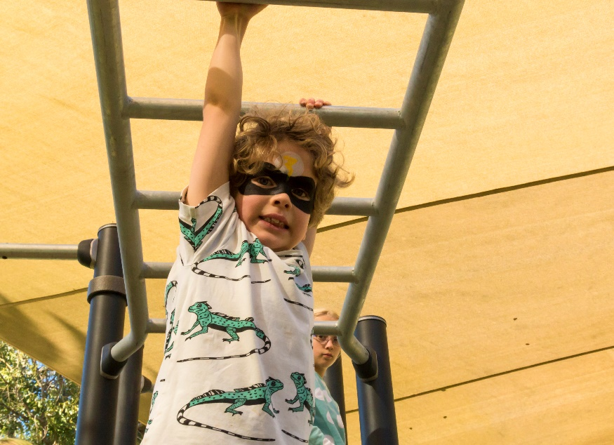

Engagement outcomes report

Algie Park Playground Upgrade

Contents
Summary 3
Background 3
Engagement Methods 4
Promotion 4
Engagement outcomes 5
Who did we hear from? 5
What did they say? 6

Summary
Feedback to shape a new play area at Algie Park playground was sought from the community between 13 February and 14 March 2021

The project was promoted via letters to residents surrounding the park, YSIW e-newsletter, onsite posters and Council’s website.
The community could influence additional play opportunities by selecting the type of equipment they would like to see at Algie Park. Insights about how often participants visit the playground, their own / their children’s age groups were also sought.
There was a total of 167 visits to the Your Say Inner West project page, out of which 31 provided feedback online. There were also 2 responses via email. All responses are included in this report.
Feedback demonstrated that this is a popular playground with most participants visiting weekly. Children of all ages use the playground with the most common age groups being 4-7 years old, followed by 8-12 years old and 0-3 years old.

- 4-7 (17 participants)
- 8-12 (13 participants)
- 0-3 (11 participants)

The top three play equipment selected are, in order of preference:
- Multiplay unit (26 participants)
- Climbing (14 participants)
- Imaginative play features (12 participants)

A concern raised by 3 participants is that there is a lack of play elements for older children (aged 8-12 years old).

Background
Based on Park Assets prioritisation, Algie Park playground is due for an upgrade. The current play areas are in three areas located adjacent to each other, separated by grass. The equipment is in good condition.

Instead of replacing what is there, Council has decided to add a fourth play area. We asked the community if they would like to see additional play opportunities at Algie Park and to identify the type of equipment they would like to see.

Engagement Methods
The community could provide feedback via:
- Your Say Inner West
- Email
- Phone (including via the National Relay Service for TIS National)

Promotion
The engagement was promoted through:
- Social media
- Direct email
- Resident letter drop
- Onsite posters
- YSIW E-newsletter
- Council website

Engagement outcomes
Who did we hear from?
Participants were primarily from Haberfield (31 respondents) with 1 participant from Lewisham.
Graph showing responses to the question about Suburb of residence.

The majority of participants identified as visiting the park weekly (16 respondents) or sometimes (a few times a month, 12 respondents). In total, only four participants identified as never coming to the park or rarely visiting.
Graph showing responses to the question ‘How often do you visit Algie Park?’

What did they say?
When asked ‘how old are you or the children you take to Algie Park?’ the top responses were:
- 4-7 (17 participants)
- 8-12 (13 participants)
- 0-3 (11 participants)
Other age groupings received one response each, except 50-59 which represented two participants.

Graph showing responses to the question ‘How old are you or the children you take to Algie Park?’

When asked to choose three pieces of equipment that they would like to see at Algie Park, the top three were:
- Multiplay unit (26 participants)
- Climbing (14 participants)
- Imaginative play features (12 participants)

Those who marked ‘other’ suggested sensory play

Graph showing responses to the question ‘Choose three pieces of equipment they would like to see at Algie Park’

Other issues raised include:
- Other than the swings, there is a lack of older children play elements (3 participants)
- Remove the ‘teen ranger equipment (3 participants)
- Requests for pathway connection to the separated play areas and a circuit path for scooters (2 participants)

Officer Comments
We will incorporate the ideas into the design brief where possible taking into account budget and practical considerations.
Issues raised that are beyond the scope of this project include:
- 4 participants are concerned that the existing shade sails do not cover the play equipment and its design needs to be reviewed. This has been noted for future shade sail reviews.
- 2 participants request for more dog off-leash areas. This will be passed on to the Planning team for consideration.
- 2 participants request for older community activities, for example exercise equipment. It will be noted for future outdoor fitness station program.

