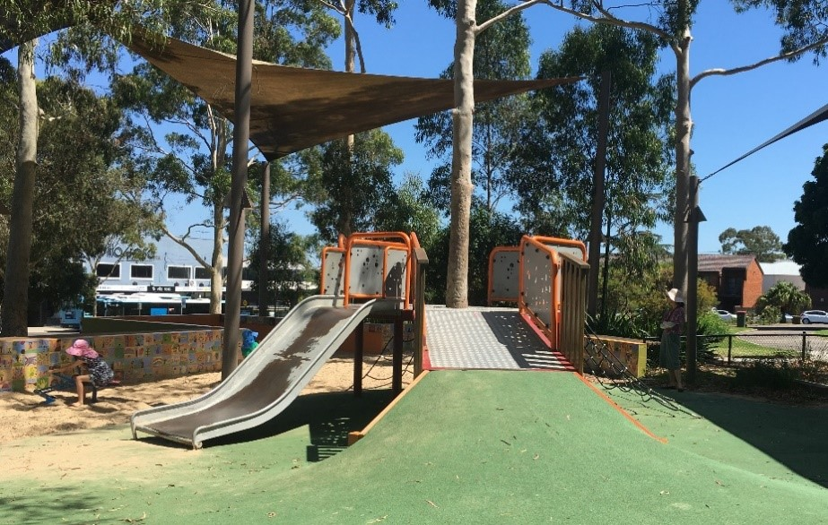

Engagement outcomes report

Pioneer Memorial Park Playground Upgrade

Contents
Summary 3
Background 3
Engagement Methods 3
Promotion 3
Engagement outcomes 4

Summary
Feedback to design a new piece of equipment at Pioneer Memorial Park was sought from the community between 13 February and 14 March 2021. The project was promoted via letters to residents surrounding the park, YSIW e-newsletter, onsite posters and Council’s website.

The community could influence the type of play opportunities offered in a new multi-play unit to replace the slide in the middle of the playground. Ideas were collected via an online ideas wall, quick poll, phone and email.
There was a total of 813 visits to the Your Say Inner West project page, out of which, 99 provided feedback online. There were also 2 responses via email. All responses are included in this report.
Overall, the top 8 ideas included:

- Nature play (25 participants)
- Slide (25 participants)
- Climbing (19 participants)
- Water theme (16 participants)
- Imaginative Play (13 participants)
- Flying fox (10 participant)
- Monkey Bars (6 participants)
- Additional Swings (6 participants)

Background
Based on Park Assets prioritisation, Pioneer Memorial Park playground is due for an upgrade. The slide and platform unit is rusted and is due for replacement. The other pieces of equipment are in good condition and will be retained.

The slide unit is constructed around a eucalyptus tree and the health of the tree will need to be considered and will be assessed by an arborist.

In replacing the slide unit, we asked the community what they play opportunities they would like to see added to the replacement unit.

Engagement Methods
The community could provide feedback via:
- Your Say Inner West via Ideas Wall tool and the Quick Poll feature.
- Email
- Phone (including via the National Relay Service and TIS National)

Promotion
The engagement was promoted through:
- Direct email
- Resident letterbox drop
- Onsite posters
- YSIW E-newsletter
- Council website

Engagement outcomes
Who did we hear from?
Responses came from residents of Leichhardt and Marrickville.

What did they say?
Overall, 118 people viewed the ideas wall tool online at Your Say Inner West. Of these, 88 participants contributed an idea to the wall. There were 16 ideas shared and 238 interactions which includes comments and liking other people’s ideas.

The top ideas shared by participants were:
- Nature play (25 participants)
- Slide (25 participants)
- Climbing (19 participants)
- Water theme (16 participants)
- Imaginative Play (13 participants)
- Flying fox (10 participant)
- Monkey Bars (6 participants)
- Additional Swings (6 participants)
Other ideas:
- Add basketball hoop for kids (4 participants)
- In-ground trampolines (2 participants)
- Adventure playground (2 participants)
- Inclusive equipment (2 participants)
- More play elements in the sand pit (1 participant)
- Mix age groups (1 participant)
- More planting (1 participant)
- Cover for the central pavilion (1 participant)

The quick poll feature on Your Say Inner West was opened part way through the engagement to encourage interaction and collect quick sentiments about types of play. A total of 16 people participated in the quick poll. The results were:
- Slide (4 respondents)
- Nature play (4 respondents)
- Climbing (3 respondents)
- Imaginative play (2 respondents)
- Monkey bars (1 respondent)
- Other (2 respondents)

Officer Comments

We will incorporate the ideas into the design brief where possible taking into account budget and practical considerations.

Some of the ideas shared are out of this project scope. However, these have been noted for future planning and include:
- To make the playground area bigger
- Expand the water play
- Cover for the central pavilion to allow for outdoor activities such as Pilates
- Large scale adventure play unit
- Shade sails for new play equipment
- BBQ area
- Additional swings

