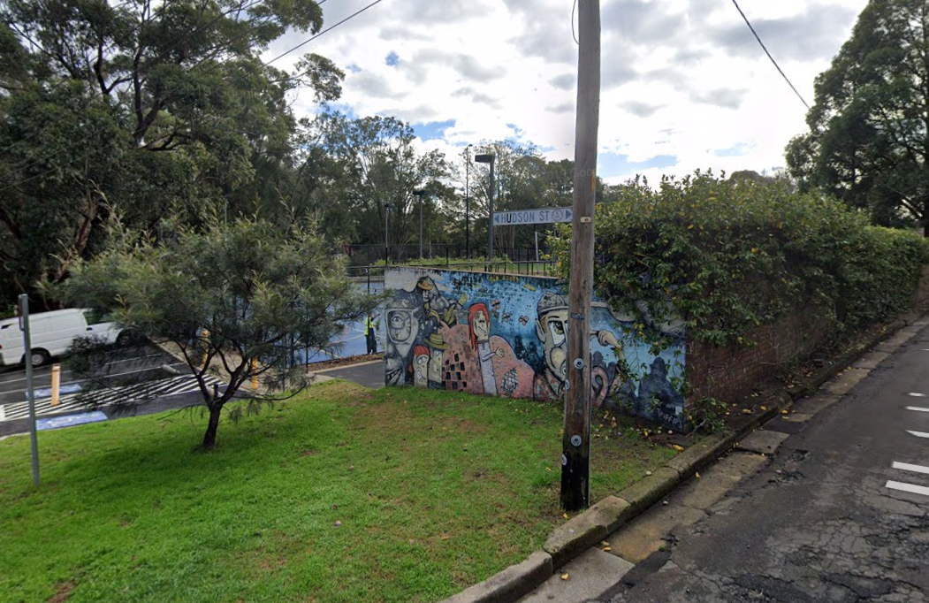

Engagement outcomes report
Cohen Park tennis courts temporary change in access

Contents
Summary 3
Background 3
Engagement Methods 3
Promotion 3
Engagement outcomes 4
Officer comments 5

Summary
The project was open for community feedback on 16 February and closed on 1 March. It was promoted on social media with targeted posts, Council website, on site and by letters to local residents. There were 260 visits to the project page and 135 provided feedback. Ninety-three people were likely to support the change of use, with 87 completely likely supportint the change and six very likely. Forty-one people were slightly likely or not at all likely to support the change in use. One person was moderately likely in support of the change.
The people who completed the survey were:
- Residents 53
- Park users 14
- Casual tennis court users 38
- Leichhardt Tennis Academy clients 28
Top three themes
In support of the change:
- Great for the children to exercise 22
- Small change not much impact 15
- In support of the Leichhardt Tennis Academy running coaching sessions with children 7
Against the change
- Access to the community should be prioritised 29
- Commercial hires should not be allowed on community assets 14
- Criticism of Leichhardt Academy for their conduct on courts 3

Background

At its meeting on 9 February 2021 council decided to seek community’s feedback about temporary change of access to tennis court two at Cohen Park. See notice of motion below:
C0221(1) Item 19 Notice of Motion: Cohen Park Tennis Courts
Motion: (Macri/McKenna OAM)
THAT Council:
1. Notes that due to the need to safely socially distance children during the COVID-19
crisis, Leichhardt Tennis Academy has requested the temporary use of a second
tennis court at Cohen Park for training lessons; and
2. Undertakes at least 2 weeks community consultation with local residents and
users of the second court on the proposal from the Leichhardt Tennis Academy to
remove the current free community use on the second court between 5.15 and 6.15
for the first and second school terms in 2021.

Engagement Methods

  - Online survey on yoursay.innerwest.nsw.gov.au

Promotion
The project was promoted through:
- Social media
- Council website - Announcements
- Onsite posters
- Notification letters to surrounding residents

Engagement outcomes

Who did we hear from?
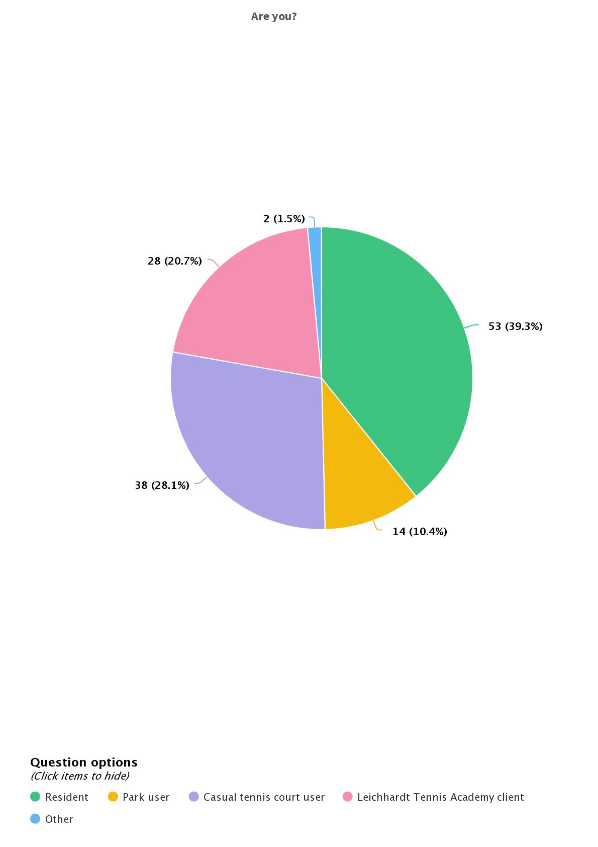
What did they say?
