Engagement outcomes report

Diagram

Aerial view with a red outline of the property 1 to 5 Chester St, Annandale 

1-5 Chester St, Annandale

Amendments to Leichhardt Local Environmental Plan (LLEP) 2013 and Leichhardt Development Control Plan (LDCP) 2013

Contents

Summary 3

Background 3

Engagement Methods 3

Promotion 3

Engagement outcomes 4

# Summary

The Planning Proposal for 1-5 Chester Street, Annandale was exhibited for public consultation for 29 days between 28 October 2020 and 25 November 2020. The exhibition material was made available online at Your Say Inner West (YSIW) and 858 letters were posted to the surrounding neighbours, including landowners and occupiers.

23 submissions were received during the exhibition period, including 17 sent to YSIW and 6 by direct email. 13 (56.5%) were opposed to the proposed amendments, 8 (34.7%) supported or had no objection in principle to the proposed amendments and 2 (8.8%) were neutral.

# Background

On 9 October 2020, the Department of Planning, Industry and Environment (DPIE) issued a Gateway Determination that the Planning Proposal for 1-5 Chester Street, Annandale should proceed to public exhibition. The Planning Proposal seeks to amend the Leichhardt Local Environmental Plan (LLEP) 2013 as follows:

* rezone the site from IN2 Light Industrial to B7 Business Park;
* allow a maximum floor space ratio (FSR) of 2:1 including a minimum FSR of 0.75:1 for businesses and light industries in the technology, bio-medical, arts, production and design sectors;
* restrict the maximum building height to 17 metres or 5 storeys;
* allow boarding house land use for student accommodation;
* provide a 6 metres pedestrian and cycle path and landscaping along Johnstons Creek; and
* include a provision to ensure that the development will be environmentally sustainable with a minimum 4-star Green Star rating.

The proposal is accompanied by site-specific amendments to the Leichhardt Development Control Plan (LDCP) 2013. The Planning Proposal and the site-specific Development Control Plan (DCP) were exhibited together. Feedback was also sought from State and Federal government agencies as required by the Gateway Determination.

# Engagement Methods

The following engagement methods were used:

* + Online through yoursay.innerwest.nsw.gov.au
  + Direct mail
  + Email

# Promotion

The engagement was promoted via:

* Council website in the news/announcement section
* Social media
* YSIW monthly subscribers’ email

# Engagement outcomes

*How did people respond?*

Council received 23 written submissions in total. These included 17 responses on the YSIW webpage and 6 email responses including 5 submissions from government agencies and 1 from a local resident.

*Who did we hear from?*

The majority of YSIW submissions were received from Annandale and Camperdown residents. The graph below identifies where respondents live. One respondent did not indicate where she or he lives and therefore only 16 of the 17 are shown.

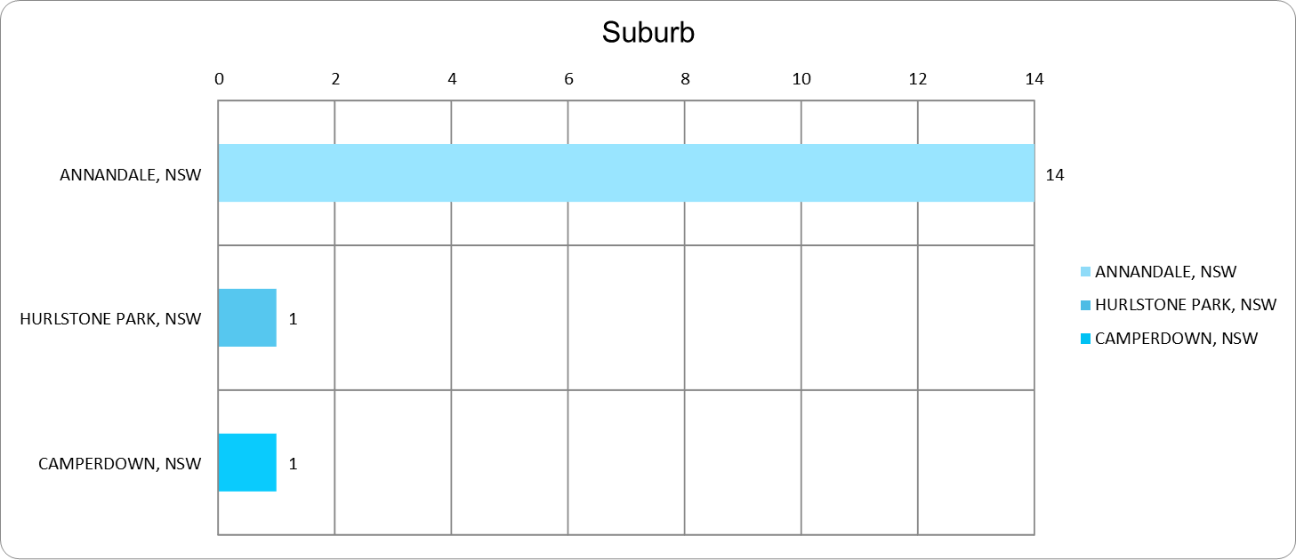

*What did they say?*

The submissions to the Your Say Inner West webpage responded to the following question *“Do you support the planning proposal?”*

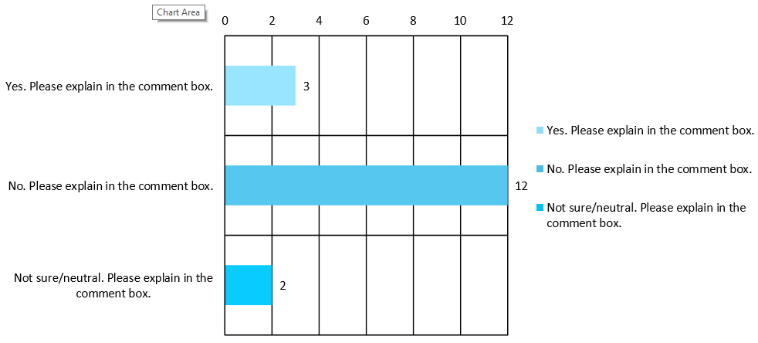

There were 17 responses to this survey. 3 responses supported the planning proposal, 12 opposed the proposal. 2 were neutral. The following key themes emerged from community feedback:

* parking and traffic
* built form, excessive height and density
* loss of privacy and noise impacts
* heritage impacts
* proposed zoning/ student housing use
* loss of urban services

These issues were also raised previously as part of the Pre-Gateway consultation undertaken by the proponent in January 2020 and considered by Inner West Local Planning Panel and Council in April/May 2020 meetings prior to supporting the Planning Proposal for Gateway submission. Further details of the most recent submissions and officer responses are provided in the table at the end of this report.

*State / Federal Government and Sydney Airport Comments*

Sydney Water; Federal Department of Infrastructure, Transport, Regional Development and Communications; and Sydney Airport raised no objections.

Transport for NSW (TfNSW)

TfNSW had no objection in principle but did make the following recommendations in relation to the possibility that the rezoning might be finalised prior to the completion of the current Parramatta Road Corridor Urban Transformation Strategy (PRCUTS) traffic and transport study. This is due to be completed by April 2021.

In this respect TfNSW requested DPIE and Council to be satisfied that PRCUTS Implementation Plan Out of Sequence Checklist requirements have been met by the Planning Proposal. It also asked that the Local Environmental Plan (LEP) amendment should include a clause requiring the developer to make contributions toward the state and regional transport infrastructure.

Both the Out of Sequence Checklist and the LEP clause requiring state infrastructure contributions have been fully addressed by the exhibited Planning Proposal.

TfNSW also recommended that the PRCUTS Precinct Transport Report maximum parking rates should be included in the site-specific DCP and that any future development application (DA) condition should ensure that service vehicles can manoeuvre within the site or at the end of the adjacent cul-de-sac.

The PRCUTS parking rates are already reflected in the site-specific DCP and a new provision under Part G11.13 addresses the service vehicle manoeuvre matter to ensure it is addressed at the DA stage.

TfNSW also suggested that a ‘No Stopping’ area should be provided at the northern end of Chester Street to help cyclists and pedestrians access the approach to the Johnstons Creek bridge more safely. Council’s Traffic and Transport Team have been advised of this recommendation and it is being addressed.

DPIE Environment, Energy and Science (EES) Group

EES recommends that Council considers:

1. The requirements of the Leichhardt DCP (2013) under 1% AEP (1 in 100 year flood event) and PMF (maximum extent of flood prone land at a particular location) events on cumulative flooding impacts, floor levels and basement car parking.
2. The need to maintain flow conveyance, floodway and flow paths along the western side of the site adjacent to Johnstons Creek. Obstructions of flood conveyance areas would alter flow behaviour and adversely impact adjacent properties.
3. The provision of an emergency response plan to manage rarer flood events up to and including the PMF event. The Plan should be prepared in consultation with the NSW State Emergency Service (SES) and Council.

Points a and b have been addressed by the exhibited Planning Proposal and the site–specific DCP amendment. Part E of the LDCP 2013 also contains hazard/ flood risk management provisions similar to the above points a and b which will have to be addressed at the DA stage. In relation to point c, Part E1.1.4 Flood Risk Management Report of the LDCP 2013 requires provision of on-site response and evacuation plan.

No changes to the proposal are suggested.

Officer Response to Public Submissions

**Supporting submissions key themes**

| **Key themes (no. of submissions)** | **Officer’s comment** |
| --- | --- |
| Proposed mix of land uses are suitable to the site. (4) | Noted. |
| Redevelopment of the site would activate the area and Chester Street. (4) | Noted. |
| The proposal will contribute to active transport infrastructure. (3) | Noted. |
| Support for off-street cycle link to enable future expansion of cycling network. | Noted. |

**Neutral submissions key themes**

| **Key themes (no. of submissions)** | **Officer’s comment** |
| --- | --- |
| 3-metre bike path may be adequate for now but might not be wide enough in the future. | The 3 metre wide width for bike path is consistent with Council’s local cycling network standards. The proposal provides 6 metre setback from the creek with potential to extend the cycle link into the setback if necessary. |
| Support for cycling infrastructure. (2) | Noted. |
| Parking and traffic. | See discussion below. |
| Privacy impacts on western side of Johnsons Creek. | See discussion below. |
| Improvements required to crossings and lighting between Parramatta Road and the site to facilitate public transport usage. | Implementation of Council’s adopted Parramatta Road Urban Amenity Improvement Plan (UAIP) Masterplan will improve the public domain in this area. Future transport infrastructure and road safety improvements will be informed by the outcomes of the current precinct-wide traffic study and implemented as the precinct redevelops. |

**Opposing submissions key themes**

| **Key themes (no. of submissions)** | **Officer’s comment** |
| --- | --- |
| Parking and Traffic   * Lack of on-site parking for students (4) * Impacts on existing street parking (7) * Traffic impacts on narrow streets (3) * Increase in traffic (7) * Vehicle and pedestrian safety (1) * Limited access available to the site (4)   No right turn off Booth St and Bridge Road limits vehicle manoeuvrability in the area | The proposal meets PRCUTS parking rates for the employment floorspace in the development, but as with another recent boarding house approval in the vicinity does not provide parking for the residents.  The proposal is designed to encourage students to use active and public transport because of the site’s proximity to universities and bus routes along Booth Street and Parramatta Road. No on-street parking permits will be issued to the occupants of the building.  Council can investigate extending on-street parking restriction hours on the north side of the creek to discourage people without resident permits from parking in that area.  The proponent's traffic report demonstrates that traffic generated by the new development will be less than the levels that that could be generated by uses permitted under existing controls.  Part G11.13 of the site-specific DCP includes provisions to ensure safe and efficient access to the site and encourage active transport and car sharing. Further, proposed amendments to site-specific DCP will ensure that service vehicles can manoeuvre on site or at the end of Chester Street.  Traffic and parking will be further considered during the Development Application (DA) process. |

| Built form   * Excessive height (12) with submissions supporting 1-3 storeys (3) * Out of character (4) * Overdevelopment/ Excessive scale (8) * Excessive floor space ratio (3) * Poor architectural design and finishes * Averse amenity impacts (5)   Inappropriate precedent for the rest of the area (3) | The proposal is consistent with the desired future character of the area and maximum building height as recommended in PRCUTS.  The proposed FSR of 2:1 is within the building envelope envisaged in PRCUTS and was recommended by Council’s independent urban design peer reviewers.  Part G11.9 Finishes and Materials of the site-specific DCP includes provisions to provide appropriate building materials and finishes.  Part G11.8 of the site-specific DCP includes provisions to minimise and mitigate amenity impacts on neighbouring properties which will have to be addressed at the DA stage. |
| --- | --- |
| Overlooking impacts and loss of privacy (7)  Windows facing north to provide external screen to prevent overlooking into Taylor Street and Douglas Grant Memorial Park | The building layout was redesigned to accord with Council’s independent urban design peer reviewer’s recommendations to minimise visual impacts on the residential area to the north.  The proposal generally maintains a two-storey scale with a 5-storey corner to Chester Street. The proposed building separation of 35 metres – 60 metres to the residential dwellings north of the creek significantly exceeds the minimum 18 metres separation distance required by the Apartment Design Guide.  Part G11.10 of the site-specific DCP includes provisions that will minimise impacts on the visual privacy of residential properties north of the creek, including screening on the north facing windows and for common area.  Overlooking and loss of privacy will be further considered during the DA process. |
| Heritage   * Heritage impacts (3) * Impacts on the Annandale Heritage Conservation Area (2)   Reference to the PRCUTS Fine Grain Study for the need to ensure development in the vicinity of heritage items is designed and sited to protect heritage items. | The site is not a heritage item or in a Conservation Area. The site is separated from Annandale Heritage Conservation area by a buffer zone made up of Johnstons Creek and Douglas Grant Memorial Park.  The proposal has been designed to minimise any potential heritage impacts on the neighbouring Conservation Area.  Part G11.16 of the site-specific DCP includes provisions to minimise visual impacts on the adjacent Annandale Heritage Conservation area. |
| Zoning - Proposed Business Park zoning is not suitable to this area (2) | The proposed zoning is better suited to the site than rezoning to purely residential uses as envisaged in PRCUTS which would result in the irreversible loss of employment floorspace. |
| Adverse noise impacts to residential properties (6)  Associated safety and security issues (2)  Specific concerns about sound reverberation in relation to the topography of the stormwater channel and park (2) | The existing car repair use of the site already has noise impacts.  The large separation distance between the site and residential dwellings to the north will reduce potential noise impacts from the proposed development.  The site-specific DCP includes provisions to ensure that appropriate acoustic measures will minimise any potential adverse impacts on the surrounding area. The site-specific DCP has been supplemented with a new provision to cease the use of communal areas after 10pm.  Noise impacts will be further considered during the DA process. |
| Loss of view from playground to Parramatta Road | The proposal would not result in any significant view loss. |
| Loss of local employment and urban services (2)  The proposal will set a precedent for rezonings and loss of industrial uses in the precinct (3) | Noted. Loss of urban services is a concern for Council as well. PRCUTS recommends rezoning the site to residential uses.  Council officers recommended the site be rezoned to B7 Business Park to retain employment uses. The proposal will provide 980sqm of modern light industrial and business floorspace which is equivalent to the existing employment floorspace on the site. |
| Proposed student housing use (4)  Oversupply of student housing (2)  Demand for student housing especially in the light of COVID-19 | The subject site is close to major universities and TAFEs.  The student accommodation will service regional, interstate and international students and its residents will not compete for other forms of housing in the vicinity.  The current COVID-19 situation and associated reduction in the numbers of students on local campuses is expected to be temporary. If there were to be a permanent reduction in student numbers rendering the proposed development unviable, any resultant change of use that did not comply with this LEP amendment would need to be the subject of a new Planning Proposal. |
| Safety of students (3) | There are concerns regarding the safety of students as the industrial area is perceived to be unsafe at night. It is envisaged that the redevelopment of this site and renewal of Camperdown precinct will increase footfall in the area and provide passive surveillance to make this a safer area.  This will be complemented by improved street lighting as part of Council’s PRCUTS Urban Amenity Improvement Plan Masterplan and through the future Local Infrastructure (Developer) Contributions Plan. |
| Inadequate mature tree planting | Any DA will be assessed against the site specific DCP Part G11.11 Deep soil area and landscaping provision which requires a minimum of 17.4% of the site is to be provided as deep soil mature tree planting fronting Johnstons Creek. This exceeds both the standard Inner West Tree DCP 15% tree canopy coverage target for this type of redevelopment and the minimum requirements of the Apartment Design Guide. |
| Impacts on the property value of surrounding houses (2) | This is not a matter of consideration under the Environmental Planning and Assessment Act. |
| Overshadowing | The urban design report demonstrates that residential dwellings to the north will continue to receive more than the minimum of 2 hours of solar access which is consistent with the site specific DCP provisions and standard LDCP requirements.  Overshadowing will be further considered during the DA process. |
| Lack of infrastructure | Concerns were raised regarding lack of infrastructure to support the redevelopment of site.  The proponent’s Integrated Infrastructure Delivery Plan has been peer reviewed on Council’s behalf by Elton Consulting. The review confirmed that there will be no significant impact on existing infrastructure. The developer will also have to make monetary contributions for local and state infrastructure. |
| Insufficient consideration of the current planning guidelines  Proposal fails cursory scrutiny | This Planning Proposal has evolved over almost four years. The proponent has worked with Council, the Inner West Local Planning Panel (IWLPP) and DPIE to produce the exhibited version which has substantial merit in relation to adopted Council and State strategies. |
| Planning Proposal is in part: incorrect, misleading or out of date | Enough information has not been provided to support this claim. |
| Concerns regarding increased night-time activity (4) | Increase in evening and night-time footfall from residents and workers in this new mixed-use development will enhance safety in the area. It will also help regenerate the industrial area south of the creek. |
| Inadequate meaningful community consultation (2) | Community consultation was carried out in accordance with Council’s community engagement framework and the Gateway Determination.  858 letters were mailed to the surrounding area’s owners and occupiers. The proponent also undertook pre-Gateway consultation in January 2020 involving a similar number of letter box drops in the area. The issues raised this time are similar to the ones raised previously which were also reported to the IWLPP and Council as part of the Pre-Gateway process in April/May 2020.  If the LEP amendment is made, there will be opportunity for future community consultation as part of the DA process. |
| Long term interest of community and future management of the student accommodation (4) | Concern is raised whether the developer has a long-term interest in managing the property.  Site ownership is not a consideration for assessment of a Planning Proposal.  The developer has however indicated that he intends to retain and manage the proposed student accommodation and the employment floorspace.  The LEP amendment also includes a provision to discourage the site from any future sub-division. This in turn will encourage ongoing single ownership of the property. |
| Impacts to public open space (4)  Concerns regarding ‘boarding house’ impacts on Douglas Grant Memorial Park. This includes potential anti-social behaviour, loud noise and impacts on safety of users. (4) | There are concerns that the proposal would result in increased nuisance behaviour in the park at night.  These submitters stated that this type of behaviour was already a cause of concern, but Council’s Parks Department has not received any such complaints and considers the park is currently underused.  The proposed built form would enhance passive surveillance of the park, especially at night, which can in-turn discourage anti-social behaviour. |