Engagement outcomes report

Name this space at Ashfield Aquatic Centre

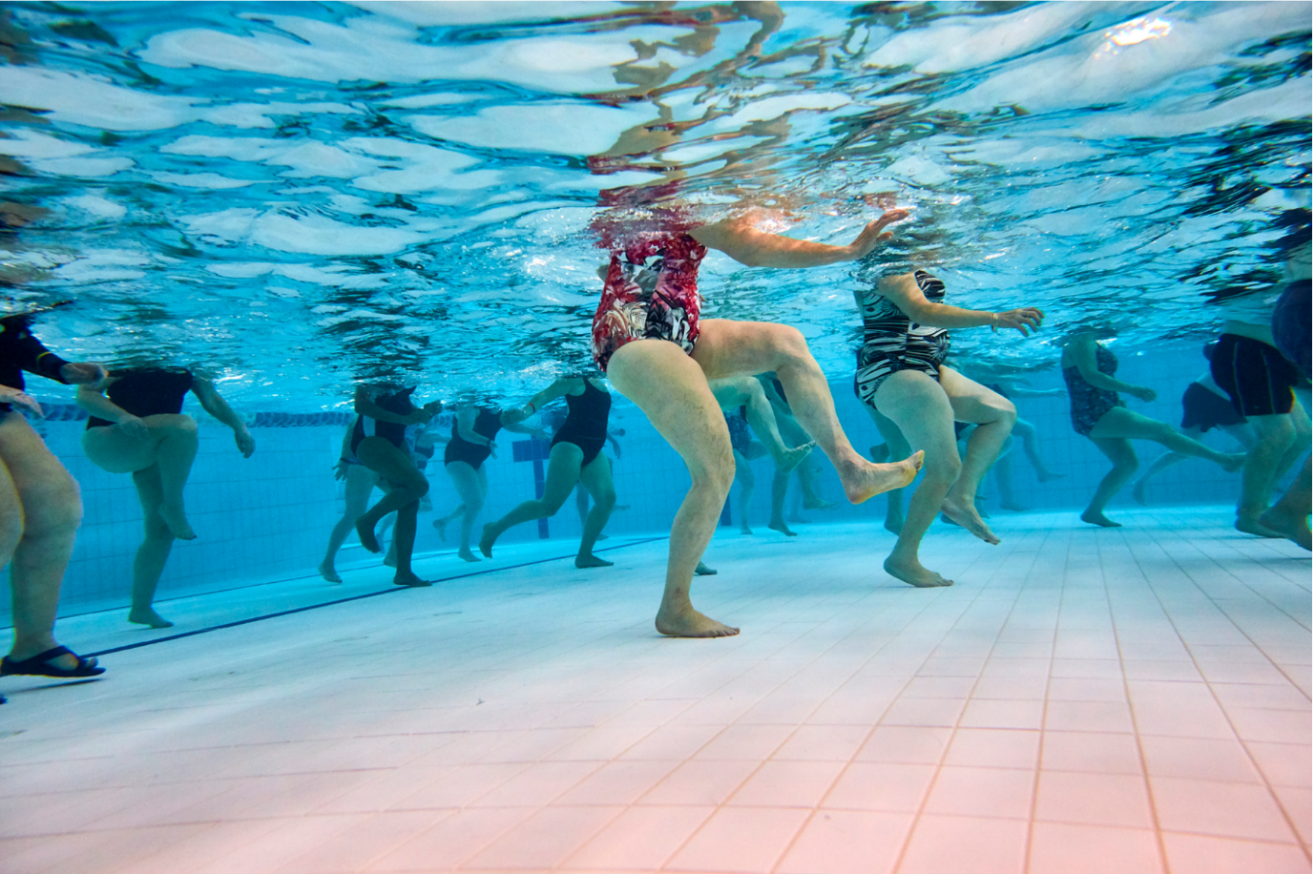

Contents
Summary 3
Background 3
Engagement Methods 4
Promotion 5
Engagement outcomes 5
Who did we hear from? 5
What did they say? 5
Panel’s recommendation to elected Council 5

Summary
From the 14 September – 19 October 2020, the community shared naming suggestions for nine spaces in Ashfield Aquatic Centre. (See appendix for locations).
Criteria: Names should be local citizens and sports people who are associated with the Pool and the community.
Over 1000 individuals viewed the project page, of these 417 people reviewed the content, including reading the Frequently Asked Questions and downloading the translated materials, and 197 directly participated in the ideas wall by posting a suggestion, commenting and/or ‘liking’ each other’s ideas.
In total, 26 ideas were listed on the wall. Excluding duplicates and variations on the same name, eight suggestions met the specifics of the criteria.
- Warwick Webster
- Neville Bayfield OAM
- Edna Wilson
- Paul Misfud
- Mark “Lefty” Wright
- Kevin John Berry
- The Nest (based on a group of people connected with the pool)
- The Diving Pool (based on a group of people connected with the pool)
All naming suggestions were presented to the deliberative panel for consideration. The Panel had representatives from:
- Ashfield Swimming Club
- Ashfield District Historical Society
- Wests Water Polo Club
- Council’s Aboriginal Advisory Committee
- A representative of Warwick Webster’s swimming students.
The deliberative panel reviewed the suggestions, developed decision making principles and made three recommendations to Council:
- Four spaces to be named immediately
  - Grandstand: Warwick Webster
  - Olympic pool: Neville Bayfield OAM
  - Outdoor leisure pool and family area: Edna’s Pond
  - Marshalling area: The Green
- The outdoor pool is reserved for naming by the UNSW Wests Water Polo Club

- Council commits to having an ongoing conversation about naming at Ashfield Aquatic Centre, as appropriate suggestions are brought forward.

Background

Council became aware of a petition to name the new centre after Mr Warwick Webster. The petition was presented by his students and was supported by the family. In 1995, the eastern grandstand was named after Mr Webster to honour his 30 years of service to the community. He passed away in December 2012.

Historically, Ashfield Aquatic Centre has been named after its location:
- Baily Park Pool (during the planning stages only)
- Ashfield Olympic Swimming Centre
- Ashfield Municipal Pool
- Ashfield Aquatic Centre (now)

At the Council meeting on the 11 August 2020, Council decided to acknowledge the heritage of Ashfield and the community’s connection to Ashfield Aquatic Centre by naming spaces/sections within the Centre after local sports people and citizens, while maintaining the historical approach to naming the overall centre.

Engagement Methods
Feedback could be provided:
- Online via and ideas wall on yoursay.innerwest.nsw.gov.au
- Email
- Interactive PDF translated into Traditional Chinese, Simplified Chinese and Nepalese

Promotion
The opportunity to provide suggestions was promoted throughout the engagement period. Channels include:
- Council’s main E-newsletter list and Your Say Inner West list
- Your Say Inner West homepage
- Council’s Facebook on 15 and 19 September 2020
- Council’s Twitter on 15 and 22 September 2020
- Press release led to a story in Inner West Courier
- Direct emails to key stakeholders and groups,
- Council community groups including the LGBTIQ Advisory Committee and Multicultural Advisory Committee

Engagement outcomes
Who did we hear from?
Ideas were shared by students of Warwick Webster, residents and pool users, including those affiliated with organisations.
What did they say?
Names that met the criteria:
- Warwick Webster
- Neville Bayfield OAM
- Edna Wilson
- Paul Misfud
- Mark “Lefty” Wright
- Kevin John Berry
- The Nest (based on a group of people connected with the pool)
- The Diving Pool (based on a group of people connected with the pool)
- Deliberative Panel recommendation
- Grandstand: Warwick Webster
- Olympic pool: Neville Bayfield OAM
- Outdoor leisure pool and family area: Edna’s Pond
- Marshalling area: The Green
- The outdoor program pool naming is reserved for the water polo club
The meeting minutes can be found on the YSIW project page document library.

Appendix
Item A. Map of the new centre and spaces that can be named

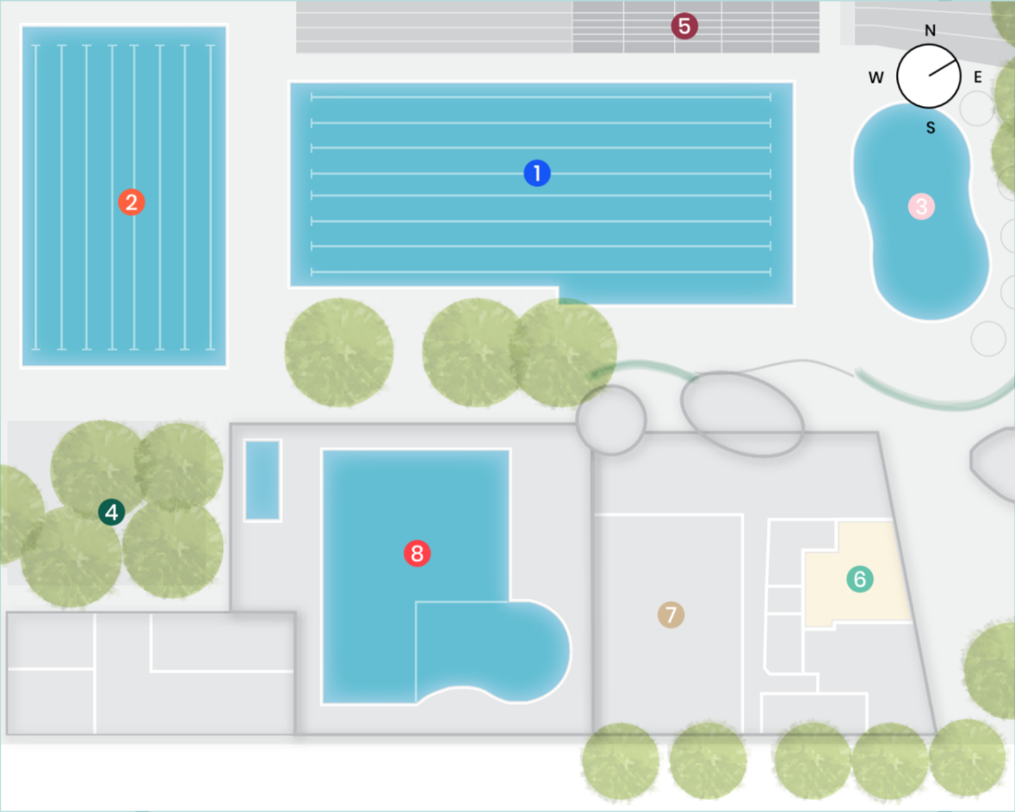
Spaces that can be named include:
- Olympic 50m pool
- Outdoor program pool
- Outdoor leisure pool and family area
- Outdoor marshalling area
- Outdoor grandstand
- Creche
- 2x Group exercise studios
- Indoor pool

