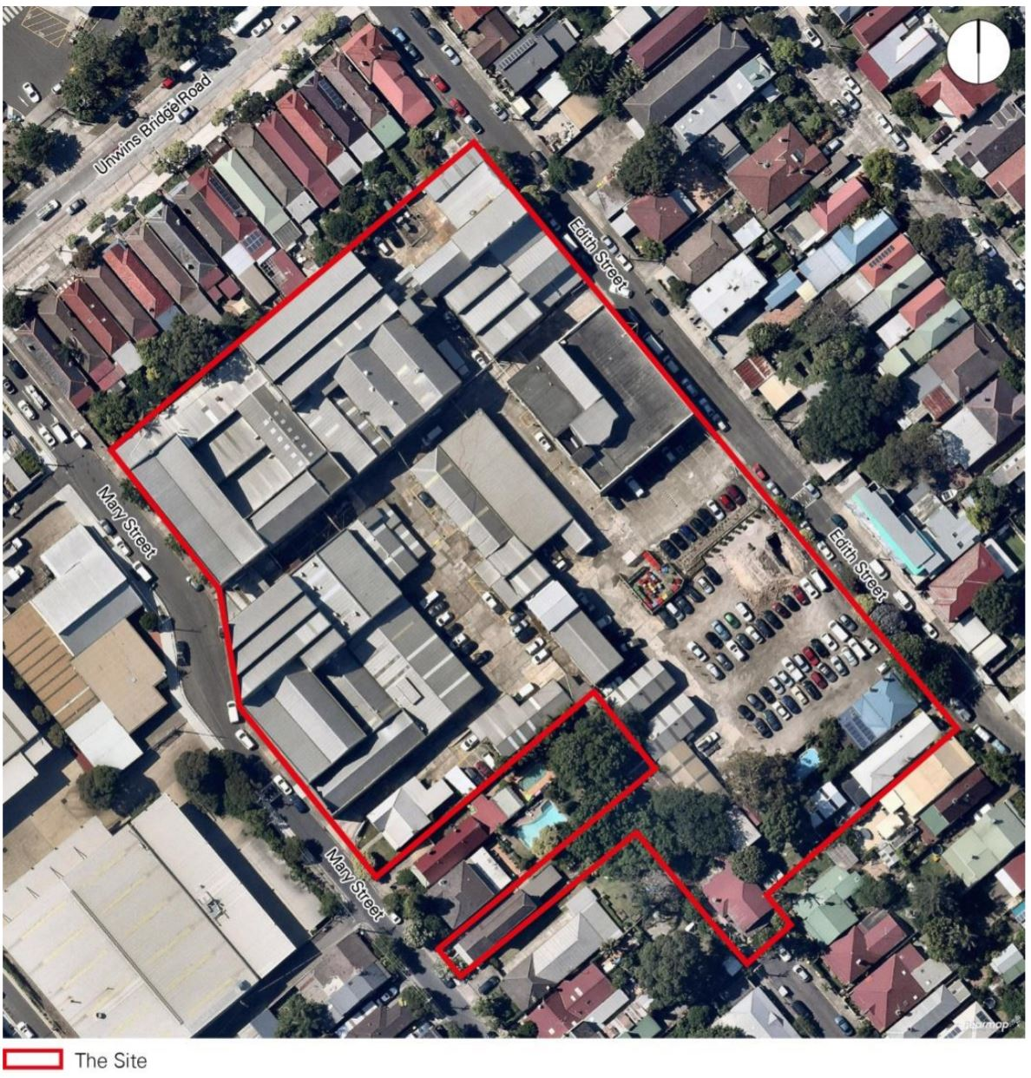

Engagement outcomes report

Precinct 75, St Peters – amendment to Marrickville Development Control Plan 2011

Contents
Summary 3
Background 3
Engagement Methods 3
Promotion 3
Engagement outcomes 4
Officer comments 5

Summary
The draft site-specific Development Control Plan for the site known as Precinct 75 at 67 and 73-83 Mary, 50-52 Edith and 43 Robert Streets, St Peters was publicly exhibited for 28 days from 4 September 2020 to 2 October 2020. The exhibition material was made available on Your Say Inner West (YSIW) and 1156 letters posted to surrounding neighbours, including landowners and occupiers.
During exhibition, the YSIW project page was viewed 717 times with relevant documents downloaded 171 times.
Respondents were asked “Do you support the amendment to Marrickville DCP 2011 for the site-specific provisions at Precinct 75”. Throughout the 28 days of public exhibition, 66 respondents provided feedback. Fifty-four opposed the proposed amendment, 7 supported it and 5 supported the amendment conditionally.

Background
In June 2020 the Marrickville Local Environmental Plan 2011 was amended which changed the land use zoning for the site known as Precinct 75 at 67 and 73-83 Mary, 50-52 Edith and 43 Robert Streets, St Peters.
Key changes include:
- Land use zoning to B4 Mixed Use
- Maximum Floor Space Ratio of 2.2:1
- Maximum building height ranging from two to seven storeys.
Council officers prepared this draft site-specific DCP Amendment with controls to help create a high quality development with minimal adverse impacts. The controls include provisions for setbacks, landscaping, public open space, improved footpaths, green walls and roofs and public art.

Engagement Methods
Several engagement methods were utilised, including the following:
  - Online on yoursay.innerwest.nsw.gov.au
  - Via mail Social media

Promotion
- Council website in the news/announcement section
- Social media
- Direct mail – 1156 notification letters sent to owners and occupiers in the surrounding area

Engagement outcomes
Who did we hear from?
Majority of submissions were received from local residents. Most represented suburbs were:
- St Peters 58
- Marrickville 4
- Tempe 2

What did they say?
Report on the data from the method/s you used such as:
- Online via yoursay.innerwest.nsw.gov.au
Do you support the amendment to Marrickville DCP 2011

Officer comments in response to public exhibition

Submissions that support the Draft Development Control Plan (DCP)
Issues | Officer’s comment
The project is long overdue and is needed for the area. | Noted.
Higher density development mixed with employment spaces improves amenity and supports businesses. | Noted.
The DCP should encourage greater use of public transport and minimise parking requirements on site.  The DCP fails to meet the provisions of the Marrickville LEP 2011 Amendment No.18 with respect to encouraging sustainable transport, including use of public transport, walking and cycling, and appropriate parking provisions.  The DCP fails to meet Council’s Integrated Transport Strategy (ITS) objectives. | The DCP amendment does not reduce or change the existing Marrickville DCP (MDCP) 2011 parking requirements.  The DCP amendment includes provisions for walking, cycling, accessibility for people with accessibility restrictions, a permeable pedestrian network of open space and through site links, local street and footpath improvements, efficient and safe on-site commercial vehicle circulation, car sharing and potential electric vehicle charging and thus aligns with the ITS’s core objectives.
Setbacks for new residential buildings along Edith Street should be no greater than those setbacks in the Urban Design Report supported by Council, Department of Planning, Industry and Environment (DPIE) and Council’s Architectural Excellence Panel. | The LEP controls have been gazetted by the State Government. The DCP amendment provide additional detail to the LEP controls to mitigate any potential adverse impacts and do not adversely affect the development potential of the site.
Overhead power cables are not situated on the site and the DCP should not require these to be put underground. | Council consider that given the development potential contemplated in the LEP controls, the DCP amendment is able to require power lines adjacent to the site to be placed underground. This would provide significant aesthetic benefit, including allowing for viable street tree planting.
The DCP should not require the provision of affordable housing units. | The DCP amendment includes affordable housing controls in Section 12 as prescribed by the LEP amended controls.
50% of roof area as green roof is excessive and this should be no more than 30%. | Council considers the prescribed 50% requirement is a reasonable control given the development potential on the site with the recently amended LEP controls. This type of control has been consistently applied in recent DCP amendments such as the Balmain Leagues Club Precinct DCP amendment.
I support the DCP controls relating to public art, retention of existing buildings and high standards of design and architecture. | Noted.
Submissions that are unsure
Issues | Officer’s comment
Creating lots of greenery would be good but too much greenery may damage cars. | The DCP requires 15% of the site to have a tree canopy which is consistent with Part 2.20 -Tree Management of MDCP 2011. In addition, many of the trees to be planted will not be adjacent to on-street car parking and where they are, they would be planted in accordance with Council’s street planting practice to avoid damage to private property.
Provide more than enough car parking for both residents and visitors at Precinct 75. | The DCP amendment adopts the general MDCP 2011 parking rates which contemplate the sites location near public transport such as Sydenham Station.
Edith Street is not big enough to cater for the future traffic. | Any future development application will require the submission of a Traffic Report prepared by a qualified Traffic Engineer that addresses how traffic circulation will operate, identify the vehicle entry and exits points on the site, proposed traffic calming measures to reduce impacts and ensure the required streetscape and infrastructure improvements for Edith Street are achieved.
8 storeys is too high, should only be 5 storeys. | It is noted that the LEP controls already contemplate up to 8 storeys (approx. 29 metres). The maximum number of storeys in the DCP Amendment ranges from 2 – 8 storeys. The majority of the buildings will be up to 5 storeys with the exception of one 7 storey and one 8 storey building.  The 8 storey building is located in the centre of the site with substantial setback from street frontages. This will minimise any potential overshadowing impacts on the surrounding residential properties.
Submissions that do not support the proposal
Issues | Officer’s comment
The site is a former lead paint factory and highly contaminated.  (12 submissions) | The contamination issue was fully addressed by the Planning Proposal (LEP amendment) to the level required for the rezoning to be approved. The detailed approach to the treatment of the contamination will be dealt with at the development application stage.
The height is out of line with the current residential area.  (28 submissions)  The purported ‘set back’ of these higher properties is minimal and will not materially reduce the impact 7-8 story high buildings on privacy and shadowing.  (8 submissions)  The development should have a maximum height of 4-5 storeys.  (15 submissions)  Poor architectural designs.  (5 submissions)  A DCP should not be prepared without a visual impact analysis and 3D renders of the proposed development  (1 submission)  The development will have an impact on flight paths.  (2 submissions) | These comments relate to the Planning Proposal (LEP amendment) and the specific issues raised cannot be addressed in a DCP as the DCP cannot be inconsistent with the LEP controls under the NSW planning system.  The majority of the buildings will however be no more than 5 storeys with the exception of one 7 storey and one 8 storey building.  The 8 storey building is located in the centre of this large site with a substantial setback from street frontages. This will minimise any potential overshadowing impacts on the surrounding residential properties.  The DCP objectives include: To achieve design excellence that provides a high quality built form that responds to the existing and future context, using principles drawn from an analysis of the site and its context.  Relevant architectural plans were submitted during the preparation and assessment of the DCP amendment which was considered to be reasonable.  The development will not have an impact on flight paths. Sydney Airport provided comments on the original Planning Proposal (LEP amendment) and raised no objections.
Edith Street, Mary Street and Roberts Street and Roberts Lane are far too small to deal with the current traffic volume without the addition of more cars.  (17 submissions)  The development will cause traffic chaos and will put children at risk who play in the area.  (1 submission)  The bus network is not reliable and will promote the use of cars.  (1 submission) | Any future development application will require the submission of a Traffic Report prepared by a qualified Traffic Engineer that addresses how traffic circulation will operate, identify the vehicle entry and exits points on the site, road safety and how traffic on the surrounding streets generated by the development will be minimised.  The DCP amendment adopts the general MDCP 2011 parking rates which contemplate the sites location near public transport such as Sydenham Station.
Lack of parking.  (13 submissions)  A clear requirement on the number of car spaces that should be provided.  (1 submission)  The development of the site will result in loss of street parking to residents. Residents should be given a car space in the development.  (1 submission) | The DCP amendment adopts the general MDCP 2011 parking rates.  The carparking rates should be maintained given that the car parking controls have already contemplated that the site is within walking distance of Sydenham Station (new Metro station).
Artists will lose their workspaces.  (4 submissions)  0.1% for public art is not sufficient and the art should be updated to keep constantly to showcase new artworks.  (1 submission) | The DCP states that a ‘minimum’ of 0.1% of the overall development value should be provided for the development of public art.  The public art will be developed in consultation with Council and community groups and the use of public artists is encouraged.  It would be unreasonable to expect the developer to pay for ongoing regular replacement of the initial public art installation.
Lack of affordable housing.  (3 submissions) | The DCP amendment includes affordable housing controls in Section 12 as prescribed by the LEP amended controls.
A visual impact analysis and accurate 3D renders should be provided.  (2 submissions) | Detailed architectural drawings were provided in the urban design study exhibited with the Planning Proposal (LEP amendment).
Houses will be devalued because of this development.  (1 submission) | No evidence is provided that this will be the case and this is not considered to be a planning consideration under the Environmental Planning and Assessment Act.
Over development of St Peters.  (14 submissions)  Out of character.  (9 submissions)  This development is not in the communities’best interest.  (3 submissions) | These issues relate to the already LEP amendment gazetted by the State Government, which Council did not support. The DCP will mitigate the potential adverse impacts of the LEP Amendment.
Rezoning of the site should not be supported.  (6 submissions) | The State Government has already rezoned the site by amending the Marrickville Local Environmental Plan (MLEP) 2011 in June 2020 against Council’s advice.
Reduction of tree canopy and vegetation.  (1 submission) | The DCP amendment requires the provision of 15% of the site to have tree canopy which is consistent with Part 2.20 -Tree Management of MDCP 2011.
Precinct 75 will lose its village and community feel as a result of the development.  (1 submission)  Precinct 75 will lose its appeal and residents won’t be able to visit cafes, furniture shops and conduct their daily shopping needs.  (2 submission)  Precinct 75 is a creative and retail hub and its employment prospects out way the short term benefits of a construction site.  (1 submission)  Modern shops are likely to be vacant.  (1 submission) | The DCP sets out the desired future character for the site as a vibrant mixed-use development with businesses, homes and publicly accessible shared open spaces including a public town square and ground level active uses to encourage pedestrian activity.  The rezoning to B4 Mixed Use makes retail, personal services and cafes permissible the new residential population will help attract tenants for the new shops and to retain these businesses when they do start to trade.
A footpath must be installed on Albion Lane between Mary Street and Alfred Street and a ‘no left turn – local traffic only’ sign needs to be installed on the corner of Mary Street and Albion Lane.  (1 submission) | Albion Lane does not form part of the site and these proposed traffic calming measures are not relevant to the DCP amendment.  The suggestions will be referred to Council’s Traffic Engineers for further consideration.
Properties adjacent to the site should be included in the DCP.  (1 submission) | These properties are not covered by the recent LEP amendment and are therefore not included in the DCP amendment.
Access to Sydenham Station from Mary Street should be provided through the Council depot.  (1 submission) | This cannot be provided as part of this site specific DCP. There are footpaths on both sides of Unwins Bridge Road to Sydenham Station.
This project has never been supported by Council previously. Why does it continue to be considered.  (1 submission) | The DCP is not concerned with the merits of the Planning Proposal (LEP amendment). That has already been completed against Council’s recommendation. The DCP only relates to additional controls to mitigate any potential adverse impacts from the development.
Not enough natural sunlight to the central green area and the small park at the end of Roberts Street.  (2 submission) | The large, central open space and the smaller Roberts Street park will receive a minimum of 2 hours of solar access between 9:00am and 3:00pm midwinter. This is consistent with the existing solar access controls in MDCP 2011.
The site has heritage significance.  (2 submissions) | The LEP amendment and the DCP amendment both contain measures to facilitate the retention and adaptive re-use of the historic buildings on the site.
Trucks servicing the site during construction and post construction cannot fit on the street.  (1 submission)  Construction noise will impact the local community and past construction projects have decimated and damaged the community.  (1 submission) | The DCP requires any development application for the site to address these issues of servicing and construction noise.  Any development consent conditions will mitigate construction impacts.
The overland flood flow path should be reconsidered and the expanses for the damage caused by the runoff from Precinct 75 cannot be passed on to the neighbouring residential properties.  (1 submission) | Council’s Development Engineers have reviewed the DCP and raised no concerns in this respect.  This type of drainage issue will also be addressed by any future development application.
The wording around the requirements for the ESD principles (e.g. use of reclaimed water, WSUD, use of recycled materials, power conservation) are very fluffy and should require implementation regardless of cost to the developer and should be stated to that effect in the DCP (e.g. replacing the word "should" with the word "must").  (2 submissions) | These controls have been consistently applied within Council’s DCPs such as in the recently adopted Balmain Leagues Club Precinct DCP amendment. The proposed ESD controls are commonly applied to large scale redevelopments.  The word ‘should’ is more appropriate and has been consistently used Council’s DCP controls.
Tenants of a house on the site expressed a concern that they may lose their home because of the redevelopment.  (1 submission) | The LEP contemplates this redevelopment and the DCP amendment is not able to contain controls related to existing tenancies.
Council should provide a community recycling centre at its depot on Unwins Bridge Road.  (1 submission) | This is not an issue that is within the remit of the DCP amendment, but the suggestion will be referred to Council’s Resource Recovery team.

