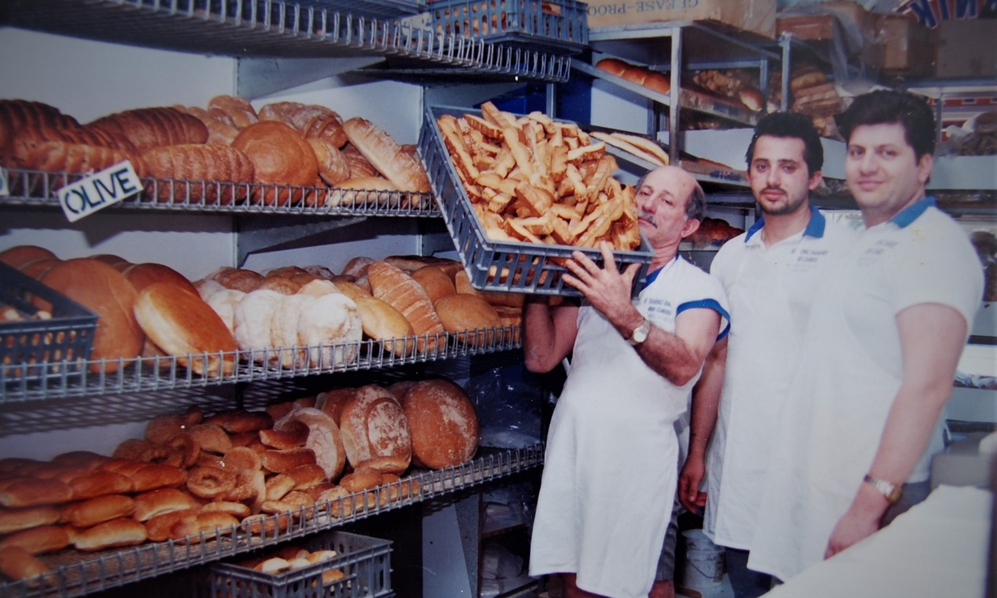

Engagement outcomes report

Greek precinct

Summary
Between 15 June and 12 July 2020, the community could provide feedback on identifying a Greek precinct in Dulwich Hill and/or Marrickville. The community could influence an appropriate name and location for the precinct, and shared ideas for how they would like Council to recognise the precinct.
Overall, 69 people participated in the engagement, which was conducted during the height of pandemic restrictions. The project page received 1,800 unique visits, with 28 participating in the engagement online via the interactive map and stories tool. COVID-safe conversations were held with two Greek seniors’ groups via an interpreter, totalling 36 participants. A letter was received from the Consulate General of Greece in Sydney and two participants associated with a Greek cultural association provided feedback over the phone.
Overall, 63 participants supported the project, four people were opposed and two were neutral in their response. Those who opposed the project said it was not appropriate to name a precinct after one cultural group in a multicultural society. They believed that Council should choose another way to recognise the Greek contribution. This position was supported by one neutral responder who suggested Council consider other ways to share historical information. The second neutral response suggested a partnership with City of Canterbury Bankstown to include Earlwood in the precinct.
The Consulate General supported the project and suggested naming a precinct ‘Little Athens’. They acknowledged that 2021 was a significant year for the Greek community. An announcement to coincide with 200 years of independence in March would be appropriate.
Those who supported the project stated their preferred name and location for the precinct. The preferred name was ‘Little Greece’, supported by 58% of participants.
Approximately 20 locations of significance to the Greek community were proposed spanning across Dulwich Hill and Marrickville. Most suggestions were in Marrickville. For ease of reporting, this information has been summarised here based on roads.
Note: suggestions from the seniors’ groups were not quantified and therefore not presented numerically.
Location | Total
Marrickville Road | 13 people plus members of the seniors’ groups
Livingstone Road | 2 people plus member of the seniors’ groups
Illawarra Road | 4 people plus members of the seniors’ groups
Other | 4 people

Ideas to recognise the precinct can be summarised into three common themes:
- A celebration to mark 200 years of Greek Independence on 25 March 2021
- Public art, such as mosaics or a statute of an Ancient Greek figure
- Sharing historical information, such as a permanent exhibition of photographs, plaques on buildings with cultural significance and a heritage trail/tour.

Background
At the Council meeting on 21 April 2020, the elected Council unanimously voted to engage communities in Dulwich Hill and Marrickville to identify a Greek Precinct.
This is a continuation of efforts to recognise the significant contribution that migrant communities have made to the Inner West and society more broadly. In 2019, following approval from the Geographical Names Board, a Portuguese Precinct was identified in Petersham and an Italian Precinct was identified in Leichhardt.

Engagement Methods
The community could provide feedback through the following methods:
- Your Say Inner West storytelling tool: participants could share text, images and videos about their experiences of Greek culture. There were two contributions via this tool, one was an interview conducted by one of Council’s Engagement Officers.
- Your Say Inner West places tool: participants could drop a pin on a map of Marrickville and Dulwich Hill. They could then complete a short survey about their preferred name, suggest an alternative name and share how they would like to recognise the precinct.
- The Greek Consulate was contacted and sent a letter via email
- Your Say Inner West request a call back in either English or Greek
- Covid-Safe face to face conversations in Greek with two groups of seniors
- Email

Promotion
- Facebook posts on 21 June, 28 June, 10 July 2020
- Shared on the University of Sydney’s Chau Chak Wing Museum’s social media channels as an extension of their exhibition program
- Linkedin post in June 2020
- Twitter posts 22 June, 28 June, 11 July 2020
- Media release
- Direct email to business chamber and identified Greek stakeholders
- Letter to Greek Consulate
- YSIW e-newsletter

Engagement outcomes
Who did we hear from?
We heard from 36 seniors with Greek heritage, the Consulate-General of Greece in Sydney, and residents from Marrickville and Dulwich Hill. Two participants affiliated with the Athenian Association also responded.

What did they say?

Support for the project
The Consulate-General of Greece in Sydney welcomed the project in Marrickville and Dulwich Hill, supporting the name ‘Little Athens’. It was noted that 2021 will mark 200 years since the start of the Greek Revolution that led to the creation of the modern Greek state. It was indicated that 2021 would be a momentous year to announce a Greek precinct.
Overall, 63 participants (91% of all participants) welcomed the project, sharing lived experiences and positive memories of interactions with Greek businesses and culture in Marrickville and Dulwich Hill.
The preferred name, ‘Little Greece’ was supported by 40 participants (58% of all participants). Using Greece/Greek/Hellenic was considered more appropriate because it is inclusive of all who have Greek heritage.

A summary of all names suggested:
Name | Total
Little Greece | 40
Hellenic Precinct | 8
Greek Precinct | 5
Little Athens | 4
Other – please specify:
Agora (Means marketplace in Greek and was the centre of the athletic, artistic, spiritual, and political life in the city) | 3
Platia | 2
Hellenic District | 1
Hellenic Platia | 1
Hellenic Topo (place) | 1
People’s Agora | 1
Ideas to recognise the precinct can be summarised into three themes:
- A celebration to mark 200 years of Greek Independence on 25 March 2021
- Public art, such as mosaics or a statute of an Ancient Greek figure
- Sharing historical information, such as a permanent exhibition of photographs, plaques on buildings of cultural significance or a heritage trail/tour

Opposition to the project
There were four participants who opposed the project. They said that it was not appropriate to name a precinct after one cultural group in a multicultural society. Two people were neutral, not indicating a strong sentiment either for or against the project. They believed Council should choose another way to recognise the Greek contribution, such as considering Earlwood as a better location or focusing on highlighting individual sites of cultural significance with plaques, not an overarching precinct.
Overview of the sentiment on social media
This project generated a strong response on social media, with 222 comments and 87 shares on Facebook. There was a mixed sentiment for whether a precinct was an appropriate way to recognise the Greek-migrant contribution to the area. Comments posted that oppose the project included that Council is out of touch with the community, precinct naming is not appropriate in a multicultural area or it’s too late. The suggestion Earlwood should be included was mentioned 40 times. Those who supported the project were nostalgic and reflected on businesses they like/d to visit.

