Aboriginal and Torres Strait Islander Statement
Inner West Council acknowledges the Gadigal and Wangal peoples of the Eora Nation, who are the traditional custodians of the lands in which the Inner West local government area (LGA) is situated.
We celebrate the survival of Aboriginal and Torres Strait Islander cultures, heritage, beliefs and their relationship with the land and water. We acknowledge the continuing importance of this relationship to Aboriginal and Torres Strait Islander peoples living today, despite the devastating impacts of European invasion. We express our sorrow for past injustices and support the rights of Aboriginal and Torres Strait Islander peoples, to self-determination.
Inner West Council understands our responsibilities and role in working with the Aboriginal community to promote cultural heritage and history, address areas of disadvantage, and to protect and preserve the environment, as well as sites of significance to Aboriginal peoples. In doing so, we acknowledge that Aboriginal cultures continue to strengthen and enrich our community.
Today, diverse groups of Aboriginal and Torres Strait Islander peoples live and work across the Inner West Council area. We admire the resilience displayed in their significant achievements and in making immense contributions to both Council and the broader community.
Inner West Council is committed to embedding the values and perspectives of the Aboriginal and Torres Strait Islander communities, to ensure we learn from the mistakes of our past and forge a positive future of long-lasting value, built on mutual respect, equality and opportunity.

Administration and review record of this development contributions plan:
Date of approval of this development contributions plan  Date in force of this contributions plan: | Adopted - IWC Council Meeting of:  This development contributions plan is in force from:
Exhibition period:

Group responsible for the development of this contributions plan: | Planning, Development and Recreation
Groups responsible (shared responsibility) for the administration and implementation of this contributions plan: | Planning, Development and Recreation and Infrastructure
Related plans and documents:

Appendices: | N/A
References & legislation: | See body of document
Document identifier:

Table of Contents
Table of Contents 4
Part A Executive Summary 6
Part B Summary schedules and abbreviations/definitions 6
Summary works schedule for public amenities and services to be provided under this contributions plan 7
Summary schedule of levies that are applied under this plan 7
Abbreviations/Definitions 8
Part C Demand for public amenities or services 10
Expected population growth in the former Leichhardt LGA component of the current Inner West LGA 10
Expected employment growth in the former Leichhardt LGA component of the current Inner West LGA 10
Part D Administration and Operation of this Plan 12
What is the name of this development contributions plan? 12
Application of this plan 12
C.1.1 Land to which this plan applies 12
C.1.2 Development to which this plan applies 12
C.1.3 Relationship to existing other former Leichhardt Local Government Area contribution plans 12
When does this contributions plan commence? 12
What is the purpose of this contributions plan? 13
Are there any exceptions to the levy? 13
Application of money obtained under this plan 14
Pooling of levies 14
How will contributions be imposed 14
Construction certificates and the obligation of accredited certifiers 14
Complying development and the obligation of accredited certifiers 15
How will the levy be calculated? 15
When is the levy payable? 16
How will the levy be adjusted? 16
Can deferred or periodic payments be made? 17
Appendices 18
A. Land to which this plan applies 19
B. Detailed works schedule for this development contributions plan 1
C. Public amenities and services location maps 1
D. Pro forma Condition of Development Consent 9
E. Pro forma Complying Development Certificate Condition 10
F. Procedure to determine the cost of the proposed development 11

Executive Summary
The Inner West Council predominantly obtains funds towards the provision of public infrastructure through two key sections of the Environmental Planning and Assessment Act - “the Act” (and its associated Regulations):
- section 7.11 (area specific/tailored contribution amounts - formerly known as section 94); and
- section 7.12 (fixed flat rate percentage levy amounts set by the NSW State Government via the Regulations – formerly known as section 94A.)
Section 7.11 and 7.12 funds are used to service any expected future population and employment increase in the Local Government Area (LGA).
Following the amalgamation of the former Ashfield, Leichhardt and Marrickville Local Government Areas into a single Council area in 2016, the new Inner West Council inherited a development contributions framework comprising of seven different plans. The former Leichhardt area is the only part of the Inner West that currently does not have a section 7.12 plan, in place, because its plans predated the widespread use of this section of the Act. This is a harmonisation project which ensures that, section 7.12 levies can be applied uniformly and equitably across the Inner West LGA whilst Council staff prepare a single Inner West Contributions Plan.
Section 7.12 levies are based on flat percentage rates set by the NSW Government in its planning legislation. Given this, the levies are not required to establish, the connection (nexus) between the development paying the levy and the object of the expenditure of the levy which typically requires costly detailed research.
This draft section 7.12 plan provides for the delivery of public amenities and services for the expected population increase, within the former Leichhardt area, to an approximate value of $63 million, over the next 20 years. The draft plan will also seek to recoup over $2.7million that Inner West Council has recently outlaid on public amenities and services, within the former Leichhardt Council area, to address the needs of that expected population increase.
As explained within the body of this document, developments within the former Leichhardt Council area will either pay for section 7.11 or section 7.12 contributions (not both), or none at all, depending on the circumstances.

Summary schedules and abbreviations/definitions
The following summary schedules are included in this plan:
- Works schedule; and
- Summary of levies.

Summary works schedule for public amenities and services to be provided under this contributions plan
The works schedule and public amenities and services location maps identify the public amenities and services for which section 7.12 levies will be required (See Appendices B and C).
Section 7.12 levies paid to Council will be applied towards meeting the cost of the provision of new or the augmentation of existing, public amenities or services. Under the terms of this section of the Act the imposition of the levy (which is calculated as a flat percentage) does not require any connection (nexus) to be established between the development which pays the levy and the object of the expenditure of the levy.
Schedule 1 below provides a summary of public amenities or services that will be provided by Inner West Council over the next 20 Years and the estimated cost of provision and the timing of their delivery. A more detailed list of the works schedule is provided in Appendix B.
Schedule 1: Works schedule for public amenities or services for which levies will be sought under this plan
Community Infrastructure- Former Leichhardt LGA only | Estimated Costs $
Completed Works | 2,789,000
Children and Family Services | 2,299,000
Community Services/Public Art | 10,450,667
Library Services | 227,000
Property and Assets | 3,593,000
Recreation and Aquatics | 8,900,000
Trees, Parks and Sportsfields | 15,012,000
Motor Vehicle Traffic Facilities | 1,055,600
Cycleways | 10,881,000
Town Centre Upgrades/Commercial Strip Improvements | 8,144,000
Total value of proposed works under this development contributions plan | 63,351,267
Source: Inner West Council –S.7.12 Contributions Plan (Former Leichhardt LGA) Schedule of Works – Appendix A

Summary schedule of levies that are applied under this plan
Schedule 2: Summary schedule of levies
Type of development | Levy (% of development costs) *
All forms of development (unless exempted under the provisions of this plan) | 0% under $100,000
 | 0.5 % $100,001 to $200,000
 | 1.0% for all developments over $200,000
* In accordance with Clause 25K of the Environmental Planning and Assessment Regulation 2000 (as amended).

Abbreviations/Definitions
The abbreviations used in this plan are:
Term/ Abbreviation | Full term and explanation where required
AQIS | Australian Institute of Quantity Surveyors (AIQS) “is a professional standards body. Through its leadership, standards and code of ethics, it ensures that practising Quantity Surveyors are dedicated to maintaining the highest standards of professional excellence.” For more information go to www.aiqs.com.au
ATO | Australian Taxation Office (ATO). “The ATO is the Australian Government’s principal revenue collection agency.”
Capital Cost | “a cost incurred on the purchase of land, buildings, construction and equipment to be used…” Collins English Dictionary - www.collinsdictionary.com
Contributions plan | Means a contributions plan referred to in section 7.18 of the Act
Council | Inner West Council (See also IWC below)
CPI | Consumer Price Index. For the purposes of this plan it refers to the Sydney All Groups Consumer Price Index as published quarterly by the Australian Bureau of Statistics (ABS)
CSP | Community Strategic Plan – Our Inner West 2036  (See details of the main strategic directions within this plan at the end of this table)
Development | Has the same meaning as “development” in section 1.5 of the Act:  “..1 (a) the use of land, (b) the subdivision of land, (c) the erection of a building (d) the carrying out of a work, (e) the demolition of a building or work, any other act, matter or thing that may be controlled by an environmental planning instrument…”
DP | Delivery Program (Inner West Council 2018 – 2022)
DCP | Development Control Plan
Environmental Heritage (item of) | The terms “item” and environmental heritage” have the same meaning as in the Heritage Act 1977:
“Environmental heritage means those places, buildings, works, relics, moveable objects, and precincts, of State or local heritage significance.
Item means a place, building, work, relic, moveable object or precinct.”
Term/ Abbreviation | Full term and explanation where required
ERLS | IWC Employment and Retail Lands Study/Strategy prepared by Hill PDA Consulting
IWC | Inner West Council/ Inner West Council Local Government Area
LEP | Local Environmental Plan
LGA | Local Government Area
Local Housing Strategy | Our Place Inner West Local Housing Strategy prepared by Elton Consulting
LSPS | IWC Local Strategic Planning Statement
Public amenities or services | Refers to public infrastructure that are to be provided or augmented under this plan within the former Leichhardt Local Government Area of the Inner West. For the purposes of this plan they include capital works for:  - Children and Family Services;  - Community Services/Public Art;  - Library Services;  - Property and Assets;  - Recreation and Aquatics;  - Trees, Parks and Sportsfields;  - Motor Vehicle Traffic Facilities;  - Cycleways; and  - Town Centre Upgrades/Commercial Strip Improvements.
the Act | Environmental Planning and Assessment Act 1979 (as amended)
the Regulation or the Regulations | Environmental Planning and Assessment Regulation 2000 (as amended)
Schedule of works/Works schedule | Inner West Council - S.7.12 Contributions Plan (Former Leichhardt LGA) Schedule of works – Appendix A
Details of Strategic Directions within the IWC Community Strategic Plan – Our Inner West 2036:
- Strategic direction 1: An ecologically sustainable Inner West (Page 17 CSP);
- Strategic direction 2: Unique, liveable, networked neighbourhoods (Page 19 CSP);
- Strategic direction 3: Creative communities and a strong economy (Page 21 CSP);
- Strategic direction 4: Caring, happy, healthy communities (Page 23 CSP); and
- Strategic direction 5: Progressive local leadership (Page 25 CSP).

Demand for public amenities or services

Expected population growth in the former Leichhardt LGA component of the current Inner West LGA
As of 30 June 2018, the Inner West Council’s population was about 198,000. In the 10 years to this point, the population of the Inner West grew by approximately 1.3% each year. By way of comparison, the population of Greater Sydney grew by about 1.7% over the same period.
Inner West Council has adopted a Local Housing Strategy (2019) which identifies the housing needs of Inner West’s current and expected future residents. The Local Housing Strategy anticipates a growth of about 42,000 people, in the Inner West, over the 20 years to 2036.
Furthermore, based on the NSW Department of Planning & Environment’s projections, the number of dwellings within the Inner West is expected to increase by about 1,000 per year, over the next 20 years.
This local development contributions plan only relates to that part of the Inner West which comprised the former Leichhardt Local Government Area. The Local Housing Strategy contains an analysis of the potential opportunities for housing growth within various parts of the Inner West. The analysis envisages a combined potential housing increase to 2036, for identified opportunity areas, located within the former Leichhardt LGA boundary, of an approximate range of 5,602 - 7,586 dwellings.
Accordingly, this local contributions plan seeks to recoup costs for public amenities or services (which has or will be completed) to service the population growth expected within the former Leichhardt LGA.

Expected employment growth in the former Leichhardt LGA component of the current Inner West LGA
The executive summary of the draft Inner West Employment and Retail Study (2019) notes on page 11 that: “the Inner West LGA has over 3,000,000 sqm of land in employment precincts, [which play]..an important role for providing goods and services to meet the local communities’ needs. Combined, the LGA’s employment precincts currently accommodates around 1.8 million square metres of employment floorspace. Projections indicate that this could increase to between 2.1 million sqm and 2.5 million sqm. This would be an addition of between 300,000 sqm and 700,000 sqm of floorspace. Associated jobs growth includes increases by between 23,000 jobs (35%) and 27,000 jobs (41%) to 2036.”
As previously mentioned, this local development contributions plan only relates to that part of the Inner West which comprised the former Leichhardt Local Government Area. The draft Inner West Employment and Retail Study (2019) contains an analysis of the potential opportunities for employment growth within precincts across the Inner West up to 2036. A review of that information indicates that the range of employment/additional office and retail floorspace growth, within the employment precincts of the former Leichhardt LGA, will be in the approximate range of:
Table 1: Total employment floorspace demand by precinct (Source: Hill PDA)
Expected total employment growth within precincts wholly located within the former Leichhardt LGA up to 2036 | Current floorspace (sqm) | Additional expected demand by 2036
 |  | Low growth estimate (sqm) | High growth estimate (sqm)
Former Leichhardt LGA employment precincts including:*
Balmain Road Industrial Precinct; | 18,073 | 22,379 | 32,426
Balmain Working Waterfront; | 6,808 | 8,107 | 13,489
Canal Road Arts Precinct; | 33,943 | 40,470 | 40,468
Lilyfield Employment Precinct; | 7,256 | 8,520 | 10,178
Marion Street Industrial Precinct; | 4,064 | 5,371 | 5,601
Moore Street Industrial Precinct; | 60,355 | 76,390 | 103,356
Terry Street Industrial Precinct; and | 15,159 | 18,550 | 27,148
White Bay Industrial Precinct | 73,551 | 88,275 | 119,783
Totals: | 219,209 | 268,062 | 352,449
*Note: Some precincts were excluded from this summary table because they are not wholly located within the former Leichhardt LGA.
Table 2: Forecast increase in office workers within Commercial centres located within the former Leichhardt LGA (Source: HILLPDA Estimate from TPA (Transport Performance and Analytics – Transport NSW) forecasts at SA2 level).
Commercial centres located within the former Leichhardt LGA* | Expected net increase in workers
 | 2016-26 | 2026-36
Balmain | 292 | 526
Leichhardt | 239 | 403
Rozelle | 860 | 526
Totals: | 1,391 | 1,455
*Note: Some parts of the former Leichhardt LGA that fall within the “Other” category of the original table of this information were excluded from this summary table because it was not possible to discern this level of detail.
Table 3: Forecast demand and current supply of retail floorspace (sqm) within the former Leichhardt LGA. (Source: HillPDA and various other sources)
Suburb in which the retail area is located | Current supply (sqm) | Additional Expected Demand for retail floorspace (sqm) |  |  | Additional GLA* Required | Additional GFA Required
 |  | 2018 | 2026 | 2036
PRCUTS (Parramatta Road Corridor Urban Transformation Strategy) Leichhardt Core | 26,700 | 37,682 | 44,753 | 46,928 | 20,228 | 23,798
Balmain | 19,600 | 21,978 | 22,437 | 23,206 | 3,606 | 4,242
Rozelle | 18,500 | 21,472 | 21,822 | 22,441 | 3,941 | 4,637
Marion Street Centre | 14,900 | 21,884 | 25,916 | 27,099 | 12,199 | 14,352
Totals: | 79,700 | 103,016 | 114,928 | 119,674 | 39,974 | 47,029
*GLA refers to Gross Lettable Area
**GFA refers to Gross Floor Area
Accordingly, this local contributions plan also seeks to recoup costs for public amenities or services (which has or will be completed) to service the employment growth expected to occur within the former Leichhardt LGA component of the Inner West.

Administration and Operation of this Plan

What is the name of this development contributions plan?
This development contributions plan is called the “Former Leichhardt Local Government Area Section 7.12 Development Contributions Plan 2020”.

Application of this plan

Land to which this plan applies
This plan applies to that part of the Inner West Local Government Area, which formed all of the former Leichhardt Local Government Area, as shown on the map (included in this plan as Appendix A).

Development to which this plan applies
This plan applies to applications for development consent and applications for complying development certificates under Part 5B of the Environmental Planning and Assessment Act, for sites within the former local government area of Leichhardt (See Appendix A for further details).

Relationship to existing other former Leichhardt Local Government Area contribution plans
This development contributions plan does not supersede or amend the other existing former Leichhardt Local Government Area plans, which are still in operation following the amalgamation of the former Leichhardt; Marrickville; and Ashfield Local Government Areas. These section 7.11 plans (formerly section 94 plans) include: Development Contributions Plan No.1 – Open Space and Recreation (as amended); Development Contributions Plan 2 – Community Facilities and Services; and Development Contributions Plan No.3 – Transport and Access.
The relevant provisions of the Act (section 7.12) prevent Council staff from imposing contribution conditions for a development site under both sections 7.11 and 7.12 for the same development, accordingly, a development site would be required, where relevant, to either pay for development contributions pursuant to the requirements of the abovementioned existing section 7.11 plans for sites within the former Leichhardt Local Government Area or under the provisions of this section 7.12 development contributions plan, as relevant.

When does this contributions plan commence?
This plan commenced on the date stated within the public notice issued pursuant to the relevant requirements of the Regulation. (Refer to page 3 of this plan for further details).

What is the purpose of this contributions plan?
The primary purposes of this plan are:
- To authorise the imposition of a condition on certain development consents and complying development certificates requiring the payment of a contribution pursuant to section 7.12 of the Act.
- To assist Council to provide the appropriate new or augmented public amenities or services, required to maintain and enhance amenity and service delivery with the expected population increase, within the area which is the subject of this plan.
- To ensure, generally, that there is uniformity across all of the Inner West Council land area, in its application of levies under section 7.12 of the Act.
- To publicly identify the purposes for which the levies are required.

Are there any exceptions to the levy?
As previously indicated, development located within the former Leichhardt Local Government Area (As shown in Appendix A) that is currently required to pay development contributions under the existing former Leichhardt section 7.11 plans (formerly section 94 plans) Development Contributions Plan No.1 – Open Space and Recreation (as amended); Development Contributions Plan 2 – Community Facilities and Services; and Development Contributions Plan No.3 – Transport and Access will not be levied for development contributions under this plan. For further information see the Section 94 Contributions page on the Inner West Council website.
Conversely, any development, located within the former Leichhardt Local Government Area (As shown in Appendix A), which costs greater than $100,000, and is not currently required to pay development contributions under the existing former Leichhardt section 7.11 plans (mentioned above) will be required to pay the applicable levies under this plan, unless exempted from doing so under the provisions stated below.
The levy will not be imposed in respect of development relating to:
- Where the proposed cost of carrying out the development is $100,000 or less;
- For the purpose of disabled access;
- For the sole purpose of providing affordable housing;
- For the purpose of reducing the consumption of mains supplied potable water, or reducing the energy consumption of a building;
- For the sole purpose of the adaptive re-use of an item of environmental heritage;
- For the purpose of ‘seniors housing’ as defined in State Environmental Planning Policy (Housing for Seniors or People with a Disability) 2004, which is undertaken by a ‘social housing provider’;
- That has been the subject of a condition under section 7.11 (or its predecessor – section 94) under a previous development consent, relating to the subdivision of the land on which the development is to be carried out; and
- Applications submitted by or on behalf of Inner West Council.

Note: these items of development have been previously identified within (now revoked) NSW Ministerial Directions on local infrastructure contributions, pursuant to relevant provisions of the Act.

The levy may not be imposed in respect of development relating to (which will be at the sole discretion of Council):
- Circumstances where the proposed development includes the provision, extension or augmentation of public amenities or public services that provide a public benefit:
  - for example - schools; places of worship; public hospitals; police stations; fire stations; and other emergency services; and
  - small scale works proposed to be undertaken for charitable purposes, by or on behalf of, a not-for-profit charity (as defined by the ATO).

Application of money obtained under this plan
Monies paid to Inner West Council under a condition authorised by this plan are to be applied by Council towards meeting the capital costs associated with the provision, extension or augmentation of public amenities or public services of one or more of the public facilities that will be, or have been, provided within the former Leichhardt LGA, as listed in Appendix B of this plan.

Pooling of levies
The Act (section 7.3) provides for development contributions levies, paid for different purposes, to be pooled and applied progressively for those purposes.
Where this occurs, the priorities for the expenditure of the contributions or levies must be particularised by reference to the works schedule.
This plan authorises the monetary pooling of funds to enable Council to more efficiently use funds to build facilities to meet the needs of our growing community.
The priorities for the expenditure of pooled monetary contributions under this plan are the priorities for works as set out in the relevant works schedule – (See Appendix B).

How will contributions be imposed
In accordance with the Act, development contributions under this plan will be imposed as a condition of development consent (See Appendix D) or as a condition on a complying development certificate (See Appendix E).
The Act provides that such a condition is not invalid by reason only that there is no connection between the development, the subject of the development consent, and the object of expenditure of any money required to be paid by the condition.

Construction certificates and the obligation of accredited certifiers
In accordance with clause 146 of the Environmental Planning and Assessment Regulation 2000 (Regulation), as amended, a certifying authority must not issue a construction certificate for building work or subdivision work under a development consent, unless it has verified that each condition of the development consent (required to be complied with before the issue of a construction certificate), have been satisfied (including where relevant, those requiring the payment of levies).
The only exception to this requirement is where an alternative payment method has been previously agreed by Council. In such cases, Council will issue a letter confirming that an alternative payment method has been agreed with the applicant.

Complying development and the obligation of accredited certifiers
In accordance with the Act, a complying development certificate, issued by accredited certifiers under section 4.28 (9) of the Act, must be issued subject to a condition that the relevant contribution or levy must be paid to Council before any work authorised by the certificate commences. Failure to follow this requirement would render such a certificate invalid.
The relevant condition imposed (where relevant) must be consistent with Council’s standard condition for complying development certificates (See Appendix E) and be strictly in accordance with this plan.
It is the professional responsibility of accredited certifier to ensure that the contribution has been calculated in accordance with the provisions of this plan by an appropriately qualified person and to apply the development contribution correctly.

How will the levy be calculated?
The levy will be determined on the basis of the percentage rate as set out in Summary Schedule 2 and calculated as follows:
Levy payable = %C x $C
Where:
%C = is the levy rate applicable; and
$C = is the proposed cost of carrying out the development as certified.
The proposed cost of carrying out the development will be determined in accordance with clause 25J of the Regulation. The procedures set out in Appendix F to this plan must be followed to enable Council to determine the amount of the levy to be paid.
The value of the works must be provided by the applicant at the time of the request and must be independently certified by a Quantity Surveyor who is the registered with the Australian Institute of Quantity Surveyors (AIQS) or a person who can demonstrate equivalent qualifications.
Without the limitation to the above, Council may review the valuation of works and may seek the services of an independent person to verify the costs. In these cases, all costs associated with obtaining such advice will be at the expense of the applicant and no construction certificate will be issued until such time that the levy has been paid.

When is the levy payable?
A levy must be paid to Council at the time specified in the condition that imposes the levy. If no such time is specified, the levy must be paid prior to the issue of a construction certificate or prior to the commencement of works in the case of complying development certificates.

How will the levy be adjusted?
Contributions required as a condition of consent under the provisions of this plan will be determined in accordance with the provisions of this plan. A certified cost report is taken to be accurate on the day it was certified.
The contribution required is to be adjusted at the time of payment of the contribution in accordance with the following formula:
Contribution at the time of payment = $Co + A
Where:
$Co = is the original contribution as determined in accordance with the provisions of this plan as set out in the consent for the relevant work.
A = is the adjustment amount which is =

$Co x ([Current CPI – Base CPI])
[Base CPI]
Where:
Current CPI is the Sydney All Groups Consumer Price Index as published quarterly by the Australian Bureau of Statistics and available at the time of review of the contribution rate.
Base CPI is the Sydney All Groups Consumer Price Index as published quarterly by the Australian Bureau of Statistics at the date of adoption of this plan which is shown on page 3 of this plan.
Note 1: The CPI Sydney All Groups Consumer Price Index is published quarterly for the periods of December to February; March to May; June to August; and September to November. If an issued contribution condition (pursuant to provisions of this plan) and the corresponding subsequent levy payment for that contribution condition occurs within the same CPI period, no indexing of the payment amount will occur.
Note 2: In the event that the Current CPI is less than the previous CPI, the Current CPI shall be taken as not less than the previous CPI.
Note 3: In indexing the cost of development to calculate indexed section 7.12 levies, Council will not change the percentage of the levy that is applicable. For example, if the applicable rate at the time the certificate or approval is issued is 0.5% for development costing up to and including $200,000, then the rate used for calculating the section 7.12 levy will remain at 0.5% even if the indexed cost of development increases to over $200,000 where a 1% levy is normally applicable.

Can deferred or periodic payments be made?
Deferred payment of development contributions may be permitted in certain circumstances in accordance with the criteria outlined below:
- An application for deferred payment by instalments is to be made in writing to Council explaining the circumstances of the request ( Note: where relevant this may entail the lodgement of a modification to a development consent under the provisions of section 4.55 of the Act);
- The decision to allow deferred payment will be at the sole discretion of Council;
- The timing or the manner of the provision of public facilities included in the works program will not be prejudiced;
- The works to which the request applies does not relate to public safety or health;
- The amount of the contribution or outstanding balance is not less than $5,000;
- The maximum period of deferred payment of the contribution is two years from the standard payment date; and
- Deferred payments and payments by instalments are subject to interest charges equivalent to that applied to overdue rates and an administration charge equivalent to the bank guarantee lodgement fee for subdivision related matters as stated in Council’s Fees and Charges.
If Council does decide to accept deferred payment by instalments, Council will require the applicant to provide a bank guarantee with the following conditions:
- The Bank Guarantee(s) must be in Australian Dollars from a major Australian Trading Bank and in the name of the Inner West Council;
- The Bank Guarantee(s) must have no end date, be unconditional and irrevocable, and be in the favour of the Inner West Council;
- The sum of the Bank Guarantee(s) will be the amount due to Council at the date of issue, plus an additional amount specified by Council to make provision for any anticipated indexation during the life of the Bank Guarantee until the estimated date of release;
- The bank’s obligations are discharged when payment to Council is made in accordance with this guarantee or when Council notifies the bank in writing that the guarantee is no longer required;
- Where a bank guarantee has been deposited with Council, the guarantee shall not be cancelled until such time as the original contribution, accrued interest and other charges are paid; and
- An administration fee may apply to utilise the bank guarantee option.

Appendices
List of Appendices:
Appendix A. Land to which this plan applies – Map of the former Leichhardt Local Government Area;
Appendix B. Detailed works schedule for this development contributions plan;
Appendix C. Public amenities and services location maps;
Appendix D. Pro forma condition of development consent;
Appendix E. Pro forma complying development certificate condition; and
Appendix F. Procedure to determine the cost of the proposed development.

Appendix A - Land to which this plan applies

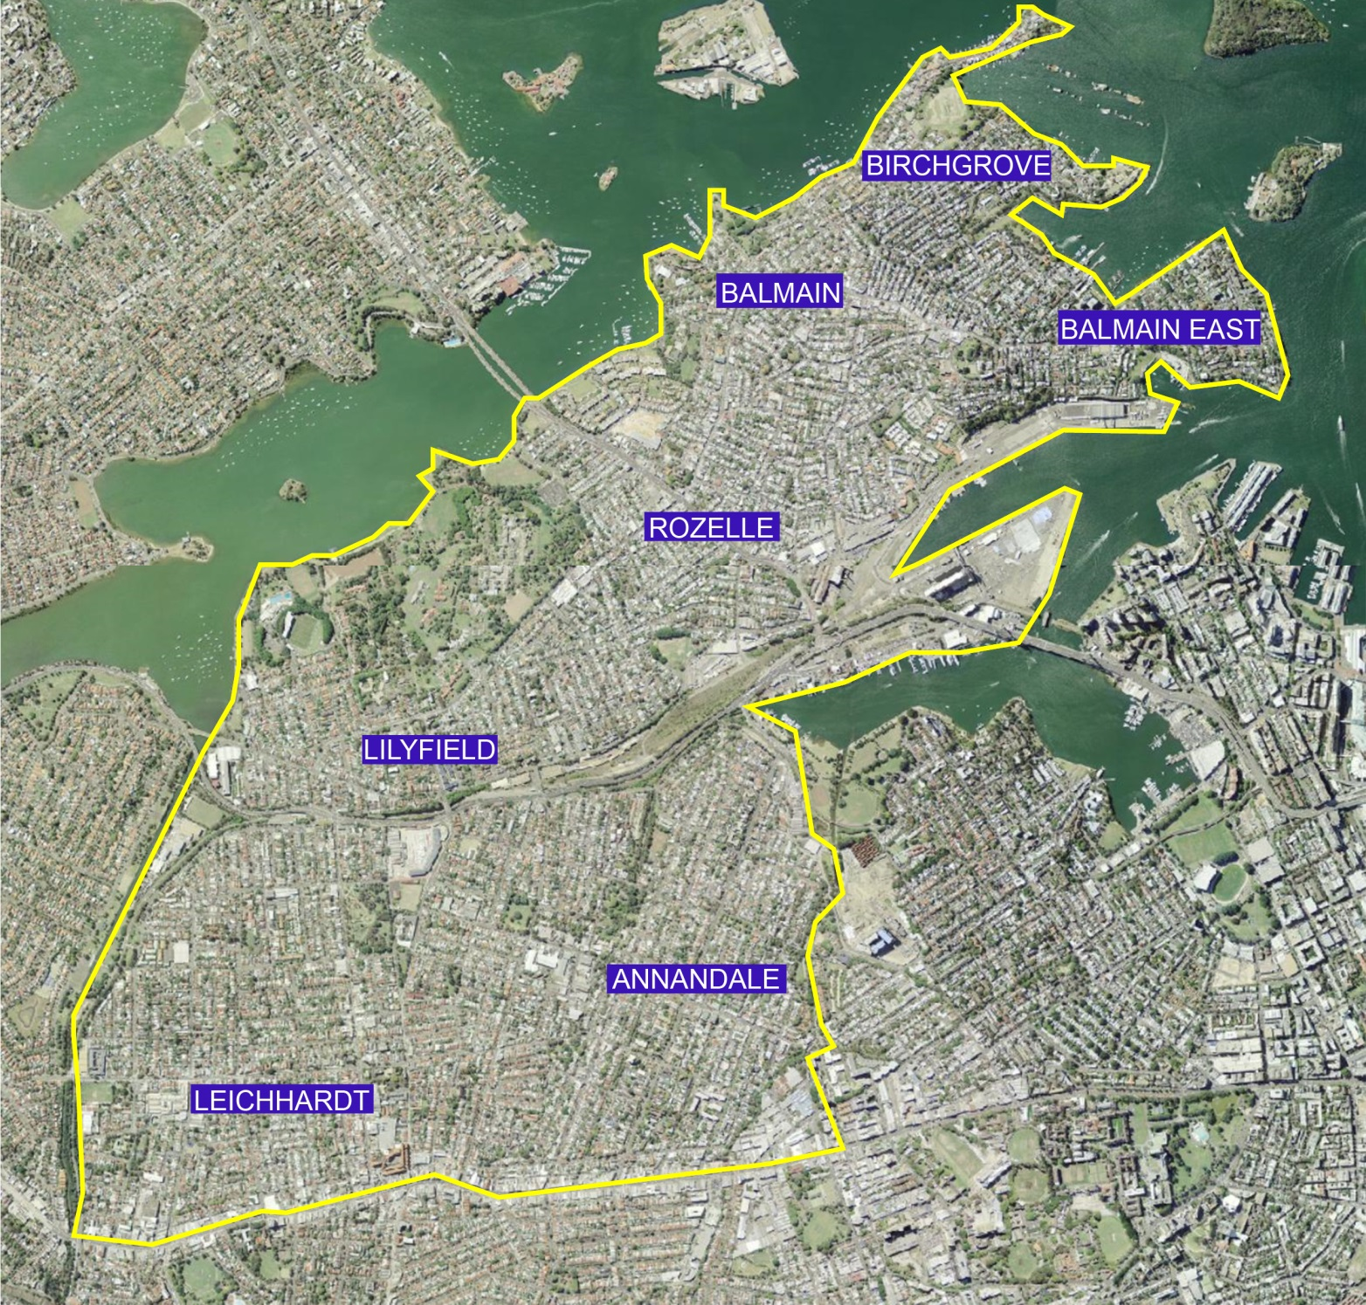
Figure 1: The land to which this plan applies (within the yellow boundary) which equates to the boundary of the former Leichhardt Local Government Area.

Appendix B - Detailed works schedule for this development contributions plan
Appendix B - Section 7.12 Contributions Plan (Former Leichhardt LGA) Schedule of Works:
 | Strategic direction areas from the Community Strategic Plan
Strategic direction 1: An ecologically sustainable Inner West
Strategic direction 2: Unique, liveable, networked neighbourhoods
Strategic direction 3: Creative communities and a strong economy
Strategic direction 4: Caring, happy, healthy communities
Strategic direction 5: Progressive local leadership
Priorities:
Short Term: 1-2 years (FY20 and FY21)
Medium Term: 3-4 years (FY22 and FY23)
Long Term: 5-10 years (FY24, FY25, FY26, FY27, FY28, FY29 and FY30)
Aligned Strategic Directions |  | Item No. | Item |  | Description | Estimated Cost $ |  | Priority
Completed Works
Strategic directions: 2;3 & 4 |  | C1 | 2-8 Weston St and Illoura Reserve |  | Adaptive reuse of State Heritage Listed Fenwick Stone Building, construction of new lift, accessible public amenities, creation of an accessible parking space and path of travel through Illoura Reserve connecting to foreshore | 1.8M |  | Completed
Strategic directions: 1 & 2 |  | C2 | Birchgrove Park Amenities |  | Construction of new wheelchair accessible WC and path of travel. | 800K |  | Completed
Strategic directions: 1 & 2 |  | C3 | Leichhardt Park Amenities |  | New accessible amenities | 189K |  | Completed
 |  |  |  |  | Completed works which are to be recouped under this plan- total | 2,789,000
Children and Family Services
Strategic directions: 1; 2 & 4 |  | C&FS1 | Leichhardt Street Child Care Centre |  | Renewal works | 679K |  | Medium
Strategic directions: 1; 2 & 4 |  | C&FS2 | Balmain Occasional Care |  | Refurbishment | 350K |  | Short
Strategic directions: 1; 2 and 4 |  | C&FS3 | John McMahon Child Care Centre |  | Refurbishment | 370K |  | Medium
Strategic directions:1; 2;3 & 4 |  | C&FS4 | Leichhardt Park Child Care Centre |  | Refurbishment and Upgrade | 400K |  | Long
Strategic directions: 2 & 4 |  | C&FS5 | Balmain Early Childhood Centre |  | Refurbishment | 300K |  | Medium
Strategic directions: 2; 3 & 4 |  | C&FS6 | Balmain East Playroom House |  | Refurbishment | 200K |  | Medium
 |  |  |  |  | Child Care and Family Services Total | 2,299,000
Community Services/Public Art
Strategic directions:1; 2;3 & 4 |  | CS/PA1 | Balmain Town Hall Site |  | Renewal works | 1M |  | Short
Strategic directions: 2; 3 & 4 |  | CS/PA2 | Hannaford Community Centre |  | Refurbishment | 175K |  | Medium
Strategic direction: 4 |  | CS/PA3 | Leichhardt Market Town Community Room |  | Refurbishment | 55K |  | Medium
Strategic directions: 2;3 & 4 |  | CS/PA4 | Cecily Street/Jimmy Little Community Centre |  | Refurbishment | 370K/60K |  | Medium/Long
Strategic directions:1; 2;3 & 4 |  | CS/PA5 | Rozelle Bay Community Native Nursery Shelter |  | Refurbishment | 220K |  | Medium
Strategic directions:1; 2;3 & 4 |  | CS/PA6 | Whites Creek Cottage & Stables |  | Refurbishment | 310K |  | Long
Strategic directions:1; 2;3 & 4 |  | CS/PA7 | Annandale Community Centre |  | Refurbishment | 808K |  | Short
Strategic directions:1; 2;3 & 4 |  | CS/PA8 | Annandale Town Hall Community Centre |  | Refurbishment | 700K |  | Short
Strategic directions: 2;3 & 4 |  | CS/PA9 | Balmain East Craft Cottage |  | Refurbishment | 150K |  | Long
Strategic directions: 2 & 4 |  | CS/PA10 | Callan Park Recreational Hall |  | Refurbishment | 300K |  | Long
Strategic directions: 2; 3 & 4 |  | CS/PA11 | Clontarf Cottage Community Centre |  | Refurbishment | 450K |  | Short
Strategic directions: 2 & 3:  (3.2 Inner West is the home of creative industries and services) |  | CS/PA12 | Purchase and fit-out of an approximate 700sqm  warehouse styled creative space for visual artists; sculptors; and writers etc. |  | Initial purchase and fit-out only | 4.5M |  | Medium-Long
Strategic directions: 2 & 3  (3.2 Inner West is the home of creative industries and services) &  (Urban hubs and main streets are distinct and enjoyable places to shop, eat, socialise and be entertained) |  | CS/PA13 | Public art and placemaking projects within Parramatta Road; the Greenway; and the linking of the works to the Gadigal Wangal wayfinding and public art trail. |  | Capital works only | 1.3M |  | Short-Medium
Strategic directions:1; 2;3 & 4 |  | CS/PA14 | Additional IWC Community Transport Bus (22 Seater) (Former Leichhardt LGA Component only - 1/3 of the total purchase cost of $158,000) |  | Initial purchase of bus only which includes accessible chair lift fit-out | 52,667K
 |  |  |  |  | Community Services/Public Art Total | 10,450,667
Library Services
Strategic directions: 2;3 & 4 |  | LS1 | Leichhardt Library |  | Renewal works | 77K |  | Medium
Strategic directions:1; 2;3 & 4 |  | LS2 | Mobile Library Bus |  | Initial purchase of bus and fit-out only | 150K |  | Short- Medium
 |  |  |  |  | Library Services Total | 227,000
Property and Assets
Strategic directions; 1; 2; & 4 |  | P&A1 | Victoria Road Toilet Block |  | Refurbishment | 650K |  | Long
Strategic directions: 2;3; 4 & 5 |  | P&A2 | Leichhardt Town Hall |  | Renewal works | 850K |  | Short
Strategic directions: 2;3 & 4 |  | P&A3 | Elliot Street Kiosk |  | Renewal works | 600K |  | Short
Strategic directions: 2 & 4 |  | P&A4 | Blackmore Park - NSW State Emergency Service (SES) Facility |  | Building renewal works | 200K |  | Short
Strategic directions: 2; 3 & 4 |  | P&A5 | Café Bones Hawthorne Canal Reserve |  | Renewal works | 78K |  | Medium
Strategic directions: 1 & 2 |  | P&A6 | Balmain Town Hall Glass House |  | Upgrade | 100K |  | Long
Strategic directions: 2 & 4 |  | P&A7 | Balmain Town Hall Toilet Block |  | Refurbishment | 10K |  | Medium
Strategic directions: 2;3 & 4 |  | P&A8 | Bridgewater Park Pump House |  | Upgrade | 75K |  | Long
Strategic directions: 1; 2; 3; 4 & 5. |  | P&A9 | Balmain West Wharf Kiosk |  | Refurbishment | 1.03M |  | Long
 |  |  |  |  | Property and Assets Total | 3,593,000
Recreation and Aquatics
Strategic directions:1; 2;3 & 4 |  | R&A1 | Leichhardt Park Aquatic Centre - Master Plan Implementation |  | Redevelopment works –  Implementation of key priorities contained in the Leichhardt Aquatic Centre Master Plan – Capital works only | 6.4M |  | Short
Strategic directions: 2 & 4 |  | R&A2 | Iron Cove Bay Run Improvements |  | Improving accessibility and safety to facilitate and promote greater use and enjoyment of the Iron Bay Run | 2.5M |  | Long
 |  |  |  |  | Recreation and Aquatics Total | 8,900,000
Trees; Parks; and Sportsfields
Strategic directions:1; 2;3; 4 & 5 |  | TP&S1 | Pioneers Memorial Park |  | Renewal works | 311K |  | Short
Strategic directions: 1; 2 and 4 |  | TP&S2 | Pioneer Memorial Park Amenities Block Tool Shed |  | Refurbishment | 85K |  | Long
Strategic directions: 1; 2 and 4 |  | TP&S3 | Birchgrove Park |  | Renewal works | 1.56M |  | Medium
Strategic directions:1; 2;3 & 4 |  | TP&S4 | Birchgrove Park Amenities, Dressing Shed &Toilets |  | Refurbishment | 170K |  | Long
Strategic direction: 1: |  | TP&S5 | Birchgrove Park Toilet Block Garden Store shed |  | Refurbishment | 60K |  | Long
Strategic directions: 1; 2 and 4 |  | TP&S6 | Easton Park Amenities |  | Renewal works | 40K |  | Long
Strategic direction: 2 |  | TP&S7 | Mort Bay Park -Toilet Block |  | Renewal works | 50K |  | Short
Strategic directions:1; 2;3; 4 & 5 |  | TP&S8 | Elkington Park Bandstand |  | Renewal works | 70K |  | Long
Strategic directions: 1 & 2 |  | TP&S9 | Elkington Park Cottage |  | Restoration works | 498K |  | Short
Strategic directions :1; 2 and 4 |  | TP&S10 | Elkington Park Toilet Block |  | Refurbishment | 100K |  | Short
Strategic directions: 1; 2 and 4 |  | TP&S11 | Blackmore Oval Amenities Block A |  | Refurbishment | 371K |  | Medium
Strategic direction 4: Caring, happy, healthy communities |  | TP&S12 | Cohen Park Tennis Courts Amenities & Storage |  | Refurbishment | 27K |  | Long
Strategic directions:1; 2;3 & 4 |  | TP&S13 | Leichhardt Oval |  | Upgrade works | 1M |  | Short
Strategic directions: 2 & 4 |  | TP&S14 | Leichhardt Oval No. 1 Turnstiles and other related works |  | Refurbishment | 600K |  | Short
Strategic directions: 1; 2 and 4 |  | TP&S15 | Leichhardt Park No 2 Amenities + Canteen |  | Upgrade works | 295K |  | Short
Strategic directions: 2 & 4 |  | TP&S16 | Leichhardt Oval No. 3 Amenities |  | Upgrade works | 35K |  | Long
Strategic directions 1; 2 and 4 |  | TP&S17 | Leichhardt Park Plan of Management Improvements |  | Implementing key priorities of the Leichhardt Park Plan of Management – Capital works only | 3M |  | Medium
Strategic directions: 1; 2 and 4 |  | TP&S18 | King George Park Plan of Management |  | Implementation of the King George Park Plan of Management– Capital works only | 1.4M |  | Short-Medium
Strategic directions: 2 & 4 |  | TP&S19 | Gladstone Park |  | Upgrade works in accordance with the Gladstone Park Plan of Management and Master Plan | 1.8M |  | Short
Strategic directions: 2& 4 |  | TP&S20 | Gladstone Park Toilet Block |  | Refurbishment | 90K |  | Medium
Strategic directions: 1; 2 and 4 |  | TP&S21 | Future Rozelle Parkland Improvements |  | Development of the Rozelle Parklands in response to community recreation needs | 3.2M |  | Medium - Long
Strategic directions: 1 & 4 |  | TP&S22 | Biodiversity Improvements within Local Parks |  | Implementing the Leichhardt Biodiversity Action Plan – Capital works only | 250K |  | Medium
 |  |  |  |  | Trees; Parks; and Sportsfields Total | 15,012,000
Motor Vehicle Traffic Facilities
Strategic direction: 2 |  | MVTF1 |  | Intersection of Curtis Road and Mort Street, Balmain | LATM (Local Area Traffic Management) - Kerb blisters |  | 70K |  |  | Short
Strategic direction: 2 |  | MVTF2 |  | Intersection of Darling Street and Manning Street, Rozelle | Kerb extensions |  | 25K |  |  | Short
Strategic direction: 2 |  | MVTF3 |  | Intersection of Beattie Street and Mullens Street, Balmain | Intersection pedestrian fence |  | 35K |  |  | Short
Strategic direction: 2 |  | MVTF4 |  | Intersection of Batty Street and Mansfield Street, Rozelle | Kerb extensions |  | 50K |  |  | Short
Strategic direction: 2 |  | MVTF5 |  | Park Street, Rozelle | Construction of an asphalt speed hump |  | 10K |  |  | Short
Strategic direction: 2 |  | MVTF6 |  | Intersection of Emma Street and Hill Street, Leichhardt | Construction of kerb extensions and garden beds |  | 30K |  |  | Short
Strategic direction: 2 |  | MVTF7 |  | Intersection of Mansfield Street and Smith Street, Rozelle | Construction of kerb extensions and garden beds |  | 30K |  |  | Short
Strategic direction: 2 |  | MVTF8 |  | Intersection of Mansfield Street and Starling Street, Rozelle | Construction of kerb extensions and garden beds |  | 12K |  |  | Short
Strategic direction: 2 |  | MVTF9 |  | Intersection of Evans Street and Roseberry Street, Balmain | Construction of kerb extensions and garden beds |  | 30K |  |  | Short
Strategic direction: 2 |  | MVTF10 |  | Intersection of Flood Street and Lords Road, Leichhardt | Raised pedestrian crossing |  | 60K |  |  | Medium
Strategic direction: 2 |  | MVTF11 |  | Intersection of William Street and Hubert Street, Leichhardt | Construction of kerb extensions and garden beds |  | 15K |  |  | Short
Strategic direction: 2 |  | MVTF12 |  | Catherine Street, Leichhardt | Construction of speed cushions and garden beds |  | 60K |  |  | Medium
Strategic direction: 2 |  | MVTF13 |  | Intersection of Elliott Street and Glassop Street, Balmain | Construction of roundabout |  | 180K |  |  | Medium
Strategic direction: 2 |  | MVTF14 |  | Beattie Street at intersection with Darling Street, Balmain | Raised pedestrian crossing |  | 100K |  |  | Short
Strategic direction: 2 |  | MVTF15 |  | Booth Street, Annandale | Installation of speed cushions |  | 15K |  |  | Medium
Strategic direction: 2 |  | MVTF16 |  | Intersection of Kegworth Street and Tebbutt Street, Leichhardt | Construction of kerb extensions and garden beds |  | 35K |  |  | Medium
Strategic direction: 2 |  | MVTF17 |  | Darling Street Balmain (at intersection with Elliott Street) Balmain | Construction of speed humps |  | 10K |  |  | Short
Strategic direction: 2 |  | MVTF18 |  | Elswick Street, Leichhardt | Construction of raised pedestrian crossing |  | 60K |  |  | Short
Strategic direction: 2 |  | MVTF19 |  | Stephen Street, Balmain | Kerb indentation |  | 35K |  |  | Medium
Strategic direction: 2 |  | MVTF20 |  | Wallace Street, Balmain | Kerb indentation |  | 35K |  |  | Medium
Strategic direction: 2 |  | MVTF21 |  | Cameron Street,  Balmain | Kerb indentation |  | 60K |  |  | Medium
Strategic direction: 2 |  | MVTF22 |  | Allen Street, Leichhardt at intersection with Elswick Street, Leichhardt | Installation of speed cushions at roundabout approaches |  | 34.3K |  |  | Short
Strategic direction: 2 |  | MVTF23 |  | Mullens Street/Montague Street at intersection with Beattie Street, Balmain | Installation of speed cushions at roundabout approaches |  | 34.3K |  |  | Short
Strategic direction: 2 |  | MVTF24 |  | Wharf Road, Birchgrove | Installation of 10km/hr shared zone and associated traffic calming devices |  | 30K |  |  | Short
 |  |  |  |  | Motor Vehicle Traffic Facilities Total |  | 1,055,600
Cycleways
Strategic directions:1; 2;3 & 4 |  | CY1 |  | Lilyfield Road, Lilyfield - cycleway (between Iron Cove to Anzac Bridge) | Design and construction of cycleway |  | 4.3M |  | Short - Medium
Strategic directions:1; 2;3 & 4 |  | CY2 |  | Various Local Cycleways | Plan, design and construction |  | 400K |  | Long
Strategic directions:1; 2;3 & 4 |  | CY3 |  | Leichhardt Bicycle Route NS07- Bicycle Boulevarde – Parramatta Road to Perry Street via Balmain Road, Leichhardt/Lilyfield | Implementation of bicycle route |  | 500K |  | Short - Medium
Strategic directions:1; 2;3 & 4 |  | CY4 |  | Leichhardt Bicycle Route NS02 – ‘Glenferrie Road’ conversion - Parramatta Road to Lilyfield Road via Tebbutt/Foster/Darley/James Streets, Leichhardt/Lilyfield | Conversion to bicycle route |  | 350K |  | Long
Strategic directions:1; 2;3 & 4 |  | CY5 |  | Leichhardt Bicycle Route NS10 – Parramatta Road to Leichhardt Bowling Club via Renwick/Marion/James Street/City West Link/Derbyshire/Emerick /Glover Streets, Leichhardt/Lilyfield | Bicycle route upgrade |  | 70K |  | Medium - Long
Strategic directions:1; 2;3 & 4 |  | CY6 |  | Annandale Bicycle Route NS11A – Parramatta Road to Callan Park via Young/Hutchinson/Cecily Streets (section A) - Annandale | Bicycle Boulevarde upgrade |  | 500K |  | Medium - Long
Strategic directions:1; 2;3 & 4 |  | CY7 |  | Rozelle Bicycle Route NS13 – Denison Street to Beattie/Elliott Street via Evans/Beattie Streets, Rozelle | Implementation of stencils/ Head start boxes |  | 11K |  | Short
Strategic directions:1; 2;3 & 4 |  | CY8 |  | Annandale Bicycle Route NS11C – Parramatta Road to Callan Park via Young/Hutchinson/Cecily Streets (section C) - Annandale | Bicycle Boulevarde upgrade |  | 580K |  | Medium - Long
Strategic directions:1; 2;3 & 4 |  | CY9 |  | Annandale Bicycle Route NS14 – Parramatta Road to City West Link via Nelson/Piper/Johnstons Creek Path/Chapman/The Crescent - Annandale | Bicycle Boulevarde upgrade |  | 380K |  | Long
Strategic directions:1; 2;3 & 4 |  | CY10 |  | Annandale Bicycle Route NS15 – Nelson Street to City West Link via Johnstons Creek - Annandale | Implementation of separated path |  | 1.75M |  | Long
Strategic directions:1; 2;3 & 4 |  | CY11 |  | Rozelle Bicycle Route - NW/SE03 – Victoria Road Alternative via Terry/Wellington/Nelson/Merton/Evans/Hanover/Mansfield/The Crescent/Roberts Streets, Rozelle | Bicycle Boulevarde upgrade |  | 480K |  | Long
Strategic directions:1; 2;3 & 4 |  | CY12 |  | Annandale Bicycle Route EW04C – The Greenway/Marion Light Rail Station to Booth Street via Marion/Styles/Collins/Nelson/Chester and Guihen Streets, Annandale (section C) | Implementation of Johnston Street Crossing Link |  | 40K |  | Long
Strategic directions:1; 2;3 & 4 |  | CY13 |  | Annandale Bicycle Route EW04D – The Greenway/Marion Light Rail Station to Booth Street via Marion/Styles/Collins/Nelson/Chester and Guihen Streets, Annandale (section D) | Bicycle route upgrade |  | 650K |  | Long
Strategic directions:1; 2;3 & 4 |  | CY14 |  | Leichhardt Bicycle Route EW02- Flood Street to Chester Street via Albert/Elswick/Jarrett/Renwick/Dot/Redmond/Catherine/Albion/Susan Streets, | Bicycle route upgrade |  | 870K |  | Long
 |  |  |  |  | Cycleways Total |  | 10,881,000
Town Centre Upgrades/ Commercial Strip Improvements
Strategic directions: 2; 3 & 4 |  | TCU1 |  | Darling Street, Balmain East (Between Union Street & Little Nicholson Street) | Town Centre upgrade |  | 80K |  |  | Short
Strategic directions: 2; 3 & 4 |  | TCU2 |  | Darling Street, Balmain East (Between Duke Street & Nicholson Street) | Town Centre upgrade |  | 460K |  |  | Short
Strategic directions: 2; 3 & 4 |  | TCU3 |  | Darling Street frontage at Gladstone Park, Balmain | Town Centre upgrade |  | 1.3M |  |  | Long
Strategic directions: 2; 3 & 4 |  | TCU4 |  | Darling Street/ Curtis Road Roundabout, Balmain | Town Centre upgrade |  | 770K |  |  | Long
Strategic directions: 2; 3 & 4 |  | TCU5 |  | Darling Street, Balmain (Fire Station to North Street) | Town Centre upgrade |  | 130K |  |  | Medium
Strategic directions: 2; 3 & 4 |  | TCU6 |  | Darling Street, Balmain (at Elliott Street Intersection) | Town Centre upgrade |  | 420K |  |  | Short
Strategic directions: 2; 3 & 4 |  | TCU7 |  | Darling Street, Rozelle (Entry and Historic Gateway) | Town Centre upgrade |  | 75K |  |  | Medium
Strategic directions: 2; 3 & 4 |  | TCU8 |  | Darling Street, Rozelle (Waterloo Street to Victoria Road) | Town Centre upgrade |  | 450K |  |  | Short
Strategic directions: 2; 3 & 4 |  | TCU9 |  | Darling Street, Rozelle (South of Victoria Road – Red Lion Street to Denison Street) | Town Centre upgrade |  | 130K |  |  | Short
Strategic directions: 2; 3 & 4 |  | TCU10 |  | Birchgrove Road (King Street Intersection), Balmain | Commercial Strip Improvements |  | 1M |  |  | Short-Long
Strategic directions: 2; 3 & 4 |  | TCU11 |  | Marion Street, Leichhardt (No.153 Marion Street to Flood Street) | Commercial Strip Improvements |  | 100K |  |  | Short
Strategic directions: 2; 3 & 4 |  | TCU12 |  | Flood Street and Marion Street/Marketplace, Leichhardt | Commercial Strip Improvements |  | 200K |  |  | Short
Strategic directions: 2; 3 & 4 |  | TCU13 |  | Leichhardt Civic Precinct Improvements (Intersection of Marion and Norton Streets, Leichhardt) | Town Centre upgrade |  | 1.68M |  |  | Long
Strategic directions: 2; 3 & 4 |  | TCU14 |  | Parramatta Road, Leichhardt (Elswick Street to National Street) | Commercial Strip Improvements |  | 40K |  |  | Long
Strategic directions: 2; 3 & 4 |  | TCU15 |  | Parramatta Road, Leichhardt (National Street to Flood Street) | Commercial Strip Improvements |  | 135K |  |  | Long
Strategic directions: 2; 3 & 4 |  | TCU16 |  | Parramatta Road, Leichhardt (Flood Street to George Street) | Commercial Strip Improvements |  | 65K |  |  | Long
Strategic directions: 2; 3 & 4 |  | TCU17 |  | Parramatta Road, Leichhardt (George Street to Upward Street) | Commercial Strip Improvements |  | 120K |  |  | Long
Strategic directions: 2; 3 & 4 |  | TCU18 |  | Parramatta Road, Leichhardt (Upward Street to Tebbutt Street) | Commercial Strip Improvements |  | 75K |  |  | Long
Strategic directions: 2; 3 & 4 |  | TCU19 |  | Parramatta Road, Leichhardt (Tebbutt Street to Brown Street) | Commercial Strip Improvements |  | 75K |  |  | Medium
Strategic directions: 2; 3 & 4 |  | TCU20 |  | Parramatta Road, Annandale (Young Street to Macquarie Street) | Commercial Strip Improvements |  | 264K |  |  | Medium
Strategic directions: 2; 3 & 4 |  | TCU21 |  | Parramatta Road, Annandale (Macquarie Street to Catherine Street) | Commercial Strip Improvements |  | 135K |  |  | Long
Strategic directions: 2; 3 & 4 |  | TCU22 |  | Parramatta Road, Annandale (Johnston Street to Trafalgar Street) | Commercial Strip Improvements |  | 110K |  |  | Long
Strategic directions: 2; 3 & 4 |  | TCU23 |  | Parramatta Road, Annandale (Trafalgar Street to Nelson Street) | Commercial Strip Improvements |  | 170K |  |  | Long
Strategic directions: 2; 3 & 4 |  | TCU24 |  | Parramatta Road, Annandale (Nelson Street to Pyrmont Bridge Road) | Commercial Strip Improvements |  | 160K |  |  | Long
 |  |  |  |  | Town Centre Upgrades/ Commercial Strip Improvements Total |  | 8,144,000
 |  |  |  |  | Combined Totals |  | 74,207,267

Note 1: Where practicable, details of all of the locations of the above work schedule items are shown on the public amenities and services location maps provided in the following Appendix C. If there is a discrepancy, the text in Appendix B takes precedence over the maps in Appendix C.
Note 2: Some of the works listed in the Detailed Works Schedule may not be fully funded under this Plan and may be partially funded from a variety of other sources, for example monies obtained from grants.

Appendix C - Public amenities and services location maps
List of public amenities and services location maps included within this appendix:
Map 1: Completed works;
Map 2: Children and Family Services, Libraries;
Map 3: Community Services, Public Art and Property Assets;
Map 4: Recreation and Aquatics;
Map 5: Motor Vehicle Related Traffic Facilities;
Map 6: Cycleways; and
Map 7: Town Centre Upgrades/Commercial Strip Improvements.
Note: All of the site notations on the following maps correspond to the item nos. within the works schedule in Appendix B.
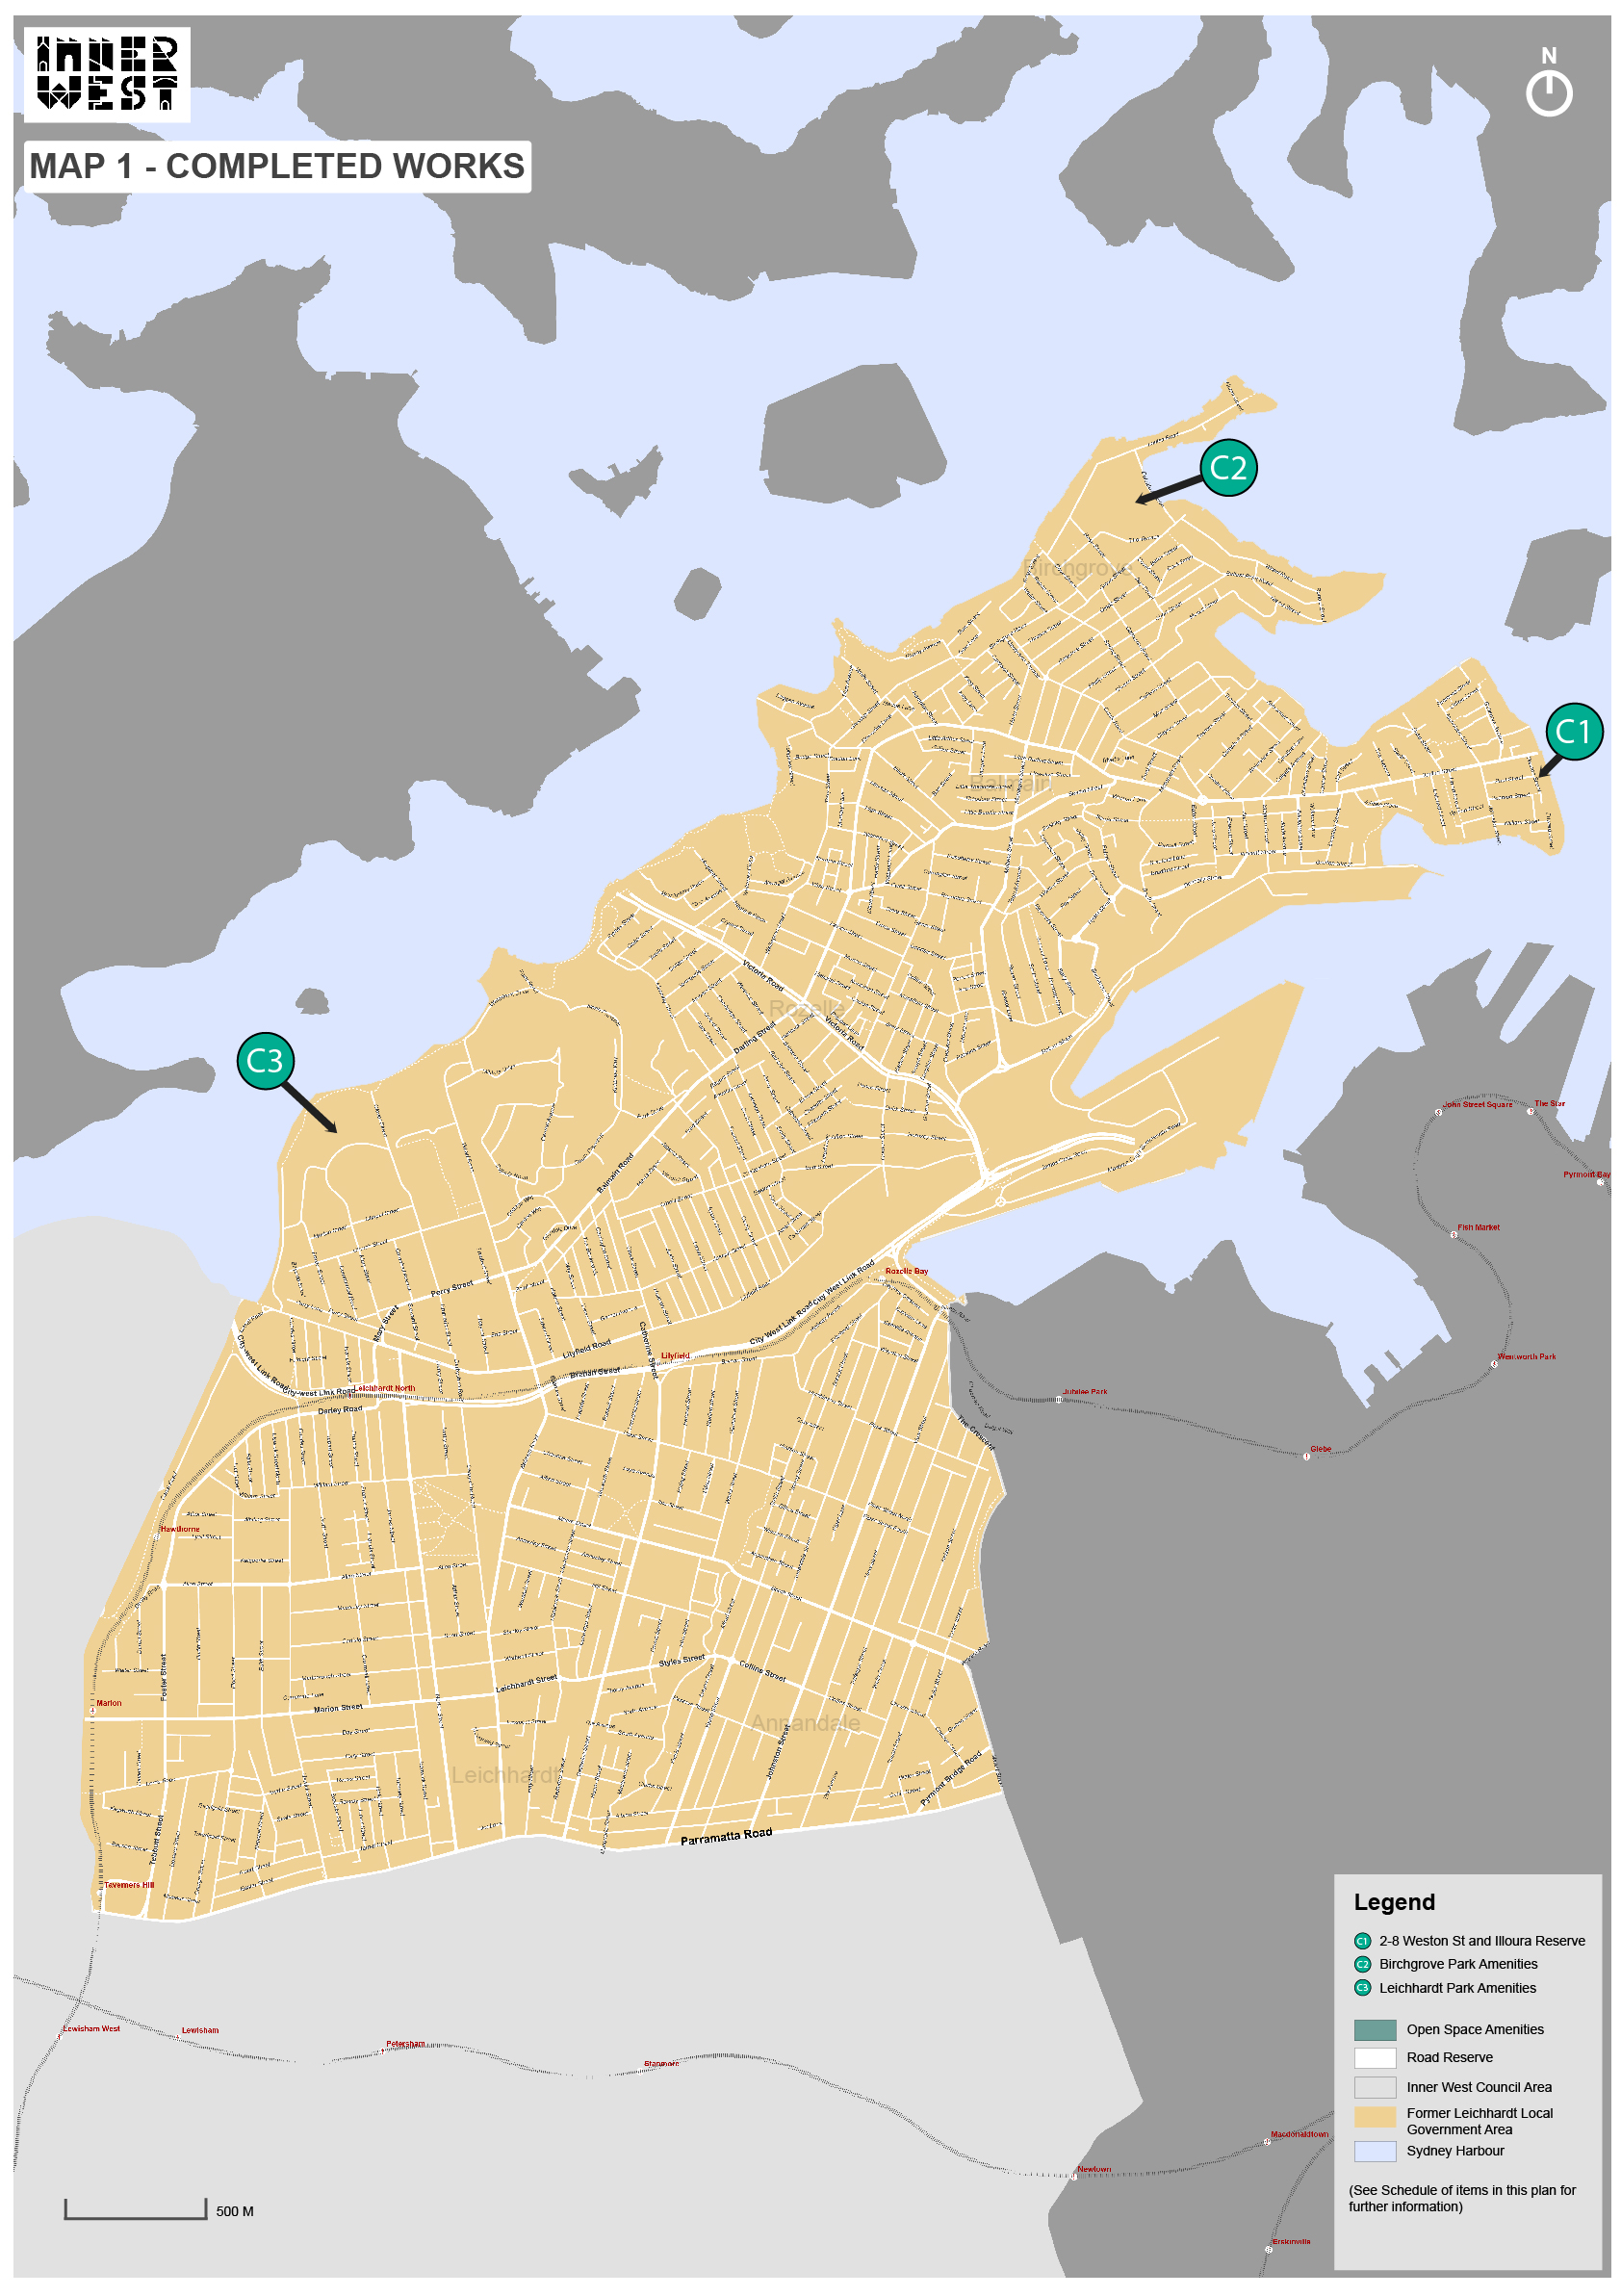
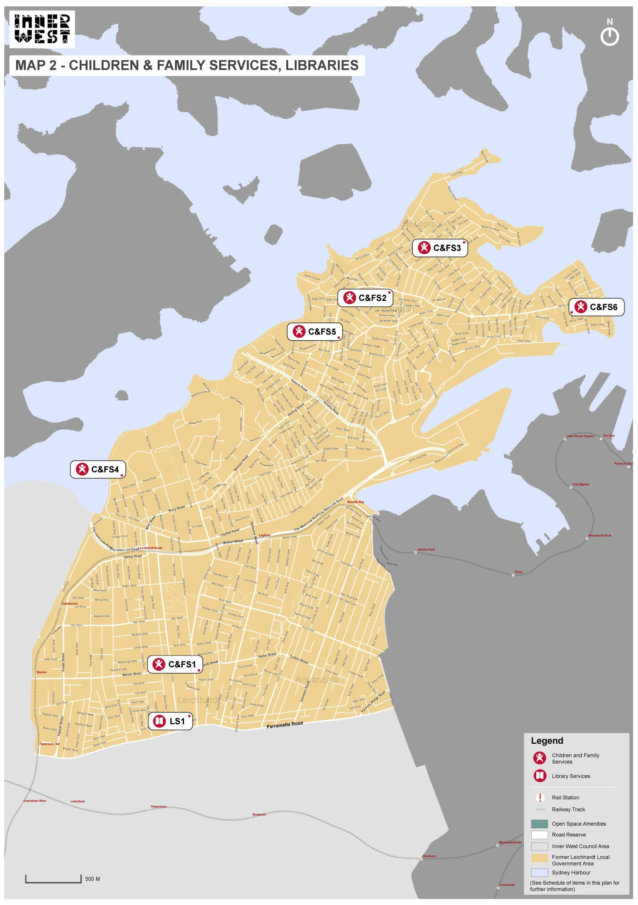
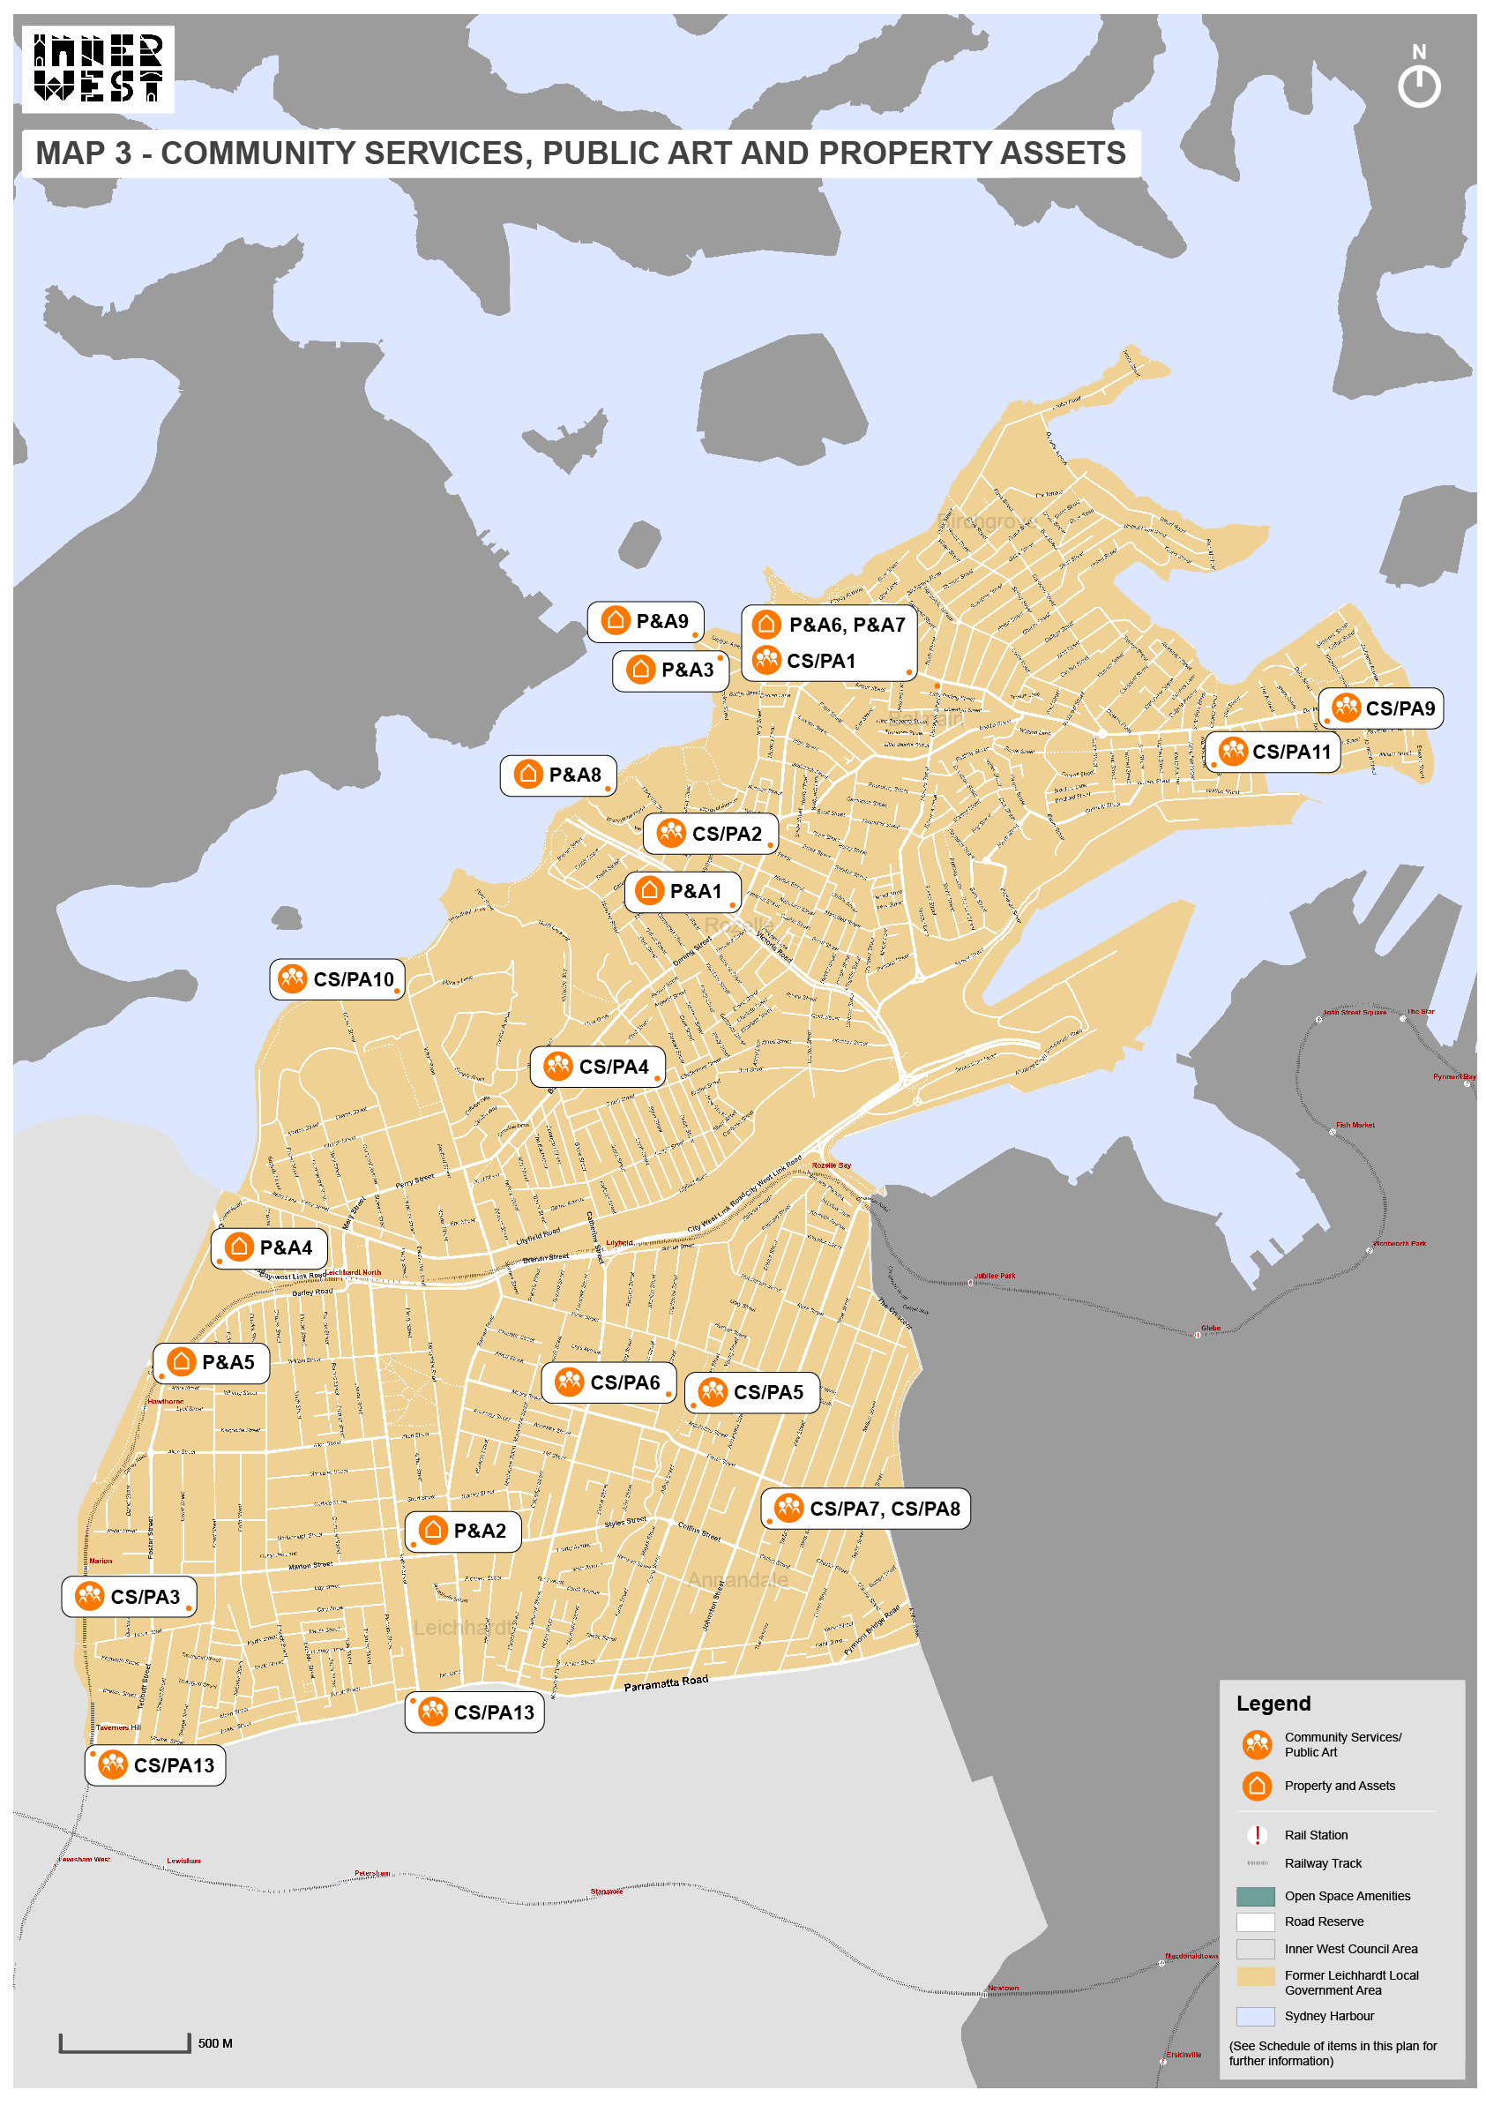
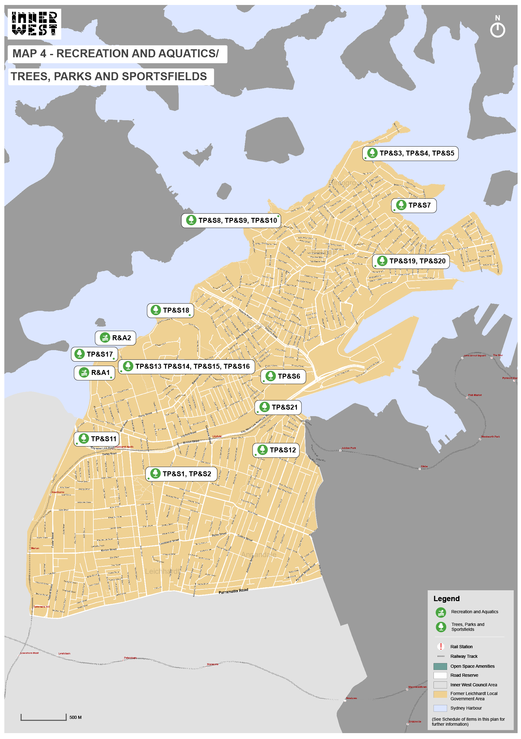
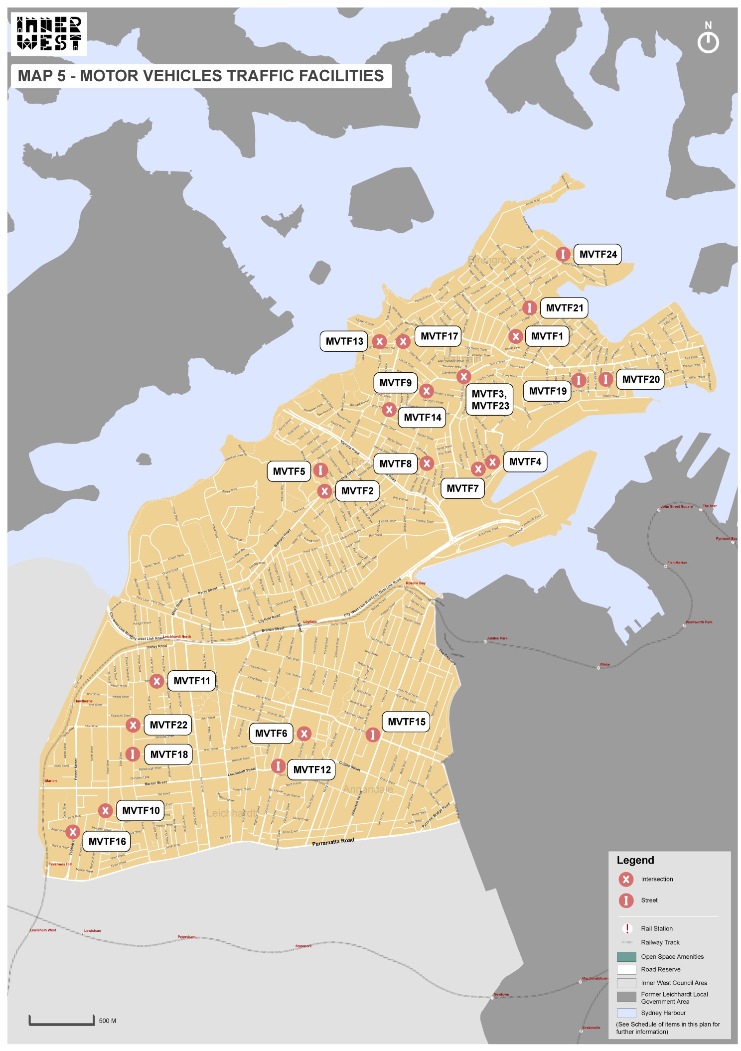
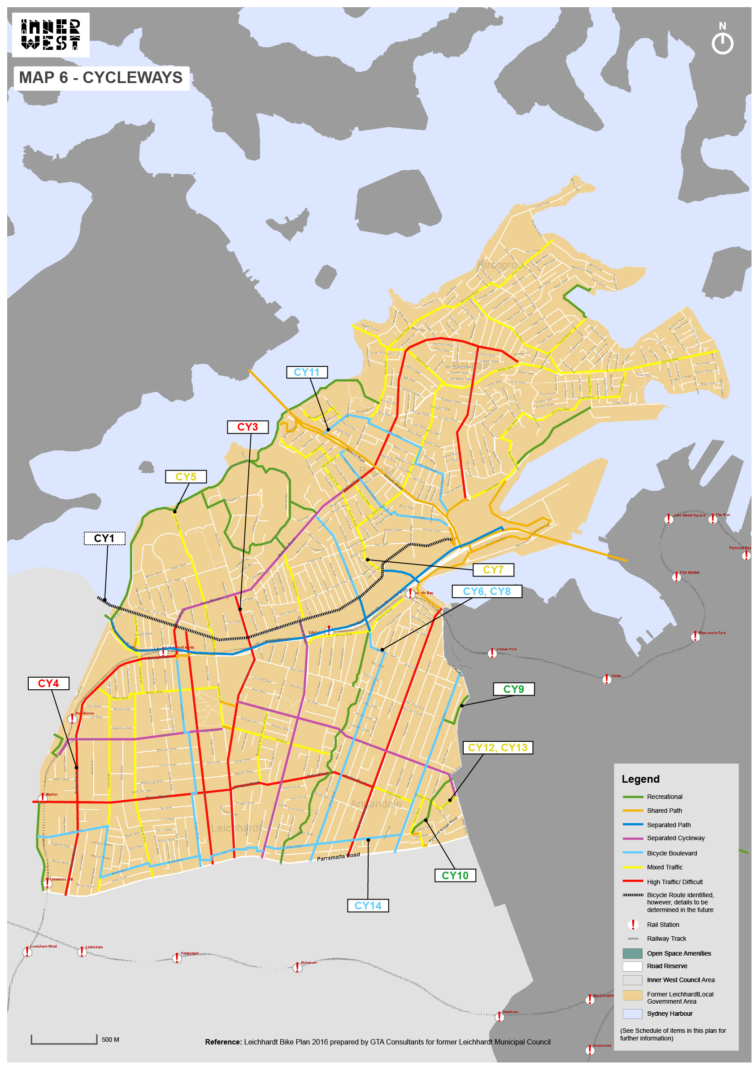
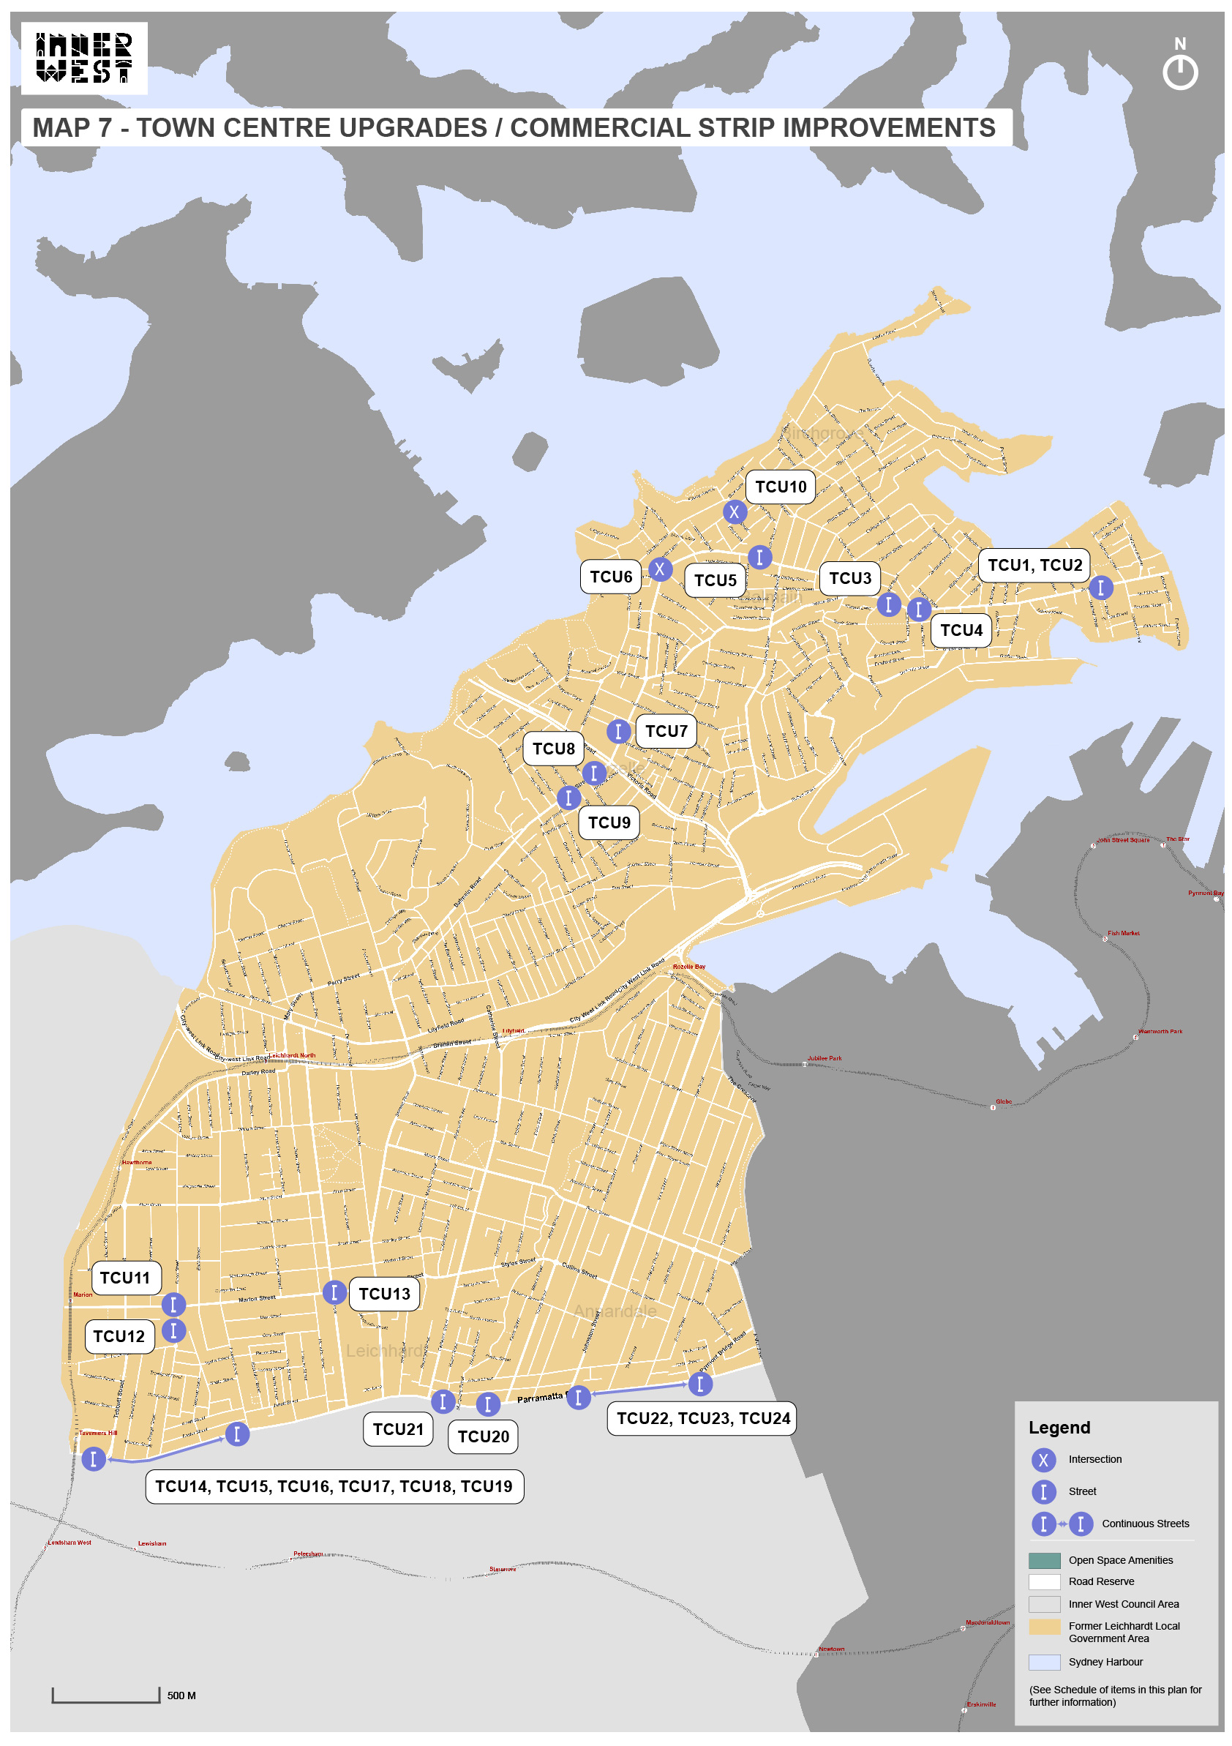

Appendix D - Pro forma Condition of Development Consent
- In accordance with section 7.12 of the Environmental Planning and Assessment Act 1979 (As amended) and the “Former Leichhardt Local Government Area Section 7.12 Development Contributions Plan 2020”, $[INSERT FIGURE] shall be paid to Council.
- If the contributions are not paid within the financial quarter that this consent is granted, the contributions payable will be adjusted in accordance with the provisions of the Former Leichhardt Local Government Area Section 7.12 Development Contributions Plan 2020 and the amount payable will be calculated at the time of payment in the following manner:
$C_{PY} | = |  |  | $C_{DC} x CPI_{PY}
 |  |  |  | CPI_{DC}
Where:
$C_{PY} is the amount of the contribution at the date of Payment
$C_{DC} is the amount of the contribution as set out in this Development Consent
CPI_{PY} is the latest release of the Consumer Price Index (Sydney – All Groups) at the date of Payment as published by the ABS.
CPI_{DC} is the Consumer Price Index (Sydney – All Groups) for the financial quarter at the date that this plan commenced.
Note: “Financial quarter” for the purposes of this condition refers to the following periods - December to February; March to May; June to August; and September to November.
- The monetary contributions shall be paid to Council:
- prior to the issue of the Subdivision Certificate where the development is for subdivision; or
- prior to the issue of the first Construction Certificate where the development is for building work; or
- prior to issue of the Subdivision Certificate or first Construction Certificate, whichever occurs first, where the development involves both subdivision and building work; or
- prior to the works commencing where the development does not require a Construction Certificate or Subdivision Certificate.
It is the professional responsibility of the Principal Certifying Authority to ensure that the monetary contributions have been paid to Council in accordance with the above timeframes.
The “Former Leichhardt Local Government Area Section 7.12 Development Contributions Plan 2020” may be viewed at https://www.innerwest.nsw.gov.au/develop/planning-controls/section-94-contributions or a copy may be inspected at Council’s Administration Centre during normal business hours.

Appendix E - Pro forma Complying Development Certificate Condition
- In accordance with section 7.12 of the Environmental Planning and Assessment Act 1979 and the “Former Leichhardt Local Government Area Section 7.12 Development Contributions Plan 2020”, $[INSERT FIGURE] shall be paid to Council.
- If the contributions are not paid within the financial quarter that this complying development certificate is granted, the contributions payable will be adjusted in accordance with the provisions the Former Leichhardt Local Government Area Section 7.12 Development Contributions Plan 2020 and the amount payable will be calculated at the time of payment in the following manner:
$C_{PY} | = |  |  | $ C_{CDC} x CPI_{PY}
 |  |  |  | CPI_{CDC}
Where:
$C_{PY} is the amount of the contribution at the date of Payment.
$C_{CDC} is the amount of the contribution as set out in this Complying Development Certificate.
CPI_{PY} is the latest release of the Consumer Price Index (Sydney – All Groups) at the date of Payment as published by the ABS.
CPI_{CDC} is the Consumer Price Index (Sydney – All Groups) for the financial quarter at the date of this Complying Development Certificate.
Note: “Financial quarter” for the purposes of this condition refers to the following periods - December to February; March to May; June to August; and September to November.
- The monetary contributions shall be paid to Council:
- prior to the works commencing where the development requires building works;
- prior to occupation or the issue of an interim occupation certificate or issue of a final occupation certificate, whichever occurs first, where no works are required.
It is the professional responsibility of an Accredited Certifier to ensure that the monetary contributions have been paid to Council prior to the authorised works commencing.

Appendix F - Procedure to determine the cost of the proposed development
A report specifying the cost of the proposed development is required to be submitted to allow Council to determine the contribution that will be required. The following should be provided:
- A Cost Summary Report must be completed for works with a value of $3,000,000 or less.
- A Quantity Surveyor’s Detailed Cost Report must be completed by a registered Quantity Surveyor for works with a value greater than $3,000,000.
To avoid doubt, section 25J of the Environmental Planning and Assessment Act Regulation 2000 (As amended) provides:
- The proposed cost of carrying out development is to be determined by the consent authority, for the purpose of a section 7.12 levy, by adding up all the costs and expenses that have been or are to be incurred by the applicant in carrying out the development, including the following—
  - if the development involves the erection of a building, or the carrying out of engineering or construction work—the costs of or incidental to erecting the building, or carrying out the work, including the costs (if any) of and incidental to demolition, excavation and site preparation, decontamination or remediation,
  - if the development involves a change of use of land—the costs of or incidental to doing anything necessary to enable the use of the land to be changed,
  - if the development involves the subdivision of land—the costs of or incidental to preparing, executing and registering the plan of subdivision and any related covenants, easements or other rights.
- For the purpose of determining the proposed cost of carrying out development, a consent authority may have regard to an estimate of the proposed cost of carrying out the development prepared by a person, or a person of a class, approved by the consent authority to provide such estimates.
- The following costs and expenses are not to be included in any estimate or determination of the proposed cost of carrying out development—
  - the cost of the land on which the development is to be carried out,
  - the costs of any repairs to any building or works on the land that are to be retained in connection with the development,
  - the costs associated with marketing or financing the development (including interest on any loans),
  - the costs associated with legal work carried out or to be carried out in connection with the development,
  - project management costs associated with the development,
  - the cost of building insurance in respect of the development,
  - the costs of fittings and furnishings, including any refitting or refurbishing, associated with the development (except where the development involves an enlargement, expansion or intensification of a current use of land),
  - the costs of commercial stock inventory,
  - any taxes, levies or charges (other than GST) paid or payable in connection with the development by or under any law,
  - the costs of enabling access by disabled persons in respect of the development,
  - the costs of energy and water efficiency measures associated with the development,
  - the cost of any development that is provided as affordable housing,
  - the costs of any development that is the adaptive reuse of a heritage item.
- The proposed cost of carrying out development may be adjusted before payment, in accordance with a contributions plan, to reflect quarterly or annual variations to readily accessible index figures adopted by the plan (such as a Consumer Price Index) between the date the proposed cost was determined by the consent authority and the date the levy is required to be paid.
- To avoid doubt, nothing in this clause affects the determination of the fee payable for a development application.

Cost Summary Report
[Development Cost of $3,000,000 or less]
DEVELOPMENT APPLICATION No. |  | REFERENCE:
COMPLYING DEVELOPMENT CERTIFICATE APPLICATION No.
CONSTRUCTION CERTIFICATE No. |  | DATE:

APPLICANT’S NAME:
APPLICANT’S ADDRESS:
DEVELOPMENT NAME:
DEVELOPMENT ADDRESS:

ANALYSIS OF DEVELOPMENT COSTS:
Demolition and alterations | $ | Hydraulic services | $
Structure | $ | Mechanical services | $
External walls, windows and doors | $ | Fire services | $
Internal walls, screens and doors | $ | Lift services | $
Wall finishes | $ | External works | $
Floor finishes | $ | External services | $
Ceiling finishes | $ | Other related work | $
Fittings and equipment | $ | Sub-total | $
Sub-total above carried forward | $
Preliminaries and margin | $
Sub-total | $
Consultant Fees | $
Other related development costs | $
Sub-total | $
Goods and Services Tax | $
TOTAL DEVELOPMENT COST | $

I certify that I have:
- inspected the plans the subject of the application for development consent, complying development certificate or construction certificate.
- calculated the development costs in accordance with the definition of development costs in clause 25J of the Environmental Planning and Assessment Regulation 2000 (As amended) at current prices.
- included GST in the calculation of development cost.

Signed:
Name:
Position and Qualifications:
Date:
Registered* Quantity Surveyor’s Detailed Cost Report

[Development Cost greater than $3,000,000]
*A member of the Australian Institute of Quantity Surveyors

DEVELOPMENT APPLICATION No. |  | REFERENCE:
COMPLYING DEVELOPMENT CERTIFICATE APPLICATION No.
CONSTRUCTION CERTIFICATE No. |  | DATE:

APPLICANT’S NAME:
APPLICANT’S ADDRESS:
DEVELOPMENT NAME:
DEVELOPMENT ADDRESS:

DEVELOPMENT DETAILS:
Gross Floor Area – Commercial | m² | Gross Floor Area – Other | m²
Gross Floor Area – Residential | m² | Total Gross Floor Area | m²
Gross Floor Area – Retail | m² | Total Site Area | m²
Gross Floor Area – Car Parking | m² | Total Car Parking Spaces
Total Development Cost | $
Total Construction Cost | $
Total GST | $

ESTIMATE DETAILS:
Professional Fees | $ | Excavation | $
% of Development Cost | % | Cost per m² of site area | $ /m²
% of Construction Cost | % | Car Park | $
Demolition and Site Preparation | $ | Cost per m² of site area | $ /m²
Cost per m² of site area | $ /m² | Cost per space | $ /space
Construction – Commercial | $ | Fit-out – Commercial | $
Cost per m² of commercial area | $ /m² | Cost per m² of commercial area | $ /m²
Construction – Residential | $ | Fit-out – Residential | $
Cost per m² of residential area | $ /m² | Cost per m² of residential area | $ /m²
Construction – Retail | $ | Fit-out – Retail | $
Cost per m² of retail area | $ /m² | Cost per m² of retail area | $ /m²

I certify that I have:
- inspected the plans the subject of the application for development consent, complying development certificate or construction certificate.
- prepared and attached an elemental estimate generally prepared in accordance with the Australian Cost Management Manuals from the Australian Institute of Quantity Surveyors.
- calculated the development costs in accordance with the definition of development costs in the Former Leichhardt Local Government Area Section 7.12 Development Contributions Plan 2020 at current prices.
- included GST in the calculation of development cost.
- measured gross floor areas in accordance with the Method of Measurement of Building Area in the AIQS Cost Management Manual Volume 1, Appendix A2.
Signed:
Name:
Position and Qualifications:
Date:

