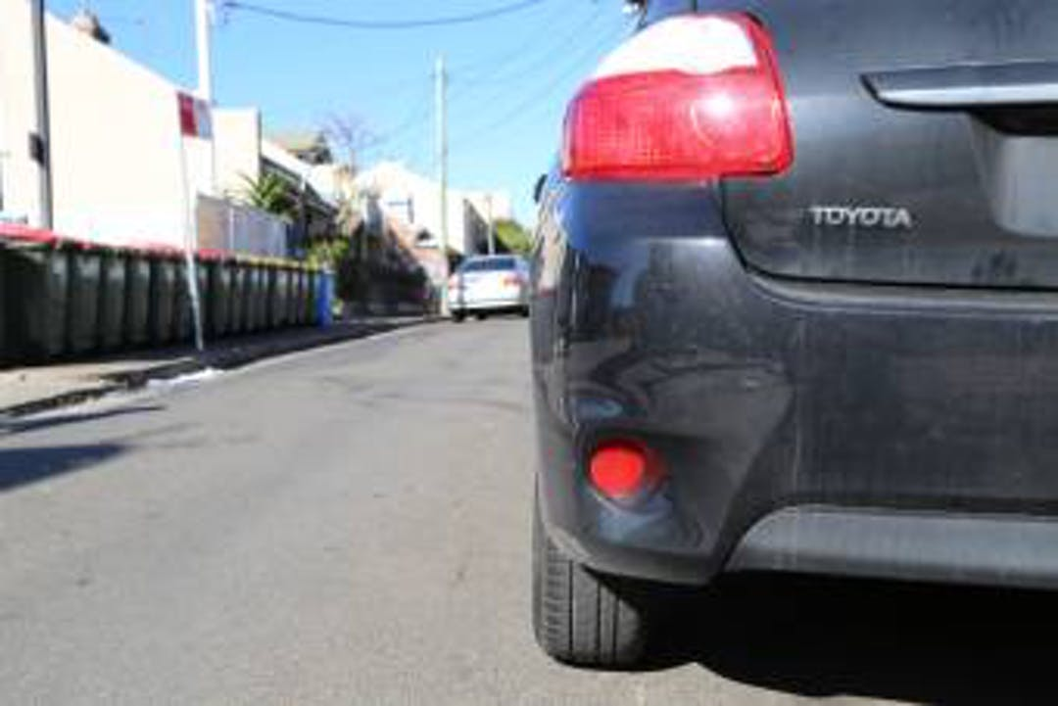

Engagement outcomes report

Lilyfield Parking Study

Contents
Contents 2
Summary 3
Background 3
Stage 1 – Initial community insights 4
Overview 4
Engagement Methods 4
Promotion 4
Who did we hear from? 4
What did they say? 5
Stage 2 – Public Exhibition of the draft Lilyfield Parking Study 7
Overview 7
Engagement Methods 7
Promotion 7
Who did we hear from? 7
What did they say? 8
Officer comments in response to public exhibition 9

Summary
This Engagement Outcomes Report outlines the feedback received during two stages of community engagement: the initial survey with the community and public exhibition of the draft Lilyfield Precinct Parking Study.

The initial survey was conducted from February to March 2020. Overall, 390 people participated. Of these 90% lived in Lilyfield, with other responses contributed from neighbouring areas. Responses indicated the most difficult time to find parking near residences is weekday evenings/nights.

This information was used to inform the draft study, which was placed on Public Exhibition in late October 2020. The community could provide feedback from 22 October 2020 until 20 November 2020. A total of 3,460 letters were mailed out with a colour map of the draft proposals, inviting the community to provide comments online, via email or post.

Overall, 80 people provided feedback on the draft Lilyfield Parking Strategy. The project page had 517 visits, with 67 people providing feedback online and a further 13 responses received via email, customer service enquiry and post.

The feedback can be summarised into three common themes:
- The lack of parking enforcement in Lilyfield
- General dissatisfaction with boat and trailers in public streets and the belief that it is of low importance to Council enforcement
- Strong concern that WestConnex Rozelle Interchange has put pressure on local parking.
Area specific feedback is detailed on page seven of this report.

Background

The Lilyfield Precinct Parking Study reviews how parking is managed and investigates opportunities for improvement. As part of this study, staff intended to examine parking in Lilyfield during a large event at Leichhardt Oval. Due to Covid-19 restrictions, no full capacity events were held in 2020. As restrictions ease, future parking levels will be reviewed during a full capacity event.

The review combines community sentiment and technical studies, including:
- Current parking management: Supply and demand of parking, distribution of residential and commercial parking, including long-stay and short stay parking.
- A review of current parking strategies and policies, including permit allocation in the Resident Parking Scheme.

Stage 1 – Initial community insights

Overview
The initial survey was conducted from February to March 2020 with 390 participants. Of these 90% lived in Lilyfield, with other responses contributed from neighbouring areas. Responses indicated that weekday evenings/nights were the most common time for issues finding parking near to place of residence.

Engagement Methods
The community could provide feedback online via Your Say Inner West or request a paper copy of the questionnaire. Paper responses could be submitted via email or post.

Promotion
The opportunity to participate was promoted via:
- Council’s social media
- Your Say Inner West E-news and homepage
- Letters to residents and businesses
- Council website

Who did we hear from?

- Overall, 90% of participants responded ‘Yes’ to living in Lilyfield. Other responses came from neighbouring suburbs
- The majority of participants (91%) were received from people living in a house and 79% usually are able to park less than 100 metres away from their place of residence
- 42% have access to off-street parking at their residence while 66% of workers don’t have off-street parking at their workplace

What did they say?

The questionnaire asked participants about their views on different aspects of parking management in Lilyfield, especially concerning ways to manage residential parking, commuter parking and event parking near Leichhardt Oval. The results and commentary are provided below.

Managing residential parking
When asked about how best to manage residential parking, participants highly favour resident parking permits to be made available to only those residents of dwellings without any off-street parking (97). or in a manner that can be purchased by residents on an as-needed basis (77). Notwithstanding these views, a large proportion of participants (108) also wanted the existing scheme to remain free as it currently is (60) or to remain free and be supported by better enforcement of the time limits (48).

Figure 1: Respondents’ views toward addressing residential parking management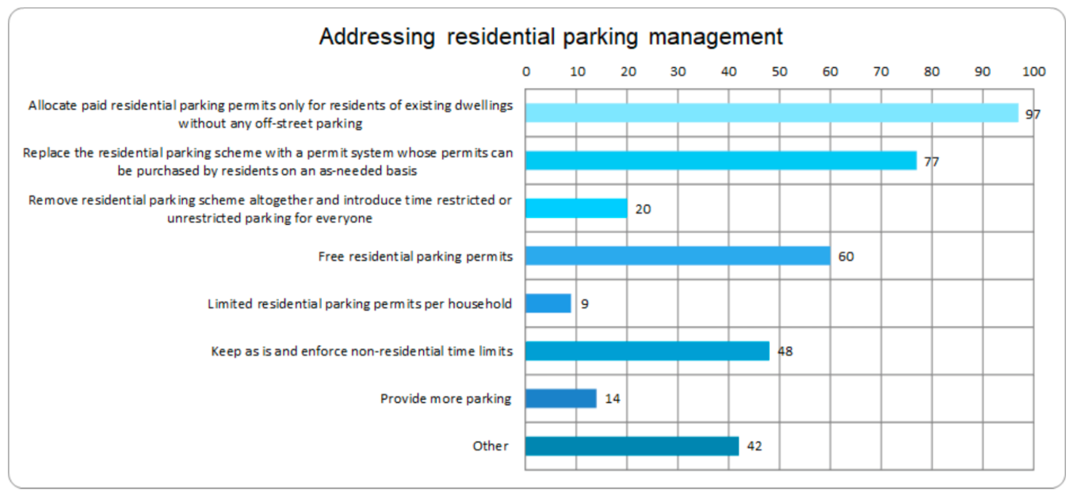

Managing commuter parking
While 139 participants were favourable to setting aside some spaces for possible paid commuter on-street parking, the majority of participants (156 people) favoured the status quo or excluding commuters from parking near light rail stops via time-restricted parking.

Figure 2.20: Respondents’ views toward addressing commuter parking
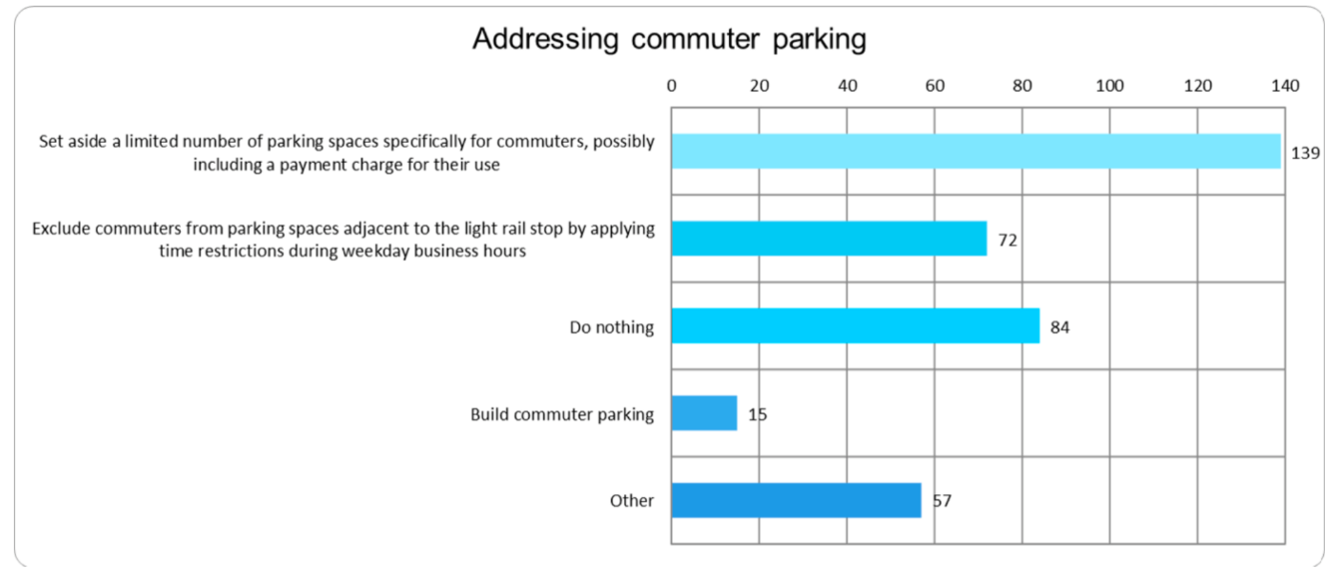

Event parking near Leichhardt
The exploration of using event shuttles from another origin for patrons to access Leichhardt Oval is the most sought-after intervention by the respondents (171 participants). Some of respondents also suggest expanding the area of the LY permit parking zone, indicating the presence of event-visitors may cause parking and traffic disruption to residents living near Leichhardt Oval.

Figure 2.21: Respondents’ views toward addressing event parking near Leichhardt Oval
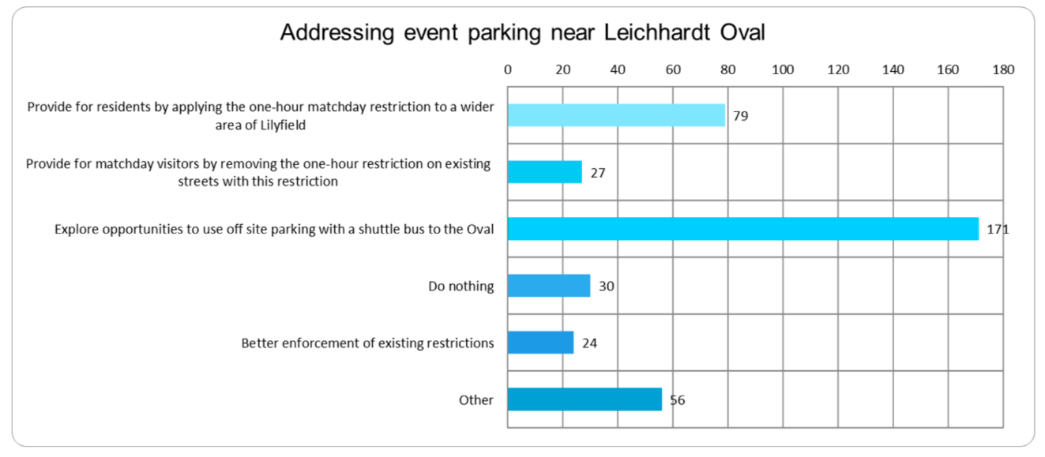

Feedback via direct email
Separate correspondence was received from residents raising specific concerns about their locality. Common concerns include: residents living on Hubert Street requesting angled parking to increase parking capacity, and a request for time-restricted parking on Canal Road.

Stage 2 – Public Exhibition of the draft Lilyfield Parking Study

Overview
The information from stage one was combined with technical studies to inform the draft study. Public exhibition commenced on the 22 October 2020 and the community could provide comments until 20 November 2020. The project page had 517 visits and 67 people provided feedback. A further 13 responses were received via email, customer service enquiry, and post.

Engagement Methods

During public exhibition, the community could provide feedback via:
- An online feedback form on Your Say Inner West
- Via email
- Via post

Promotion
The engagement was promoted via:
- Letters mailed to 3,460 addresses, including residents and businesses, with a colour map of the draft proposals
- An email to participants of the initial engagement in February 2020
- Your Say Inner West E-News
- Council Website

Who did we hear from?
Overall, 80 people provided feedback on the draft Lilyfield Parking Strategy. In total 67 responses were received via the yoursay.innerwest.nsw.gov.au website and 13 received via e-mail or mail.

Participants via Your Say Inner West could tick more than one response when asked about their relationship to Lilyfield. Most participants were residents from Lilyfield, totalling 64 people, three people identified as business owners/operators, one was a worker in the area and two visitors.

What did they say?

Based on the Your Say Inner West responses, 24 participants support the parking strategy, 23 are unsure/neutral and 20 participants do not support the strategy. Those who responded via email did not definitively state their position and therefore are not included in these numbers.

The main themes in the comments are summarised below:

Area-wide issues:
- Enforcement of existing parking restrictions is not up to standard and that many of the issues could be resolved with more enforcement. A specific concern was that cars are staying long after the posted restriction.
- Widespread dissatisfaction with boat and trailer parking on Lilyfield’s streets. General desire to increase its priority in the strategy.
- Frequent concerns about the impact of WestConnex construction worker parking negatively impacting parking availability for residents.
- Mixed responses on the proposed angled parking (rear to kerb) in Hubert Street and Charles Street. Change to rear to kerb angle parking on east side of Francis Street, but the majority are in strong support.
Locally-specific issues:
- Support from multiple residents for angled parking on the entirety of Rayner Street.

Officer comments in response to public exhibition
An independent consultant and council officers reviewed your feedback. The Council officers have prepared a response to key issues below.

Area-wide issues | Officer response
Frequent comment that enforcement of existing parking restrictions is not up to standard. Multiple anecdotes of cars staying long after the posted restriction. General community view that if enforcement was improved, many of Lilyfield’s parking issues would be resolved. | Inner West Council’s Parking Services proactively patrols timed parking restrictions across the whole Inner West Council Local Government Area (LGA). Within Parking & Ranger Services there is a specialist Parking Analysis team, who monitor trends within parking throughout the LGA. They continually re-assessing parking patrol areas to determine the optimum allocation of resources.  If illegal parking, unrelated to timed parking, is reported Parking Services will attend to those complaints as soon as resources are available.
Widespread dissatisfaction with boat and trailer parking on Lilyfield’s streets. General desire to increase its priority in the strategy. | All boat and trailer parking should be in accordance with the NSW Road rules. If there are any instances of boat trailers and/or trailers parking illegally, please contact Inner West Council and report the illegal parking. Upon receipt of a request for service, Inner West Council’s Parking Services will organise for an Officer to attend and patrol the location as soon as practical.
Frequent concerns about the impact of WestConnex construction worker parking negatively impacting parking availability for residents. | In addition, the parking impact on streets near the WestConnex Rozelle Interchange site has been a source of concern for residents in Lilyfield and Rozelle. Council has worked together on the consultation on including additional streets in the RPS in October 2020. Due to the low overall support from the community, this was not implemented. However, Council is continuing discussions with Transport for NSW to explore parking options to alleviate parking pressures until the completion of the WestConnex Rozelle Interchange in 2023.
Mixed responses on the proposed angled parking in Item 2, but the majority are in strong support. | No change is recommended to Item 2.

Locally-specific issues | Officer response
Support from multiple residents for angled parking on the entirety of Rayner Street. | It is recommended that Council investigate this proposal further as it would accommodate the high parking demand on Saturdays associated with the nearby Orange Grove Market.

