HAVE YOUR SAY

Making parking fairer in Lilyfield

Dear resident/owner,

Council is developing an integrated Parking Strategy for Lilyfield. We invite you to be a part of this study to inform the Strategy. The study area is located in the Balmain – Baludarri Ward and bounded by the waterfront between Glover Street, Balmain Road, Foucart Lane, Lilyfield Road and City West Link Road. Please refer to the map of the study area on the following page.
The aim of the study is to:
- Understand the current parking situation and issues
- Reflect the needs and desires of the community to manage parking
- Develop an effective parking management strategy

Have your say
Local knowledge is vital to this work. You are invited to contribute by completing an online survey at yoursay.innerwest.nsw.gov.au. We ask you questions about your experience of parking in your local area and invite feedback about options for key issues in Lilyfield.
Last date to complete the survey is Wednesday 4 March 2020.

Who should complete the survey?
We would like to hear from schools, residents, business owners and workers. The experiences of pedestrians, cyclists, motorists and other road users are all welcomed.

What happens next?
Your feedback, along with data collected onsite and other information will be considered as we work to develop the draft Strategy.

The draft Strategy is expected to be placed on public exhibition in June 2019. You can provide for further feedback before it is considered by Council. We will hold a drop-in session during the exhibition period where you will be able to view the draft Strategy and talk to the team.

Those who provide feedback in this initial study will be notified when the draft Strategy is open for comment.
You can also stay updated by signing up for monthly email updates at yoursayinnerwest.nsw.gov.au

What about WestConnex parking?
Council is working on a separate study that will address parking issues arising from the WestConnex Rozelle Rail Yard, Annandale and Iron Cove work sites. Council will consult the community separately in March/April with a plan to improve parking for residents and their visitors.

Enquiries

If you need a paper copy of the survey or any further information please contact me on 9392 5965 or email sunny.jo@innerwest.nsw.gov.au.
Sincerely,

Sunny Jo
Traffic and Parking Planner

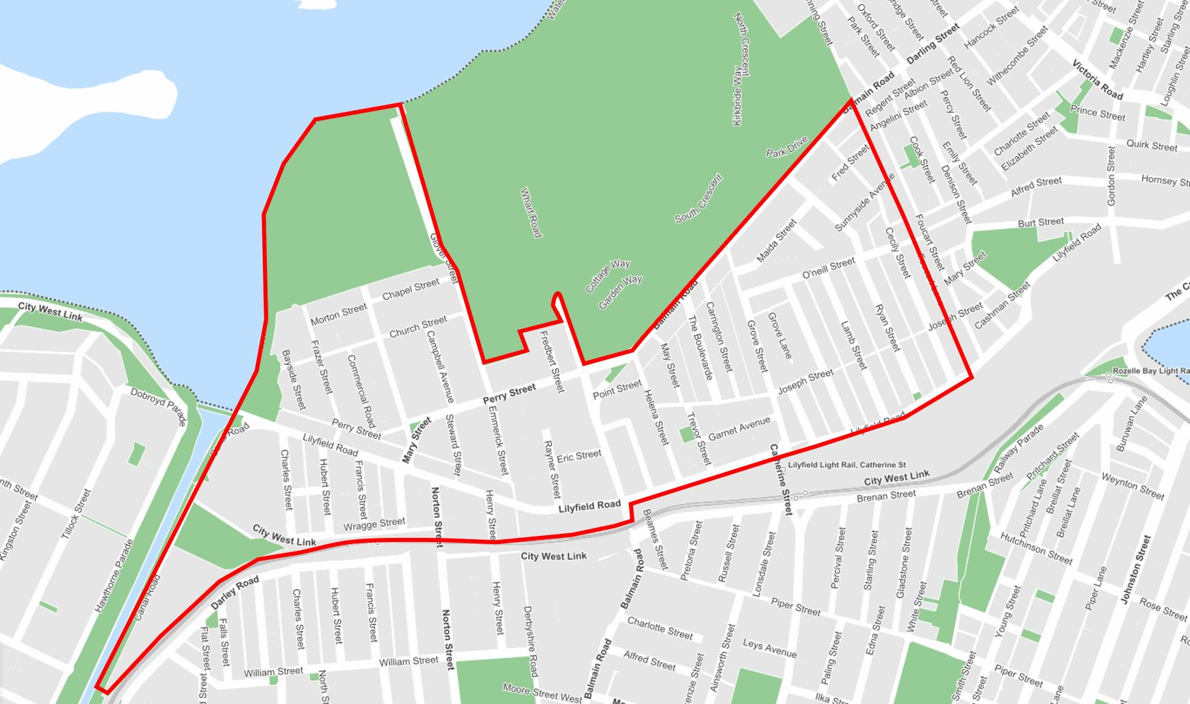
Map – Lilyfield precinct study area

