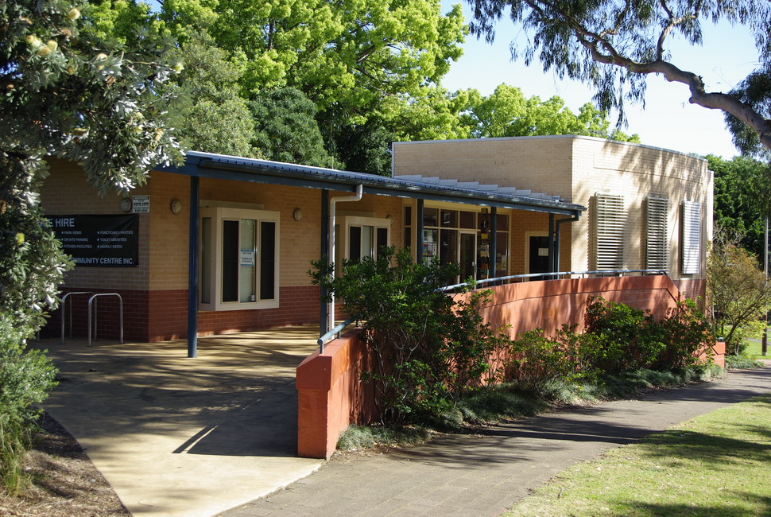

Engagement outcomes report

Summer Hill Neighbourhood Centre

Contents
Summary 3
Background 3
Engagement methods 4
Promotion 4
Engagement outcomes 4
Who did we hear from? 4
What did they say? 7
Officer comments 11

Summary
Council resolved on 22 September 2020 to undertake community consultation in relation to the Neighbourhood Centre in Summer Hill; and following that consultation proceed to an Expression of Interest (EOI) for a suitably qualified and experienced community-based tenant to operate the Neighbourhood Centre.
The purpose of the engagement was to assist in determining the service model and future functions of the Summer Hill Neighbourhood Centre. The community was asked for feedback on the types of facilities, programs, services and operating hours.
Community engagement was undertaken via Your Say Inner West for a four-week period closing on 4 December 2020, with 113 survey responses being received. Community feedback suggests residents overwhelmingly want a neighbourhood centre that is multi-purpose in terms of the range of programs and services offered, and diverse in terms of the range of the people who will go there.
The Your Say survey found the highest level of support was received for a facility that caters for a range of local community programs and services, and general community space for meetings, activities and events. There was also strong support for the Centre to provide specialist social support services (including for vulnerable people) and a place for arts, recreation and cultural activities.
Significant numbers also mentioned the importance of the facility providing programs for specific population groups, including older people, families with small children and young people. Lower levels of interest were recorded for the Centre being hired for private functions or providing specialist learning and education programs.
A detailed breakdown regarding the demand expressed by respondents for various types of programs and services is included in the Engagement Outcomes section of this report.

Background
What is a neighbourhood centre?
Neighbourhood and community centres typically provide a range of community programs and services and operate from spaces that allow for flexible use. While some are managed directly by Councils (such as the Hannaford Centre), others can be leased to not-for -profit organisations (such as Newtown Neighbourhood Centre).
Context within the Inner west
The Summer Hill Neighbourhood Centre is centrally located in Summer Hill in the grounds of the Darrell Jackson memorial Gardens. It includes four flexible public spaces that can accommodate a range of activities and services. The Summer Hill Neighbourhood Centre forms part of a network of 29 Council owned community spaces that includes civic centres, town halls, community centres and community halls.
Council owned community spaces operate under differing management models and provide for a diversity of activities. While smaller local centres such as Summer Hill Neighbourhood Centre have local neighbourhood catchments, other larger venues such as the Ashfield Civic Centre play a broader district role, attracting usage both from across the Inner West Local Government Area (LGA) and beyond.
There are five community centres in the Inner West LGA (four owned by Council): four of the five are located towards the western boundary of the LGA, with Summer Hill Neighbourhood Centre being the only one located in the western half of the LGA. This highlights the significant role that the Summer Hill Neighbourhood Centre will play now and in the future in addressing the needs of communities located in the central and western portions of the LGA.

Engagement methods
Community consultation was conducted online via Your Say Inner West. The Your Say survey included five key questions concerning how residents would like to use the Summer Hill Community Centre in the future, including questions regarding what types of facilities, programs, services operating hours and demographic questions. People were also provided with open questions to facilitate any other comments.

Promotion
Awareness of the Your Say page and survey link was promoted via:
- Inner West Council website
- Your Say Inner West monthly e-news
- Direct emails to community organisations, schools and clubs in Summer Hill, Dulwich Hill, Ashfield South and Lewisham.
- Inner West Council local democracy groups
- Emails to previous complainants relating to Summer Hill Community Centre
- Social media: including Facebook, twitter

Engagement outcomes
Who did we hear from?
113 survey responses were received in total. The vast majority (100) were from individuals, while 13 responses were from people representing a range of organisations including those working with diverse cultural groups; people with disabilities; older people; Aboriginal people; people with mental health issues; carers; children; local mothers; and environment groups. 88% of survey respondents lived in the Inner West LGA, most of whom lived in the three suburbs in closest proximity to the Summer Hill Neighbourhood Centre: 75% of all respondents lived in Summer Hill, Ashfield or Dulwich Hill.
Age group
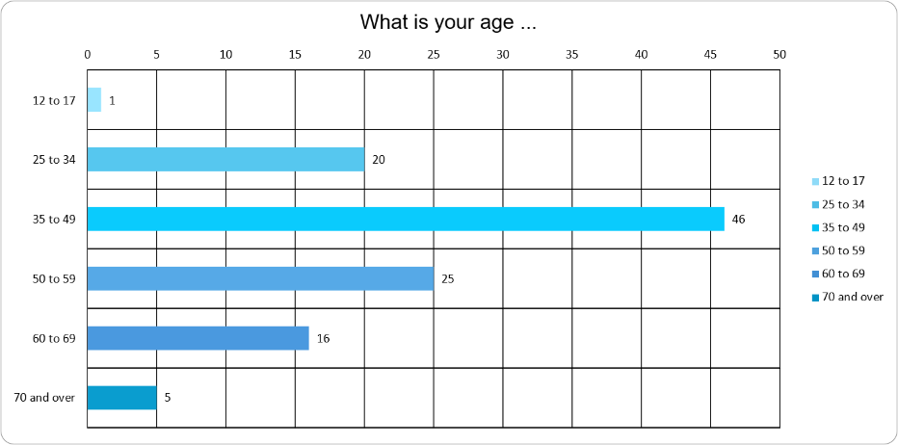
Gender identity -
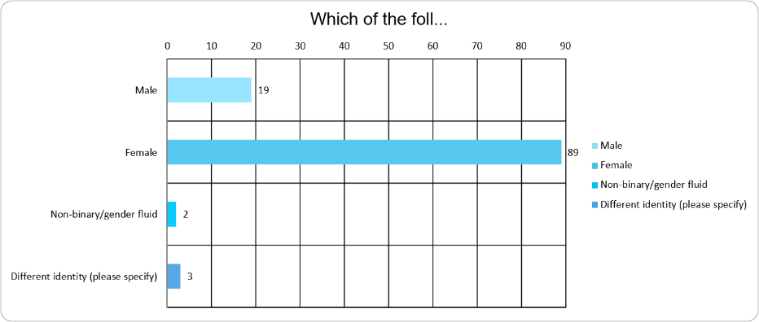

Sexual orientation
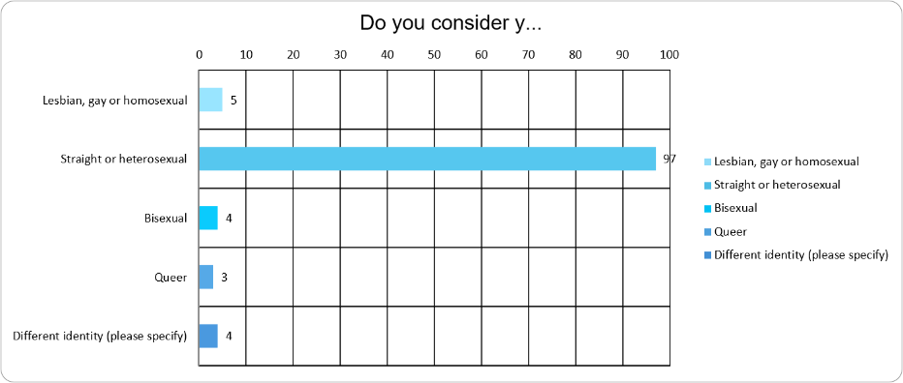
What country were you born in?
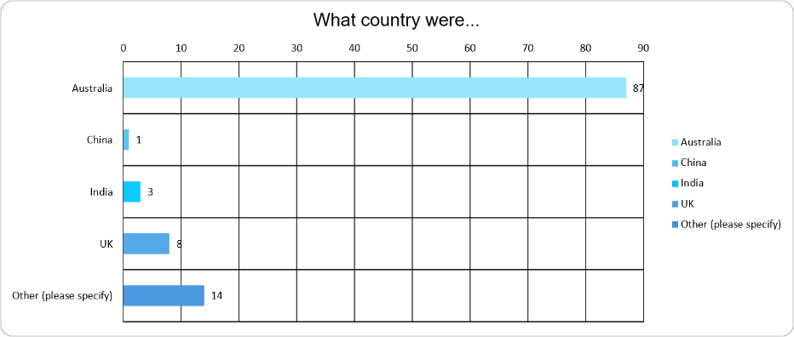
Do you identify as having a disability?
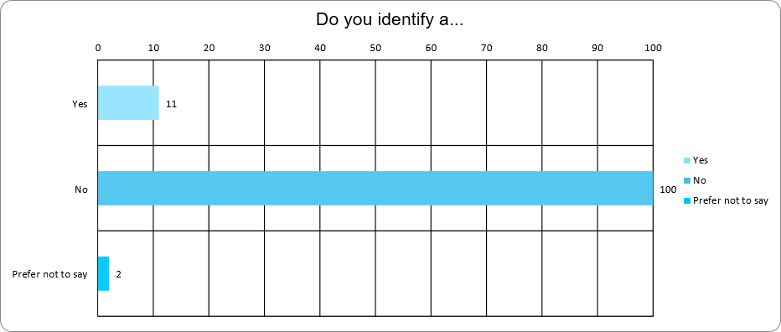

Aboriginal People and Torres Strait Islander People
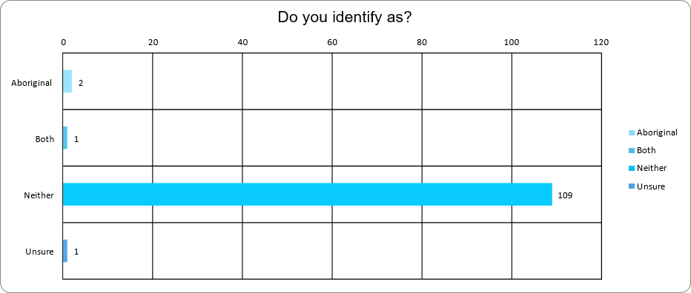
What did they say?
Three key themes emerged from the survey regarding what residents would like to see happen at the Summer Hill Neighbourhood Centre.
- A multi-purpose Centre
The highest level of support was for the Centre to be a place that provides a range of local community services and programs, catering for general community use spaces for meetings, activities or events. There was interest from residents wanting to use the Centre on weekdays, weekends, day and evenings. The most common response was that people would use the Centre as and when there is something offered that they wanted to attend.
How important is it to you that the Centre provides a place where there’s a range of local community services and programs?
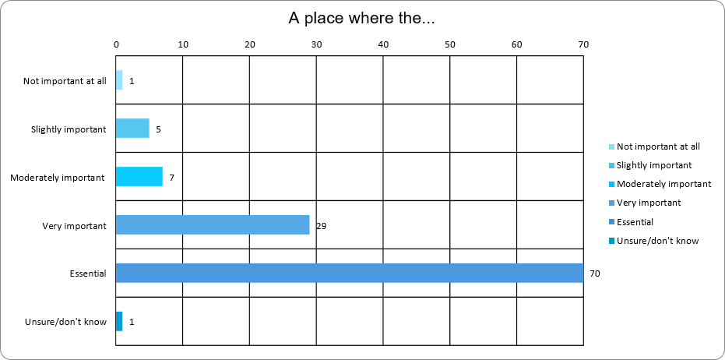
How important is it to you that the Centre provides general community use space for meetings, activities or events?
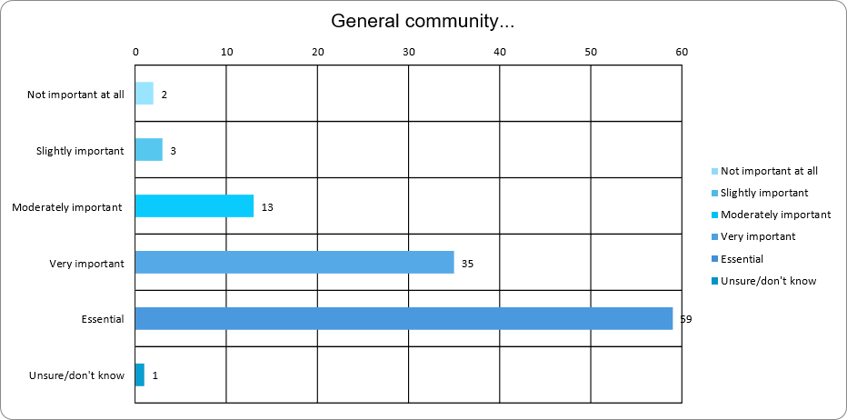
When would you use the Summer Hill Neighbourhood Centre?
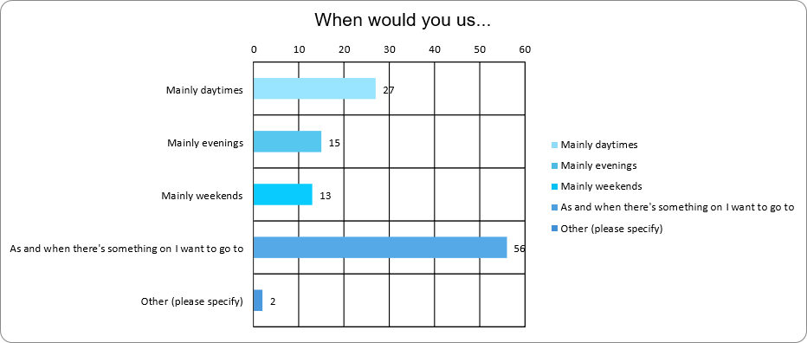
- A place for everyone
When asked to focus on the three most important facilities needed at the Centre, residents also indicated that the Centre needs to cater for specific population and interest groups. This included people needing social support services for vulnerable people; arts, recreation and cultural activities; programs and services for older people; programs and services for families with small children; and programs and services for young people. Less frequently mentioned was the importance of spaces for private functions and specialist learning and education programs. Responses to questions about providing information and services in other languages and how to make the Centre more accessible also reveal the importance that the community places on the Centre catering for everyone.

Three most important facilities for you at the Summer Hill Neighbourhood Centre?
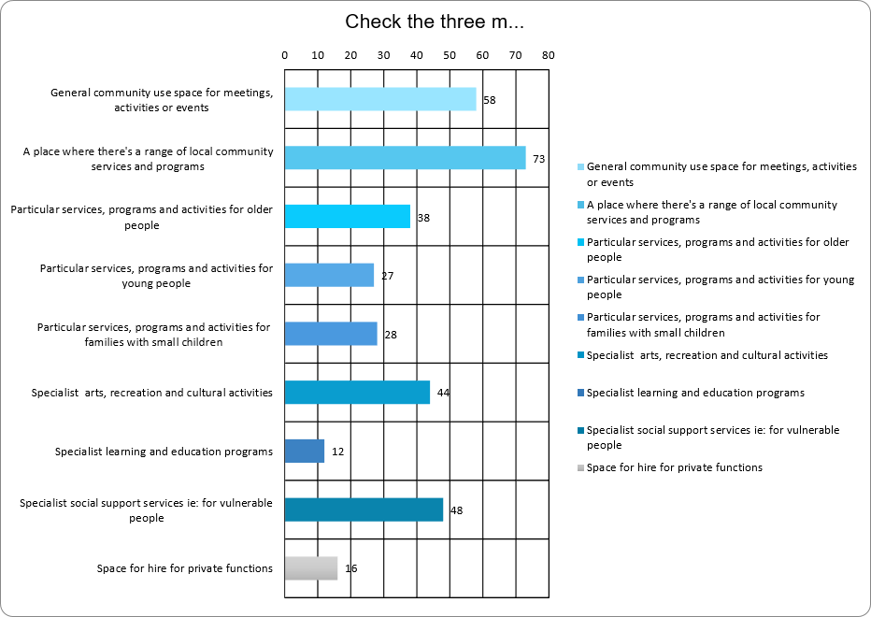
What language other than English do you need provided at the Centre?
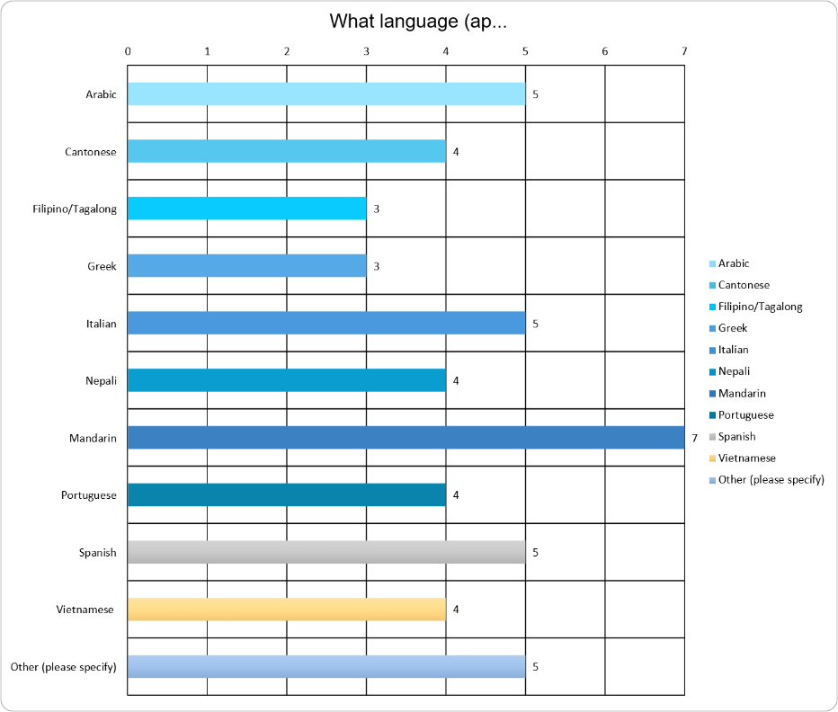
What’s needed to make the Centre accessible for you?
- high contrast colours for special awareness, braille for signage, ramps for access
- phone and online bookings
- accessible bathrooms
- quiet spaces at events that might be sensory overwhelming
- access without stairs
- reopen the Centre so support programs can be resumed
In addition to the multiple-choice questions graphed above, two open ended questions provided residents with opportunities to comment on what they would like to do at the Centre and make any other comments. Responses overwhelmingly reinforced the types of programs and targeted population groups identified above. However, there were a few other responses that relate to this theme of the Centre fostering inclusion, such as:
- provide free or affordable access to spaces and activities;
- celebrate the diversity of the Inner West and cater for people from LGBTIQ communities;
- provide Aboriginal programs; management; space for Aboriginal organisations; and recognition of the significance of the area’s use by Aboriginal people pre-colonisation due to the location of ochre sites.

- A neighbourhood centre that is open, well utilised, professionally managed and responsive to community needs
Just over 50% of respondents took the opportunity to respond when asked if they had anything to add. The most common issues themes related to the management of the centre included:
- Need for more professional management: examples include inability to get a response when inquiring about venue hire; impolite manner; lack of transparency regarding booking information and charges
- Underutilisation: many comments about the Centre being closed despite groups expression of interest in hiring it, that community centres should be mostly open and used by the community rather than hired by businesses; the need for management to inject some energy and creativity
- Community perception regarding exclusivity: several respondents commented on the Centre feeling more like a “private club” than being for all community members
- Community participation in Centre management: community voices on management committee should be encouraged and welcomed; they want a “community centre for the community, by the community”; feedback should be encouraged
- Improved communication: it should be easy for the community to know what's on; currently no newsletter or marketing to let people know what’s happening.
- Importance of welcoming, inviting approach: some residents don’t feel welcome there; street frontage and signage should be improved
- Pricing: venue hire cost prohibitive for some not-for-profit community groups and artists.

Officer comments

Three key themes emerged from the Community engagement regarding the Summer Hill Neighbourhood Centre. The community wants a multi-purpose Centre that:
- accommodates a range of community services, programs, activities and events;
- catering to the diverse needs of the Inner West population; and
- is managed in an open professional manner that rebuilds community participation and support for the Centre.
The engagement outcomes will be incorporated into the Expression of Interest document so that interested parties can be informed by these community insights when preparing their proposals.

