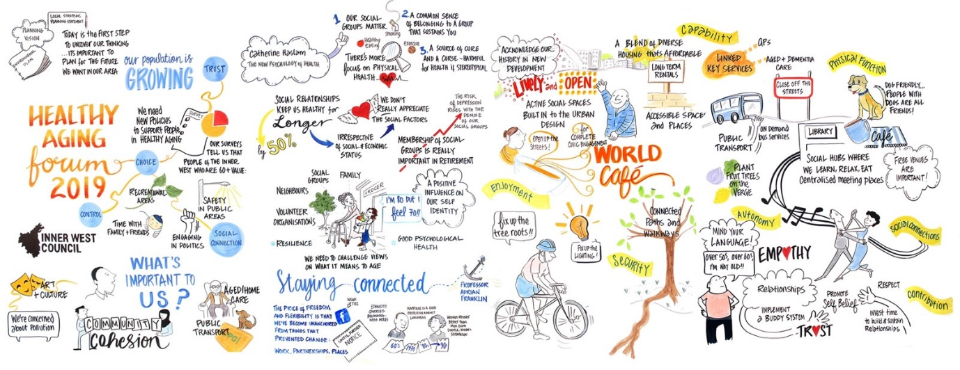

Engagement outcomes report

Healthy Ageing Strategy

Contents
Summary 3
Background 3
Engagement Methods 3
Engagement outcomes 4
A. Accessible Infrastructure to support active living 5
B. Codesign of accessible infrastructure 5
C. Accessible communication 5
D. Accessible transport for better connectivity 6
E. Housing affordability and diversity 6
F. Safety 6
G. Social Participation 7
Officer comments in response to public exhibition 7

Summary
The draft Healthy Ageing Strategy and Action Plan were exhibited on Your Say Inner West for 40 days to engagement on the proposed policy direction.
Feedback from Public Exhibition was very supportive with strong support for the priorities in the Strategy.
Social media, email and a flyer distribution to 80,000 households resulted in 901 visitors to yoursay.innerwest.nsw.gov.au, 185 downloads of a strategy document, and 67 online submissions, ten email and seven phone calls. The summary of the strategy was translated into five community languages and one person downloaded the Chinese Simplified translation.
The results of the survey indicate that:
- 56 % of respondents support the strategy (strongly agree/ agree)
- 32% support the strategy but want more detail (somewhat/slightly agree)
- 2% do not support the strategy, arguing for better footpaths and a need for more active transport infrastructure.

Background
The Healthy Ageing Strategy is a collaborative strategic planning document to guide Council, its stakeholders and partners to support the Inner West community to live active, healthy, connected and fulfilling lives at any age.

Stakeholder engagement with the community, educational and research providers, organisations, business and industry sectors and all levels of government marks a crucial step in the realisation of a shared vision for what healthy ageing means in the Inner West.

Engagement Methods
During Public Exhibition the method of engagement included:
  - Online on yoursay.innerwest.nsw.gov.au
  - Flyer distributed to every household in the Inner West to notify and invite feedback
  - Social media campaign
  - Local democracy group meetings to invite submissions
  - Phone support
  - Hard copies sent to those who requested.

Engagement outcomes
During the Public Exhibition submission were received from residents (72) and community organisations (6) via the survey tool, phone and email. Contributions were also received via email from Councils Transport Team, the Access Advisory Committee, the Housing and Affordability Advisory Committee, the Multicultural Advisory Committee, the Seniors Working Group as well as the Inner West Aged Services Interagency.
Out of the total number of responses:
- 56% strongly agree or agree with the strategy
- 32% somewhat or slightly agree
- 2% disagree arguing for more specific investment in better footpaths, safety and active transport infrastructure.

Responses were received from 20 suburbs across the Inner West and 2 neighbouring suburbs. The highest response rate came from Dulwich Hill (8), Leichhardt (8), Marrickville (6), Ashfield (6) and Balmain (6).
Suburb | No of participants |  | Suburb | No of participants
 | Survey | Other |  | Survey | Other
Ashfield | 5 | 1 | Hurlstone Park | 1
Annandale | 3 |  | Lilyfield | 3
Balmain | 4 | 2 | Leichhardt | 7 | 1
Birchgrove | 1 |  | Marrickville | 6
Camperdown | 2 |  | Marrickville South | 1
Chiswick | 1 |  | Petersham | 1
Croydon | 3 | 2 | Rozelle | 1
Drummoyne | 1 |  | Stanmore | 1
Dulwich Hill | 6 | 2 | St. Peters | 2 | 1
Enmore | 2 |  | Sydney | 1
Haberfield | 4 |  | Tempe | 2

The main themes from the Public Exhibition feedback are presented below.

Accessible Infrastructure to support active living
Residents considered age-friendly public and green spaces and accessible, shaded outdoor seating as the most important elements to encourage and enable people to stay active as they age.
Council could introduce more seating in shopping centres and benches in local shopping strips with an artsy graphic (not a graphic of a hunchback with a walking stick!) senior seats are marked on trains and respected by commuters, so why not elsewhere?
Organisations also called for more accessible seating options and rest areas close to facilities used by older people; accessible paths of travel, including level footpaths and non-slip surfaces; and community transport options that can be booked on demand.
Sheltered spaces around the suburbs and at bus stops are important for all ages but particularly the elderly. For example, the bus stop on Parramatta Road at Bland Street heading west. Since the demolition of the small strip of shops to make way for a WestConnex car park, the bus stop with one seat has not had any shelter from the sun or rain which the shops’ awning had provided prior to demolition
Accessible infrastructure supports everyone at any stage of life including older people, but also those with prams/children, people living with dementia and people with mobility impairment.

Codesign of accessible infrastructure
Building accessible infrastructure means that everyone can get around safely all the time. Residents want to be consulted and be invited to participate in the co design of infrastructure upgrades and solutions to getting around.

I'm hoping that co-design of spaces mentioned in the plan would be with a wide range of diverse community stakeholders and not just this group

Accessible communication
Accessible communication helps support older people to develop and maintain their connections. Digital and traditional means of communication provide information on contributing and participating.
Choice around digital literacy
Is there some digital strategy to replace local papers?

Accessible transport for better connectivity
Transport to work, shopping, facilities, and services is important to older people. Local community bus services, accessible rail and light rail stations, and active transport modes like cycling and walking routes were specifically mentioned.
The provision of community transport will enable elders to maintain their independence for longer

It all looks good, and I am glad that transport has been considered for those who cannot manage to get about due to lack of transport

Much greater use of frequent small local public transport

Housing affordability and diversity
The availability of affordable, accessible, and adaptable housing options is very important. Ensuring people can live and work close to their longstanding communities is important, as is the provision of information on the types of diverse accommodation available, including granny flats, tiny houses, co-housing or cross generational sharing of housing.

I note affordable housing is included but this is critical in the Inner West where property and rents are expensive. Council needs to be more accommodating in allowing affordable and social housing, even if not generally popular with voters
Social connection is vital to older people as we age. We would like more emphasis in the housing section on ensuring secure stable housing that also maximises opportunities for social connection

Organisations valued flexibility as a contributor to affordability, including flexible housing arrangements, pet-friendly accommodation, ensuring a range of affordable, accessible, and adaptable housing options and improved planning and design measures to allow people to age in place, especially for older single women.

Safety
Pedestrian sovereignty while sharing pathways with cyclists and other mobility devices was mentioned by several residents. The need for more traffic calming in residential streets was also mentioned.

Seriously reducing traffic flows and congestion. Increasing traffic calming in residential streets. Creating dedicated bike routes for leisure, for travel, separately.
Please reaffirm the sovereignty of pedestrians on footpaths, without exception

Preparedness for climate change and the effects of isolation, staying well in extreme weather events and adapting due to the COVID pandemic were also mentioned.

We need local government to respond at the local level and quickly, especially as state and federal gov is doing such a poor job at addressing the issue

Social Participation
Residents value activities that help them stay active and connected including activism, art, dance, exercise in parks, learning, sharing, storytelling, swimming, volunteering. Participation and inclusion for people from diverse cultural backgrounds, people with disability or people living with dementia need consideration in Council planning. Intergenerational participation through schools, childcare centres and residential age care was supported with enthusiasm.

I love the idea of involving school children and day care centres. It's a lovely and mutually beneficial way to create community connections, companionship and promote knowledge and skill sharing

Officer comments in response to public exhibition

Engagement theme | Strategy | Action Plan
- Accessible Infrastructure to support active living | No change required. | No change required.
- Codesign of accessible infrastructure | No change required. | Change to Section 2.6  Contribute to improving transport policy  Railway station and Light Rail accessibility upgrades are completed
- Accessible communication | Addition to Key priorities for Council action to include:  - stronger communication support via traditional and digital modes.  Under Table 1, Section 2. Getting around and staying connected addition of:  ensure communication is tailored to older residents via both traditional and digital channels | Change to Section 5.5 Learning and Sharing Knowledge  Action: 5.5 Provide opportunities to support communication via traditional methods and digital inclusion for older residents  Amend Short term actions to include:  - Continue to support opportunities for older people to increase skills in digital technology  - Evaluate traditional methods of communication with older people to tailor to their needs
- Accessible transport for better connectivity | No change required. | Change to Section 2.6 Contribute to improving transport policy, Light rail included
- Housing affordability and diversity | No change required. | Wording clarified in Short and Medium term actions in Section 3.2 Review Council’s Affordable Housing Policy to say:  - Review of Council’s Affordable Housing Policy will be undertaken concurrently with a revision to update Council’s Voluntary Planning Agreements Policy and updates to the Affordable Housing Policy to reflect changing legislation.  - These are likely to be reported to Council early next year.
- Safety | No change required. | No change required.
- Social Participation | No change required | Include residential aged care as a category under section 1.5 Promote and support intergenerational participation  Build collaborations to co-create increased intergenerational participation in community activities, including with schools and childcare centres; residential aged care, social, arts and culture, community and religious groups; and registered clubs
Minor word changes in response to public exhibition | The word seniors changed to older people as a preferred deference throughout | Changed the deference from seniors to older people where appropriate throughout

