Engagement outcomes report

Improving engagement at Inner West

Summary
In September 2019, the community could provide feedback on how Inner West conducts community engagement. This formed part of the Community Engagement Framework Review, which involved a review of Council’s processes and capacity to deliver engagement activities.
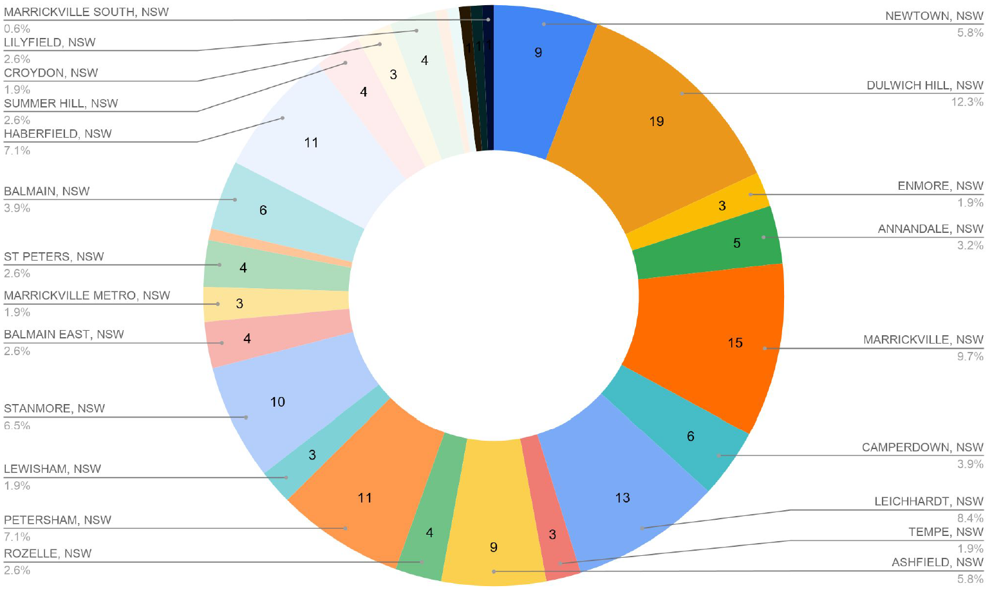
Figure 1: Responses to 'What suburb do you live in?’
The engagement was promoted via:
- Your Say Inner West homepage
- Your Say Inner West e-newsletter
- Social media
- Direct email
- Council column in the Courier
Feedback was collected online via Your Say Inner West (YSIW) and in person at the Your Say stall at Dulwich Hill Neighbourhood Feast. There were 631 people from across the Inner West who were aware of the project and visited the project page. Of these, 297 people provided feedback. The majority (60%) of responses came from women. The most represented age groups were 35-49 and 60-69 years.
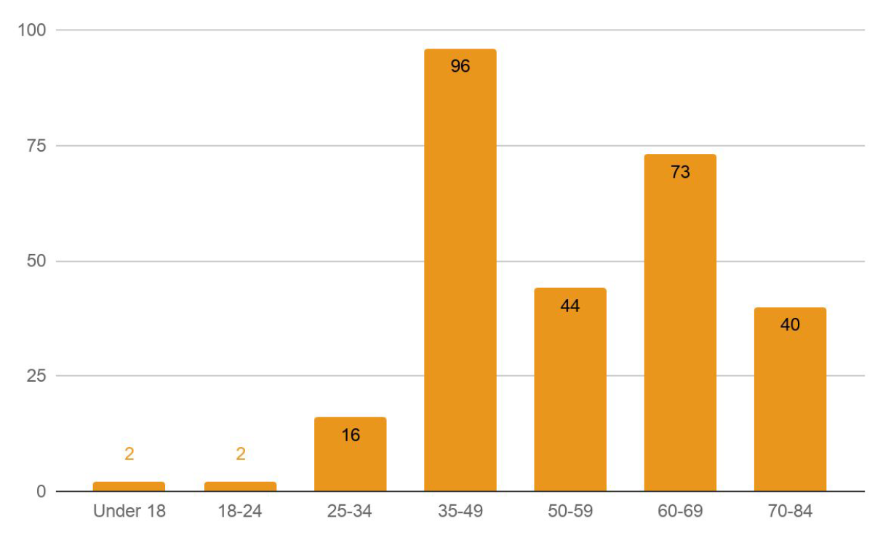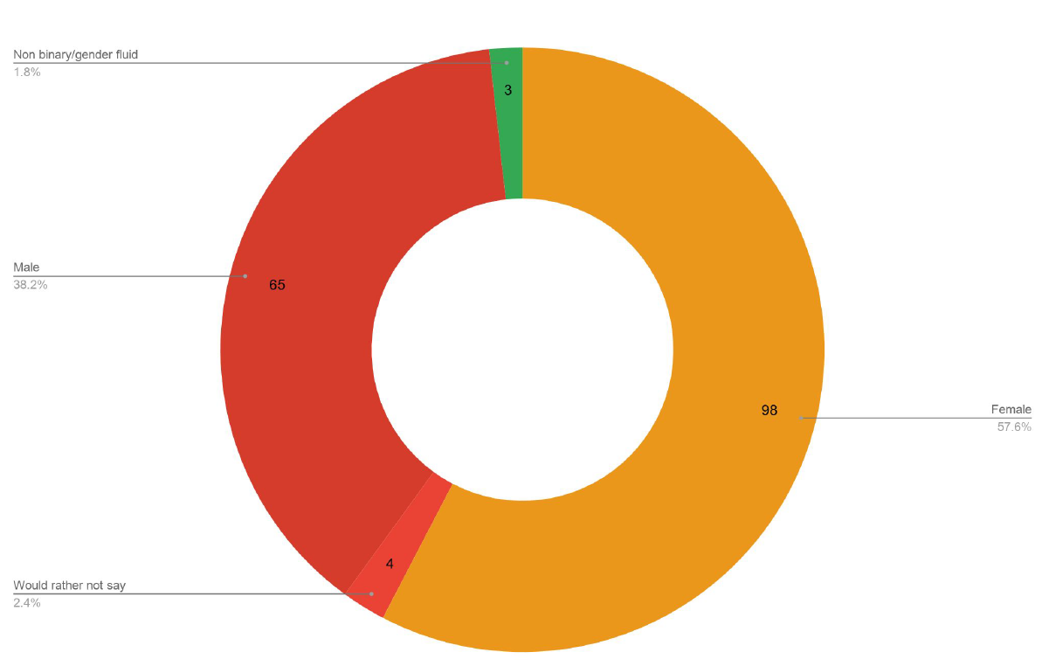
Figure 2: Responses to 'How old are you?' Figure 3: Responses to 'What is your gender?'

What we heard

The community told us:
- Engagement is important, however they are not completely satisfied with how their input was influencing decisions
- Council can improve engagement by moving away from tokenism and improving communications and transparency
- They mostly hear about engagement via letters and flyers in their mailbox or the quarterly newsletter
- They were only moderately or slightly satisfied with the information provided on a recent project
- The majority (60%) were not kept informed of the project progress and final outcomes
- They are moderately satisfied with YSIW and don’t use the search by ward function
- They did not know if they were registered to YSIW and of those who weren’t, they might have their say if registration was compulsory
- The majority (80%) indicated that they would be interested in email updates about projects they could provide feedback on.

