Marrickville Parklands including golf course draft plans - public exhibition

Engagement Outcomes Report – Stage two

Summary
Council engaged the Inner West community on the draft Marrickville Parklands Plan of Management and Master Plan via engagement platform, Your Say Inner West (YSIW). The plans were on public exhibition from 20 May to 17 June 2019 and the project page received 4,700 visits. There were 1,265 responses to the online submission form. Respondents were predominantly local residents and a significant number of respondents visit the Parklands frequently.
The submission form required participants to select one of three options regarding the golf course configuration. The options and support for each were:
- Option A: keep the golf course at 18 holes with upgrades to the parkland
  - 277 supporters
- Option B: reduce the golf course to 9 holes and diversify opened up space for a variety of uses.
  - 561 supporters
- Option C: No changes are made to the 18 hole golf course.
  - 309 supporters
Option C was added to the submission form two days into the public exhibition on 22 May 2019. The results from the original survey were as follows:
- Option A: 57 supporters
- Option B: 71 supporters.
A full ecological restoration of the Dibble Avenue Waterhole which requires Marrickville Golf Course to find an alternative water source was supported by most respondents.

Background
The preparation of a Plan of Management for Marrickville Parklands was prioritised at Council’s meeting on 28 February 2017. The site has an extensive and complex history of use and management. Issues include:
- Complex landownership issues
- Complex land and water management issues
- Recommendation from Marrickville Rec Needs Study adopted in 2012 to reduce course to 9 holes and specific Council resolution that it remains 18 holes
- Marrickville Council exhibited a draft Plan of Management and Master Plan in 1999 but these were never adopted
- Recent changes to NSW, coastal and biodiversity / vegetation legislation.
Initial consultation in 2018 was considered in the preparation of the draft Plan of Management and Master Plan.

Promotion
The public exhibition period was promoted via:
- Your Say Inner West project page
- Onsite signage
- Media release
- Social media
- E-news
- Council website
- Email to identified groups
All promotion collateral directed people to the online submission form on YSIW.
Engagement outcomes
An analysis of the of the updated survey which received 1,130 responses precedes the analysis of the original survey which received 135 responses.
Quantitative questions from the survey are displayed visually. Issues raised in comments have been themed.

Who did we hear from?
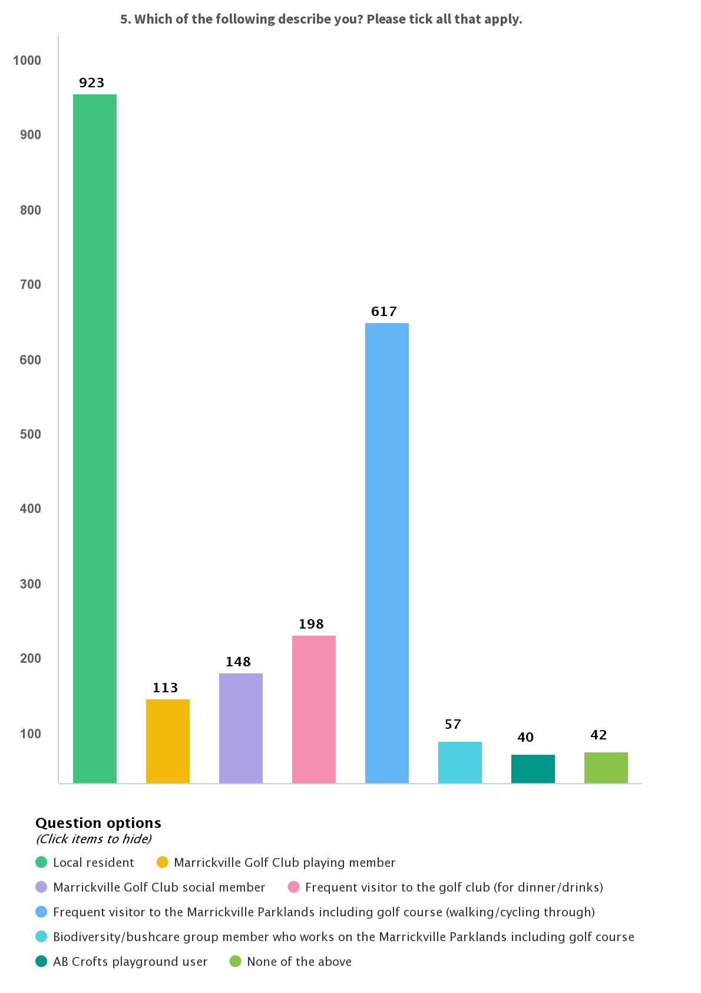

Figure 1 Which of the following describes you? Please tick all that apply chart

Options

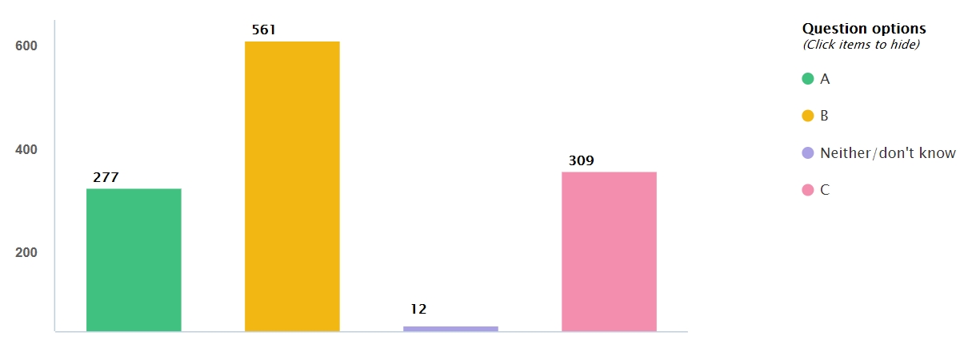
Q1. Which option do you support?

Figure 2 Which option do you support? Chart
Issues raised in the comments following this question have been themed.
Option A Maintain the golf course at 18 holes with upgraded parklands:
- The space is already multi use and open to the community
- The course is a community asset as the only public golf course of its size in the area
- A reduction in size would be the end of MGC including its financial viability
- There is already sufficient open space and under utilised sports facilities along the river.
Option B Reduce the golfcourse to 9 holes and open up the resulting space to other community uses:
- The golf course is a large area of public land that serves a small portion of the community
- The space should be diversified and opened up to the broader community for other leisure and recreation uses
- A reduction in the golf course size would be a good environmental and biodiversity outcome.
Option C No changes to be made to the 18 hole golf course and parklands:
Issues raised as in Option A

Dibble Avenue Waterhole

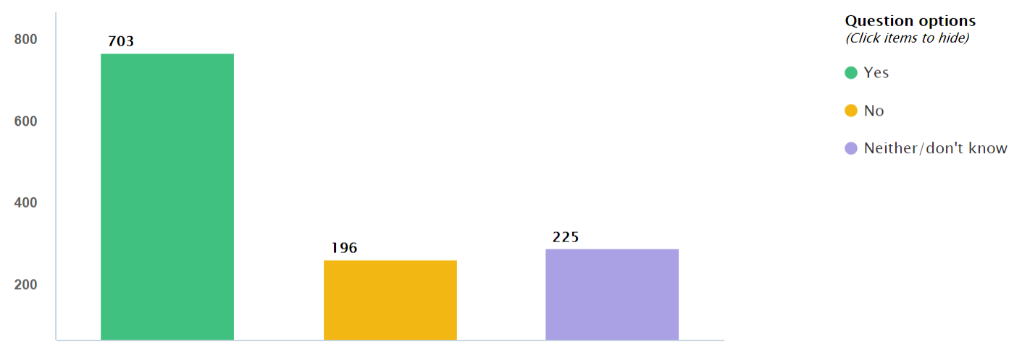
Q2. The Plan of Management proposes a full ecological restoration of the Dibble Avenue Waterhole and requires Marrickville Golf Club (MGC) to find alternative sources of irrigation. Do you support this?

Figure 3 The Plan of Management proposes a full ecological restoration of the Dibble Avenue Waterhole and required Marrickville Golf Club to find alternative sources of irrigation. Do you support this? Chart
Issues raised in the comments have been themed.
Those who answered yes raised the following issues:
- The golf course should be sustianably sourcing its own water for irrigation
- Water is a scarce resource and golf courses use too much water
- The water hole should be restored, protected and opened up to the public.
Those who answered no:
- MGC has used the waterhole since the 1940s, why should it be changed now?
- It is the only option, what are viable alternatives?
- The golf course does not take from town water which is a good thing
Those who responded ‘neither/don’t know’:
- the view that they didn’t know enough about the situation and
- that they would like to see alternative options.

Dibble Avenue Waterhole and AB Crofts Playground further comments
Comments on Dibble Avenue Waterhole repeat what was mentioned already in response to question 2. Themes included:
- Support for a full restoration of the Dibble Avenue Waterhole as a sanctuary for wildlife including regular maintenance
- Increased public access to a restored waterhole
- Restricted public access to preserve the waterhole and habitat
- Golf course has more use of the waterhole than the community who aren’t invested in it
- Storm water improvements required for the area which experiences flooding
- AB Crofts Playground could be improved and play equipment upgraded

Marrickville Parklands including golf course further comments
Comments on Marrickville Parklands including golf course were consistent with what was already mentioned in question 1 falling into the following key themes:
- This is a great opportunity to create a nature corridor with increased tree plantings and biodiversity
- The parklands belong to all Inner West residents and are only being used by a minority
- The space should be diversified and accessible to all members of the community
- It would be great to have a cycling track and facilities
- The golf course should stay as it is, reducing the size would have a negative impact on the club and area
- The golf course is a unique community asset that caters to all ages but especially seniors

Outcomes from original survey
On 22 May, two days into the engagement, Option C was added to the proposal and question 1 of the survey. There were 136 responses to the survey before it was updated. The results are displayed below.

Who did we hear from?
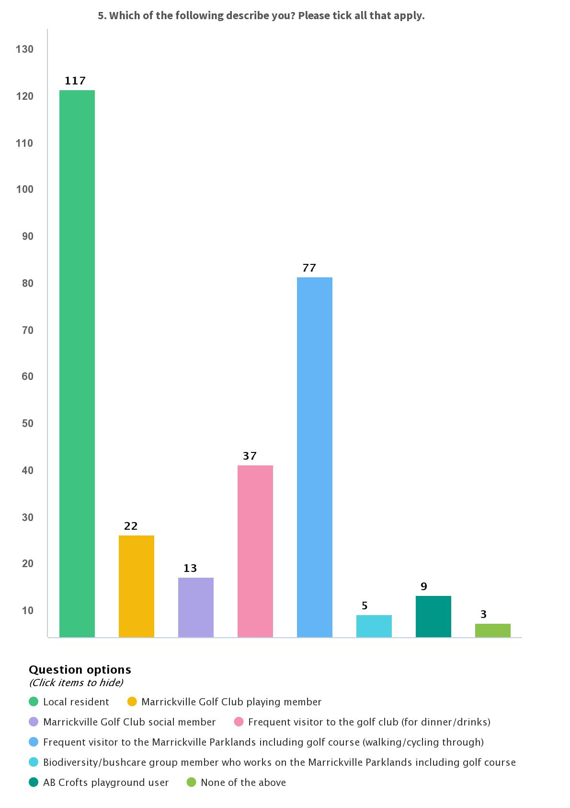

Figure 4 Which of the following describes you? Please tick all that apply chart

Options
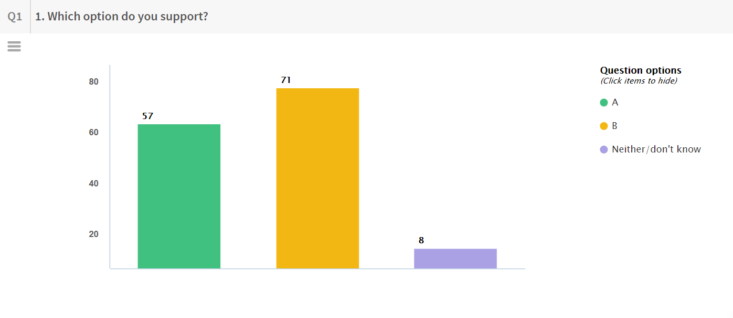
Q1. Which option do you support?

Figure 5 Which option do you support? Chart
- Option A: keep the golf course at 18 holes with upgrades to the parkland
  - 57 supporters
- Option B: reduce the golf course to 9 holes and diversify opened up space for a variety of uses.
  - 71 supporters

Comments on this question were consistent with the themes in the updated survey.

Dibble Avenue Waterhole
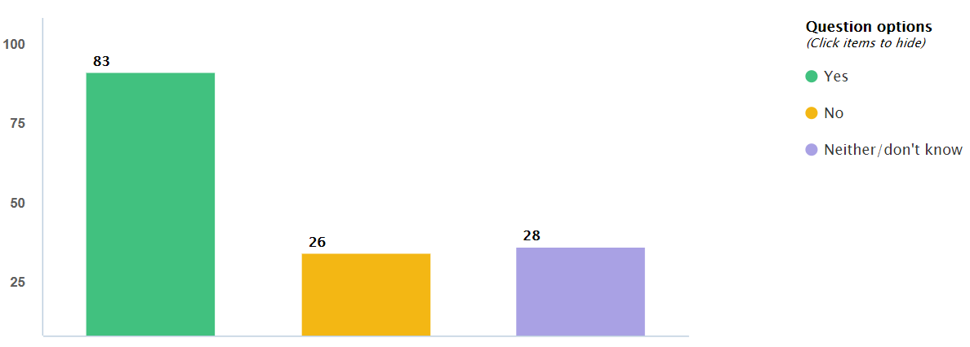
Q2. The Plan of Management proposes a full ecological restoration of the Dibble Avenue Waterhole and requires Marrickville Golf Club (MGC) to find alternative sources of irrigation. Do you support this?
Figure 6 The Plan of Management proposes a full ecological restoration of the Dibble Avenue Waterhole and required Marrickville Golf Club to find alternative sources of irrigation. Do you support this? Chart
Comments on this question are consistent with the themes in the updated survey.

Engagement Outcomes Report – Stage three

Summary
Council sought input from the community during public exhibition of the final draft Marrickville Parklands and Golf Course Plan of Management and Master Plan after receiving approval from the NSW Government. The draft Plans were open for community comment between 19 March and 1 May 2021 on Council’s engagement hub Your Say Inner West. The project page received 1007 visits. There were 67 responses to the online submission form. Respondents were asked whether they supported the draft Master Plan. The responses were as follows:
- Yes – 19
- No – 47
- Not sure / Neutral - 5

Background
At the ordinary Council on 22 September 2020 (C0920(2) Item 2) Council noted that on receipt of owner’s consent by the Minister the Draft Plan will be exhibited for 28 days and brought back to Council for adoption.
Noting that Council also resolved to maintain an 18 hole golf course and this is how the Plan of Management and Masterplan was exhibited.

Engagement Method
The method of engagement was online on yoursay.innerwest.nsw.gov.au
Meeting with the Golf Club management

Promotion
The engagement was promoted through:
- Council website
- Email to those who had contributed to the stage two engagement
- Onsite posters

What did they say?
Do you support the proposed Plan of Management and Master Plan?

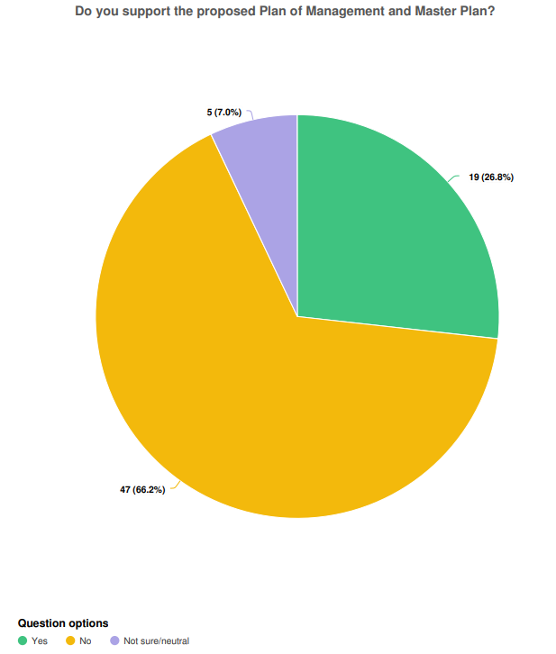
Yes – 19 (26.8%)
No – 47 (66.2%)
Not sure/neutral – 5 (7%)

The responses reflect the wider community views on the use of the land as an 18 hole golf course. This issue was decided by Council prior to this final public exhibition. The elected Council voted to maintain the 18 hole course on this land.

Comments about the plan from those who supported the Plan of Managememnt and Master Plan are themed below:
- Support for the retention of the 18 holes
- Support for the walking pathways on the course
- Support for community access to the open space
- Overall support for implementation of the plan

Comments from those who did not support the Plan of Management and Master Plan are themed below:
- Lack of fair and equitable access to community land due to the 18 holes course
- Sustainability and environmental concerns

Other Comments
The responses have been grouped into themes which relate to the draft Master Plan Strategies.
Access
- Responses supported continued community access to the course
- Responses supported improved walking and cycling access
- Responses supported upgrades to pathways and improved accessibility
- Responses did not support an 18 hole golf course
Sustainability
- Water management – Responses support a review of existing uses and proposed stormwater management
- Positives in the plan native planting, expanding wildlife corridors and revegetation

Social and Mental Health
- Responses show that there is a strong community focus for the golf club. A popular restaurant and a meeting place for the community.
- Responses show the golf course is a great place for many physical activities including golf, walking, walking with a dog and cycling,
- Responses have indicated that it is a great place to catch up and support each other, especially during covid. Golf was one of the activities that still could take place during this time
Officer comments in response to public exhibition

The initial plan proposed a 9 hole course, however Council resolved to retain the 18 hole course. This meant that there were changes needed to update the plan. These are listed in the table below.
Item | Changes made | Officer Explanation
Zone 1 (item 5) | leave tee box in current location | As per 18 hole course layout
Zone 1 (item 5) | readjust path through this section | For safety
Proposed Playground | remove playground from the plan. | With the 18 hole course adopted by Council this now cannot be accommodated
Proposed BBQ's | remove BBQ area from the plan | With the 18 hole course adopted by Council this now cannot be accommodated
Zone 1 (item 12) | pathway adjusted to the boundary to avoid moving tee box | For safety
Zone 1 (item 20) | area flaged as one of the worst flooding spots on the course | Wetland planting is proposed here rather permanent structures
Zone 1 (item 21) | possible water harvesting location | The golf club are looking at several water harvesting locations and solutions
Zone 1 (item 24) | sporting grounds removed | With the 18 hole course adopted by Council this now cannot be accommodated
Zone 2 (item 2) | - walkway moved to boundary to avoid moving tee box  - tee box left in current location | For safety
Zone 2 (item 8) | - move path to the east to avoid replacing tee box  - play structures deleted | For safety. A 18 holes course cannot accommodate a playground.
Zone 2 (item 9) | Nursery removed | With the 18 hole course adopted by Council this now cannot be accommodated
Zone 2 (item 11) | Fence not appropriate in this location | Fencing amended to be low level to ensure safety of pedestrians whilst enabling competent golfers to play over water.
Zone 2 | Excessive fencing removed | Fencing has been amended where it is not seen to be needed for safety reasons, nor an obstacle for those playing golf
Zone 2 (item 15) | Heavy flood area | Noted
Zone 2 (item 16) | heavy flood area | wetland planting is proposed here rather than permanent structures
Zone 2 (item 20) | possible water harvesting location | The golf club are looking at several water harvesting locations and solutions
Zone 2 (item 21 & 22) | any works in this section should be avoided due to flooding | All built form proposed previously has now been deleted
Zone 2 (item 26) | Bruce Street rain garden is not suitable for water harvesting. This area has fallen into disrepair | Council have agreed to undertake more regular maintenance on this landscape element
Zone 2 (item 29) | sporting grounds removed | With the 18 hole course adopted by Council this now cannot be accommodated
Zone 2 (item 30) | - existing tee boxes to remain in current location  - play structures and events area to be removed | With the 18 hole course adopted by Council this now cannot be accommodated
Zone 3 (item 8) | - there is insufficient room to double the size of the car park  - it would affect the 2nd, 3rd and 6th holes | With the 18 hole course adopted by Council this now cannot be accommodated
Zone 3 (item 18) | This area currently houses the sheds containing the plant and equipment, this should be extended and improved in an environmental style. | Possible extension of replacement structures now shown on masterplan
Zone 3 (item 23) | The pond should be expanded to harvest 1.5 mglt of water. | Expansion of pond included in the masterplan
Zone 3 | The toilet block and the old timber tea house should be upgraded as a community toilet block and the building to be replaced and extended. | Existing toilet building should be refurbished to meet current standards and community expectations. A new building is not required.
Zone 3 | Increased provision of infrastructure for bushcare volunteer organisations and community participation (eg. ‘Mudcrabs’ site shed) | Removal of old storage sheds to build new shared facilities

Officer comments below relate to themes that arose from participants feedback

Theme | Concern | Officers Response
Golf course to stay at 18 holes | That the golf course will be reduced to 9 holes | Council has resolved to keep the course at 18 holes
Community access to the golf course | That the community will no longer be able to access the course for recreational reasons | The Golf club welcomes safe access on to the course for recreational needs. There will be additional paths built to facilitate safe walking areas through the parklands
Watering of the course | That the club continues to take water from the Dibble Ave waterhole | The club is permitted to take an agreed amount of water from the waterhole (as addressed in the POM) They are also looking at water harvesting options

