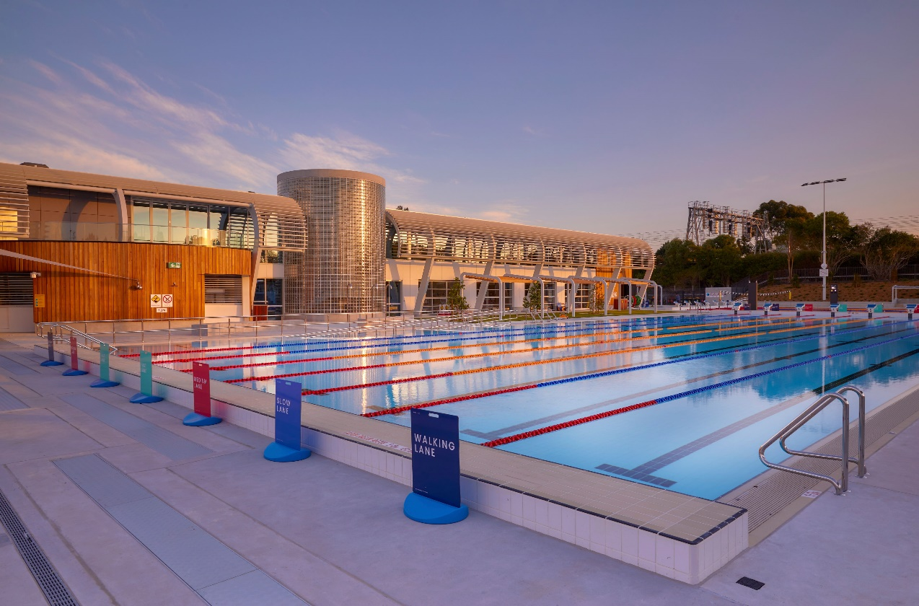

Engagement outcomes report

Making swimming more affordable

Contents
Summary 3
Background 4
Engagement Methods 5
Promotion 6
Engagement outcomes 7
What did they say? 7
Comments 8

Summary
Community feedback was sought between 5 August and 2 September 2021 regarding a proposal to reduce the cost of entry into most Inner West Council aquatic centres for those receiving social security payments. The change would see a standard casual swimming fee of $1.20 applied for social security recipients across all Inner West Council Aquatic facilities.
The following community input was received over a four-week period:
- Online by filling in the feedback form - 298
- Emailing the Acting Director, Development & Recreation – 0
- Emailing the Centre Manager, Ashfield Aquatics Centre – 0
- Telephoning the Centre Manager, Ashfield Aquatics Centre including free interpreter or National Relay Services – 0

The project page on YSIW received 874 visits and 298 submissions were received.

Of those who submitted online, 279 were in support of the proposal to apply a standard $1.20 fee for standard casual swimming across all Inner West Aquatic facilities for Social Security recipients, 11 were against the proposal and 8 were not sure/neutral.

Background

On 29 June 2021, Council resolved to exhibit a proposed change to the fee for the ‘Pensioner Concession’ (to be renamed 'Social Security Recipient Concession' to apply to social security recipients including JobSeekers, DSP, etc) rate for all aquatic centres to the LPAC rate of $1.20.
'Social Security Recipient Concession'
It was proposed that all Inner West Council Aquatics Facilities including Ashfield Aquatic Centre, Fanny Durack Aquatic Centre, Dawn Fraser Baths and Annette Kellerman Aquatic Centre offer a new (reduced) casual swimming fee for Social Security recipients. This would see a reduction in the current fee at each of these facilities and a $1.20 fee be implemented. This fee is already in existence at the Leichhardt Park Aquatic Centre
The purpose of the change is to provide equitable access for those who are eligible for this category and to promote additional attendance and subsequently healthy lifestyles and wellbeing.

Engagement Methods
The community was invited to provide feedback via:
- Your Say Inner West through an online feedback form
- Email through Local Democracy Groups
- Phone (including via the National Relay Service for Translating and Interpreting Service)

The community had access to the Council meeting minutes via a web page on Your Say Inner West and was also notified they could obtain a hard copy of the proposal and provide feedback by contacting a named officer.

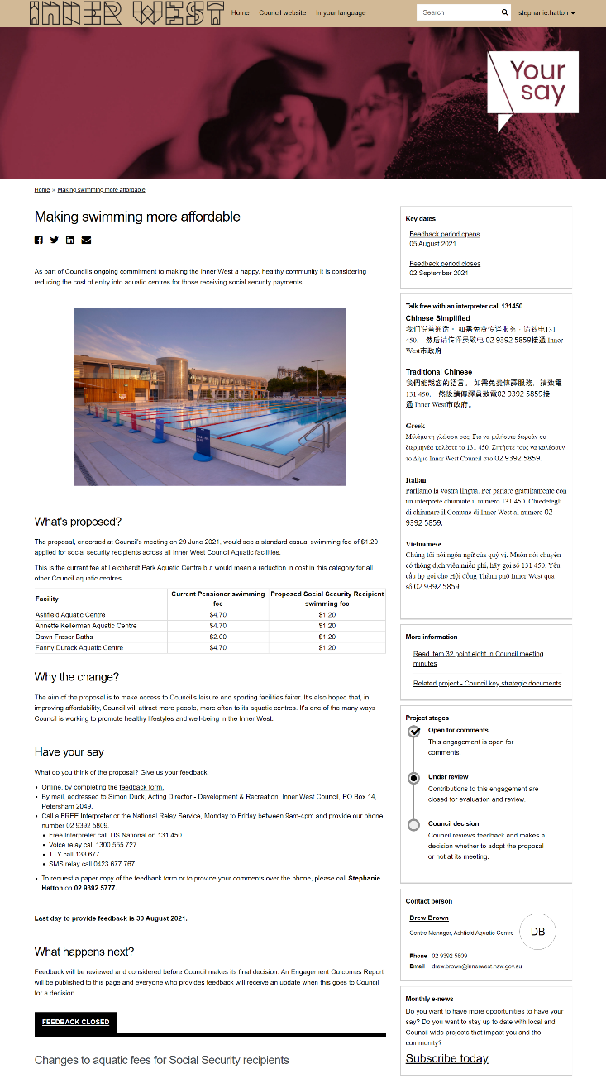

Promotion
The engagement was promoted through:
- Council website
- Council e-newsletter
- Inner West Council social media platforms – Facebook and Instagram
- Inner West Aquatics Facebook page (run by Council’s Aquatics team)
- Email to relevant Council Local Democracy Groups - Access Advisory Committee and Seniors Working Group

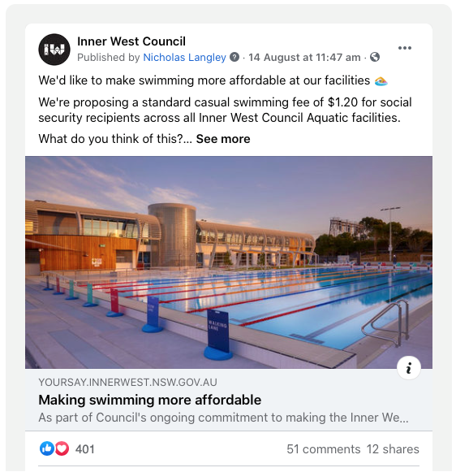

Engagement outcomes

Who did we hear from?
We did not ask demographic questions in this engagement.

What did they say?
- Online via yoursay.innerwest.nsw.gov.au

Of the 298 participants on the online survey, 279 were in support of the changes to swimming fees for Social Security recipients, 11 were opposed to the change and 8 were not sure or neutral in their response.

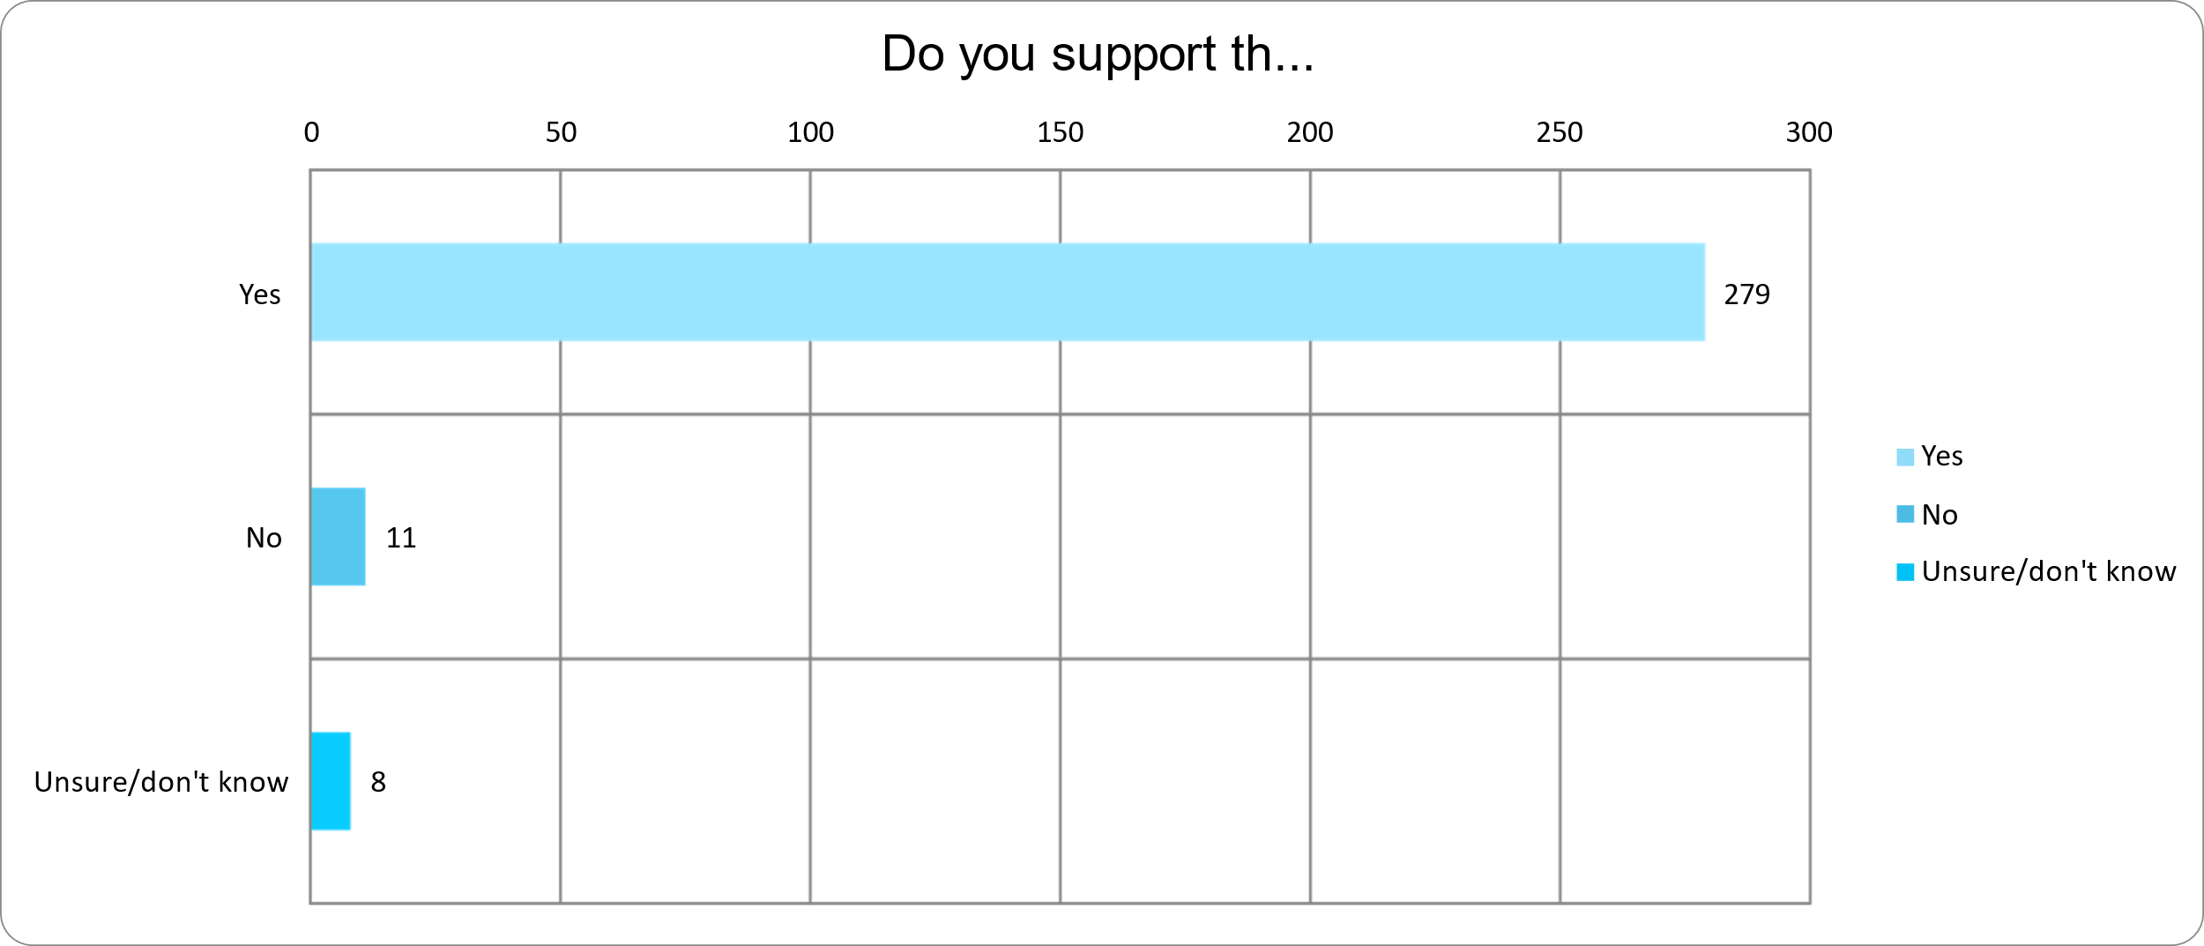
Do you support the changes in swimming fees for Social Security recipients?

Comments
In total, 278 people out of 298 provided comments in the survey.

Key themes:
Comments from those in support of proposal:
- Believe it’s important that Council facilities are accessible for all (106 respondents).
- Highlighted the benefits of access to swimming for health and wellbeing particularly for those experiencing hardship (53 respondents).
- Thought the current fees are too expensive (26 respondents).
- It’s important to support those on Social Security benefits (21 respondents).
- Would swim more regularly if this change came into effect (19 respondents).
- Swimming should be free, especially for over 65s (8 respondents).
- Important that swimming fees are harmonized across all Council aquatic centres (8 respondents).
- Covid-related financial hardship has hit those in need the most, believe this change would be welcome relief (3 respondents).

Comments from those not in support of/unsure about the proposal:
- Offer the discounted rates for Social Security recipients at off-peak times as the aquatic centres are already too busy (3 respondents).
- Concern it would increase the cost of paid entry (1 respondent).
- Questioned what the $1.20 fee is based on (1 respondent).
- Support the change for elderly social security recipients but not those on NewStart (1 respondent).
- Should only be offered to those in the Inner West LGA. Could offer a reduced rate for Social Security recipients outside LGA but focus on those living in Inner West (1 respondent).
- Council already in debt, it’s a good cause but not affordable for Council. (1 respondent).
- Pensioners already get many benefits, don’t need this one (1 respondent).
- Questioned why the discount doesn’t apply to rate payers who have experienced large fee increases (1 respondent).

In addition, comments included the following issues:
- Would also like to see the cost of swimming for families reduced including the spectator fee for those supervising children (8 respondents).
- Use of the Gym should be reduced to the same price (4 respondents) as well as pool group exercise classes (1 respondent).
- Suggested implementing multi-passes and benefits for regular uses of the aquatic centres (3 respondents).
- Would like to see the discount also apply to self-funded retirees (2 respondents).
- Requested accessibility lanes for walkers at all Council aquatic centres (1 respondent).
- Should have reduced fees for kids with disabilities (1 respondent).
- Discount should also apply to students (1 respondent).
- Suggest discount also applies to dependents of Social Security recipients (1 respondent).
- Would like to see Council lobby NSW Government to open more pools during lockdown (1 respondent).

