XX:XXX: XXX
4 May 2022

<First last name>
<Address 1>
<Address 2>
<Suburb NSW 1234>

Dear <name>,

HAVE YOUR SAY
Improving safety and calming traffic in Petersham North

Council is developing a Local Area Traffic Management (LATM) Plan to manage traffic and improve walking and cycling in the Petersham North precinct. This study area is bounded by West Street, Parramatta Road, Crystal Street and Terminus Street - see a map overleaf.

The plan will aim to:

- Improve road safety for pedestrians, cyclists and motorists
- Calm traffic and improve access for pedestrians and cyclists
- Manage changing traffic needs over the next ten years

Have your say

Local knowledge of walking, cycling and driving in your neighbourhood is invaluable to this work. You are invited to share information and experiences by providing feedback online at: yoursay.innerwest.nsw.gov.au

Who should provide feedback?
We would like to hear from schools, residents, business owners and workers. The experiences of pedestrians, cyclists, motorists and other road users are all welcomed.

The last day to provide feedback is Wednesday 4 June 2022.

Enquiries
If you need a printed copy of the feedback form mailed to you or if you have any questions about this project, contact me on 9392 5561 or email jason.scoufis@innerwest.nsw.gov.au.

Yours sincerely

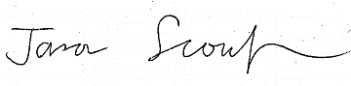

Jason Scoufis
Traffic and Parking Planner

Map – Petersham North LATM study area

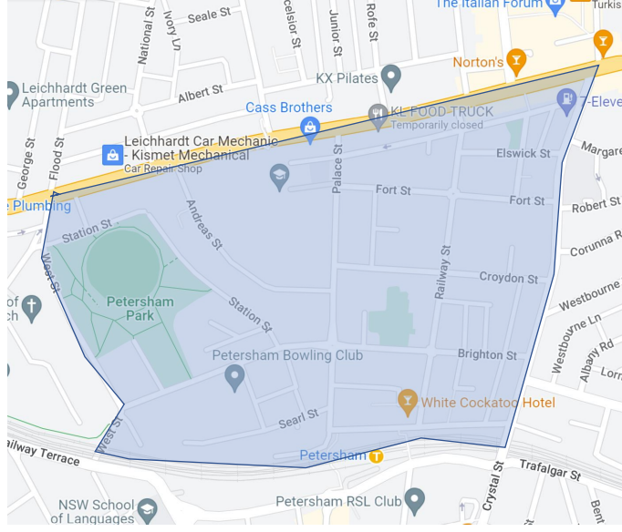

Basemap source Google Maps

