XX:XXX: XXX
4 May 2022

Dear <name>,

HAVE YOUR SAY
Improving safety and calming traffic in Newtown South

Council is developing a Local Area Traffic Management (LATM) Plan to manage traffic and improve walking and cycling in the Newtown South precinct. This study area is bounded by Edgeware Road, Lord Street, King Street and Alice Street - see a map overleaf.

The plan will aim to:

- Improve road safety for pedestrians, cyclists and motorists
- Calm traffic and improve access for pedestrians and cyclists
- Manage changing traffic needs over the next ten years

Have your say

Local knowledge of walking, cycling and driving in your neighbourhood is invaluable to this work. You are invited to share information and experiences by providing feedback online at: yoursay.innerwest.nsw.gov.au

Who should provide feedback?
We would like to hear from schools, residents, business owners and workers. The experiences of pedestrians, cyclists, motorists and other road users are all welcomed.

The last day to provide feedback is Wednesday 1 June 2022.

Enquiries
If you need a printed copy of the feedback form mailed to you or if you have any questions about this project, contact me on 9392 5561 or email jason.scoufis@innerwest.nsw.gov.au.

Yours sincerely

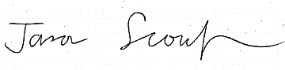

Jason Scoufis
Traffic and Parking Planner

Map – Newtown South LATM study area

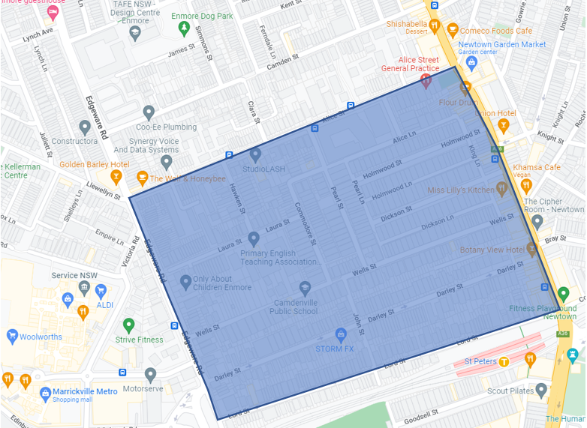

Basemap source Google Maps

