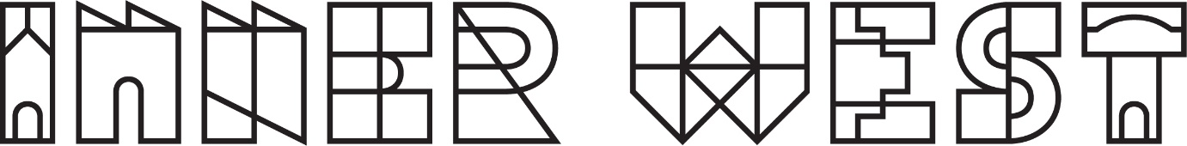

Terms and Conditions for Inner West Council
Community Recycling Centre awareness survey prize draw.

- The promoter is Inner West Council.

- Everyone who lives, works, studies, plays, visits or conducts business within the Inner West Local Government Area is able to participate in the survey. Inner West Council staff and their families can respond to the survey but are not eligible for prizes.

- By participating in the survey, participants are deemed to accept the Terms and Conditions set out in this document.

- Participant contributors below the age of 14 as of 1 March 2022 must obtain the consent of their parent or legal guardian to participate in this project so that the parent or legal guardian agrees to the Terms and Conditions set out in this document.

- It is free to contribute to the survey and no fee is required.

- Responses will be archived for future researchers and become part of our online research findings in the future.

- Without prejudice to any other provision of these Terms and Conditions, Inner West Council Resource Recovery Planning reserves the right to disqualify any participant for failure to abide by any of the Terms and Conditions set out in this document, or for submitting false, inaccurate or incomplete information, or for any other reasonable cause.

- Entrants to the draw must complete Inner West Council Community Recycling Centre awareness survey.
All completed contributions to the survey received through these channels are eligible for the draw.
- yoursay.innerwest.nsw.gov.au

- All respondents that complete a survey will be entered into the prize draw to win one of 3 prizes. Winners are selected at random using a random number generator.

- The survey is open from 27/04/2022 until 29/05/2022. All completed surveys received during this time are eligible for the draw. The deadline may be extended at the discretion of the organisers if insufficient entries are received.

- The prizes are for 3 x $100 visa debit cards. Total prize value $300. The split of the prize total may be changed at the discretion of the organisers.

- The Promoter is not responsible for any late or invalid entries due to technical issues.

- Winners are selected by random draw from all completed survey entries within 4 weeks of the closing date of the survey. Winners will be emailed regarding their prize after the draw has been completed.

- If Council does not receive a response to the email within 2 weeks an alternative winner will be chosen. Should an entrant’s contact details change during the promotional period, it is the entrant's responsibility to notify the Promoter. A request to access or modify any information provided in an entry should be directed to the Promoter.

- Contributors may contribute once only.

- Council will publish the names of the prize winners on yoursay.innerwest.nsw.gov.au

- Subject to complying with all relevant State and Territory legislation, the Promoter reserves the right to amend, cancel or suspend this competition if an event beyond the control of the Promoter corrupts or affects the administration security, fairness, integrity or proper conduct of the competition. The Promoter will disqualify any individual who has tampered with the entry process or any other aspect of this draw.

