XX May 2022

<First last name>
<Address 1>
<Address 2>

Dear Sir/Madam,

Have your say on the amendment to the Marrickville Local Environmental Plan 2011 for the Cyprus Club site: 58-76 Stanmore Road, 2-20 Tupper Street and 1, 3-9 Alma Avenue, Stanmore
Council seeks your feedback on the proposed amendments to the Marrickville Local Environmental Plan (MLEP) 2011 for the Cyprus Club site.
The Department of Planning and Environment (DPE) issued a Gateway Determination for the Planning Proposal in June 2021 to proceed to public exhibition.
Key features of the planning proposal
The Planning Proposal seeks to rezone the subject site (see below map) and amend the maximum Floor Space Ratio (FSR) and Height of Building (HOB) to enable a mixed-use development comprising up to 160 dwellings with a minimum of 1500m² floorspace for commercial/club uses.
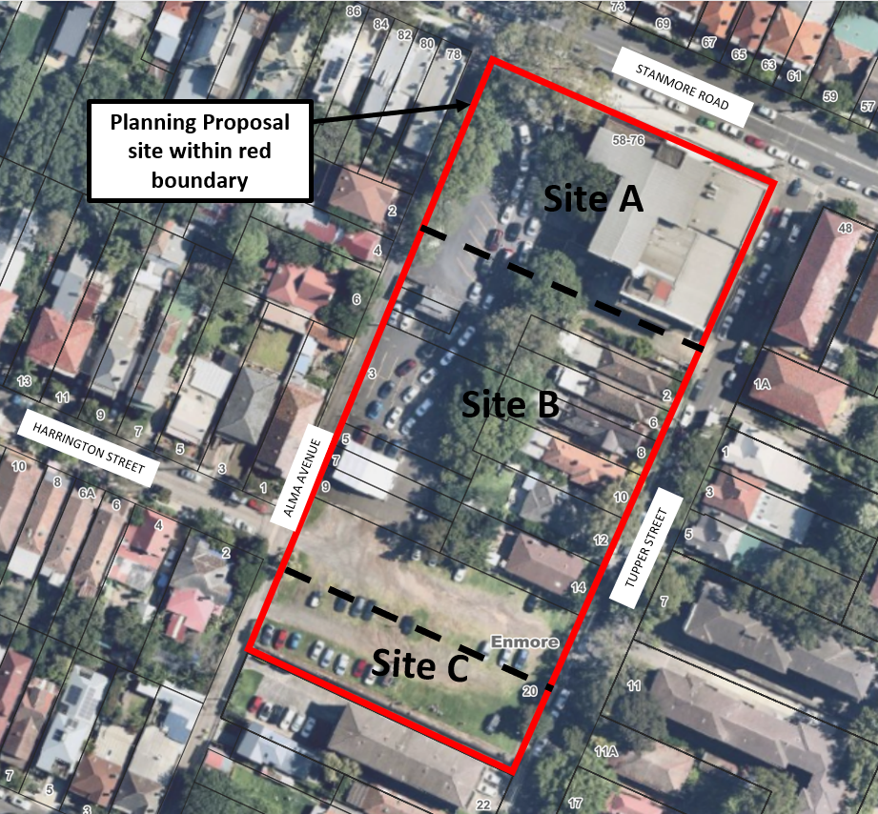
Proposed changes to the MLEP 2011 include:
  - Rezone parts of the site: Site A - B4 Mixed Use, Site B and Site C – R1 General Residential
  - Amend the FSR controls: Site A and Site B - 1.75:1; and Site C - 1 :1
  - Amend the HOB controls: Site A – 21m, Site B – 17m (western side), 21m (eastern side) and Site C -11m
  - Amend the Key Sites map to identify the Cyprus Club site
- Introduce a site-specific clause for the proposed B4 mixed-use zone to permit a residential flat building only if it includes a minimum of 1500m² floorspace for a Registered Club and Commercial premises
  - Introduce an additional local provision which requires preparation of a site-specific Development Control Plan to address detailed matters such as built form, landscaping, streetscape, amenity etc.
For more information, and to have your say visit yoursay.innerwest.nsw.gov.au.
Submissions close on Monday 19 June 2022.
What happens next?
After the exhibition period closes, your feedback will be reported to Council who will consider whether to progress with the proposal.
Council’s recommendation will then be reported to DPE who will make the final determination regarding making the proposed LEP amendment.
Enquiries can be directed to:
Con Colot on 9392 5977 and Nicola Viselli on 9392 5968

Sincerely,
Daniel East
Strategic Planning Manager

