6 April 2022

Have your say – North Street Playground Upgrade
Dear resident,
I am writing to invite you to participate in designing the upgrade of the North Street Playground.
Children in the Inner West have less access to open space than most communities so it’s important that we invest in improving the playgrounds and recreation spaces that we do have. North Street Playground is a beautiful and precious space and we want to make it more usable for local families.
We have allocated $80,000 to the upgrade of the playground and need your input into how the equipment can be improved.
Please see over the page for information about how you can get involved in the design of the upgrade.
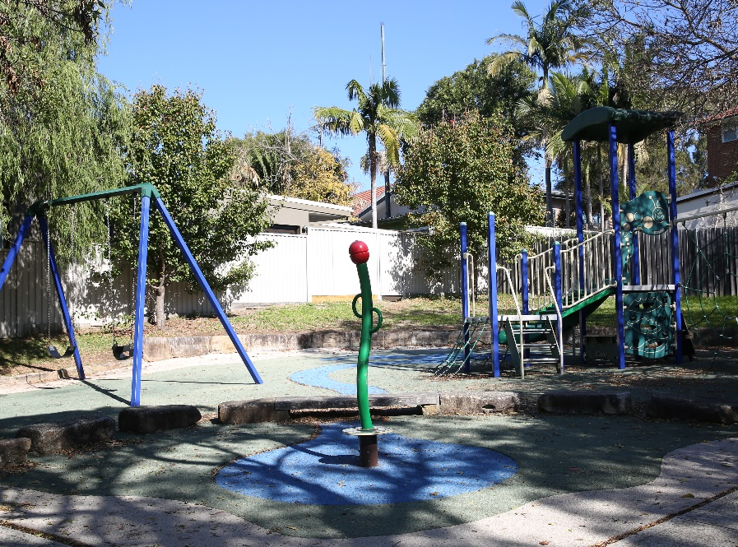
Yours sincerely,
Clr Darcy Byrne
Inner West Mayor

Get inspired!
Our focus is to give this ageing playground a new lease on life and improve safety. The upgrade will involve replacement of all existing equipment and playground surfacing. New play experiences could include:
- Active play – swinging, climbing, rocking
- Sensory play – nature, music
- Imaginative play, group play, solo play and much more!
What should we include to make this playground special?

Have your say
You can provide input:
- Online via yoursay.innerwest.nsw.gov.au – search for North Street Playground
- In person at North Street Playground, 56 North St Leichhardt
Saturday 7 May, 2 – 3pm
- Call Fiona Cui, Project Manager on 02 9392 5586
- Email fiona.cui@innerwest.nsw.gov.au
- Mail Fiona Cui, Project Manager, Inner West Council,
PO Box 14, Petersham, 2049
The last date to provide input is Sunday 15 May 2022.

Enquiries
Please contact Fiona Cui, Project Manager on 02 9392 5586 or email fiona.cui@innerwest.nsw.gov.au

