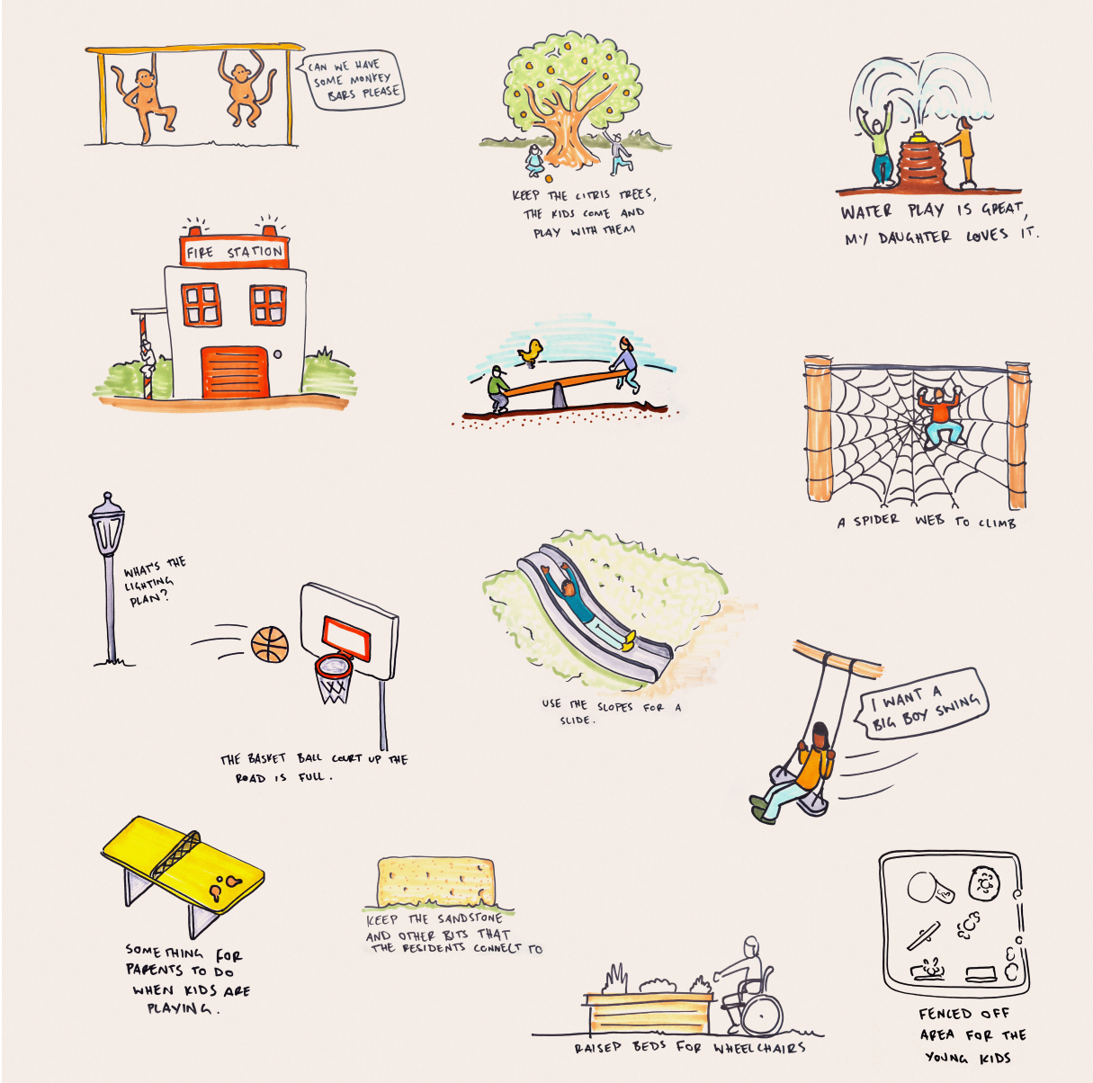

Engagement outcomes report

Cahill St Playground & Lewis Herman Reserve

Contents
Summary 3
Background 3
Engagement Methods 4
Promotion 5
Engagement outcomes 6
What did the community say? 6
Next steps 11
Attachment A – Graphic Recording 13
Attachment B – Posters on-site sessions 16

Summary
This document provides an overview of the community consultation process and outcomes for the design development of Cahill Street Playground and Lewis Herman Reserve.
Input from the community was sought both online on Your Say Inner West (YSIW) Council’s engagement hub and during on-site drop-in sessions.
From 16 November to 15 December 2021, the community could post their ideas for the playground and reserve on Your Say Inner West. Some people sent emails to Council. An onsite drop-in session was organised for the two sites on Saturday 27 November 2021, which allowed people to ask questions and provide suggestions directly to the project team.
On Your Say Inner West, 96 ideas were posted for Lewis Herman Reserve and over 500 visitors had a look online and provided comments and votes. Popular themes for the upgrade of Lewis Herman Reserve included a kids play space, a fenced dog off leash area, and gardens.
The Cahill Street playground project page received 14 ideas and over 300 people visited the page. For Cahill Street Playground the popular themes were an upgrade to the playground and improved access and connectivity, particularly along the Johnston Creek corridor.

Background

Inner West Council (IWC) has received funding from the NSW Government’s Public Spaces Legacy Program to upgrade Cahill St Playground and Lewis Herman Reserve.
The total upgrade budget for Cahill St Playground is $1,020,000 and for Lewis Herman Reserve $980,000.
IWC’s project aims are to:
- create new and expanded public spaces and increased community participation and engagement with the public domain
- support investment in the creation of high-quality public and open spaces to create a lasting community benefit
- address critical open space shortfalls and improve the quality of existing public and open spaces
- design for sustainable long-term maintenance
- respond to requirements of the broader community users of each open space and comply with the ‘Everyone Can Play’ Guidelines
- address requirements and compliance for design standards, safety in design, utility authority and landowner requirements
The input provided by the community will inform the designs and will guide the programming of the spaces. The project team will carefully consider all provided input and assess what proposed elements are compatible and feasible within the available space and budget.
Construction is planned to be completed by the end of 2022.

Engagement Methods
The methods of engagement included:
- online on yoursay.innerwest.nsw.gov.au
- onsite engagement session with graphic notetaker
- Written submissions
- email and phone
- stakeholder meeting
Online on Your Say
Residents were asked to share and discuss their ideas for Lewis Herman Reserve and Cahill St Playground on Your Say Inner West. Images could be included in these posts. All posted ideas were visible on the webpage and visitors could leave comments or votes on the posts. The number of votes a post received gives an indication of the popularity of the idea.
Onsite engagement sessions
On 27 November 2021, onsite engagement sessions were held including
- 10am-12pm at Lewis Herman Reserve and
- 1pm-3pm at Cahill Street Playground
The project team included representatives from Council, the design team from Civille, and a graphic notetaker who made sketches of the input the community provided.
For each site, three A1 posters were prepared, including:
- One poster with background information on the project and a satellite image of the park with site boundaries.
- One poster with photos of initial ideas for activities, facilities, and elements for the parks. Visitors were asked to place up to three dots (votes) on the boards to indicate which activity they would like.
- One poster asking visitors to write down their ideas and concerns for the parks.
The onsite community engagement sessions provided the community with the opportunity to speak directly with the project team and to discuss their ideas and concerns.
Stakeholder meeting
One of the key stakeholders of Lewis Herman Reserve is the Ashfield Baptist Homes (ABH), which is situated south of the reserve. ABH is a not-for-profit aged care organisation operated by Ashfield Baptist Church. The home currently houses approximately 130 residents, and plans have been approved for further expansion of the facilities. The open space east of Lewis Herman Reserve will be developed into a retirement village with 48 units (122 bedrooms).
The current and future residents of the Ashfield Baptist Homes are likely to be regular users of the park. Therefore, representatives of ABH have been consulted on 28 January 2022 to provide input into the development of Lewis Herman Reserve to ensure the wishes and needs of the senior residents will be considered in the design for the space.

Promotion
Both the onsite and online community engagement was promoted via:
- letterbox drop
- social media
- direct email
- onsite notifications
Most of the website visitors came directly to the Your Say page. A smaller proportion of the visitors were redirected via social media and some people found the website via search engines, emails, or government websites.

Engagement outcomes
What did the community say?
Lewis Herman Reserve
This section provides an overview of ideas raised for Lewis Herman Reserve, including the online Your Say ideas board, the ideas brought up during the on-site session, and the outcomes of the meeting with representatives of Ashfield Baptist Homes.
The ideas are clustered and ranked from most popular to least popular, based on the number of votes each idea received.
1. Playground (197 votes)
The most popular idea for Lewis Herman Reserve is a playground. More than a quarter of the ideas related to playground facilities of various sorts. A range of play elements for all ages and abilities were suggested and the community would like to see an inclusive park and playground.
The most popular suggestions for the playground included:
- teens/youth play space (48 votes)
- adventure & nature play elements (41 votes)
- shaded playground (31 votes)
- water play (30 votes)
2. Dog off-leash area (184 votes)
Of the 96 ideas raised online on Council’s Your Say website, 20 posts suggested to provide a dog off-leash area in the park and a total of approximately 180 votes were given to these ideas. The suggestions for off-leash areas included:
- small, fenced dog off-leash area (47 votes)
- unspecified sized dog off-leash area (96 votes)
- Separated fenced dog off-leash areas for both small and large dogs (33 votes)
- large non-fenced dog off-leash area (8 votes)
Three posts were placed opposing a dog off-leash area in the park. These posts received 40 votes. Some of the reasons provided against a dog park, included:
- The availability of a large dog off-leash area in Peace Park, only 500m away from Lewis Herman Reserve.
- Dog-off leash areas conflict with other uses, such as a playground.
- Dog parks tend to get muddy.
3. Gardens (136 votes)
Providing gardens, and trees in the park for shade, ecology, and greenery was a popular idea raised by 15 people and included the following suggestions:
- native garden (58 votes)
- sensory garden (39 votes)
- oasis/lush garden (38 votes)
4. Picnic shelters & seating (53 votes)
In the ideas that were raised by the community, picnic shelters and seating were often mentioned, particularly for around the play spaces.
5. Circuit track (34 votes)
A circuit track or pump track was suggested 6 times for kids to skate and ride their bikes and scooters on and received 34 votes.
6. Basketball half court (31 votes)
Six people posted the idea for a basketball half court and this idea received 31 votes.
7. Exercise stations (22 votes)
Six people raised the idea for multi-generational exercise stations. This idea received 22 votes.
8. Other ideas
Other ideas for the park included:
- connecting to country (18 votes)
- pedestrian crossing at Holden Street (14 votes)
- walking paths, including loop track (11 votes)
- art wall (9 votes)

Written submissions
In addition to the submissions onsite and online engagement, written submissions were made. In the written submissions, community members requested the provision of a community hall in the park, including toilets and a kitchen. It is noted that:
- in Council’s lease agreement with RMS (the landowner), it is stated that no buildings can be constructed on this site
- the available budget would be insufficient to fund a community building hall as well as funding the creation of the park
Outcomes Ashfield Baptist Homes (ABH) meeting
The following key elements for Lewis Herman Reserve were raised during the meeting with representatives of Ashfield Baptist Homes:
1. Meeting space
- Lewis Herman Reserve has great potential as a meeting point for the community and as a meeting space for all ages.
- Parks provide the opportunity for ABH residents to be part of the community and find human connections, even more so during the Covid pandemic.
- Provide picnic shelters and BBQ facilities and ensure these are accessible.
- Engagement with little kids is important for the elderly residents of ABH. The Park could play a role in providing this connection and engagement.

2. Access and connectivity
- Connect the reserve’s path network to the proposed ‘public thoroughfare’ and private access pathway as indicated on the approved DA plans for the ABH development.
- Avoid the use of steps and ensure all pathways are safe and accessible.
- Consider potential conflict on paths between kids (on bikes) and elderly park users.
- Provide sufficient seating and resting areas along pathways, including around the play spaces.
3. Inclusive space
- Provide elements that can be used by all ages and abilities. For example a ping-pong table can be used by youth, but also by kids, adults and seniors.
- Provide multi-generational exercise equipment.
- Provide inclusive play.
4. Garden spaces
- ABH is interested in a community herb garden in the park and would be willing to maintain it
- ABH likes the idea of sensory gardens and suggested an herb garden could be part of this.
- ABH likes the idea of a native garden.
5. Security and noise
- ABH suggests the youth space is placed close to the road to ensure passive surveillance is provided
- ABH would prefer some distance between active park use areas and their fence, to minimise noise impacts to the residents.
- A fence will be required between the new development and the park. Civille to coordinate with ABH’s architect.
6. Other
- Provide a lawn where people can sit and have a picnic. Families visiting the ABH residents will use this.
- ABH encourage nature-based activities, including nature play, native gardens, community gardens, etc.

Cahill St Playground
Ideas brought up on the online Your Say website and during the on-site session are clustered and ranked from most popular to least popular, based on the how often the idea was brought up and the votes it received.
1. Playground upgrade (16 ideas)
Upgrading the playground was the most popular idea for the space. The most popular ideas for the playground include:
- water play (17 votes)
- general playground upgrades (12 votes)
- climbing wall (6 votes)
- climbing structure with slide (5 votes)
- fencing (5 votes)
- obstacle course / integrate hill (3 votes)
Some of the other suggested play elements included
- trampolines
- Dutch disc
- swings
- big slide
- nest swing
- tree house
- fire station and fire pole,
- flying fox
- mini spinning chairs
2. Picnic area and seating (6 ideas)
It was suggested to provide picnic area with BBQs, seating, and a water bubbler. One submission suggested to locate this area under the natural shade of existing trees to the east of the site. These ideas received 10 votes.
3. Accessibility and connectivity (5 ideas)
Five ideas were raised by three different members of the community, for improved connectivity and accessibility to and from the surrounding area, including:
- pedestrian link above the stormwater channel from Parramatta Rd to Rozelle Bay (3 votes)
- improved connectivity to Susan/Albion Reserve (2 votes)
- Johnston Creek shared path link (2 votes)
- link to small strip of open space north of Cahill St (2 votes)
- accessible links from all directions (1 vote)
4. Shade (3 ideas)
Providing shade to play space was mentioned three times. Both shade cloths and natural shade from trees were suggested as ideas to provide more shade.
5. Raised community garden beds (2 ideas)
Two people posted the idea for raised garden beds, which could double in function as a boundary fence to the playground.
Written submissions
Council received two written submissions from a local resident, outlining some of their concerns, including:
- The low lighting and lack of passive surveillance leads to anti-social behaviour in the park. People leave rubbish behind in the park, including beer bottles, cans, food wrapping etc. The site is sometimes used as a dump for old furniture, shopping trolleys etc. At night, people urinate in the laneway and onto private gardens and walls.
- Dogs off-leash in park: people use the park as dog off-leash area, which can be conflicting and unsafe for kids using the playground. Dog waste is left behind in the park.
- Dog poo bags are dumped in local resident’s private red bins.

Next steps
The community input will be used to develop Concept Designs for both parks. Most key themes that were identified for both parks will be incorporated in the designs for the spaces. The project team will:
- balance the needs and wishes for different user groups and consider potential conflicting and complementary uses
- consider the availability of other parks and facilities in the surrounding areas
- work with the available budget and site constraints

Cahill Street playground
The Concept Designs for Cahill Street Playground will be uploaded to the project page on Your Say Inner West and the community members who provided feedback will be notified.
Lewis Herman Reserve
The community feedback collected during this consultation and a Masterplan report for Lewis Herman Reserve will be used to update the current Lewis Herman Reserve Plan of Management (POM). Once the POM is updated it will be referred to Council to be endorsed for public exhibition.
All who provided feedback will be notified when the updated POM is on public exhibition.
The project team will proceed with the detailed design for Lewis Herman Reserve and Cahill St Playground.

Attachment A – Graphic Recording
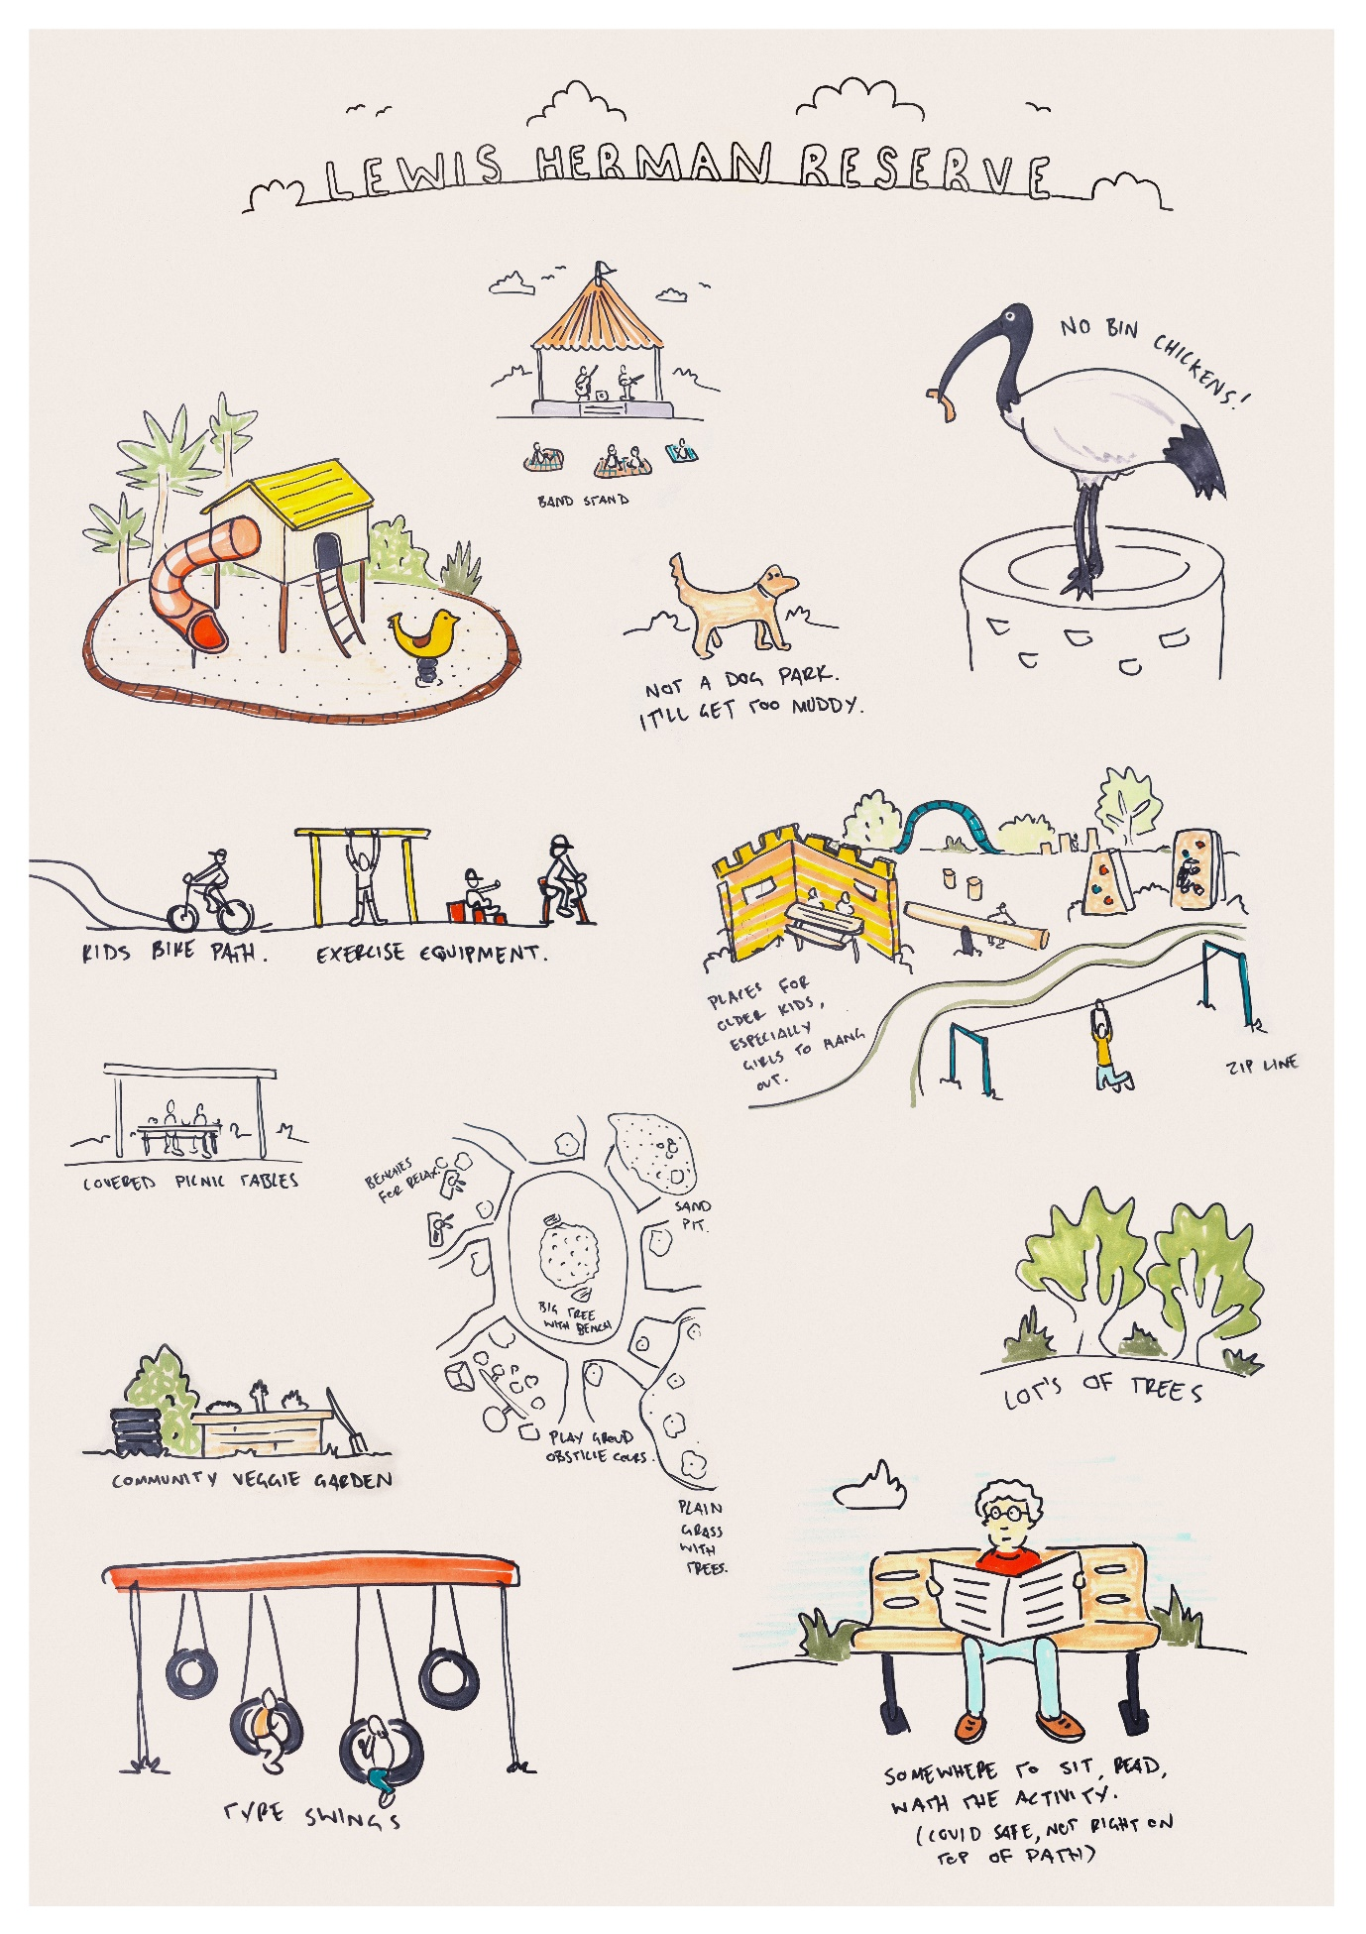
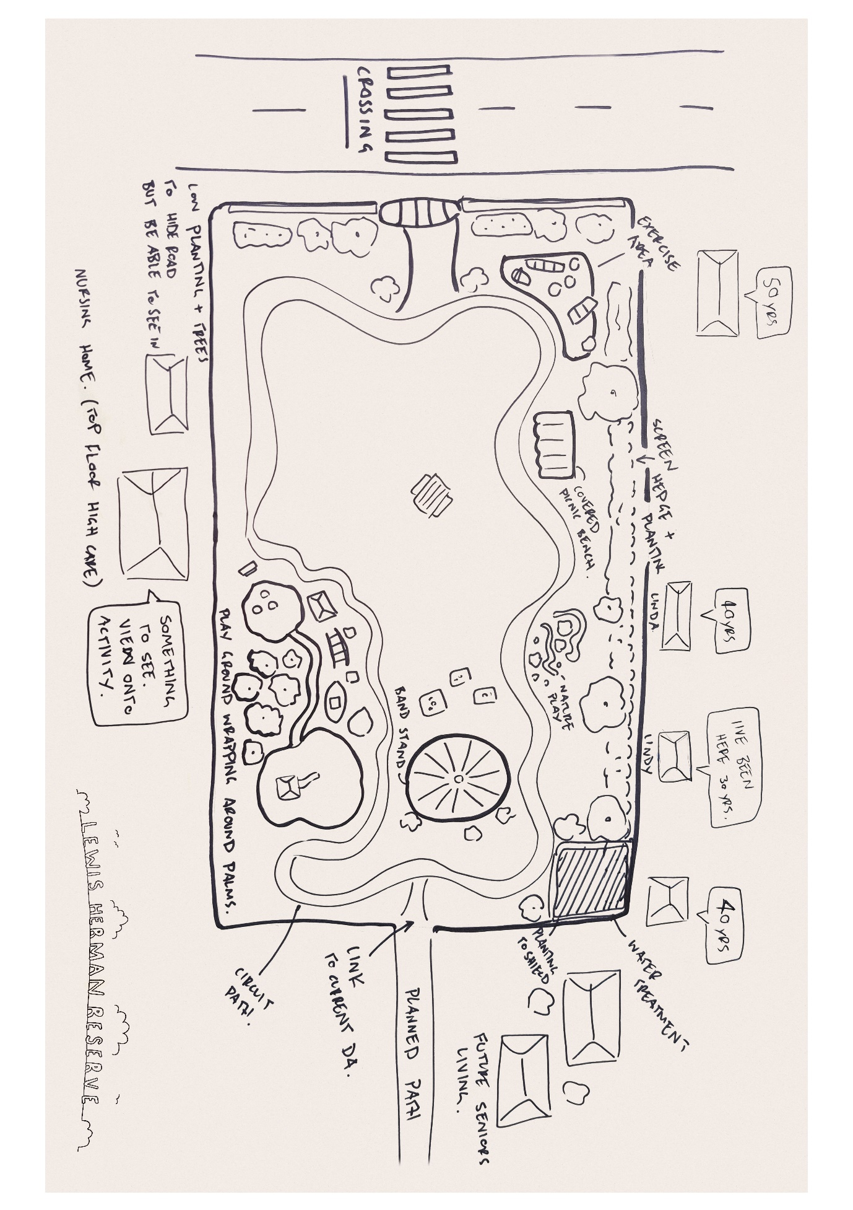

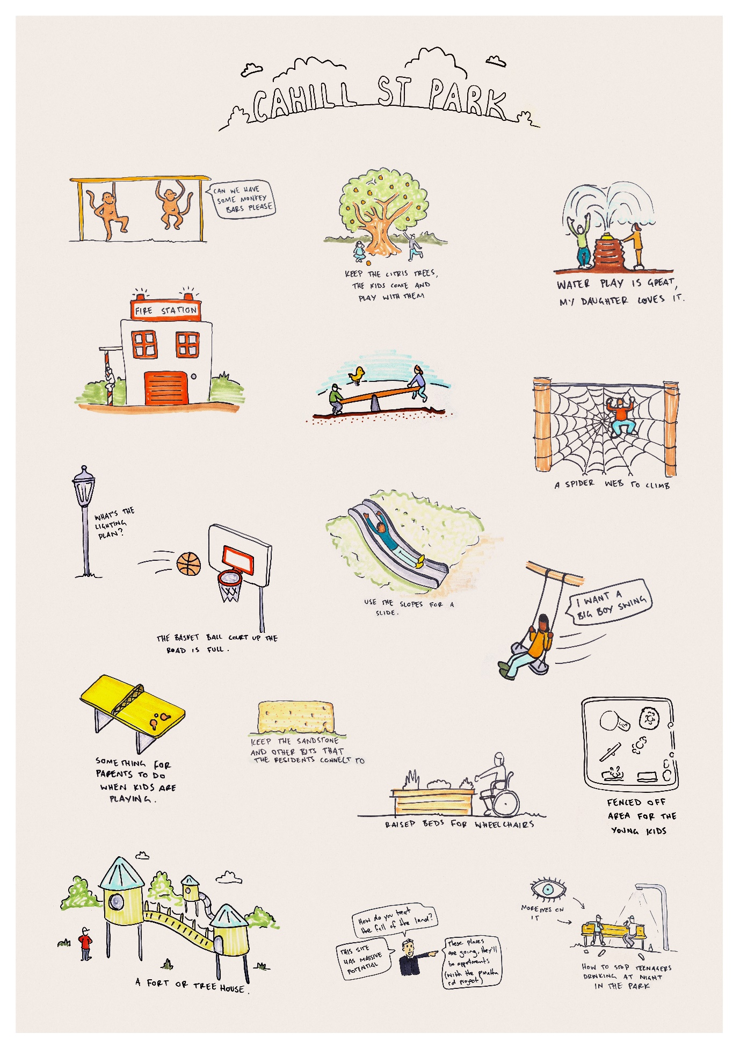

Attachment B – Posters on-site sessions
