17 November 2021

Have your say on the upgrade of the Cahill Street Reserve playground, Annandale
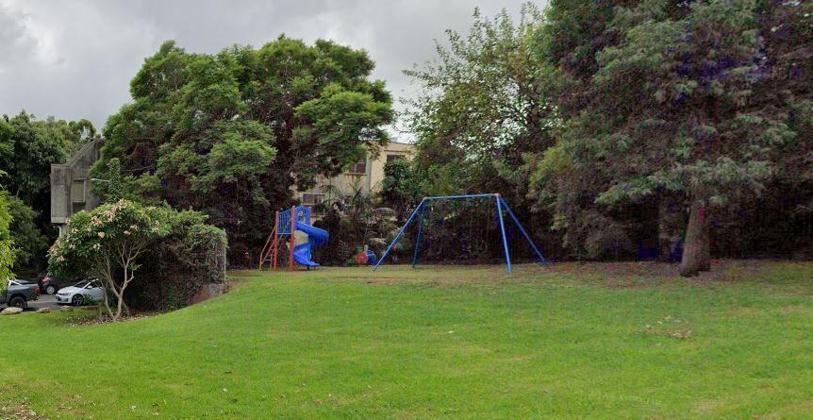

Inner West Council thanks to funding from NSW Government's Public Spaces Legacy Program is refurbishing the playground and welcomes your input to help ensure it reflects the community’s diverse needs now and into the future. The playground upgrade is part of a larger project to increase open space and to improve connectivity to Johnstons Creek.
“Playgrounds are an important and valued part of our recreational open space. Please take time to provide feedback on the new design or come to a pop up session at the park to share your thoughts with the Project Team.” - Councillor Rochelle Porteous, Inner West Mayor.

Upgrades can include:

- Play equipment | - New seating | - Bubbler | - Soft fall
- New plants | - Nature play | - Shade sail | - Bicycle racks

When is this happening?
- 17 November to 15 December 2021 - Community provides feedback
- December 2021 to January 2022 - Project team reviews feedback and commences design
- July 2022 to December 2022 - Expected construction

Have your say
Online at:
yoursay.innerwest.nsw.gov.au/cahill-street-playground-upgrade

Or

Come and chat to the project team on site at Cahill Street playground, Annandale:
- Saturday 27 November between 1 and 3pm

Last day to provide feedback is Wednesday 15 December 2021.

Enquiries
Bruce Royds on 02 9392 5511 or bruce.royds@innerwest.nsw.gov.au

