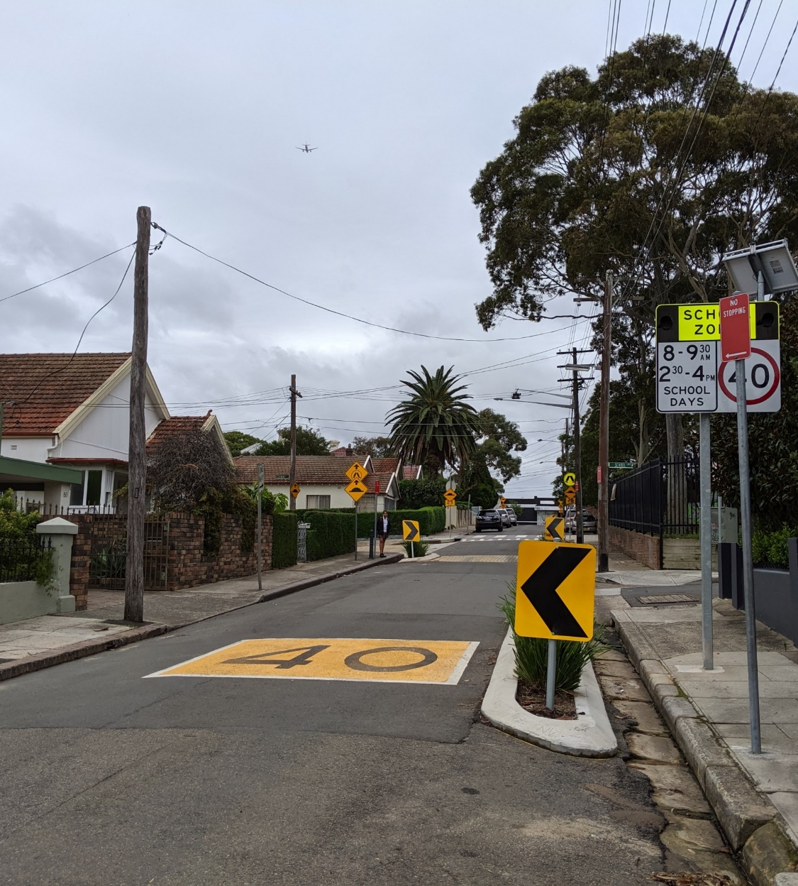

Engagement outcomes report

Tempe South LATM Study

Contents
1
Summary 3
Background 4
Promotion 4
Engagement outcomes 5
Who did we hear from? 5
What did they say? 6
General comments raised 11
Officer comments in response to public exhibition 15

Summary
As part of the development of the Tempe South Local Area Traffic Management study, the community could provide feedback on a draft LATM study report and concept designs. These documents were presented for public exhibition between 3 November 2020 and 12 January 2021.
The community could participate in the consultation via a questionnaire on the Your Say Inner West or direct email. Participants could indicate their preference on the treatment proposals and options for each subject street and provide further comments or suggestions.
It is approximated that 139 people participated in this engagement. Specific numbers cannot be determined as we can’t verify participants in group submissions. There were 519 people who visited the Your Say Inner West project page. Of these, 265 people downloaded a document and 87 people provided feedback. One of the participants later provided additional comments via email.
A community group made up of 22 residents from Union Street submitted a document via email covering several issues from the draft report. A petition by 30 residents along Smith Street was also submitted via email. Businesses in the study area have also provided their comments.
The preferred option for each street is:
- Edwin Street: no consensus on the flat top road hump
- Barden Street, Fanning Street, Hart Street and Station Streets: Contrasting pavement threshold
- Holbeach Avenue: Option 2 (speed cushions and road narrowing)
- Stanley Street: Option 1 (flat top road humps)
- Wentworth Street: Option 2 (flat top road humps)
- Smith Street: Option 1a (Road narrowing & contrasting pavement with widened footpath)
Streets where opposition was predominant include:
- Tramway Street: oppose contrasting pavement threshold
- Union Street: oppose both proposed options
General comments included:
- The calculated traffic generated from Bunnings along local streets such as Union Street is too low.
- Local streets often have children and additional Bunnings traffic will make the streets unsafe.
- Proposals are out of touch with community concerns and practicalities and do not deter additional non-local traffic.
- Banning through traffic from Smith Street to Union Street. This will also address potential rat-running problems in Stanley, Edwin and Tramway Streets.
- No substantial treatments have been proposed on many local streets in the area to stop alternative routes.
- Concerns with traffic safety and congestion affecting truck movements to and from Wood Street.
- Signage should be enforced.

Background
As part of the conditions of consent for an approved Bunnings Warehouse at 728-750 Princes Highway, the Eastern City Planning Panel has conditioned that a Local Area Traffic Management (LATM) study be undertaken for the Tempe South area. A LATM would provide proposals to manage the impacts of the proposed Bunnings development on local traffic.
Following the initial stages of the study, streets where impacts would be experienced were identified and treatment options were provided for each street. Only one treatment option was provided for Barden, Fanning, Hart, Station, Edwin and Tramway Streets, while a total of four variations of the treatment options were provided for Smith Street.
Engagement Methods
The community could provide feedback via:
- Your Say inner West (YSIW) – including online questionnaire and document download
- Email – responses went directly to the Council project team
Due to COVID-19 restrictions, it was decided not to hold in person consultation. Instead the Council project team was available to take calls regarding any questions the community had before providing their feedback.

Promotion
- Letterbox drop
- YSIW E-newsletter
- YSIW Homepage
- Council website

Engagement outcomes

Who did we hear from?
Almost half the respondents (47%) were in the 35-49 age group, followed by approximately 27% who identified with the 50-59 age group.
Age Group | Number | Percentage
25-34 | 11 | 12.1%
35-49 | 43 | 47.3%
50-59 | 25 | 27.5%
60-69 | 4 | 4.4%
70+ | 3 | 3.3%
Undisclosed | 5 | 5.5%
Total responses | 91 | 100%
Skipped | 1 | -

When asked about their relationship to the study area, 89% of respondents identified as residents, 15% of respondents who were bicycle users through the area and almost 10% were local school users.
It should be noted respondents were able to select up to three responses and as such does not present a direct correlation to the number of responders.
Relationship | Number | Percentage
Resident | 82 | 89.1%
Business Owner | 4 | 4.3%
Visitor | 5 | 5.4%
Pass through area for work | 7 | 7.6%
Bicycle user in the area | 14 | 15.2%
School user | 9 | 9.8%
Other | 4 | 4.3%
Totals | 92 | 100%

What did they say?
Online via yoursay.innerwest.nsw.gov.au
The following is an overview of the feedback provided as part of the online engagement. It should be noted all button questions asked were optional and could be skipped. This enabled respondents to provide feedback on as many streets as they wanted to.

Barden, Fanning, Hart and Station Streets
The same treatment (contrasting pavement threshold) was proposed for these streets. Participants were asked to tick the boxes of each street that they agreed with this treatment being applied to. A blank would indicate opposition for that location.
At least 32 of 34 responses (94%) to this question indicated support for the contrasting pavement threshold treatments on Barden Street, Fanning Street, Hart Street and Station Streets.
The majority of respondents (58 people) chose not to answer this question.
 | Barden Street | Fanning Street | Hart Street | Station Street
Support | 33 | 33 | 33 | 32
Blank (oppose) | 1 | 1 | 1 | 2
Total responses | 34 | 34 | 34 | 34
Skipped | 58 | 58 | 58 | 58

Key themes in the comments included:
- Concerns with high parking on these streets, often occupied by Tempe Tyres traffic and international travellers
- Vehicles parked on footpath restricts pedestrian access
- Difficulties with two way travel with parking on both sides of the road
- Physical deterrent such as a closure is preferred

Edwin Street
In total, 63 people responded to the proposal to install a flat top road hump in Edwin Street. Overall, the community was divided on whether this treatment was appropriate. A total of 24 respondents (38%) indicated they were dissatisfied or completely dissatisfied, 18 (28%) were neutral, and 21 (33%) were satisfied or completely satisfied with the proposal.
This question was skipped by 29 participants.
Response | Number |  | Percentage |  | Combined
Completely satisfied | 4 | 6.3% |  | 33.3%
Satisfied | 17 | 27.0%
Neutral | 18 | 28.6% |  | 28.6%
Dissatisfied | 13 | 20.6% |  | 38.1%
Completely dissatisfied | 11 | 17.5%
Total responses | 63 | 100% |  | 100%
Skipped | 29 | - |  | -

Key themes in the comments included:
- Proposal does not necessarily reduce rat runs, or non-local traffic in the area
- Pedestrian safety concerns
- Parking is critical and residents don’t have enough parking

Tramway Street
In total, 61 people responded to the proposal to install contrasting pavement in Tramway Street. Overall, the community did not support this treatment. A total of 24 (39%) were dissatisfied or completely dissatisfied, 19 (31%) were neutral, and 18 (29%) were satisfied or completely satisfied with the proposal.
This question was skipped by 31 participants.
Response | Number |  | Percentage |  | Combined
Completely satisfied | 1 | 1.6% |  | 29.5%
Satisfied | 17 | 27.9%
Neutral | 19 | 31.1% |  | 31.1%
Dissatisfied | 10 | 16.4% |  | 39.4%
Completely dissatisfied | 14 | 23.0%
Total responses | 61 | 100% |  | 100%
Skipped | 31 | - |  | -

Key themes in the comments included:
- Concerns with current rat running
- Proposal may not change drivers behaviour
- No footpaths on both sides of the street

Holbeach Avenue
In total 57 people responded to the proposals for Holbeach Avenue. Overall, the community preferred option 2 (speed cushions and road narrowing) with 19 people (33%). A total of 13 people (23%) preferred Option 1 (speed cushions only), 11 (19%) preferred neither and 14 (24%) had no opinion.
This question was skipped by 35 participants.
Response | Number | Percentage
Option 1 (speed cushions) | 13 | 22.8%
Option 2 (speed cushions & road narrowing) | 19 | 33.3%
Neither | 11 | 19.3%
No Opinion | 14 | 24.6%
Total responses | 57 | 100%
Skipped | 35 | -

Key themes in the comments included:
- Measures should improve pedestrian safety due to the childcare centre
- Landscaped island is a concern for cyclists, attracts litter and reduces parking
Stanley Street
In total 62 people provided feedback on the prosed treatments for Stanley Street. Overall, the preference was for option 1 (flat top road humps) with 24 people (38.7%). A total of 9 people (14%) preferred Option 2 (road narrowing), 16 (25%) preferred neither and 13 (21%) had no opinion on either treatment (neutral).
This question was skipped by 30 participants.
 | Number | Percentage
Option 1 (flat top road humps) | 24 | 38.7%
Option 2 (road narrowing) | 9 | 14.5%
Neither | 16 | 25.8%
No Opinion | 13 | 21.0%
Total responses | 62 | 100%
Skipped | 30 | -

Key themes in the comments included:
- Proposal does not necessarily reduce rat runs, or non-local traffic in the area
- Difficulties in parking in the street, often taken up by employees in Princess Highway, Tempe depot.

Wentworth Street
In total 61 people provided feedback on the prosed treatments for Wentworth Street. Overall, 21 (34%) of responses preferred Option 2 (flat top road humps), 17 (27%) preferred Option 1 (road narrowing & contrasting pavement), 8 (13%) preferred neither and 15 (24%) had no opinion on either treatment (neutral)
This question was skipped by 31 participants.
Treatment option | Number | Percentage
Option 1 (road narrowing & contrasting pavement) | 17 | 27.9%
Option 2 (flat top road humps) | 21 | 34.4%
Neither | 8 | 13.1%
No Opinion | 15 | 24.6%
Total responses | 61 | 100%
Skipped | 31 | -

Key themes in the comments included:
- Proposal does not necessarily address existing traffic and parking problems from Tempe Tyres
- Difficult for vehicles to pass each other due to parked cars on both sides
- Road hump results in more noise due to Tempe Tyres trucks
Union Street
Proposals to Union Street were the most popular among respondents, which explains the high skip rate prior and following this question. In total, 78 people provided feedback on the proposals for Union Street. Responses indicate opposition to both options (flat top road humps or shared zones) with 36 people (46%) selecting that they prefer neither treatment and 9 people (11%) had no opinion on either treatment (neutral).
Key themes that emerged in the comments were:
- The traffic expected in Union Street is a concern for residents, do not agree with the traffic generation rates, traffic distribution, assessment criteria, treatments, used in the draft report.
- Disagree with the traffic data that was used during the COVID-19 lockdown with lower traffic
- Suggested alternative options, change Bunnings design -exit only onto Princes Highway with traffic signals, Smith Street entry only into Bunnings
- Left turn and Right turn entry only from Smith Street, block through movement from Smith Street to Union Street, using ‘dog leg’ island design
A further 24 people (30%) preferred Option 2 (shared zone) and 17 people (27%) preferred Option 1 (road narrowing & contrasting pavement).
This question was skipped by 14 participants.
Treatment option | Number | Percentage
Option 1 (flat top road humps) | 9 | 11.5%
Option 2 (shared zone) | 24 | 30.8%
Neither | 36 | 46.2%
No Opinion | 9 | 11.5%
Total responses | 78 | 100%
Skipped | 14 | -

Smith Street
Proposed treatments for Smith Street received feedback from 48 people. Overall, option 1A (road narrowing and contrasting pavement, with widened footpath) was the preferred option with support from 25 respondents (52%). Only 3 respondents (6%) preferred Option 1b, 8 respondents (16%) preferred Option 2a, and 12 respondents (25%) preferred Option 2b.
This question was skipped by 14 participants.
Treatment Option | Number | Percentage
Option 1a (road narrowing & contrasting pavement, with widened footpath) | 25 | 52.1%
Option 1b (road narrowing & contrasting pavement, with widened footpath and landscaped verge) | 3 | 6.3%
Option 2a (mountable concrete median, with widened footpath) | 8 | 16.7%
Option 2b (mountable concrete median, with widened footpath and landscaped verge) | 12 | 25.0%
Total responses | 48 | 100%
Skipped | 44 | -

Key themes that emerged in the comments were:
- Concerns with vehicular access to residential properties in Smith Street and to the Tempe Wetlands.
- Preference for resident permit parking, additional parking is needed
- The options do not consider the ability of Wood Street businesses to carry out business activities requiring large trucks, and that the road should not be narrowed further

General comments raised
In addition to the comments on specific street treatments, participants could provide general comments about the project, attracting up to 108 comments on the study in general and for specific streets.
The participants provided opinions on the proposals and on the Bunnings development:
- Local streets often have children and additional Bunnings traffic will make the streets unsafe.
- The proposals on Union Street and Stanley Street do not deter additional non-local traffic.
- Proposals are out of touch with community concerns and practicalities.
- Speed humps generate additional noise.
- Landscaping attract litter and will require maintenance.
Participants also provided some suggestions:
- Turning Tramway Street to one-way northbound, or banning the left turn from Unwins Bridge Road onto Tramway Street
- Turning local roads south of Princes Highway into one-way roads
- Banning through traffic from Smith Street to Union Street. This will also address potential rat-running problems in Stanley, Edwin and Tramway Streets.
- Physical deterrent such as road closures are preferred.
One participant of the engagement emailed Council to provide additional comments and feedback:
- The report does not consider a partial closure of Union Street (i.e. left turn only from Princes Highway) and should be considered
- Changing the No Right Turn at Gannon Street
- The report does not consider the resulting threat to public safety.
- School and parents were not consulted.
- Stronger measures (including partial closure) and prioritising pedestrians (School Lane) have not been considered.

Comments from a community group
A community group representing residents raised their concerns about additional traffic generated, particularly in Union Street from the proposed Bunnings development.
Key issues raised include:
- Doubts over the draft LATMs process, including concerns that it doesn’t adequately address Council’s objectives/requirements and lacks transparency in data and modelling
- Doubts over traffic volume calculations presented in the report aligning with RMS Traffic Generation Rates and implications on the suitability of proposed treatments
- Concern that traffic modelling used to inform the proposals does not align with publicly available sources, such as Google Maps and implications on the suitability of the proposed treatments
Criticism of proposed treatments
- The proposed treatments do not aim to deter traffic, only to calm it, particularly around the school areas. This raises issues during peak times around the school, will increase traffic queuing at Unwin’s Bridge Road and are not acceptable from an environmental impact perspective
- The points criteria system is flawed, unfair and inconsistent. It does not truly account for one way and narrow nature of Union Street, and presence of school. Score is on the low end but has been recognised as significant in the report. Effectively, score should be much higher.
- A new bicycle route crosses Union street at School Lane and Edwin Street, increased traffic will not be safe.
- The 85th percentile speeds are higher on Union Street.
- Signage such as the Right Turn Only and truck load limit will need to be enforced.
Suggestions
- Suggestion 1: Change Bunnings to exit onto Princes Highway with signalised intersection, Smith Street to be used as entry only into Bunnings
- Suggestion 2: Left Turn and Right Turn only from Smith Street, block through movement to Union street, potentially using 'dog leg' island design.
Submissions from businesses
Submissions were received from businesses along Princes Highway and Wood Street.
General Comments
- Additional traffic (from Bunnings) on Smith Street will negatively impact the businesses in Wood Street
- Concern that many drivers will ignore the No Left turn restriction at the Bunnings driveway.
Feedback on the process
- Concern that the LATM has been prepared after the development approval. Residents should have been engaged on treatments prior to this as part of the DA process so that feedback could have informed the Development Assessment and consent
- No information on funding and if Bunnings is funding the LATM, has the study been done independently
- Suggestion of a follow-up study to ensure unforeseen issues are addressed
Feedback on the LATM study
- There is no information provided on what measures are proposed (only options presented), as operating conditions may be different to theoretical
- Road Safety Audit should assess the Princes Highway access and is critical to reduce impacts on Smith Street. The audit did not cover the Right Turn into Smith Street, which is expected to be intensified due to Bunnings
- Audit does not cover safety issues along local streets
- Keep Clear (on Princes Highway) may encourage drivers to undertake a right turn into Bunnings when sight lines are poor with stopped traffic
Feedback on proposals
Issue 1: The treatments are not sufficient
- Right turn only at the Bunnings exit will need enforcement, such as a physical barrier, to stop traffic from using southern streets to access the Princes Highway. Anticipate there will be delays at Smith/Princes Hwy intersection creating this behaviour
- The treatments focus on gateways to local streets and do not discourage vehicles taking alternative routes through the local area
- Local narrowing in Wentworth Street south of Princess Highway is appropriate but may not be enough. More aggressive solution is required, in conjunction with proposed flat top road humps. No measures proposed for South Street. More measures will be needed to discourage vehicles using South Street.
- Wentworth Street is a key street to some businesses. However, only heavy vehicle issues have been considered.
- The need for a kerb blister may not be required if the exit to Princes Highway is signalised.
- An extensive and elaborate regime is required, mid-block and at intersections with South Street.
Issue 2: Impact of increased queuing and traffic
- Diverted traffic issues (from Wentworth Street) should be considered, including queueing at Princes Highway.
Issue 3: Oppose loss of resident parking
- For a development of this size, Bunnings should provide its own access as Smith Street residents do not agree to any loss of on-street parking. However, they generally support a proposal which results in the lowest impact to on-street parking.

Smith Street Petition
A petition comprising signatures by Smith Street residents has been provided by email, summarising issues and concerns regarding the proposed treatment options.
- Smith Street residents do not agree to any loss of on-street parking. However, they generally support a proposal which results in the lowest impact to on-street parking.
- The need for a kerb blister may not be required if the exit to Princes Highway is signalised and should be reviewed in connection to the feasibility study of the signals.
- A Resident Parking Zone should be implemented to deter tradesmen working on the new Bunnings from parking on Smith Street during construction, and deter customers from parking after completion.
- Widen the footpath north of the Bunnings access instead of whole length due to the increased traffic. Retain the footpath width in the southern section as a narrower road section will result in an increase in vehicle damage and sideswiping.
- Retain sandstone kerbs due to the heritage nature.
- There is an existing DA application for a new dual driveway at 26-28 Smith Street, which interferes with the location of the proposed kerb blisters as part of Option 1 (road narrowing). The residents request a reduction in the width of the kerb blister to allow for the driveway entrance.

Officer comments in response to public exhibition
The draft LATM study report will be revised to address comments gathered during community consultation and include a summary of the engagement outcomes. There will be adjustments to the proposals in response to some of the comments received. A preferred option will be adapted for each street and presented in the report.
Responses to key issues identified in the public exhibition of the Draft LATM study report and concept designs are outlined in the table below.
Issue | Description | Response
Existing parking issues | Residents have highlighted difficulty in parking outside their property due to parking by nearby workers, airport users and other visitors. They prefer a residential parking scheme to be implemented to improve parking in the local area. | As part of the study, a parking survey on a number of streets was undertaken. The parking levels found were generally within 50-70% occupancy during weekdays and weekends, which do not meet the level required for a resident parking scheme as outlined in Council’s Public Domain Parking Policy.
Efficiency of LATM proposals | Residents do not agree that the proposals will be able to address the increase in non-local traffic and do not reduce non-local traffic volumes. | The proposals aim to deter non-local traffic by reducing vehicle speeds and increasing travel time as to make routes using local roads less desirable for non-local traffic. LATM proposal was selected based on traffic volumes, speed and/or crash history.
Existing rat-running and non-local traffic issues | Residents have highlighted existing rat-running routes and use by non-local traffic. They have suggested schemes such as one-way system or road closures. | The LATM study focuses on the additional non-local traffic caused by Bunnings and may not universally address existing rat running issues.
Alternative Union Street proposal | Union Street residents have suggested closing Union Street to Smith Street through traffic, i.e. left turn entry only from Princes Highway | This option may be required given the direct route along Union Street and presence of schools. This option is to be further explored.
Children safety | Local streets often have children and residents have highlighted that additional Bunnings related traffic will make the streets unsafe | The LATM study aims to minimise additional traffic by reducing through traffic and vehicle speeds using the selected proposals.
Alternative Bunnings entrance and exit | Bunnings traffic should not exit via Smith Street and an alternative access be provided on Princes Highway. | An alternative access on Princes Highway will be the subject of further investigations, however it is noted that Transport for NSW has not supported an alternative signalised exit on Princess Highway.
Alternative transport | Residents preferred solutions that encourage alternative transport such as cycleways to ensure walking and cycling are more attractive | Active transport has been considered in Smith Street, which provides connectivity to existing routes. Traffic calming results in lower vehicle speeds and improving safety for vulnerable road users such as pedestrians and cyclists.

